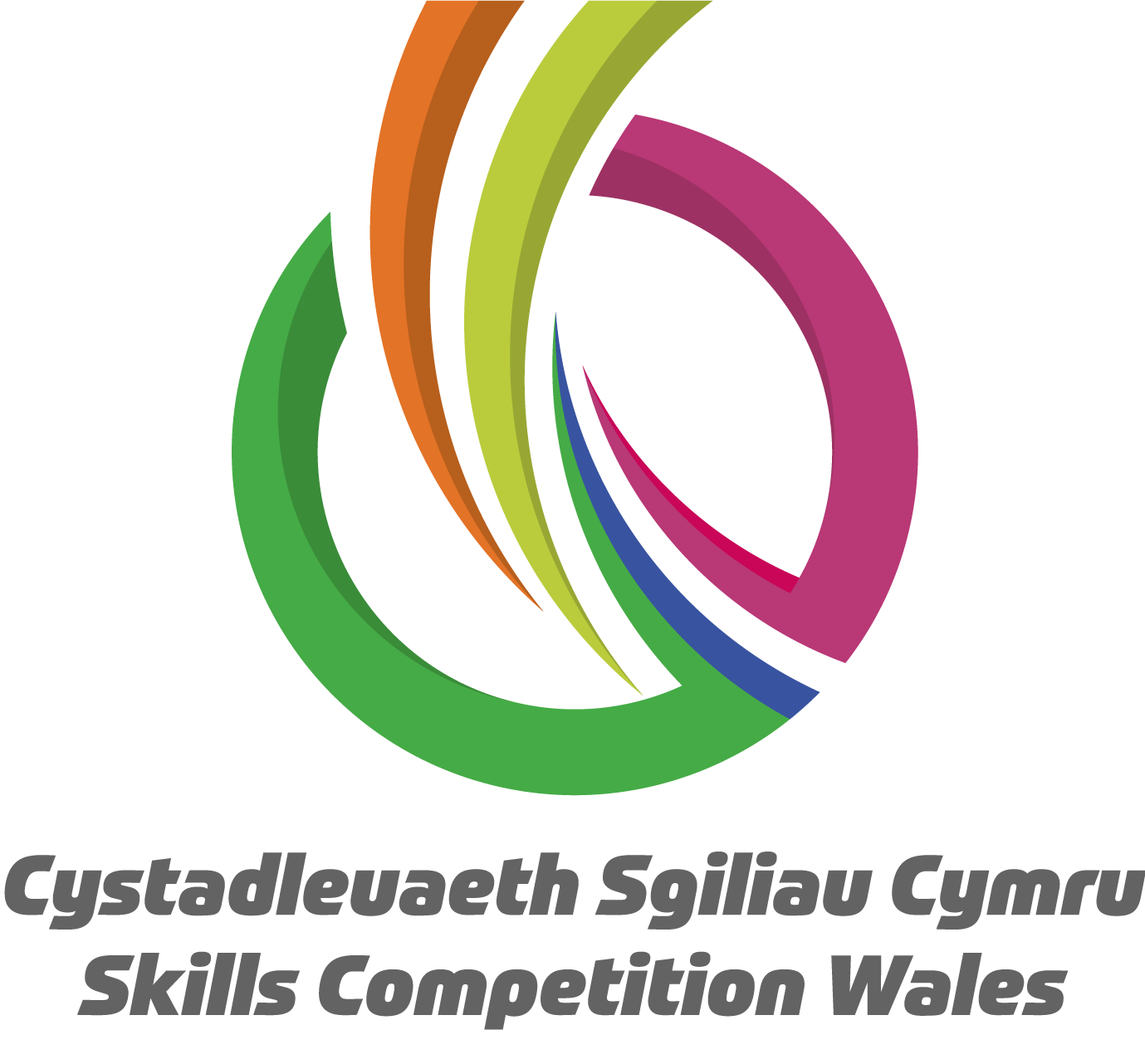

**Competition Brief**

**Competition Title**

Net Zero Skills

**Competition Overview**

This is a team competition that will research into how various technologies within the green technology sector can provide energy for homes and industry. For example, wind turbines, solar photovoltaic, tidal devices, hydro turbines and hydrogen.

The scope of the competition enables learners to develop and put into practice a variety of skills and knowledge that are required to develop a comprehensive strategy to reduce the carbon footprint and achieve net zero emissions in your school, community, or region.

Competitors taking part in this competition should, both individually and as part of a team, be able to:

* Generate ideas/spot opportunities
* Demonstrate creativity and innovation
* Develop appropriate strategies to problem solve and deal with difficult situations whilst working together
* Planning and managing resources
* Communicate effectively
* Working with others respectfully and effectively
* Demonstrate leadership skills (negotiation, persuasion and influence)
* Demonstrate self-confidence, self-belief and motivation
* Demonstrate solutions to sustainable energy options
* Demonstrate numeracy skills and understanding of costs
* Demonstrate presentation skills
* Identify and assess your individual and group strengths and weaknesses

The day will be split into a variety of tasks to allow each team to demonstrate their knowledge of Net Zero problem solving skills, both individually and as a team, which will be judged by a panel of Net Zero judges.

**Entry Criteria**

This competition is intended for competitors who are working at all levels of education up to a Level 6.

## Entry capacity restrictions by organisation

Maximum of up to **1 team per organisation consisting of up to 4 team members**. **Reserves** may also be registered to account for potential absences or withdrawals.

This is the maximum number of entries permitted by an organisation for this competition. This is determined by ‘location’ and ‘organisation’. ‘Organisation’ refers to the competitors’ training provider/employer. ‘Location’ refers to a site where the competitor studies / is employed.

This competition may be subject to a selection process if competitor registration numbers exceed the host venue capacity. Where capacity is identified in a competition the reserve competitors may be invited to compete. The decision will be made following a consultation between Skills Competition Wales and the competition lead after registration closes. All parties will be notified of any changes.

For further guidance on these capacities, [click here](https://inspiringskills.gov.wales/competitions/competition-registration-guide).

**Brief**

**The competition is based on the following:**

Your team is tasked with developing a comprehensive strategy to reduce the carbon footprint and achieve net zero emissions in your school, community, or region. This challenge will test your problem-solving skills, creativity, and ability to work collaboratively under time constraints.

**Preparation work leading up to the competition day:** To be submitted via an online portal by **Friday the 16th January 2026.**

Create a mood board or montage representing your initial ideas for achieving net zero. This will be displayed on large screens on the competition day and should be in the form of a single powerpoint slide. Please ensure you have your team name on the slide and it is in the standard 4:3 resolution.

**Competition Day Brief**

**The Challenge**

On the day of the competition, you will receive additional information to refine your solutions. Your team will have 4 hours to develop a detailed proposal addressing the following key areas:

**Solution Design**

- Outline your proposed strategy for achieving net zero, with timescales

- Describe specific initiatives and technologies you plan to implement

- Explain how your solution is tailored to your school/college/community/region.

**Environmental Impact**

- Consider the expected reduction in greenhouse gas emissions

- Discuss other environmental benefits (e.g., improved air quality, biodiversity)

- Address potential environmental challenges and mitigation strategies

**Cost Analysis**

- Provide a detailed budget for implementing your strategy

- Include initial investment costs and ongoing operational expenses

**Community Engagement**

- Describe how you will involve local stakeholders in your initiative

- Outline education and awareness programs to promote community participation

- Discuss potential partnerships with local businesses, communities and government

**Implementation Timeline**

- Provide a phased approach for implementing your strategy

- Identify key milestones and deadlines

- Discuss potential challenges and contingency plans

**Innovation and Scalability**

- Highlight any innovative aspects of your proposal

- Explain how your solution could be scaled or replicated in other communities

**Monitoring and Reporting**

- Describe how you will track progress towards your goals

- Outline a plan for regular reporting and transparency to stakeholders

**Presentation Format**

Prepare a 10-minute presentation summarising your proposal, followed by a 5-minute Q&A session with the expert panel. Your presentation should be clear, concise, and visually engaging.

Learners will be judged on their ability to communicate, interact and if working through the medium of English, make use of incidental Welsh during this activity. e.g. Welcome, introduction or a close through the medium of Welsh.

Previous competition briefs are available to view and download via the Skills Competition

Wales website, please [click here](https://inspiringskills.gov.wales/competitions/net-zero-skills/archives) to access.

**Infrastructure List**

Laptop/Chromebook, translation resources, paper/pens/calculators for group work, laptops with Microsoft office and access to the internet for research.

**Competition day activities**

Each team will be expected to undertake the following as part of the competition day:

1. Read and analyse additional information
2. Update an extended bid template based on new information and new considerations
3. Finalise the preferred solution to meet the updated scenario
4. Prepare a 10-minute presentation of the team’s solution to the panel

**Competition Rules**

For full terms and conditions of entry and competition rules [visit](https://inspiringskills.gov.wales/terms/registrations-terms-and-conditions).

**Conduct of competitors during the live competitions:**

* All teams will participate in all tasks and questioning by the Judges.
* Competitors will start and finish work/tasks as instructed by competition organisers and/or judges.
* The use of offensive behaviour of language will not be permitted; competitors could be excluded from continuing in the competition.
* The panel’s decisions will be quality assured by the ISEiW Team before winners are announced.

**Generic competition rules**

* Mobile phones can be used during the tasks for research purposes but are to be switched off during any presentations.
* Listening to music via headphones is not permitted during competition activity.
* Any questions during competition activity should be addressed to the competition lead.
* It is the responsibility of each group of competitors to arrive on time for each competition session. No additional time will be allowed if you arrive late.
* Technical failure of your equipment should be reported immediately to the competition lead. Additional time will be allocated if the fault is beyond the control of the competitor.

**Marking and Assessment**

Marking and judging of this competition will be done by a team of experts from Industry, Further Education or Training Provider, using a marking criteria and allocated marks to ensure consistency.

Competition Assessment criteria:

| A | Feasibility of the solution | 15% |
| --- | --- | --- |
| B | Innovative approach | 15% |
| C | Level of technical detail | 15% |
| D | Effectiveness of the teamwork | 15% |
| E | Value for money | 15% |
| F | Environmental impact | 15% |
| G | Presentation to include an element of welsh language | 10% |
|  | **Total** | **100%** |

**Feedback and Recognition**

Individual and Group verbal feedback will be provided at the end of the competition. No results or awards will be awarded on the day as marking will be quality assured.

All competitors will be issued with a Participation Certificate on the competition day. First, second, third and highly commended awards will be announced during the celebration event. The highly commended award recognises all competitors who have achieved above average. The celebration event will be held on Wednesday 18th March 2026, further details will be communicated to competitors and their points of contact by email.

Marksheets will be available upon request via [info@skillscompetitionwales.ac.uk](mailto:info@skillscompetitionwales.ac.uk) to competitors after the celebration event.

**Competition Lead**

Lead Contact: Lewis Jones

L.Jones1@merthyr.ac.uk

**Our partners**

This competition is delivered in partnership with

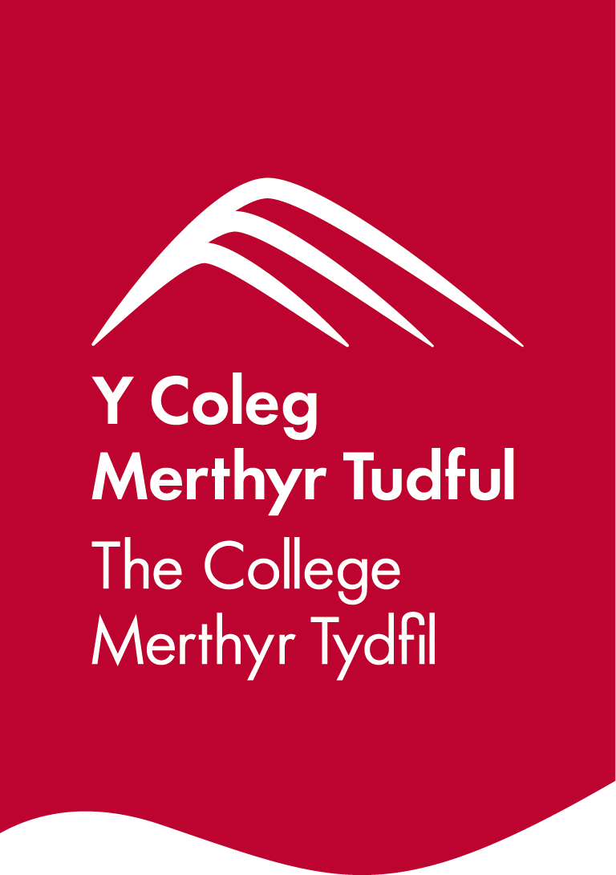



**Briff y Gystadleuaeth**

**Teitl y Gystadleuaeth**

Sgiliau Sero Net

**Trosolwg o'r Gystadleuaeth**

Cystadleuaeth tîm yw hon a fydd yn ymchwilio i sut y gall technolegau amrywiol oddi mewn i’r sector technoleg werdd ddarparu ynni ar gyfer cartrefi a diwydiant. Er enghraifft, tyrbinau gwynt, solar ffotofoltäig, dyfeisiau llanw, tyrbinau dŵr a hydrogen.

Mae cwmpas y gystadleuaeth yn rhoi cyfle i ddysgwyr ddatblygu a defnyddio amrywiaeth o sgiliau a gwybodaeth sydd eu hangen i ddatblygu strategaeth gynhwysfawr i leihau ôl troed carbon a chyflawni allyriadau sero net yn eich ysgol, cymuned neu ranbarth.

Dylai cystadleuwyr sy’n cymryd rhan yn y gystadleuaeth hon, yn unigol ac fel aelod o dîm, allu:

* Cynhyrchu syniadau/Canfod Cyfleoedd
* Arddangos creadigrwydd ac arloesedd
* Datblygu strategaethau priodol er mwyn datrys problemau ac ymdrin â sefyllfaoedd anodd wrth gydweithio
* Cynllunio a rheoli adnoddau
* Cyfathrebu'n effeithiol
* Gweithio gydag eraill a hynny’n barchus ac effeithiol
* Arddangos sgiliau arwain (trafod, perswadio a dylanwadu)
* Dangos hunanhyder, hunangred a chymhelliant
* Arddangos atebion i opsiynau ynni cynaliadwy
* Arddangos sgiliau rhifedd a dealltwriaeth o gostau
* Arddangos sgiliau cyflwyno
* Nodi ac asesu eich cryfderau a'ch gwendidau unigol ac fel grŵp

Bydd y diwrnod yn cael ei rannu’n amrywiaeth o dasgau er mwyn galluogi pob tîm i arddangos eu gwybodaeth am sgiliau datrys problemau Sero Net, yn unigol ac fel tîm, gaiff eu beirniadu gan banel o feirniaid Sero Net.

**Meini Prawf Mynediad**

Bwriedir y gystadleuaeth hon ar gyfer cystadleuwyr sy’n gweithio ar bob lefel ym maes addysg hyd at Lefel 6.

## Cyfyngiadau ar gapasiti mynediad fesul sefydliad

Uchafswm o hyd at **1 tîm fesul sefydliad, yn cynnwys hyd at 4 aelod tîm.** Gellir cofrestru **cronfeydd wrth gefn** hefyd i gyfrifon absenoldeb neu dynnu'n ôl os bydd angen

Dyma uchafswm nifer y ceisiadau cofrestru a ganiateir gan sefydliad ar gyfer y gystadleuaeth hon. Pennir hyn gan ‘leoliad’ a ‘sefydliad’. Mae ‘Sefydliad’ yn cyfeirio at ddarparwr hyfforddiant/cyflogwr y cystadleuwyr. Mae ‘Lleoliad’ yn cyfeirio at safle lle mae’r cystadleuydd yn astudio / yn cael ei gyflogi.

Gall y gystadleuaeth hon fod yn destun proses ddethol os yw'r niferoedd cofrestru cystadleuwyr yn fwy na chapasiti'r lleoliad cynnal. Lle nodir bod capasiti ar gyfer y gystadleuaeth, gellir gwahodd cystadleuwyr wrth gefn i gystadlu.

Bydd y penderfyniad yn cael ei wneud yn dilyn ymgynghoriad rhwng Cystadleuaeth Sgiliau Cymru ac arweinydd y gystadleuaeth ar ôl i'r cofrestru gau. Bydd pob parti yn cael gwybod am unrhyw newidiadau.

Am arweiniad pellach ar y galluoedd hyn, [cliciwch yma](https://inspiringskills.gov.wales/competitions/competition-registration-guide).

**Briff**

**Mae'r gystadleuaeth hon yn seiliedig ar y canlynol:**

Her eich tîm yw datblygu strategaeth gynhwysfawr i leihau ôl troed carbon a chyflawni allyriadau sero net yn eich ysgol, cymuned neu ranbarth. Bydd yr her hon yn profi eich sgiliau datrys problemau, creadigrwydd a'ch gallu i weithio ar y cyd o fewn cyfyngiadau amser.

**Gwaith paratoi cyn diwrnod y gystadleuaeth:** I'w gyflwyno trwy borth ar-lein erbyn **dydd Gwener 16 Ionawr 2026.**

Creu bwrdd naws neu 'montage' sy’n cynrychioli eich syniadau cychwynnol ar gyfer cyflawni sero net. Bydd hyn yn cael ei arddangos ar sgriniau mawr ar ddiwrnod y gystadleuaeth a dylai fod ar ffurf un sleid powerpoint. Dylech sicrhau bod enw eich tîm ar y sleid a’i fod ar ffurf cydraniad 4:3 safonol.

**Briff Diwrnod Cystadlu**

**Yr Her**

Ar ddiwrnod y gystadleuaeth, byddwch yn derbyn gwybodaeth ychwanegol i fireinio'ch atebion. Bydd gan eich tîm 4 awr i ddatblygu cynnig manwl sy'n ymdrin â'r meysydd allweddol canlynol:

**Dylunio Datrysiad**

- Amlinellu eich strategaeth arfaethedig ar gyfer cyflawni sero net, gydag amserlenni

- Disgrifio mentrau a thechnolegau penodol rydych chi'n bwriadu eu rhoi ar waith

- Esbonio sut mae eich datrysiad wedi'i deilwra i'ch ysgol/coleg/cymuned/rhanbarth

**Effaith Amgylcheddol**

- Ystyried y gostyngiad disgwyliedig mewn allyriadau nwyon tŷ gwydr

- Trafod manteision amgylcheddol eraill (e.e., gwell ansawdd aer, bioamrywiaeth)

- Mynd i'r afael â heriau amgylcheddol posibl a strategaethau lliniaru

**Dadansoddi Cost**

- Darparu cyllideb fanwl ar gyfer gweithredu eich strategaeth

- Cynnwys costau buddsoddi cychwynnol a threuliau gweithredol parhaus

**Ymgysylltu â'r Gymuned**

- Disgrifio sut y byddwch yn cynnwys rhanddeiliaid lleol yn eich menter

- Amlinellu rhaglenni addysg ac ymwybyddiaeth i hyrwyddo cyfranogiad cymunedol

- Trafod partneriaethau posib gyda busnesau, cymunedau a llywodraeth leol

**Llinell Amser Gweithredu**

- Darparu amserlen raddol ar gyfer gweithredu eich strategaeth

- Nodi cerrig milltir a dyddiadau cau allweddol

- Trafod heriau posib a chynlluniau wrth gefn

**Arloesi a Graddiadwyedd**

- Amlygu unrhyw agweddau arloesol ar eich cynnig

- Esbonio sut y gellid ehangu neu ailadrodd eich datrysiad mewn cymunedau eraill

**Monitro ac Adrodd**

- Disgrifio sut y byddwch yn olrhain cynnydd tuag at eich nodau

- Amlinellu cynllun ar gyfer adrodd yn rheolaidd a thryloywder i randdeiliaid

**Fformat y Cyflwyniad**

Paratoi cyflwyniad 10 munud yn crynhoi eich cynnig ac yna sesiwn Holi ac Ateb 5 munud gyda’r panel arbenigol. Dylai eich cyflwyniad fod yn glir, yn gryno, ac yn ddeniadol.

Bydd dysgwyr yn cael eu barnu ar eich gallu i gyfathrebu, rhyngweithio ac os ydych yn gweithio trwy gyfrwng y Saesneg, defnyddio'r Gymraeg yn achlysurol yn ystod y gweithgaredd hwn. e.e. Croeso, cyflwyno neu gloi yn Gymraeg.

Mae briffiau cystadleuaeth flaenorol ar gael i'w gweld a'u llwytho o’r wefan Cystadleuaeth Sgiliau Cymru, [cliciwch yma](https://inspiringskills.gov.wales/competitions/net-zero-skills/archives) i gael mynediad iddynt.

**Rhestr Isadeiledd**

Gliniadur/*Chromebook*, adnoddau cyfieithu, papur/beiciau/cyfrifiaduron ar gyfer gwaith grŵp, gliniaduron gyda *Microsoft Office* a mynediad i'r rhyngrwyd ar gyfer ymchwil.

**Gweithgareddau diwrnod cystadlu**

Bydd disgwyl i bob tîm gyflawni’r canlynol fel rhan o’r diwrnod cystadlu:

1. Darllen a dadansoddi gwybodaeth ychwanegol am y senari
2. Diweddaru templed cynnig estynedig yn seiliedig ar wybodaeth newydd ac ystyriaethau newydd
3. Cwblhau'r ateb a ffefrir er mwyn cwrdd â'r senario wedi'i ddiweddaru
4. Paratoi cyflwyniad 10 munud o ddatrysiad y tîm ar gyfer y panel

**Rheolau’r Gystadleuaeth**

I gael y telerau ac amodau mynediad llawn a rheolau cystadlu [ewch i](https://inspiringskills.gov.wales/terms/registrations-terms-and-conditions?lang=cy).

**Ymddygiad cystadleuwyr yn ystod y cystadlaethau byw:**

* Bydd pob tîm yn cymryd rhan ym mhob tasg ac yn y cwestiynu gan y Beirniaid.
* Bydd cystadleuwyr yn dechrau ac yn gorffen gwaith/tasgau yn unol â chyfarwyddyd trefnwyr y gystadleuaeth a/neu’r beirniaid.
* Ni chaniateir defnyddio iaith nac ymddygiad sarhaus; gallai cystadleuwyr gael eu gwahardd rhag parhau yn y gystadleuaeth.
* Bydd ansawdd penderfyniadau’r panel yn cael ei sicrhau gan Dîm ISEiW cyn y cyhoeddir enwau’r enillwyr.

**Rheolau generig y gystadleuaeth**

* Gellir defnyddio ffonau symudol yn ystod y tasgau at ddibenion ymchwil ond dylid eu diffodd yn ystod unrhyw gyflwyniadau.
* Ni chaniateir gwrando ar gerddoriaeth trwy glustffonau yn ystod y gweithgaredd cystadlu.
* Dylid cyfeirio unrhyw gwestiynau yn ystod gweithgaredd y gystadleuaeth at arweinydd y gystadleuaeth.
* Cyfrifoldeb pob grŵp o gystadleuwyr yw cyrraedd yn brydlon ar gyfer pob sesiwn gystadlu. Ni chaniateir amser ychwanegol os byddwch yn cyrraedd yn hwyr.
* Dylid rhoi gwybod ar unwaith i arweinydd y gystadleuaeth am fethiant technegol eich offer. Caiff amser ychwanegol ei neilltuo os yw'r nam y tu hwnt i reolaeth y cystadleuydd.

**Marcio ac Asesu**

Bydd tîm o arbenigwyr o fyd Diwydiant, Addysg Bellach neu Ddarparwr Hyfforddiant yn marcio ac yn beirniadu'r gystadleuaeth hon, a byddant yn defnyddio meini prawf marcio a marciau a ddyrennir er mwyn sicrhau cysondeb.

Meini prawf asesu cystadleuaeth:

| A | Dichonoldeb y datrysiad | 15% |
| --- | --- | --- |
| B | Dull arloesol | 15% |
| C | Lefel y manylion technegol | 15% |
| D | Effeithiolrwydd y gwaith tîm | 15% |
| E | Gwerth am arian | 15% |
| F | Effaith amgylcheddol | 15% |
| G | Cyflwyniad i gynnwys elfen o’r iaith cymraeg | 10% |
|  | **Cyfanswm** | **100** |

**Adborth a Chydnabyddiaeth**

Darperir adborth llafar i Unigolion a Grwpiau ar ddiwedd y gystadleuaeth.Ni chyhoeddir unrhyw ganlyniadau na gwobrau ar y diwrnod, gan y bydd ansawdd y marcio yn cael ei sicrhau.

Bydd pob cystadleuydd yn cael Tystysgrif Cyfranogi ar ddiwrnod y gystadleuaeth. Bydd gwobrau cyntaf, ail, trydydd a chanmoliaeth uchel yn cael eu cyhoeddi yn ystod y digwyddiad dathlu. Mae'r wobr canmoliaeth uchel yn cydnabod yr holl gystadleuwyr sydd wedi cyflawni sgôr uwch na'r cyfartaledd. Cynhelir y digwyddiad dathlu ar Dydd Mercher 18 Mawrth 2026, bydd manylion pellach yn cael eu rhoi i gystadleuwyr a'u pwyntiau cyswllt trwy e-bost.

Bydd taflenni marciau ar gael ar gais drwy info@skillscompetitionwales.ac.uk i gystadleuwyr ar ôl y digwyddiad dathlu.

**Arweinydd y Gystadleuaeth**

Lead Contact: Lewis Jones

L.Jones1@merthyr.ac.uk

**Ein partneriaid**

Mae'r gystadleuaeth hon yn cael ei chyflwyno mewn partneriaeth â

