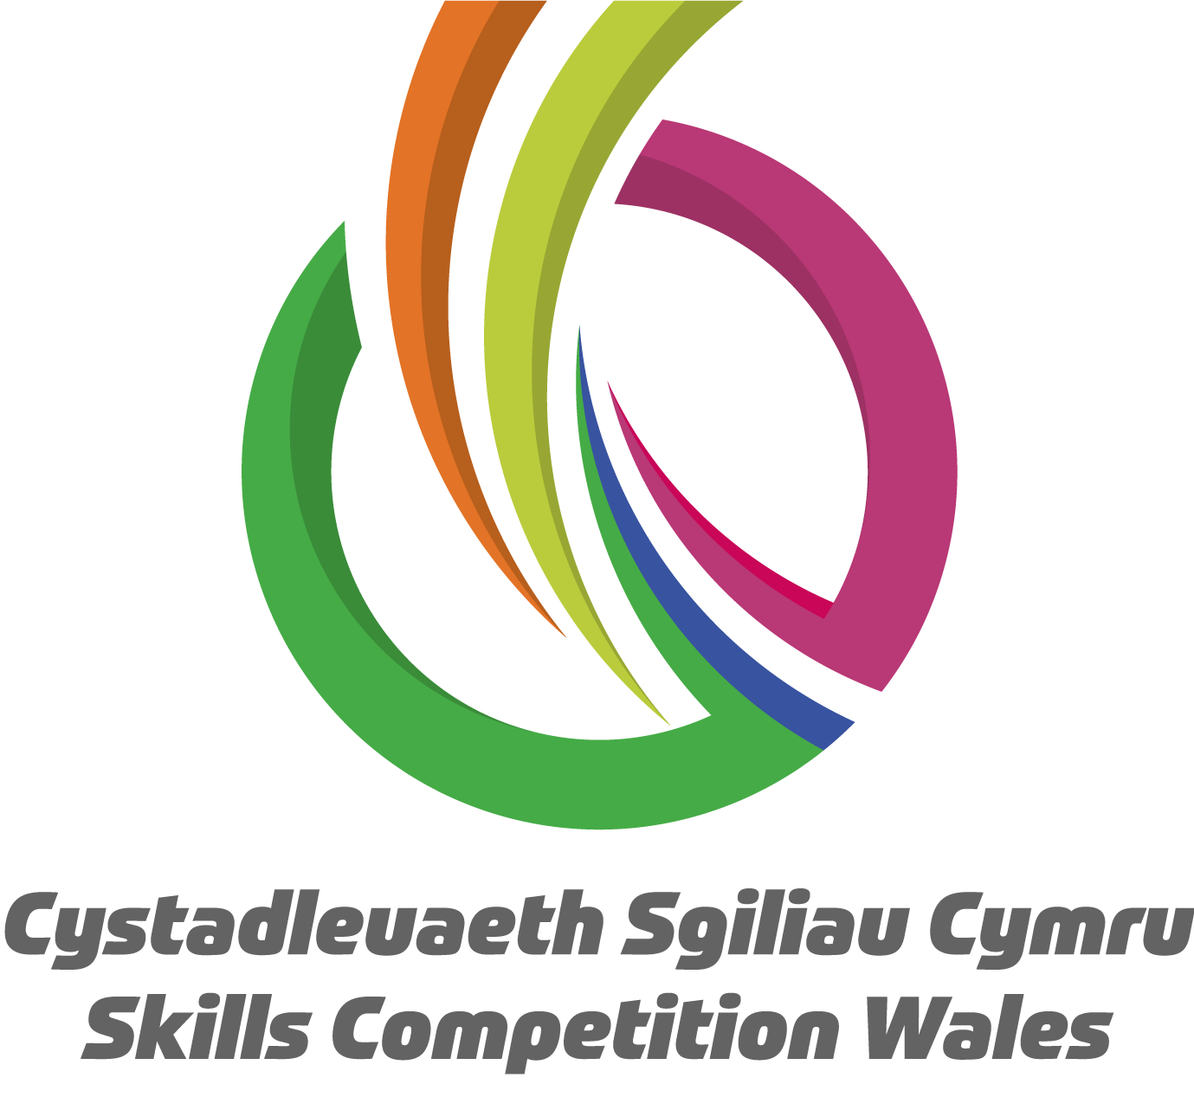

**Competition Brief**

**Competition Title**

Culinary Arts

**Competition Overview**

Culinary Artists create complex and intricate dishes using a wide range of skills and techniques. They must have a good knowledge of all aspects of a modern kitchen including butchery, fishmongery and bakery, along with good cookery and presentation skills.

In this competition, competitors will be assessed on the core skills and abilities required of a Culinary Artist. They must demonstrate professionalism as well as good time keeping.

Live competition heats will be held at various venues across Wales.

**Entry Criteria**

The competition is for those training for a career in the Hospitality & Catering Industry who are working towards or have achieved a Level 3 qualification in the last 12 months. Level 1 or 2 may also enter. Please ensure your entrants have the skills and competences to complete the task.

**Entry capacity restrictions by organisation**

Maximum of up to **2 per location**. **Reserves** may also be registered to account for potential absences or withdrawals.This is the maximum number of entries permitted by an organisation for this competition.

This is determined by ‘location’ and ‘organisation’. ‘Organisation’ refers to the competitors’ training provider/employer. ‘Location’ refers to a site where the competitor studies / is employed.

This competition may be subject to a selection process if competitor registration numbers exceed the host venue capacity. Where capacity is identified in a competition the reserve competitors may also be invited to compete. The decision will be made following a consultation between Skills Competition Wales and the competition lead after registration closes. All parties will be notified of any changes.

**Please note**

In order to accommodate as many competitors as possible to take part in this competition the day may be extended to 8am-8pm. Please ensure availability during this window prior to registering to compete.

For further guidance on these capacities, [click here](https://inspiringskills.gov.wales/competitions/competition-registration-guide).

**Brief**

The following 3 tasks are to be completed in 3 hours.

All dishes must showcase Wales and use Welsh ingredients as much as possible

Competitors must also be mindful of food sustainability throughout the competition and reduce food waste as much as possible. ie. Using meat trims etc. Competitors must also be mindful of the cost of ingredients in their dishes and use seasonal ingredients and cheaper cuts of meat.

**Task 1 - Starter - Riso Gallo, Risotto challenge, 45 mins**

**Task to be completed before starting task 2 and 3**

45 minutes of prep and cook time will be allowed to produce TWO identical portions of a stunning, imaginative, and perfectly cooked risotto starter course which showcases your skills, versatility, and presentation skills.

The Risotto Starter dish will form the first course of your 3-course competition.

Your risotto should feature at least one ingredient native to Wales, and this can be cheese, meat or vegetables - whichever best suits your recipe.

Riso Gallo will supply rice and olive oil from Filippo Berio for each competitor, and various stocks from Essential Cuisine can be made available as required. Please advise at least 3 weeks prior to the event if needed. Please note you can bring pre-made stocks if you wish.

All other ingredients and equipment for the dish will need to be supplied by the competitor.

The presentation is up to the competitor and you can use a bowl / plate of your own choice to help make the dish as exciting and appetising as possible.

Please write a maximum of 150 words on why you have chosen your dish and why you would like to win this competition and bring this along with you on the day.

Keep the title of your dish simple - don't overcomplicate.

Tell us your story, is there a personal connection with the dish? Remember to focus on local Welsh ingredients. Please provide the right quantity of ingredients for a starter dish for 2 people - Don't cook more than you need to and try to have as little waste as possible as this will be judged and will result in lost marks.

**Competitors have 2 hours and 15 minutes to complete Task 2 and Task 3**

**Task 2 - Main Course - Welsh Pork Main Course**

Prepare, cook and present a modern Welsh Pork Dish

Present 2 same plated portions of a hot modern restaurant style main course.

Competitors are encouraged to use as many skills as possible, using your own design, creativity and ingenuity to interpret the dish and to serve the dish in a modern presentation.

The dish must be served hot and the following elements must be included in your dish:

* 1 x potato component of your choice
* At least 2 × seasonal root vegetable components
* A sauce
* Cut of Welsh pork.

**Guidance Notes**

* All the ingredients for the dish are to be cooked in the competition.
* Remember that waste will be part of the judging criteria and competitors should reduce food waste as much as possible
* Remember that cost efficiency will be part of the judging criteria. Competitors should choose seasonal ingredients and cheaper cuts of meat.
* Some sauce must be served on the plate as part of the final presentation
* 2 portions to be served on separate plates of the competitor’s choice, competitors should bring their own serving plates
* ALL ingredients to be supplied by the competitor
* Limited back up common table ingredients will be available at each venue, such as

Plain Flour, Butter, Vegetable Oil.

* The garnish is deemed an integral part of the dish and is not just a micro herb.
* Please see competition specific rules for Service windows

**Task 3 - A Plated Modern Apple-Based Dessert**

Competitors should prepare, cook and present 2 identical portions of 1 type of plated apple-based dessert suitable for a modern restaurant. The dessert should include 1 hot element and 1 cold element. Competitors are encouraged to use as many skills as possible using their own design and creativity to create the dish, whilst serving in a modern presentation.

The following elements must be included in your dish:

* Apple
* A hot element
* A cold element

ALL ingredients & plates / bowls to be supplied by the competitor

**Guidance Notes**

* 2 portions to be served on separate plates / bowls of the competitors choice ALL ingredients to be supplied by the competitor
* Limited back up common table ingredients will be available at each venue, such as Plain Flour, Sugar, Butter, Vegetable Oil.
* All ingredients must be supplied by the competitor unless otherwise stated by the organisers in this briefing document. A limited common table of ingredients will be available for minimal top ups due to spillage etc. but the competitors will have full responsibility for bringing all foodstuffs necessary to complete the tasks.
* All food preparation will commence and conclude on the same day. Competitors are not permitted to do any preparation in advance.
* Peeled and washed vegetables (but not cut) will be permitted.
* Pre-made stocks may be used but must be in liquid form and not reduced.
* Competitors should aim to minimise wastage. Any waste will be measured and judged and will lose marks. Too much purchased ingredients will also lose marks. All rubbish must be separated according to Welsh Government recycling rules: Food Waste - General Waste - Plastics & Metals - Paper & Cardboard - Glass to support Wales’ r sustainability efforts.
* All competitors must bring all small equipment deemed necessary to complete the tasks, to international standards.
* Each station will have access to the following equipment.

- *cooker stove top (specify number of hob rings) with oven*

*- use of a communal combination oven – one shelf*

*- use of communal freezer and refrigeration*

*- 1 x 6ft stainless steel bench*

*- Salamander*

*(To check with competition host venues)*

* Please see competition specific rules for Service windows

Previous competition briefs are available to view and download via the Skills Competition Wales website, please [click here](https://inspiringskills.gov.wales/competitions/culinary-arts/archives) to access.

**Competition Rules**

For full terms and conditions of entry and competition rules [visit](https://inspiringskills.gov.wales/terms/registrations-terms-and-conditions).

**Competition specific rules**

* Competitors to be set up at their allocated station in full uniform and ready to begin at least 15 minutes before the starting time.
* Competitors have 45 minutes to complete Task 1 and the remaining 2 hours and 15 minutes to complete Task 2 and 3. When competitors wish to serve their main course and dessert they need to make judges aware by shouting ‘Service’ and there will then be a 10 Minutes Service Window in which they need to serve their dish.
* All work must be carried out by the competitor in a safe and secure environment and organisers will have in place all necessary arrangements to allow the competition to proceed in a safe operational workspace. Marks are allocated for Professional Work practices and Food Safety and Hygiene and all competitors should work in a well organised and tidy area.
* Standards of dress should be professional and adhere to health and safety standards
* International Standard Full Uniform is deemed as follows:
* White Chefs Jacket
* Necktie / Neckerchief
* Tall Chefs Hat (Toque)
* Black Chef Trousers
* Black Socks
* Non-Slip – Covered Back – No Lace – Chef Shoes
* Long White Apron (Compulsory for Service)
* Bibbed Black Chef Apron – Preparation & General Work

**Preparation & General Work**

* Competitors will receive a health and safety briefing at the start of the competition
* Competitors will start and finish work as instructed by the judges
* All dishes must be presented within the allocated time
* All competitors must ensure their station is left clean and tidy
* No pre-prepared items permitted unless stipulated in the competition brief

**Generic competition rules**

* Mobile phones are to be switched off during competition activity.
* Listening to music via headphones is not permitted during competition activity.
* Any questions during competition activity should be addressed to the competition judging panel.
* Competitors should not communicate with other competitors during competition activity.
* It is the responsibility of each competitor to arrive on time for each competition session. No additional time will be allowed if you arrive late.
* Technical failure of your equipment should be reported immediately to the judging panel. Additional time will be allocated if the fault is beyond the control of the competitor.

**Marking and Assessment**

Marking and judging of this competition will be done by a team of experts from Industry, Further Education or Training Provider, using a marking criteria and allocated marks to ensure consistency.

Brief marking and assessment criteria:

| **Criteria** | **Allocated marks** |
| --- | --- |
| Professional Skills | 30% |
| Presentation, Creativity and Style | 15% |
| Taste, Flavour and Temperature   * Utilisation of ingredients | 40% |
| Time Keeping | 5% |
| Sustainability | 5% |
| Personal Hygiene and Safety | 5% |
| **Total** | **100%** |

**Feedback and Recognition**

Individual and Group verbal feedback will be provided at the end of the competition. No results or awards will be awarded on the day, as marking will be quality assured.

All competitors will be issued with a Participation Certificate on the competition day. First, second, third and highly commended awards will be announced during the celebration event. The highly commended award recognises all competitors who have achieved above average. The celebration event will be held on Wednesday 18th March 2026, further details will be communicated to competitors and their points of contact by email.

Marksheets will be available upon request via [info@skillscompetitionwales.ac.uk](mailto:info@skillscompetitionwales.ac.uk) to competitors after the celebration event.

**Competition Lead**

**Lead Contact:**

Alison Collingridge – [alison.collingridge@cambriantraining.com](mailto:alison.collingridge@cambriantraining.com)

**Our partners**

This competition is delivered in partnership with

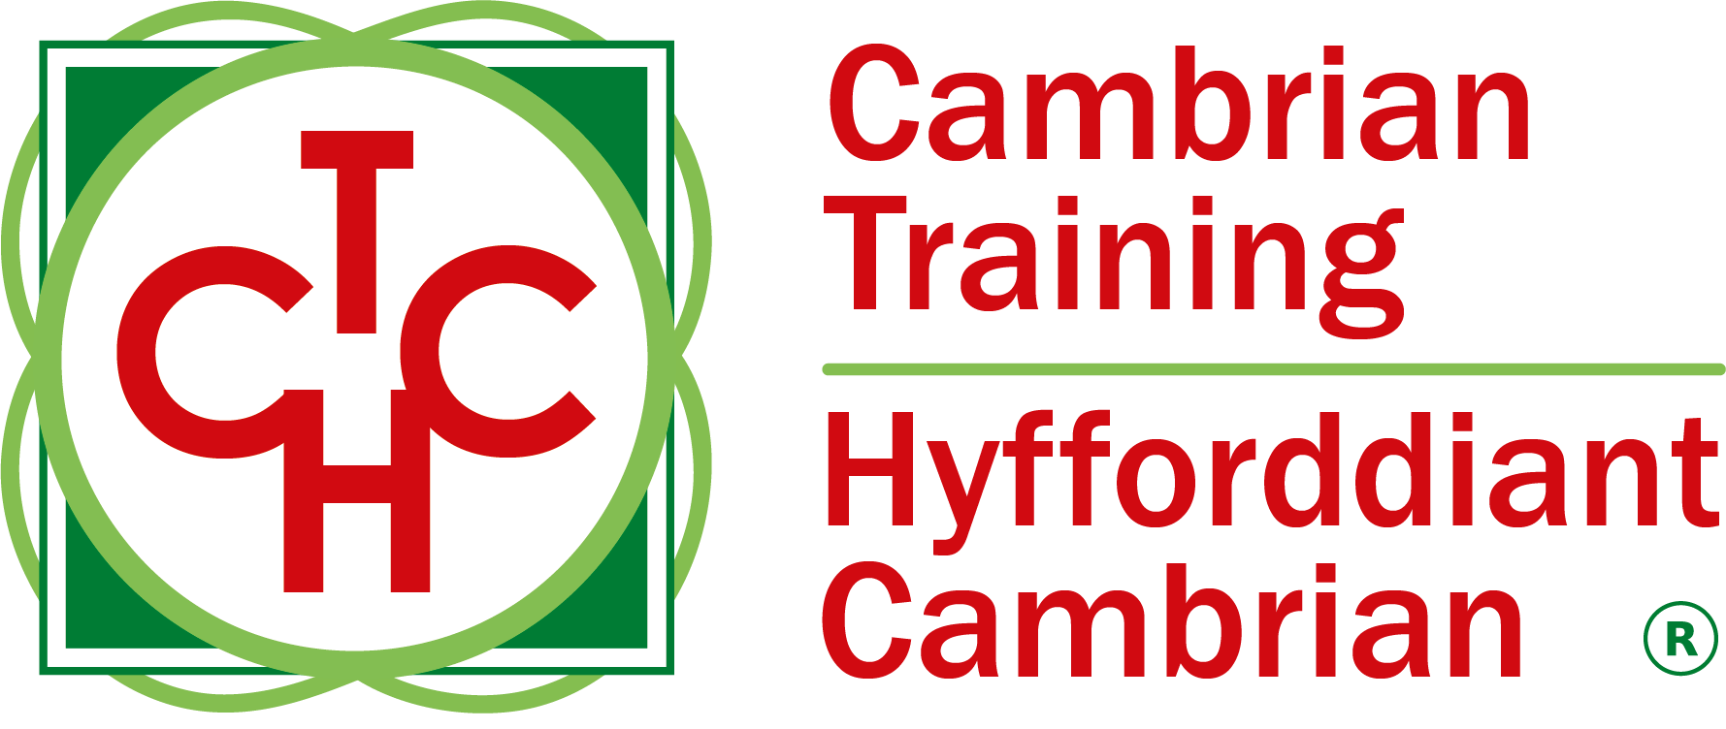



**Briff y Gystadleuaeth**

**Teitl y Gystadleuaeth**

Celfyddyd Coginio

**Trosolwg o’r Gystadleuaeth**

Mae Artistiaid Coginio yn creu prydau cymhleth ac astrus gan ddefnyddio ystod eang o sgiliau a thechnegau. Rhaid bod ganddyn nhw wybodaeth dda am bob agwedd ar gegin fodern gan gynnwys cigyddiaeth, paratoi pysgod a phobyddiaeth, ynghyd â sgiliau coginio a chyflwyno da.

Yn y gystadleuaeth hon, bydd cystadleuwyr yn cael eu hasesu ar y sgiliau craidd a'r galluoedd sy'n ofynnol gan Artist Coginio. Rhaid iddyn nhw ddangos proffesiynoldeb yn ogystal â chadw amser yn dda.

Cynhelir rowndiau rhagbrofol byw mewn sawl lleoliad ledled Cymru.

**Meini Prawf Mynediad**

Mae'r gystadleuaeth ar gyfer y rhai sy'n hyfforddi ar gyfer gyrfa yn y Diwydiant Lletygarwch ac yn astudio tuag at Gymhwyster Lefel 3 neu sydd wedi cyflawni hyn o fewn 12 mis. Lefel 1 neu 2 hefyd gymryd rhan. Sicrhewch fod gan eich ymgeiswyr y sgiliau a'r cymwyseddau i gwblhau'r dasg.

**Cyfyngiadau capasiti mynediad fesul sefydliad**

Uchafswm o hyd at **2 o bob lleoliad.** Gellir cofrestru **cronfeydd wrth gefn** hefyd i gyfrifon absenoldeb neu dynnu'n ôl os bydd angen.

Dyma uchafswm y nifer o geisiadau a ganiateir o un sefydliad ar gyfer y gystadleuaeth hon.

Caiff hyn ei benderfynu ar sail 'lleoliad' a 'sefydliad'. Mae’r 'sefydliad' yn cyfeirio at ddarparwr hyfforddiant/cyflogwr y cystadleuwyr. Mae’r 'lleoliad' yn cyfeirio at safle ble mae'r cystadleuydd yn astudio / cael ei gyflogi.

Gall y gystadleuaeth hon fod yn destun proses ddethol os yw'r niferoedd cofrestru cystadleuwyr yn fwy na chapasiti'r lleoliad cynnal. Lle nodir bod capasiti ar gyfer y gystadleuaeth, gellir gwahodd cystadleuwyr wrth gefn i gystadlu hefyd.

Bydd y penderfyniad yn cael ei wneud yn dilyn ymgynghoriad rhwng Cystadleuaeth Sgiliau Cymru ac arweinydd y gystadleuaeth ar ôl i'r cofrestru gau. Bydd pob parti yn cael gwybod am unrhyw newidiadau.

**Sylwer**

Er mwyn darparu ar gyfer cymaint o gystadleuwyr â phosibl i gymryd rhan yn y gystadleuaeth hon, gellir ymestyn y diwrnod i 8am-8pm. Gwnewch yn siŵr eich bod ar gael yn ystod y cyfnod hwn cyn cofrestru i gystadlu.

I gael rhagor o arweiniad ar y capasiti hyn, [cliciwch yma](https://inspiringskills.gov.wales/competitions/competition-registration-guide).

**Briff**

Mae’r 3 tasg ganlynol i’w cwblhau o fewn 3 awr. Bydd yr holl blatiau gwasanaeth yn cael eu darparu.

Mae'n rhaid i bob pryd arddangos y gorau o Gymru a defnyddio cynhwysion Cymreig gymaint â phosibl. Mae'n rhaid i gystadleuwyr hefyd fod yn ymwybodol o gynaliadwyedd bwyd drwy gydol y gystadleuaeth a lleihau gwastraff bwyd cymaint â phosibl. h.y. Defnyddio gweddillion cig ac ati. Rhaid i'r gystadleuwyr hefyd fod yn ymwybodol o gost cynhwysion yn eu seigiau a defnyddio cynhwysion tymhorol a darnau rhatach o gig.

**Tasg 1 - Cwrs Cyntaf- Riso Gallo, her Risotto, 45 munud amser paratoi ac awr amser cogino**

**Tasg i’w chwblhau cyn dechrau tasg 2 a 3**

45 munud o amser paratoi a 3 coginio i gynhyrchu DAU ddogn union yr un fath o gwrs cychwynnol risotto syfrdanol, llawn dychymyg, wedi'i goginio'n berffaith sy'n arddangos eich sgil, amlbwrpasedd a sgiliau cyflwyno.

Y ddysgl Risotto Starter fydd cwrs cyntaf eich cystadleuaeth 3 chwrs.

Dylai eich risotto gynnwys o leiaf un cynhwysyn sy’n frodorol i Gymru, a gall hwn fod yn gaws, cig neu lysiau – pa un bynnag sydd fwyaf addas i’ch rysáit.

Bydd Riso Gallo yn cyflenwi reis ac olew olewydd o Filippo Berio ar gyfer pob cystadleuydd, a gellir sicrhau bod stociau amrywiol o Essential Cuisine ar gael yn ôl yr angen.

Rhowch wybod o leiaf 3 wythnos cyn y digwyddiad os oes angen.

Sylwch y gallwch ddod â stociau parod os dymunwch.

Bydd angen i'r cystadleuydd gyflenwi'r holl gynhwysion ac offer eraill ar gyfer y pryd.

Mae'r cyflwyniad yn gwbl addas i'r cystadleuydd a gallwch ddefnyddio powlen / plât o'ch dewis eich hun i helpu i wneud y pryd mor gyffrous â Blasus â phosibl.

Ysgrifennwch uchafswm o 150 gair ar pam rydych wedi dewis eich pryd a pham yr hoffech ennill y gystadleuaeth hon a dewch â hwn gyda chi ar y diwrnod.

Cadwch deitl eich pryd yn syml - peidiwch â gor-gymhlethu.

Dywedwch eich stori wrthym, a oes cysylltiad personol â'r ddysgl? Cofiwch ganolbwyntio ar gynhwysion Cymreig lleol.

Darparwch y nifer cywir o gynhwysion ar gyfer pryd cychwynnol i 2 berson - Peidiwch â choginio mwy nag sydd ei angen a ceisiwch gael cyn lleied o wastraff â phosibl gan y bydd hyn yn cael ei feirniadu a bydd yn arwain at golli marciau.

**Mae gan gystadleuwyr 2 awr a 15 munud i gwblhau Tasg 2 a Thasg 3**

**Tasg 2 - Prif Gwrs - Prif Gwrs Porc Cymreig**

Paratoi, coginio a chyflwyno saig fodern o Borc Cymreig

Cyflwyno 2 blât â’r un dogn o brif gwrs poeth modern arddull bwyty

Mae cystadleuwyr yn cael eu hannog i ddefnyddio cymaint o sgiliau â phosibl gan ddefnyddio eich dyluniad, creadigrwydd a dyfeisgarwch i ddehongli'r ddysgl ac i weini’r ddysgl mewn chyflwyniad modern.

Rhaid cyflwyno'r pryd yn boeth a rhaid cynnwys yr elfennau canlynol yn eich pryd:

* 1 X tatws o'ch dewis chi
* O leiaf 2 x llysieuyn gwraidd tymhorol
* A saws
* Toriad Porc o Cymreig

**Cyfarwyddiadau**

* Mae'r holl gynhwysion ar gyfer y pryd i'w coginio yn ystod y gystadleuaeth
* Cofiwch y bydd gwastraff yn rhan o'r meini prawf beirniadu a dylai cystadleuwyr leihau gwastraff bwyd cymaint â phosibl.
* Cofiwch y bydd effeithlonrwydd cost yn rhan o'r meini prawf beirniadu. Dylai cystadleuwyr ddewis cynhwysion tymhorol a darnau rhatach o gig.
* Rhaid gweini rhywfaint o saws ar y plât fel rhan o'r cyflwyniad terfynol
* 2 ddogn i’w gweini ar blatiau ar wahân o ddewis y cystadleuydd, dylai cystadleuwyr ddod â’u platiau gweini eu hunain
* POB cynhwysyn i'w gyflenwi gan y cystadleuydd.
* Bydd ychydig o gynhwysion bwrdd cyffredin fel blawd plaen, siwgr, menyn ac olew llysiau ar gael wrth gefn.
* Mae’r garnais yn rhan annatod o'r pryd ac nid perlysiau micro yn unig.
* Gweler rheolau cystadleuaeth benodol ar gyfer ffenestri Gwasanaeth

**Tasg 3 - Pwdin modern wedi'i seilio ar afal wedi’i roi ar blât.**

Dylai cystadleuwyr baratoi, coginio a chyflwyno 2 ddarn union yr un fath o 1 math o bwdin wedi'i seilio ar afalau sy'n addas ar gyfer bwyty modern. Dylai'r pwdin gynnwys 1 elfen boeth ac 1 elfen oer.

Anogir cystadleuwyr i ddefnyddio cynifer o sgiliau â phosibl gan ddefnyddio eu dyluniad a'u creadigrwydd eu hunain i greu saig, a gweini mewn cyflwyniad modern.

Mae'n rhaid cynnwys yr elfennau canlynol yn eich saig:

* Afal
* Elfen boeth
* Elfen oer

POB cynhwysyn a phlatiau / powlenni i'w cyflenwi gan y cystadleuydd

**Canllawiau**

* 2 ddogn i’w gweini ar blatiau/powlenni ar wahân o ddewis y cystadleuydd POB cynhwysyn i’w gyflenwi gan y cystadleuydd
* Bydd cyflenwad bychan o gynhwysion cyffredin ar gael wrth gefn ym mhob lleoliad. Mae'r cynhwysion yn cynnwys blawd plaen, siwgr, menyn, olew llysiau.
* Rhaid i'r holl gynhwysion gael eu darparu gan y cystadleuydd oni nodir yn wahanol gan y trefnwyr yn y ddogfen friffio hon. Bydd bwrdd cyffredin cyfyngedig o gynhwysion ar gael ar gyfer y nifer lleiaf o ychwanegion o ganlyniad gollyngiadau etc., ond bydd gan y cystadleuwyr gyfrifoldeb llawn dros ddod â'r holl fwydydd angenrheidiol i gwblhau'r tasgau.
* Bydd yr holl waith paratoi bwyd yn dechrau ac yn dod i ben ar yr un diwrnod. Ni chaniateir i gystadleuwyr wneud unrhyw waith paratoi ymlaen llaw.
* Caniateir llysiau wedi'u plicio a'u golchi (ond heb eu torri).
* Gellir defnyddio stociau a wnaed o flaen llaw ond rhaid iddynt fod ar ffurf hylif ac ni ddylid eu lleihau .
* Dylai cystadleuwyr geisio lleihau gwastraff. Bydd unrhyw wastraff yn cael ei fesur a'i feirniadu a bydd yn colli marciau. Bydd gormod o gynhwysion a brynwyd hefyd yn colli marciau. Rhaid gwahanu'r holl sbwriel yn unol â rheolau ailgylchu Llywodraeth Cymru: Gwastraff Bwyd - Gwastraff Cyffredinol - Plastigau a Metelau - Papur a Chardbord - Gwydr i gefnogi ymdrechion cynaliadwyedd Cymru.
* Rhaid i bob cystadleuydd ddod â'r holl offer bychan sy’n cael eu hystyried yn angenrheidiol i gwblhau'r tasgau, i safonau rhyngwladol.

Bydd gan bob safle fynediad i'r offer canlynol.

- top ffwrn (nodwch nifer yr hobiau) a phopty

- Defnydd o bopty cyfunol cyffredinol – un silff

- defnydd o rewgell gyffredinol a rheweiddio

- 1 x mainc dur gwrthstaen 6 troedfedd

- Salamander

(Gwirio gyda lleoliadau sy’n cynnal y gystadleuaeth)

* Gweler rheolau cystadleuaeth benodol ar gyfer ffenestri Gwasanaeth

Mae briffiau cystadleuaeth flaenorol ar gael i'w gweld a'u llwytho o’r wefan Cystadleuaeth Sgiliau Cymru, [cliciwch yma](https://inspiringskills.gov.wales/competitions/culinary-arts/archives) i gael mynediad iddynt.

**Rheolau’r Gystadleuaeth**

Am yr holl delerau ac amodau ynghylch ymgeisio a’r rheolau cystadlu [ewch i](https://inspiringskills.gov.wales/terms/registrations-terms-and-conditions?lang=cy).

**Rheolau sy'n benodol i’r gystadleuaeth**

* Rhaid i’r cystadleuwyr fod â phopeth yn barod wrth eu gorsaf bersonol mewn gwisg lawn ac yn barod i gychwyn o leiaf 15 munud cyn yr amser cychwyn.
* Mae gan gystadleuwyr 45 munud i gwblhau Tasg 1 a 2 awr a 15 munud sy'n weddill i gwblhau Tasg 2 a 3. Pan fydd cystadleuwyr yn dymuno gweini eu prif gwrs a phwdin mae angen iddynt wneud y beirniaid yn ymwybodol trwy weiddi 'Gwasanaeth' ac yna bydd Ffenestr Gwasanaeth 10 Munud lle mae angen iddynt weini eu pryd.
* Rhaid i'r holl waith gael ei wneud gan y cystadleuydd mewn amgylchedd diogel a bydd gan drefnwyr yr holl drefniadau angenrheidiol ar waith i ganiatáu bod y gystadleuaeth yn mynd yn ei blaen mewn gweithle gweithredol diogel. Caiff marciau eu rhoi ar gyfer Diogelwch a Hylendid Bwyd ac arferion Gwaith Proffesiynol a dylai pob cystadleuydd weithio mewn ardal drefnus a thaclus.
* Dylai safonau gwisg fod yn broffesiynol ac yn cadw at safonau iechyd a diogelwch

Mae Safon Ryngwladol y Wisg Lawn yn cael ei hystyried fel a ganlyn:

* Siaced Cogyddion Gwyn
* Tei / Gyddfliain
* Het Dal Cogyddion (Toque)
* Trowsus Cogydd Du
* Sanau Du
* Esgidiau Cogydd – di-lithr – wedi’u gorchuddio’n ddu – dim careiau
* Ffedog Wen Hir (Gorfodol ar gyfer Gwasanaeth)
* Ffedog Cogydd Du gyda Bronlliain – Paratoi a Gwaith Cyffredinol

**Paratoi a Gwaith Cyffredinol**

* Bydd cystadleuwyr yn derbyn briff iechyd a diogelwch ar ddechrau'r gystadleuaeth
* Bydd cystadleuwyr yn dechrau ac yn gorffen gwaith yn unol â chyfarwyddiadau’r beirniaid
* Rhaid cyflwyno pob pryd o fewn yr amser a neilltuwyd
* Rhaid i bob cystadleuydd sicrhau bod eu gorsaf yn cael ei adael yn lân ac yn daclus
* Ni chaniateir unrhyw eitemau wedi'u paratoi ymlaen llaw oni bai eu bod wedi'u nodi ym mrÎff y gystadleuaeth.

**Rheolau cyffredinol y gystadleuaeth**

* Bydd ffonau symudol yn cael eu diffodd yn ystod gweithgareddau’r gystadleuaeth.
* Ni chaniateir gwrando ar gerddoriaeth drwy glustffonau yn ystod gweithgareddau'r gystadleuaeth.
* Dylai unrhyw gwestiynau yn ystod gweithgareddau’r gystadleuaeth gael ei gofyn i banel beirniadu'r gystadleuaeth.
* Ni ddylai cystadleuwyr gyfathrebu â chystadleuwyr eraill yn ystod gweithgareddau’r gystadleuaeth.
* Cyfrifoldeb unigol pob cystadleuydd yw cyrraedd ar amser ar gyfer pob sesiwn gystadlu. Ni chaniateir amser ychwanegol os byddwch yn cyrraedd yn hwyr.
* Dylid rhoi gwybod i'r panel beirniadu am fethiant technegol eich offer ar unwaith. Bydd amser ychwanegol yn cael ei neilltuo os yw'r nam y tu hwnt i reolaeth y cystadleuydd.

**Marcio ac Asesu**

Bydd tîm o arbenigwyr o'r Diwydiant, Addysg Bellach neu’r Darparwr Hyfforddiant yn marcio ac yn beirniadu'r gystadleuaeth hon, gan ddefnyddio meini prawf marcio a marciau sydd wedi'u dyrannu i sicrhau cysondeb.

Crynodeb o’r meini prawf marcio ac asesu:

| **Meini Prawf** | **Marciau a ddyrannwyd** |
| --- | --- |
| Sgiliau Proffesiynol | 30% |
| Cyflwyniad, Creadigrwydd ac Arddull | 15% |
| Blas a Thymheredd   * Defnyddio Cynhwysion | 40% |
| Cadw at Amser | 5% |
| Cynaladwyedd | 5% |
| Hylendid Personol a Diogelwch | 5% |
| **Cyfanswm** | **100%** |

**Adborth a Chydnabyddiaeth**

Darperir adborth llafar yn unigol ac mewn grŵp ar ddiwedd y gystadleuaeth. Ni fydd unrhyw ganlyniadau na gwobrau yn cael eu rhoi ar y diwrnod gan y bydd y marcio’n cynnwys elfen sicrhau ansawdd.

Bydd pob cystadleuydd yn cael Tystysgrif Cyfranogi ar ddiwrnod y gystadleuaeth. Bydd gwobrau cyntaf, ail, trydydd a chanmoliaeth uchel yn cael eu cyhoeddi yn ystod y digwyddiad dathlu. Mae'r wobr canmoliaeth uchel yn cydnabod yr holl gystadleuwyr sydd wedi cyflawni sgôr uwch na'r cyfartaledd. Cynhelir y digwyddiad dathlu ar Dydd Mercher 18 Mawrth 2026, bydd manylion pellach yn cael eu rhoi i gystadleuwyr a'u pwyntiau cyswllt trwy e-bost.

Bydd taflenni marciau ar gael ar gais drwy info@skillscompetitionwales.ac.uk i gystadleuwyr ar ôl y digwyddiad dathlu.

**Arweinydd y Gystadleuaeth**

**Prif Gyswllt:**

Alison Collingridge – [alison.collingridge@cambriantraining.com](mailto:alison.collingridge@cambriantraining.com)

**Ein partneriaid**

Mae'r gystadleuaeth hon yn cael ei chyflwyno mewn partneriaeth â

