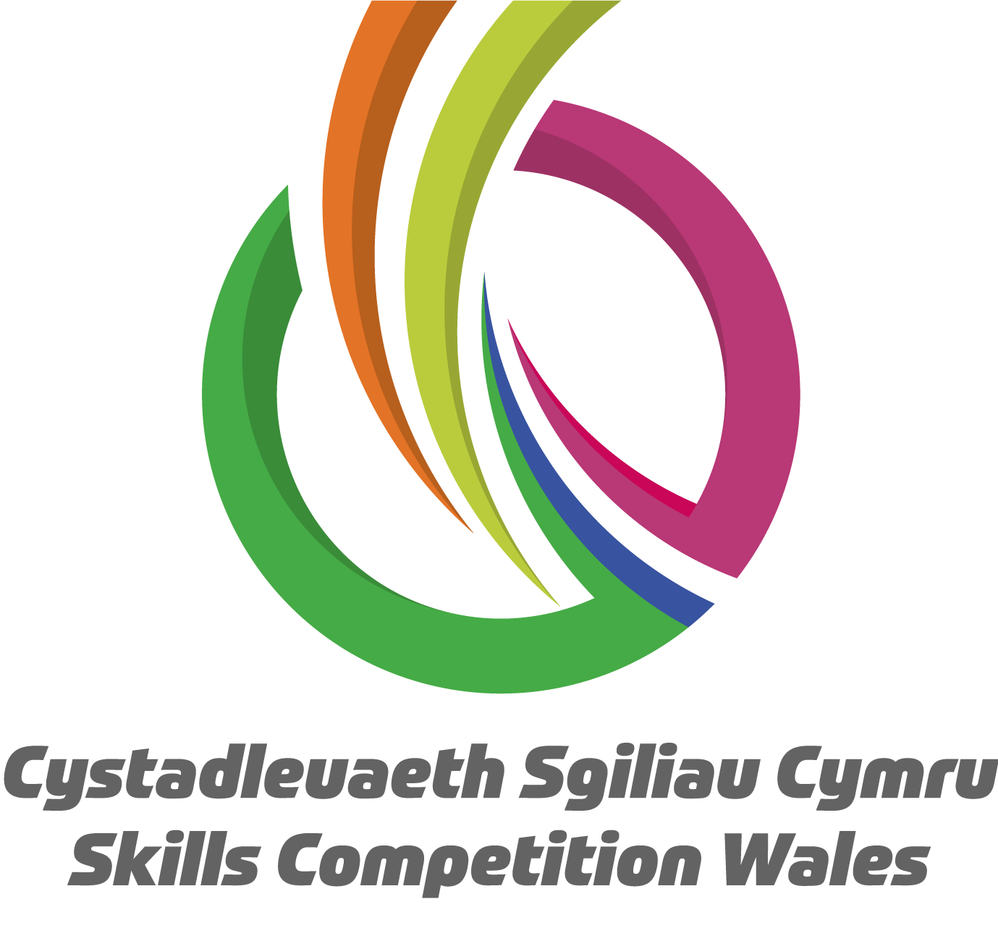

**Competition Brief**

**Competition Title**

Restaurant Service

**Competition Overview**

Restaurant Service staff play a vital role in the overall experience of a restaurant customer. From laying tables correctly to having extensive knowledge of each item on the menu; the quality of the service is something that guests often remember as much as the food and drink served.

In this competition, competitors will be assessed on the following:

Good practical skills and a sound understanding of different styles of food & beverage service; casual dining, table theatre, gueridon/silver service, and service and knowledge and appreciation of the wine. Competitors will also be judged on their social skills and will be expected to have excellent personal presentation as well as safe and hygienic working practices.

## Live competition heats will be held at various venues across Wales.

**Entry Criteria**

The competition is for those training for a career in the Hospitality Industry who are working towards or have achieved a Level 3 qualification in the last 12 months. Level 1 or 2 may also enter. Please ensure your entrants have the skills and competences to complete the task.

**Entry capacity restrictions by organisation**

A maximum of up to **2 per location**. **Reserves** may also be registered to account for potential absences or withdrawals.

This is the maximum number of entries permitted by an organisation for this competition. This is determined by ‘location’ and ‘organisation’. ‘Organisation’ refers to the competitors’ training provider/employer. ‘Location’ refers to a site where the competitor studies / is employed.

**Note:** In order to accommodate as many competitors as possible to take part in this competition the day may be extended to 8am-8pm. Please ensure availability during this window prior to registering to compete.

This competition may be subject to a selection process if competitor registration numbers exceed the host venue capacity. Where capacity is identified in a competition the reserve competitors may also be invited to compete. The decision will be made following a consultation between Skills Competition Wales and the competition lead after registration closes. All parties will be notified of any changes

For further guidance on these capacities, [click here](https://inspiringskills.gov.wales/competitions/competition-registration-guide).

**Brief**

**Task 1 Napkin folding - 30 minutes**

Competitors will be required to produce 12 folded linen napkins, 50cm x 50cm, - 6 types of napkin folds with 2 of each to be made for comparison.

There are two mandatory napkin folds. These are:

* Two napkin folds for bread service. You will be required to use one of these napkins folds during lunch service with your bread plate.
* Two napkin folds are required for presentation in a wine glass.

Suggested folds are: Breakfast; Afternoon tea; Fine dining; Banqueting; Room Service Tray. The judges will be looking for the creativity and originality of the folds.

Guidance Notes:

* Competitors will use a boxed working table to fold napkins and present.
* Folded napkins must all be free-standing, with exemption of the wine glass (i.e. no use of supports, ribbons, foil or clips).
* Competitors may set up their workstation in advance, but all napkin folding must be completed within the time allowed.
* Competitors are required to provide a tent card for each of the napkins with names of the napkin fold and what it is intended for.
* Competitors are required to bring their own 50cm x 50cm linen napkins and gloves for this task.

**Task 2 - Table Layup for Luncheon Menu (Theme: Music & Theatre ) - 20 minutes**

The table lay–up should be suitable for a two course set menu for 2 people.

Competitors will be provided with a 4ft round table to lay up for 2 people.

Competitors to lay a table for the theme of either Music and Theatre.

Competitors bring ALL equipment for a table of two to fit their theme.

Competitors bring their own lunch and wine menu (lunch menu & wine to be specified in advance) for the service.

Competitors should make a choice whether to use a napkin from Task 1 or create another specific for this layup.

**Guidance Notes:**

* Competitors may set up their workstation in advance **but** all the lay-up must be completed within the time allowed.
* Questions may be asked by the judges about their theme.
* Judging is based on the appropriateness and uniformity of the table laying.
* Table size will be a 4ft round table.
* Additional cloths will be available on a side station if required by the competitor.

**Task 3 Skills Test - Cocktail Making – 20 minutes**

Competitors will be required to create two portions of a vodka-based cocktail from a mystery box.

The vodka for this task to be provided by the competitor. The other ingredients for this task to be provided by the organiser.

Judging is based on use of ingredients, technical skills, work methods, presentation, wastage, taste and the knowledge of the history of the mystery cocktail.

Guidance Notes:

* Vodka for the cocktail to be provided by the competitor
* The organiser to provide all other ingredients for the mystery cocktail.
* The host will provide cubed/crushed ice for this task
* The organiser will provide two identical glasses per competitor for this task (TBC)
* Competitors should bring all their own cocktail making equipment, this includes; shakers and spoons, fruit knives, chopping board etc.
* Competitors will be judged on technical skills, working methods, presentation, wastage and taste.
* Drinks should be presented as you would at a cocktail bar.
* Judges will be looking for confidence to create and explain the cocktail.
* Cocktails should be measured accurately for the glass size and waste will be noted.
* Competitors should expect questions from the judges in relation to the mystery cocktail.

**Task 4 - Crêpes Suzette – 20 minutes**

Competitors should set up Flambé equipment on the metal working table provided by the host.

Competitors will be required to demonstrate the skill of flambéing and making 2 identical portions of crêpes suzettes.

These are to be served on two identical plates which will be provided by the host.

For this task competitors will be required to prepare their stations before the task starts.

All equipment and ingredients for this task should be brought to the competition by the competitor, except for the service plates which will be provided by the host.

**Guidance Notes:**

* Competitors will need to bring all equipment for this task, including - flambé lamp, pan, matches, and service equipment
* The plates will be provided by the host
* Competitors should bring ALL ingredients for this task
* Competitors will use a metal table as a workstation which will be provided by the host.
* Competitors will be judged on technical skills, working methods, presentation, and taste.
* Judges will be looking for creativity as well as the confidence to create, cook and explain the dish.
* Recipe and method provided in ‘Food and Beverage Service’ tenth edition, Dennis Lillicrap and John Cousins, Hodder Education, 2010. (Competitors without access to this book should contact the competition lead in advance of the competition.) As well as using the ingredients in the book’s recipe, competitors can choose to include additional items. Presentation is at the competitor’s preference and the judges will be looking for the competitor’s creativity with the dish.

**Task 5 - Greet and seat customers - Live service for 2 customers**

Competitors should greet their customers and sit them at their table which was laid up in task 2. Competitors should offer their customers iced water & silver serve bread rolls. Competitors should greet their customers in English and Welsh, with a few Welsh phrases.

**Guidance Notes:**

* icedwater and bread rolls and butter will be provided by the competition host
* Competitors to bring all necessary equipment for silver service and gueridon work.

**Task 6 – Lunch & Wine service - Live service to 2 customers**

Competitors to bring their printed lunch menu (a main course of chicken, potato & two vegetables & cheesecake dessert - exact menu to be specified by the organiser in advance of the competition), Competitors to give their printed lunch menu to their guests upon arrival.

Competitors will be provided with a corked bottle of white wine to accompany the meal which they will need to present and describe and offer to the customers. Competitors will receive the wine list to familiarise themselves with prior to the competition. Competitors present, explain and pour the wine to the customer at the table. Iced water will also be available from the organiser. Competitors are required to silver serve the chicken and the vegetables and pour the sauce for the customers.

Competitors are required to cut and serve the dessert (The cheesecake may be provided whole or halved, and the portion size required will be confirmed on the day of the competition).

During the lunch service, competitors should use a few Welsh phrases as well as English when serving the customers.

**Guidance Notes:**

* Competitors will be provided with a printed menu card for this task to give to customers TBC
* Competitors will be provided with a bottle of corked white wine for this task
* Iced water will also be available for customers
* The 2-course lunch will be provided by the host
* Questions may be asked by the judges about any aspect of the task and competitors should be prepared for specific knowledge questions.
* To help with timings, competitors should explain to customers the time limit of 45 minutes for service.
* Judges will be looking for technical skills, social skills, working method and presentation.
* Customer service will be staggered.
* Equipment and work area should be left in a clean and suitable manner after completing the task.

Previous competition briefs are available to view and download via the Skills Competition Wales website, please [click here](https://inspiringskills.gov.wales/competitions/restaurant-service/archives) to access.

**Infrastructure List**

|  | **Host to supply** | **Competitors to bring to competition** |
| --- | --- | --- |
| **Task 1**  **Napkin folds** | N/A | 12 x 50X50 napkins  A glass or a plate for fold  Simple card for each napkin style |
| **Task 2**  **Table lay-up** | 4 ft round table  Cloth  Main course knives and forks  Dessert spoons and forks  Side plates and knives  Wine glasses  Water glasses  Butter  Salt and pepper | Small flower display  Napkins (from task 2) |
| **Task 3**  **Cocktail Making** | 2 cocktail glasses (TBC)  Ingredients for mystery cocktail apart from Vodka  Cubed & crushed ice | Vodka for mystery vodka-based cocktail  All cocktail making equipment including shakers, spoons, knives & chopping boards etc. |
| **Task 4**  **Crêpes Suzette** | Plates | Flambe Lamp  Pan  Matches  Service equipment  All ingredients |
| **Task 5**  **Greet and seat customers** | Jugs of iced water  Bread Rolls | Printed lunch menu |
| **Task 6**  **Live Service for 2 customers** | Corked White Wine  Iced water  Main course (Chicken, potato, two vegetables & sauce)  Dessert (A cheesecake)  (Exact menu to be specified in advance of competition) | Corkscrew  Service cloths  Silver service cutlery |

**Competition Rules**

For full terms and conditions of entry and competition rules [visit](https://inspiringskills.gov.wales/terms/registrations-terms-and-conditionshttp://www.skillscompetitionwales.ac.uk/terms-and-conditions).

**Competition specific rules:**

* Standards of dress should be professional and adhere to health and safety standards.
* Competitors will receive a health and safety briefing at the start of the competition.
* Competitors will start and finish work as instructed by the judges.
* All dishes must be presented within the allocated time.
* All competitors must ensure their station is left clean and tidy.
* No pre-prepared items permitted.

**Generic competition rules:**

* Mobile phones are to be switched off during competition activity.
* Listening to music via headphones is not permitted during competition activity.
* Any questions during competition activity should be addressed to the competition judging panel.
* Competitors should not communicate with other competitors during competition activity.
* It is the responsibility of each competitor to arrive on time. No additional time will be allowed if you arrive late.
* Technical failure of your equipment should be reported immediately to the judging panel. Additional time will be allocated if the fault is beyond the control of the competitor.

**Marking and Assessment**

Marking and judging of this competition will be done by a team of experts from Industry, Further Education or Training Provider, using a marking criteria and allocated marks to ensure consistency.

Brief marking and assessment criteria:

| **Task** | **Criteria & Weighting** |
| --- | --- |
| **Task 1**  **Napkin Folds**  This task is weighted 20% of the total competition marks | Professionalism and hygiene - 30%  Presentation, creativity, style and flair, consistency - 40%  Utilisation of equipment - 10%  Time keeping - 20% |
| **Task 2**  **Table Lay up**  This task is weighted 15% of the total competition marks | Professional,technical ability & knowledge skills - 25%  Presentation, style, consistency and creativity - 40%  Utilisation of equipment and hygiene - 10%  Time keeping - 25% |
| **Task 3**  **Cocktail Making**  This task is weighted 20% of the total competition marks | Professionalism, technical ability & knowledge skills - 20%  Presentation, creativity, style and flair, consistency - 30%  Taste - 35%  Utilisation of ingredients, equipment, working practices and hygiene - 10%  Time keeping - 5% |
| **Task 4**  **Crêpes Suzette**  This task is weighted 20% of the total competition marks | Professional, technical & knowledge skills - 25%  Presentation, creativity, style and flair, consistency - 30%  Taste - 30%  Utilisation of ingredients, equipment, working practices and hygiene - 10%  Time keeping - 5% |
| **Task 5**  **Greet & Sit Customers**  This task is weighted 10% of the total competition marks | Utilisation of equipment, sequence of service and working practices - 20%  Social skills and use of Welsh language - 40%  Guest service - 40% |
| **Task 6**  **Lunch/Silver Service**  This task is weighted 25% of the total competition marks | Silver service skills - 35%  Wine knowledge and service skills - 25%  Presentation of food - 15%  Utilisation of equipment, working practices and hygiene - 5%  Social skills, use of Welsh language and guest service - 20% |

**Feedback and Recognition**

Individual and group verbal feedback will be provided at the end of the competition. (Written feedback will not be provided) Constructive feedback will be limited to 2 minutes per competitor due to time restrictions.

No results or awards will be awarded on the day as marking will be quality assured.

All competitors will be issued with a Participation Certificate on the competition day. First, second, third and highly commended awards will be announced during the celebration event. The highly commended award recognises all competitors who have achieved above average. The celebration event will be held on Wednesday 18th March 2026, further details will be communicated to competitors and their points of contact by email.

Marksheets will be available upon request via [info@skillscompetitionwales.ac.uk](mailto:info@skillscompetitionwales.ac.uk) to competitors after the celebration event.

**Competition Lead**

**Lead Contact:**

Alison Collingridge – [alison.collingridge@cambriantraining.com](mailto:alison.collingridge@cambriantraining.com)

**Our partners**

This competition is delivered in partnership with

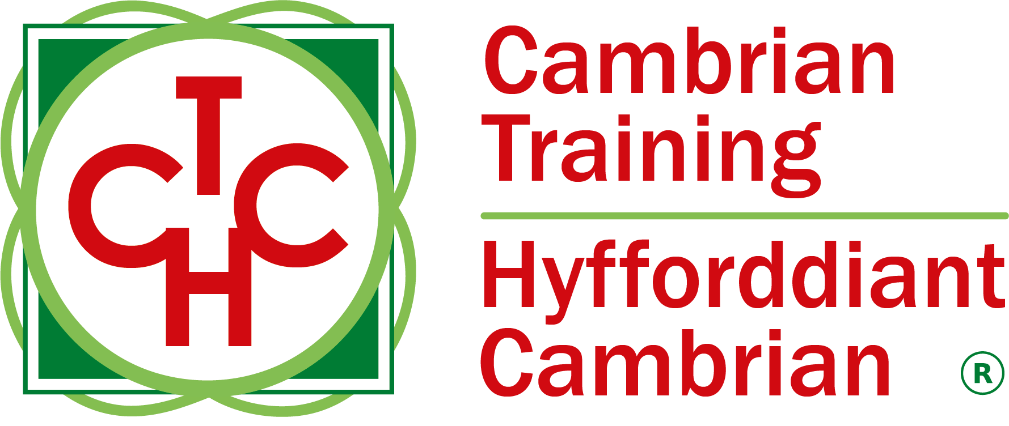



**Briff y Gystadleuaeth**

**Teitl y Gystadleuaeth**

Gwasanaeth Bwytai

**Trosolwg o'r Gystadleuaeth**

Mae staff y Gwasanaeth Bwytai yn chwarae rhan hanfodol ym mhrofiad cyffredinol cwsmer mewn bwyty. O osod byrddau'n gywir i feddu ar wybodaeth helaeth am bob eitem sydd ar y fwydlen; mae ansawdd y gwasanaeth yn rhywbeth y mae gwesteion yn aml yn ei gofio cymaint â'r bwyd a diod a weinir.

Yn y gystadleuaeth hon, bydd cystadleuwyr yn cael eu hasesu ar y canlynol:

Sgiliau ymarferol da a dealltwriaeth gadarn o wahanol arddulliau o wasanaeth bwyd a diod; cinio achlysurol, theatr fwrdd, gwasanaeth guéridon/arian, gwaith paratoi a gwasanaeth, a gwybodaeth a gwerthfawrogiad o'r gwin. Bydd cystadleuwyr hefyd yn cael eu beirniadu ar eu sgiliau cymdeithasol a bydd disgwyl iddynt fod â chyflwyniad personol rhagorol yn ogystal ag arferion gwaith diogel ac iechydol.

Cynhelir rowndiau rhagbrofol byw mewn sawl lleoliad ledled Cymru.

**Meini Prawf Mynediad**

Mae'r gystadleuaeth ar gyfer y rhai sy'n hyfforddi ar gyfer gyrfa yn y Diwydiant Lletygarwch ac yn astudio tuag at Gymhwyster Lefel 3 neu sydd wedi cyflawni hyn o fewn 12 mis. Lefel 1 neu 2 hefyd gymryd rhan. Sicrhewch fod gan eich ymgeiswyr y sgiliau a'r cymwyseddau i gwblhau'r dasg.

**Cyfyngiadau capasiti mynediad fesul sefydliad**

Uchafswm o hyd at **2 o bob lleoliad.** Gellir cofrestru **cronfeydd wrth gefn** hefyd i gyfrifon absenoldeb neu dynnu'n ôl os bydd angen.

Dyma uchafswm y nifer o geisiadau a ganiateir o un sefydliad ar gyfer y gystadleuaeth hon. Caiff hyn ei benderfynu ar sail 'lleoliad' a 'sefydliad'. Mae’r 'sefydliad' yn cyfeirio at ddarparwr hyfforddiant/cyflogwr y cystadleuwyr. Mae’r 'lleoliad' yn cyfeirio at safle ble mae'r cystadleuydd yn astudio / cael ei gyflogi.

Nodyn: Er mwyn darparu ar gyfer cynifer o gystadleuwyr â phosibl i gymryd rhan yn y gystadleuaeth hon, gellir ymestyn y diwrnod o 8am i 8pm. Sicrhewch eich bod ar gael yn ystod y cyfnod hwn cyn cofrestru i gystadlu.

Gall y gystadleuaeth hon fod yn destun proses ddethol os yw'r niferoedd cofrestru cystadleuwyr yn fwy na chapasiti'r lleoliad cynnal. Lle nodir bod capasiti ar gyfer y gystadleuaeth, gellir gwahodd cystadleuwyr wrth gefn i gystadlu.

Bydd y penderfyniad yn cael ei wneud yn dilyn ymgynghoriad rhwng Cystadleuaeth Sgiliau Cymru ac arweinydd y gystadleuaeth ar ôl i'r cofrestru gau. Bydd pob parti yn cael gwybod am unrhyw newidiadau.

I gael rhagor o arweiniad ar y galluoedd hyn, [cliciwch yma](https://inspiringskills.gov.wales/competitions/competition-registration-guide).

**Briff**

**Tasg 1 - Plygu napcynnau – 30 munud**

Bydd yn ofynnol i gystadleuwyr ddarparu 12 napcyn lliain wedi'u plygu, 50cm x 50cm – bydd 6 math o blygiadau napcyn i’w gwneud gyda 2 o bob math er mwyn eu cymharu.

Mae dau blygiad napcyn gorfodol. Y rhain yw:

Dau blygiad napcyn ar gyfer gwasanaeth bara. Bydd gofyn i chi ddefnyddio un o'r plygiadau napcynau hyn yn ystod y gwasanaeth cinio gyda'ch plât bara.

Mae angen dau blygiad napcyn i'w cyflwyno mewn gwydraid gwin.

Y plygiadau a awgrymir yw, Te prynhawn, Brecwast, Ciniawa Cain, Gwledda, Hambwrdd i’w Weini mewn Ystafell Wely ac ar gyfer Gwasanaeth. Bydd y beirniaid yn chwilio am greadigrwydd a gwreiddioldeb yn y plygiadau.

**Canllawiau:**

* Bydd cystadleuwyr yn defnyddio'r bwrdd i blygu napcynau a’u cyflwyno
* Mae'n rhaid i bob napcyn wedi'i blygu aros i fyny ei hun, gydag eithriad y gwydr gwin (h.y. dim defnydd o unrhyw gymorth, rhubanau, ffoil na chlipiau).
* Gall cystadleuwyr osod eu man gweithio o flaen llaw ond bydd rhaid cwblhau'r holl blygu napcynnau o fewn yr amser a ganiateir.
* Mae'n ofynnol i gystadleuwyr ddarparu cerdyn lle ar gyfer pob un o'r napcynnau gydag enw’r plyg napcyn a'r hyn y bwriedir iddo.
* Mae’n ofynnol i gystadleuwyr ddod â’u napcynnau a menig lliain 50cm x 50cm ei hunain ar gyfer y dasg hon.

**Tasg 2 - Gosod Bwrdd ar gyfer Bwydlen Cinio (Thema: Cerddoriaeth a Theatr ) - 20 munud**

Dylai'r gosodiad bwrdd fod yn addas ar gyfer bwydlen osod dau gwrs ar gyfer 2 o bobl.

Bydd cystadleuwyr yn cael bwrdd crwn 4 troedfedd i'w osod ar gyfer 2 o bobl.

Dylai Cystadleuwyr osod bwrdd ar gyfer y thema Cerddoriaeth neu Theatr.

Dylai cystadleuwyr ddod â'r HOLL offer ar gyfer bwrdd o ddau i gyd-fynd â'u thema.

Dylai cystadleuwyr ddod â'u bwydlen ginio a bwydlen win eu hunain (y fwydlen ginio a’r fwydlen win i'w nodi ymlaen llaw) ar gyfer y gwasanaeth.

Dylai cystadleuwyr wneud dewis p'un a ydynt yn defnyddio napcyn o Dasg 1 neu greu un arall yn benodol ar gyfer y gosodiad hwn.

Nodiadau Canllaw:

Gall cystadleuwyr sefydlu eu gweithfan ymlaen llaw ond rhaid cwblhau'r holl osod o fewn yr amser a ganiateir.

Gall y beirniaid ofyn cwestiynau am eu thema.

Mae beirniadu yn seiliedig ar briodoldeb ac unffurfiaeth gosod y bwrdd.

Bydd maint y bwrdd yn fwrdd crwn 4 troedfedd.

Bydd darnau brethyn ychwanegol ar gael ar weithfan ochr os yw'r cystadleuydd yn gofyn amdanynt.

**Tasg 3 Prawf Sgiliau – Gwneud Coctel – 20 munud**

Bydd gofyn i gystadleuwyr greu dau ddogn o goctel wedi’i seilio ar fodca o flwch dirgel.

Y fodca ar gyfer y dasg hon i'w darparu gan y cystadleuydd. Y cynhwysion eraill ar gyfer y dasg hon i'w darparu gan y trefnydd.

Mae beirniadu yn seiliedig ar y defnydd o gynhwysion, sgiliau technegol, dulliau gwaith, cyflwyniad, gwastraff, blas a gwybodaeth am hanes y coctel dirgel.

**Canllawiau:**

* Bydd y fodca ar gyfer y coctel yn cael ei ddarparu gan y cystadleuydd.
* Y trefnydd i ddarparu'r holl gynhwysion eraill ar gyfer y coctel dirgel.
* Bydd y gwesteiwr yn rhoi iâ wedi'i giwbio/ei falu ar gyfer y dasg hon
* Bydd y trefnydd yn darparu dau wydr undeb union yr un fath i bob cystadleuydd ar gyfer y dasg hon.
* Dylai cystadleuwyr ddod â'u holl offer gwneud coctels eu hunain, gan gynnwys; cymysgwyr a llwyau, cyllyll ffrwythau, bwrdd torri ac ati.
* Bydd beirniadaeth y gystadleuaeth yn seiliedig ar sgiliau technegol, dulliau gweithio, cyflwyniad a blas.
* Dylid cyflwyno diodydd fel y byddech mewn bar coctel.
* Bydd y beirniaid yn chwilio am hyder i greu ac egluro'r coctel.
* Dylid mesur y coctels yn gywir ar gyfer maint y gwydrau a bydd gwastraff yn cael ei nodi.
* Dylai cystadleuwyr ddisgwyl cwestiynau gan y beirniaid mewn perthynas â'r coctel dirgelwch.

**Tasg 4 - Crempogau Suzette – 12 munud**

Dylai cystadleuwyr osod offer Flambé ar y bwrdd gweithio metel a ddarperir gan y gwesteiwr.

Bydd gofyn i gystadleuwyr ddangos y sgil o flambéio ac gwneud 2 gyfran union yr un fath o Grempogau Suzette.

Mae'n rhaid eu gweini ar ddau blât union yr un fath a fydd yn cael eu darparu gan y gwesteiwr.

Ar gyfer y dasg hon bydd gofyn i gystadleuwyr baratoi eu gweithfanau cyn i'r dasg ddechrau

Dylai'r cystadleuwyr ddod â'r holl offer a chynhwysion ar gyfer y dasg hon gyda nhw i'r gystadleuaeth, ac eithrio'r platiau mawr a ddarperir gan y gwesteiwr.

**Canllawiau:**

* Bydd angen i gystadleuwyr ddod â'r cyfan o'r offer gyda nhw ar gyfer y dasg hon, gan gynnwys - lamp flambé, padell, matshys ac offer gweini.
* Bydd y platiau'n cael eu darparu gan y gwesteiwr
* Dylai cystadleuwyr ddod â’r HOLL gynhwysion ar gyfer y dasg hon gyda nhw.
* Bydd cystadleuwyr yn defnyddio bwrdd metel fel gweithfan a ddarperir gan y gwesteiwr
* Bydd y beirniaid yn chwilio am greadigrwydd yn ogystal â'r hyder i greu, coginio ac esbonio'r pryd.
* Gellir dod o hyd i’r ryseitiau a’r dull yn degfed rhifyn y ‘Gwasanaeth Bwyd a Diod’, Dennis Lillicrap a John Cousins, Hodder Education, 2010. (Dylai cystadleuwyr sydd heb fynediad at y llyfr hwn gysylltu ag arweinydd y gystadleuaeth) cyn y gystadleuaeth.Yn ogystal â defnyddio’r cynhwysion yn rysáit y llyfr, gall cystadleuwyr ddewis cynnwys eitemau ychwanegol. Mae’r cyflwyniad yn ôl dewis y cystadleuydd a bydd y beirniaid yn edrych am greadigrwydd y cystadleuydd gyda’r pryd.

**Tasg 5 – Cyfarch a thywys cwsmeriaid i eistedd - Gwasanaeth byw i 2 gwsmer**

Dylai cystadleuwyr gyfarch eu cwsmeriaid a’u tywys i eistedd wrth eu bwrdd a osodwyd yn barod yn nhasg 2. Dylai cystadleuwyr gynnig dŵr â rhew, a gweini rholiau bara i'w cwsmeriaid.

Dylai cystadleuwyr gyfarch eu cwsmeriaid yn Gymraeg a Saesneg, gyda rhai ymadroddion Cymraeg.

**Canllawiau:**

Darperir dŵr rhew a rholiau bara a menyn gan y gwesteiwr.

Cystadleuwyr i ddod â'r holl offer angenrheidiol ar gyfer gwasanaeth arian a gwaith gueridon.

**Tasg 6 – Gwasanaeth Cinio a Gwin - Gwasanaeth byw i 2 gwsmer**

Bydd y cystadleuwyr yn cael bwydlen wedi'i hargraffu (prif gwrs - cyw iâr; pwdin - cacen gaws), bydd y fwydlen hon yn cael ei rhoi i gystadleuwyr ar ddiwrnod y gystadleuaeth i'w rhoi i'w gwesteion wrth gyrraedd. Bydd cystadleuwyr yn cael potel (gyda chorcyn) o win gwyn i gyd-fynd â’r pryd a gynigir. Bydd angen iddynt ei chyflwyno a’i disgrifio i’r cwsmer, bydd y cystadleuwyr yn derbyn y rhestr win i ymgyfarwyddo â hi cyn y gystadleuaeth (bydd Rob yn cael gafael ar y gwin ac Alison yn rhannu’r rhestr win o leiaf ychydig wythnosau cyn y gystadleuaeth fel y gellir ei darparu i gystadleuwyr).

Cyflwyno, egluro ac arllwys y gwin i'r cwsmer wrth y bwrdd.

Bydd dwr oer hefyd ar gael gan y trefnydd. Mae'n ofynnol i gystadleuwyr weini'r cyw iâr a'r llysiau ac arllwys y saws i'r cwsmeriaid.

Mae gofyn i gystadleuwyr dorri a gweini’r pwdin (Gellir darparu’r gacen gaws yn gyfan neu wedi’i haneru, a bydd maint y dogn sydd ei angen yn cael ei gadarnhau ar ddiwrnod y gystadleuaeth).

Yn ystod y gwasanaeth cinio, dylai cystadleuwyr ddefnyddio rhai ymadroddion Cymraeg yn ogystal â rhai Saesneg wrth wasanaethu'r cwsmeriaid.

**Canllawiau:**

* Bydd cystadleuwyr yn cael bwydlen wedi'i hargraffu ar gyfer y dasg hon i'w rhoi i gwsmeriaid (TBC)
* Bydd cystadleuwyr yn cael potel (gyda chorcyn) o win gwyn ar gyfer y dasg hon
* Bydd dŵr oer hefyd ar gael i gwsmeriaid.
* Bydd cinio 2 gwrs yn cael ei ddarparu gan y gwesteiwr
* Gall y beirniaid ofyn cwestiynau am unrhyw agwedd ar y dasg a dylid eu paratoi ar gyfer cwestiynau gwybodaeth benodol.
* Er mwyn helpu gydag amseru dylai cystadleuwyr esbonio i gwsmeriaid y terfyn amser o 45 munud ar gyfer gweini.
* Bydd sgiliau technegol, sgiliau cymdeithasol, dull gweithio a chyflwyniad yn cael eu beirniadu.
* Bydd cwsmeriaid yn derbyn y gwasanaeth bob hyn a hyn.
* Dylid gadael yr offer a'r gweithle yn lân ac yn briodol ar ôl cwblhau'r dasg.

Mae briffiau cystadleuaeth flaenorol ar gael i'w gweld a'u llwytho o’r wefan Cystadleuaeth Sgiliau Cymru, [cliciwch yma](https://inspiringskills.gov.wales/competitions/restaurant-service/archives) i gael mynediad iddynt.

**Rhestr Seilwaith**

|  | **Gwesteiwr i ddarparu** | **Cystadleuwyr i ddod gyda nhw i'r gystadleuaeth** |
| --- | --- | --- |
| **Tasg 1**  **Plygiadau napcyn** | Amh | 12 x napcyn 50X50  Gwydr neu blât ar gyfer plygiad  Cerdyn syml ar gyfer pob arddull napcyn |
| **Tasg 2**  **Gosod y bwrdd** | Bwrdd crwn 4 troedfedd  Brethyn  Cyllyll a ffyrc ar gyfer y prif gwrs  Llwyau a ffyrc ar gyfer pwdin  Platiau a chyllyll ochr  Gwydrau gwin  Gwydrau dŵr  Menyn  Halen a phupur | Addurniad blodau bach  Napcynau (o dasg 2) |
| **Tasg 3 Gwneud Coctel** | 2 wydr coctel (i'w gadarnhau)  Cynhwysion ar gyfer coctel dirgel ar wahân i Fodca  Iâ wedi'i dorri a'i falu | Fodca ar gyfer coctel dirgel sy'n seiliedig ar fodca  Yr holl offer i wneud coctel gan gynnwys ysgytwyr, llwyau, cyllyll a byrddau torri ac ati. |
| **Tasg 4**  **Crempogan Suzette** | Platiau | Lamp Flambe  Padell  Matsys  Offer gweini  Yr holl gynhwysion |
| **Tasg 5**  **Cyfarch a helpu cwsmeriaid i eistedd** | Jygiau o ddŵr a rhew  Rholiau Bara | Bwydlen cinio printiedig |
| **Tasg 6**  **Gwasanaeth ar gyfer dau gwsmer** | Botel o Win Gwyn Wedi’i Hagor  Dŵr iâ  Prif gwrs (Cyw iâr, tatws, dau fath o lysieuyn a saws)  Pwdin (Cacen gaws)  (Yr union Ddewislen i'w nodi cyn y gystadleuaeth) | Tynnwr corcyn  Dillad gweini  Cyllyll a ffyrc gweini |

**Rheolau’r Gystadleuaeth**

Am yr holl delerau ac amodau ynghylch ymgeisio a’r rheolau cystadlu [ewch i](https://inspiringskills.gov.wales/terms/registrations-terms-and-conditions?lang=cyhttp://www.skillscompetitionwales.ac.uk/terms-and-conditions).

**Rheolau sy'n benodol i’r gystadleuaeth:**

• Dylai safon y wisg fod yn broffesiynol ac yn cadw at safonau iechyd a diogelwch.

• Bydd cystadleuwyr yn derbyn briff iechyd a diogelwch ar gychwyn y gystadleuaeth.

• Bydd y cystadleuwyr yn cychwyn a gorffen eu gwaith yn unol â chyfarwyddiadau’r beirniaid.

• Rhaid cyflwyno pob pryd o fewn yr amser a neilltuwyd.

• Rhaid i bob cystadleuydd sicrhau bod eu gorsaf yn cael ei gadael yn lân ac yn daclus.

• Ni chaniateir unrhyw eitemau a baratowyd o flaen llaw.

**Rheolau cyffredinol y gystadleuaeth**

• Bydd ffonau symudol yn cael eu diffodd yn ystod gweithgareddau’r gystadleuaeth.

• Ni chaniateir gwrando ar gerddoriaeth drwy glustffonau yn ystod gweithgareddau’r gystadleuaeth.

• Dylai unrhyw gwestiynau yn ystod gweithgareddau’r gystadleuaeth gael eu gofyn i banel beirniadu'r gystadleuaeth.

• Ni ddylai cystadleuwyr gyfathrebu â chystadleuwyr eraill yn ystod gweithgareddau’r gystadleuaeth.

• Cyfrifoldeb unigol pob cystadleuydd yw cyrraedd ar amser ar gyfer pob sesiwn cystadlu. Ni chaniateir amser ychwanegol os byddwch yn cyrraedd yn hwyr.

• Dylai rhoi gwybod i'r panel beirniadu am fethiant technegol eich offer ar unwaith. Bydd amser ychwanegol yn cael ei neilltuo os yw'r nam y tu hwnt i reolaeth y cystadleuydd.

**Marcio ac Asesu**

Bydd tîm o arbenigwyr o'r Diwydiant, Addysg Bellach neu o’r Darparwr Hyfforddiant yn marcio ac yn beirniadu'r gystadleuaeth hon, gan ddefnyddio meini prawf marcio a marciau sydd wedi'u gosod i sicrhau cysondeb.

Crynodeb o’r marcio a’r meini prawf asesu:

| **Tasg** | **Meini Prawf a Phwysoli** |
| --- | --- |
| **Tasg 1**  **Plygiadau Napcyn**  Mae'r dasg hon wedi'i phwysoli 20% o gyfanswm marciau'r gystadleuaeth | Proffesiynoldeb a hylendid (30%)  Cyflwyniad, creadigrwydd, arddull a dawn, cysondeb (40%)  Defnydd o offer (10%)  Cadw amser (20%) |
| **Tasg 2**  **Gosod y Bwrdd**  **Mae pwysoliad y dasg hon yn cynrychioli 15% o gyfanswm marciau’r gystadleuaeth.** | Sgiliau proffesiynol, technegol a gwybodaeth - 25%  Cyflwyniad, arddull, cysondeb a chreadigrwydd - 40%  Defnyddio offer a hylendid - 10%  Cadw amser - (25%) |
| **Tasg 3**  **Gwneud Coctel**  Mae'r dasg hon wedi'i phwysoli 20% o gyfanswm marciau'r gystadleuaeth | Proffesiynoldeb, gallu technegol a sgiliau gwybodaeth (20%)  Cyflwyniad, creadigrwydd, arddull a dawn, cysondeb (30%)  Blas (35%)  Defnydd o gynhwysion, offer, arferion gwaith a hylendid (10%)  Cadw amser (5%) |
| **Tasg 4**  **Crempogan Suzette**  Mae'r dasg hon wedi'i phwysoli 20% o gyfanswm marciau'r gystadleuaeth | Sgiliau proffesiynol a thechnegol a gwybodaeth (25%)  Cyflwyniad, creadigrwydd, arddull a dawn, cysondeb (30%)  Blas (30%)  Defnydd o gynhwysion, offer, arferion gwaith a hylendid (10%)  Cadw amser (5%) |
| **Tasg 5**  **Cyfarch Cwsmeriaid a’u Tywys i Eistedd**  Mae'r dasg hon wedi'i phwysoli 10% o gyfanswm marciau'r gystadleuaeth | Defnydd o offer,dilyniant o wasanaeth ac arferion gwaith (20%)  Sgiliau cymdeithasol a defnyddio'r iaith Gymraeg (40%)  Gwasanaeth gwadd (40%) |
| **Tasg 6**  **Gwasanaeth Cinio**  Mae'r dasg hon wedi'i phwysoli 25% o gyfanswm marciau'r gystadleuaeth | Sgiliau gwasanaeth arian (35%)  Gwybodaeth gwin a sgiliau gwasanaeth (25%)  Cyflwyniad bwyd (15%)  Defnydd o offer, arferion gwaith a hylendid (5%)  Sgiliau cymdeithasol, defnydd o'r iaith Gymraeg a gwasanaeth gwadd (20%) |

**Adborth a Chydnabyddiaeth**

Darperir adborth llafar yn unigol ac mewn grŵp ar ddiwedd y gystadleuaeth. (Ni ddarperir adborth ysgrifenedig.) Bydd adborth adeiladol yn cael ei gyfyngu i 2 funud i bob cystadleuydd oherwydd cyfyngiadau amser.

Ni fydd unrhyw ganlyniadau na gwobrau yn cael eu rhoi ar y diwrnod gan y bydd y marcio’n cynnwys elfen sicrhau ansawdd.

Bydd pob cystadleuydd yn cael Tystysgrif Cyfranogi ar ddiwrnod y gystadleuaeth. Bydd gwobrau cyntaf, ail, trydydd a chanmoliaeth uchel yn cael eu cyhoeddi yn ystod y digwyddiad dathlu. Mae'r wobr canmoliaeth uchel yn cydnabod yr holl gystadleuwyr sydd wedi cyflawni sgôr uwch na'r cyfartaledd. Cynhelir y digwyddiad dathlu ar Dydd Mercher 18 Mawrth 2026 , bydd manylion pellach yn cael eu rhoi i gystadleuwyr a'u pwyntiau cyswllt trwy e-bost.

Bydd taflenni marciau ar gael ar gais drwy info@skillscompetitionwales.ac.uk i gystadleuwyr ar ôl y digwyddiad dathlu.

**Arweinydd y Gystadleuaeth**

**Prif Gyswllt:**

Alison Collingridge – [alison.collingridge@cambriantraining.com](mailto:alison.collingridge@cambriantraining.com)

**Ein partneriaid**

Mae'r gystadleuaeth hon yn cael ei chyflwyno mewn partneriaeth â

