Competition Brief

Competition Title

Popular Music

Competition Overview
Popular music is a general term for a wide variety of music that appeals to a large segment of the population.

This competition offers learners to select, rehearse and perform a short set of three songs as a band of two or more members. The songs can be cover versions, original compositions, or a combination of both.

The competition will be held virtually using a video conferencing and social media platform

Performances will be recorded within college in one single camera shot. These will be presented on the day of competition to the judges in the virtual competition room.

The aim is that the competition will be live streamed to enable a wide audience to access and enjoy the performances. (Details to follow)

Entry Criteria
The competition is for learners who are part of a band and training for a career in the Music Industry. They should be working towards or have achieved a Level 2 or 3 musical qualification (or equivalent).
Please ensure that your entrants have the skills and competences to complete the task.

Core Competencies
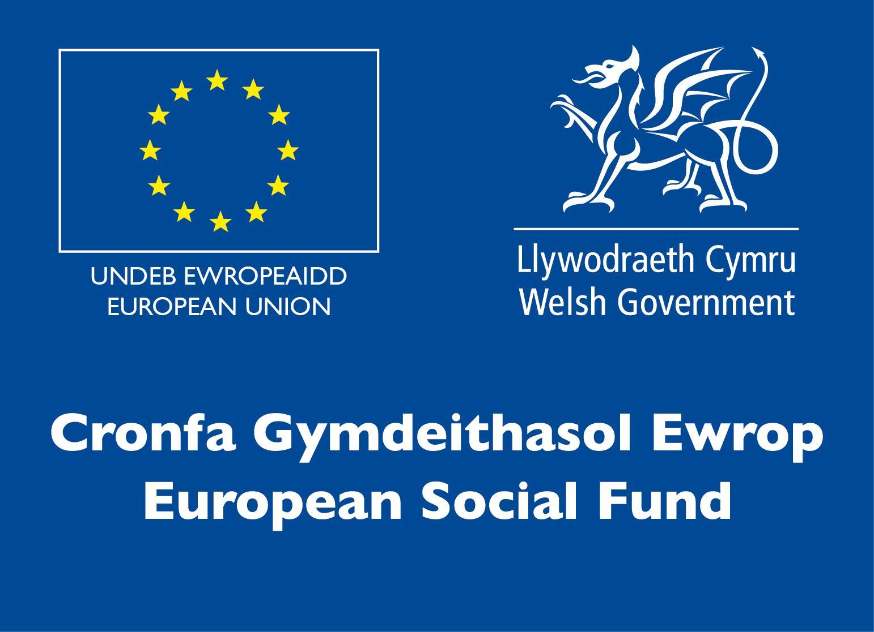
The scope of the competition enables learners to develop and put into practice a variety of skills that are required to be a working musician within the industry.

Competitors taking part in this competition should be able to:
- Play an instrument or sing to an advanced level
- Understand the technical operation and maintenance of their instrument and appropriate contemporary sound generation

- Be able to apply genre-specific performance and arranging techniques
- Understand and apply appropriate performance aesthetics and stagecraft
- Work collaboratively and communicate effectively
- Solve problems and meet challenges using practical and creative skills
- Demonstrate innovation in musical performance and arrangement
- Proactively manage disciplined personal practice.

Conduct for competitors during live competition
(these are guidelines only and may be subject to change):
- Competitors will be invited into the virtual platform at the scheduled time of their set
- Competitors will keep their mics on mute, apply appropriate backgrounds, or keep cameras off whilst in the virtual room
- Competitors will be unmuted to answer questions and receive feedback from the judges. This will also be an opportunity for bands to give information about themselves as well as make clear to the judges what they are trying to do in terms of market awareness (Aspect ID F).
- Competitors will behave appropriately and professionally in the virtual room. Any offensive or inappropriate behaviour will result in immediate disqualification.
- Competitors will perform three songs of their choice
- If there are technical difficulties during the airing of the performance / whilst in the virtual room, the competitors must act according to the instruction of the organiser
- The use of inappropriate and offensive language in songs will need to be edited for the performance.

Entry capacity restrictions by organisation
Maximum of up to 1 group per organisation, with a maximum of 12 competitors per group. This is the maximum number of entries permitted by an organisation for this competition.

This is determined by ‘location’ and ‘organisation’. ‘Organisation’ refers to the competitors training provider/employer. ‘Location’ refers to a site where the competitor studies / is employed. For further guidance on these capacities, click here

Brief
- Total set performance time - 20 minutes
- Points will be deducted for going over the time allocated.
- There are no regional heats for this category but rather a ‘Battle of the Bands’ event which is very exciting and a much sought-after accolade. This will take place on January 22nd, 2021 via Zoom and Facebook/ Youtube live feed.
- Select, rehearse and perform a short set of three songs as a band of two or more members. The songs can be cover versions, original compositions, or a combination of both.
- It is important to note that this is not a song writing competition therefore any original compositions will be marked on exactly the same criteria as the cover songs (please see below). No additional marks will be awarded for composing.
- All three songs will be recorded in one continuous single camera shot. The recording and video quality will not be judged. This is to ensure fairness across all competing teams.
- Groups will receive brief oral feedback from the judges at the end of their video.
- Detailed feedback will be available to each college once approved by Skills Competition Wales.

Optional Extras
- If a college wishes to submit a multi-camera video for the social media channel, they are welcome to do so. This will not be taken into account by the judges and is purely for audience enjoyment.
- We hope to include as much content as possible on the Facebook page www.facebook.com/SgiliauCyfryngauaChreadigol/.
- The event will be live streamed on a social media platform to enable access for students, tutors and other supporters.

Competition Rules
For full terms and conditions of entry and competition rules visit www.skillscompetitionwales.ac.uk/terms-and-conditions

General competition rules:
Any questions during competition activity should be addressed to the event organisers via the chat function.

Marking and Assessment
Marking and judging of this competition will be carried out by a team of experts from Industry and Higher Education, using a marking criteria and allocated marks to ensure consistency.

All teams will receive feedback after their performance. The songs will be recorded live in college and played on the day of competition, in front of a panel of judges.

The judges will assess each performance against the criteria outlined below:

Aspect ID | Description | Max Marks
A | Musicality  Phrasing, articulation, expression, dynamics, tone, consistent with style and content with regards to genre | 5
B | Technical Accuracy  Timing, rhythm, pitch, intonation, consistent with style and content with regards to genre | 5
C | Stagecraft and awareness  Appropriate performance aesthetic with regards to genre  Attitude and delivery, movement, visual presentation, balancing of the stage, time management | 5
D | Ensemble skills  Unity as an ensemble, tightness, musical interaction, control of individual dynamics | 5
E | Arrangement and Selection  Effective use of ensemble resources, understanding of arranging for live performance  Inventive arrangements and Interpretations | 5
F | Market awareness and originality  Selection of appropriate repertoire with regards to genre and target audience (intended market)  Original performance (No extra marks for original compositions) | 5
 | Total | 30

Feedback and Recognition
Individual and Group verbal feedback will be provided at the end of each set.

No results or awards will be awarded on the day as marking will be quality assured.

Electronic certificates of Participation will be issued on the day.

Medallists will be invited to a Celebration Event which will be held in March 2021, where the First, Second and Third Awards will be presented.

Marksheets will be made available to competitors after the quality assurance process has been completed. Further details will be provided to all competitors upon notification of outcomes.

Competition Lead
For general enquiries about the competition please contact Nia Rhys Jones: n.jones@gllm.ac.uk

For technical advice about the competition contact Rhodri Owen:
rhodri.owen@gllm.ac.uk

Briff y Gystadleuaeth

Teitl y Gystadleuaeth

Cerddoriaeth Boblogaidd

Trosolwg o'r Gystadleuaeth
Mae cerddoriaeth boblogaidd yn derm cyffredinol ar gyfer amrywiaeth eang o gerddoriaeth sy'n apelio at ran fawr o'r boblogaeth.

Mae'r gystadleuaeth hon yn cynnig i ddysgwyr ddewis, ymarfer a pherfformio set fer o dair cân fel band o ddau neu fwy o aelodau. Gall y caneuon fod yn fersiynau o’r gwreiddiol, cyfansoddiadau gwreiddiol, neu gyfuniad o'r ddau.

Cynhelir y gystadleuaeth yn rhithiol gan ddefnyddio llwyfan fideo-gynadledda a chyfryngau cymdeithasol

Bydd perfformiadau'n cael eu recordio yn y coleg mewn un siot camera sengl. Bydd y rhain yn cael eu cyflwyno ar ddiwrnod y gystadleuaeth i'r beirniaid yn yr ystafell gystadlu rithwir.

Y nod yw y bydd y gystadleuaeth yn cael ei ffrydio'n fyw i alluogi cynulleidfa eang i gael mynediad at y perfformiadau a'u mwynhau. (Manylion i ddilyn)

Meini Prawf Mynediad
Mae’r gystadleuaeth ar gyfer dysgwyr sy'n rhan o fand ac sy’n hyfforddi ar gyfer gyrfa yn y Diwydiant Cerddoriaeth. Dylai nhw fod yn gweithio tuag at gymhwyster cerddorol Lefel 2 neu 3 (neu gymhwyster cyfatebol) neu wedi ennill y cymhwyster.

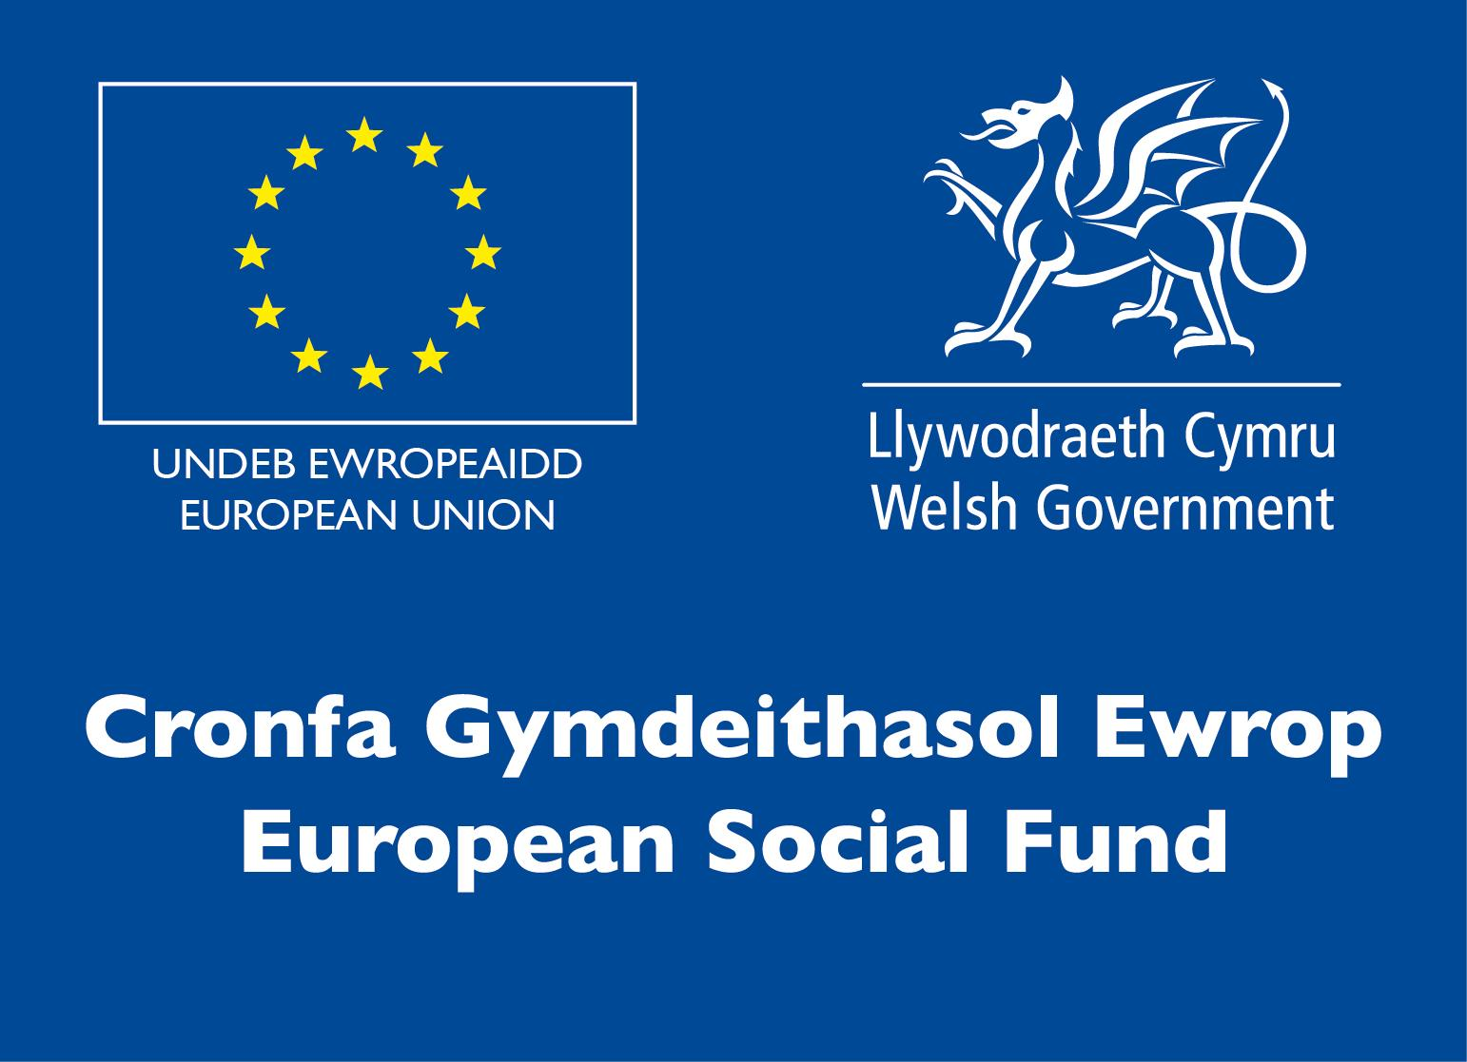
Sicrhewch fod gan eich ymgeiswyr y sgiliau a'r cymwyseddau i gyflawni'r dasg a ddarperir.

Cymwyseddau Craidd
Mae cwmpas y gystadleuaeth yn galluogi dysgwyr i ddatblygu a rhoi ar waith amrywiaeth o sgiliau sy'n ofynnol i fod yn gerddor gweithredol yn y diwydiant.

Dylai cystadleuwyr sy'n cymryd rhan yn y gystadleuaeth hon allu:
● Chwarae offeryn neu ganu i lefel uwch
● Deall gweithrediad technegol a chynnal a chadw eu hofferyn a chynhyrchu sain gyfoes briodol
● Gallu defnyddio technegau perfformiad a threfnu genre-benodol
● Deall a chymhwyso estheteg perfformiad a llwyfannau perfformiad priodol
● Cydweithio a chyfathrebu'n effeithiol
● Datrys problemau a chwrdd â heriau gan ddefnyddio sgiliau ymarferol a chreadigol
● Dangos arloesedd mewn perfformiad cerddorol a threfniant
● Rheoli ymarfer personol disgybledig yn rhagweithiol.

Ymddygiad i gystadleuwyr yn ystod cystadleuaeth fyw
(canllawiau yn unig yw'r rhain a gallant fod yn agored i newid):
● Gwahoddir cystadleuwyr i'r llwyfan rhithwir ar adeg gofrestredig eu set
● Bydd cystadleuwyr yn cadw eu meics yn fud, yn cymhwyso cefndiroedd priodol, neu'n cadw camerâu i ffwrdd tra yn yr ystafell rithwir
● Bydd cystadleuwyr yn cael eu tynnu oddi ar fod yn fud i ateb cwestiynau a chael adborth gan y beirniaid. Bydd hyn hefyd yn gyfle i fandiau roi gwybodaeth amdanynt eu hunain yn ogystal â'i gwneud yn glir i'r beirniaid beth y maent yn ceisio'i wneud o ran ymwybyddiaeth o'r farchnad (Agwedd ID F).
● Bydd cystadleuwyr yn ymddwyn yn briodol ac yn broffesiynol yn yr ystafell rithwir. Bydd unrhyw ymddygiad tramgwyddus neu amhriodol yn arwain at anghymhwysiad ar unwaith.
● Bydd cystadleuwyr yn perfformio tair cân o'u dewis
● Os oes anawsterau technegol wrth ffrydio’r perfformiad / tra yn yr ystafell rithwir, rhaid i'r cystadleuwyr weithredu yn unol â chyfarwyddyd y trefnydd
● Bydd angen golygu defnyddio iaith amhriodol a sarhaus mewn caneuon ar gyfer y perfformiad.

Cyfyngiadau capasiti mynediad fesul sefydliad
Uchafswm o hyd at 1 grŵp fesul sefydliad, gydag uchafswm o 12 cystadleuydd i bob grŵp. Dyma uchafswm nifer yr ymgeiswyr a ganiateir gan sefydliad ar gyfer y gystadleuaeth hon.

Pennir hyn gan 'leoliad' a 'sefydliad'. Mae 'sefydliad' yn cyfeirio at ddarparwr/cyflogwr hyfforddiant y cystadleuwyr. Mae 'lleoliad' yn cyfeirio at safle lle mae'r cystadleuydd yn astudio / yn cael ei gyflogi. I gael rhagor o arweiniad ar y capasiti hyn, cliciwch yma <https://www.skillscompetitionwales.ac.uk/terms/entry-capacity-restrictions-by-organisation>

Briff
● Cyfanswm amser perfformiad a bennwyd - 20 munud
● Caiff pwyntiau eu didynnu am fynd dros yr amser a neilltuir.
● Nid oes unrhyw ragbrawf rhanbarthol ar gyfer y categori hwn ond yn hytrach digwyddiad 'Brwydr y Bandiau' sy'n gyffrous iawn ac yn anrhydedd y ceisir llawer amdano. Bydd hyn yn digwydd ar 22 Ionawr, 2021 drwy borthiant byw Zoom a Facebook/ Youtube.
● Dewis, ymarfer a pherfformio set fer o dair cân fel band o ddau neu fwy o aelodau. Gall y caneuon fod yn fersiynau o’r gwreiddiol, cyfansoddiadau gwreiddiol, neu gyfuniad o'r ddau.
● Mae'n bwysig nodi nad cystadleuaeth ysgrifennu cân yw hon felly bydd unrhyw gyfansoddiadau gwreiddiol yn cael eu marcio ar yr un meini prawf yn union â'r fersiynau o ganeuon gwreiddiol (gweler isod). Ni ddyfernir unrhyw farciau ychwanegol ar gyfer cyfansoddi.
● Bydd y tair cân yn cael eu recordio mewn un siot camera sengl parhaus. Ni fydd y recordio ac ansawdd y fideo yn cael eu barnu. Mae hyn er mwyn sicrhau tegwch ar draws yr holl dimau sy'n cystadlu.
● Bydd grwpiau'n cael adborth llafar byr gan y beirniaid ar ddiwedd eu fideo.
● Bydd adborth manwl ar gael i bob coleg ar ôl iddo gael ei gymeradwyo gan Gystadleuaeth Sgiliau Cymru.

Ychwanegiadau Dewisol
● Os yw coleg yn dymuno cyflwyno fideo aml-gamera ar gyfer y sianel cyfryngau cymdeithasol, mae croeso iddynt wneud hynny. Ni fydd hyn yn cael ei ystyried gan y beirniaid ac er mwyn mwynhad y gynulleidfa yn unig y mae.
● Gobeithiwn gynnwys cymaint o gynnwys â phosibl ar y dudalen Facebook www.facebook.com/SgiliauCyfryngauaChreadigol/ <http://www.facebook.com/SgiliauCyfryngauaChreadigol/>.
● Bydd y digwyddiad yn cael ei ffrydio'n fyw ar lwyfan cyfryngau cymdeithasol er mwyn galluogi myfyrwyr, tiwtoriaid a chefnogwyr eraill i gael mynediad.

Rheolau Cystadlu
Am delerau ac amodau llawn rheolau mynediad a chystadleuaeth ewch i https://inspiringskills.gov.wales/terms-and-conditions?lang=cy <http://www.skillscompetitionwales.ac.uk/terms-and-conditions>

Rheolau cystadleuaeth gyffredinol
Dylid rhoi sylw i unrhyw gwestiynau yn ystod gweithgarwch cystadlu at drefnwyr y digwyddiad drwy'r ffwythiant sgwrsio.

Marcio ac asesu
Bydd marcio a beirniadu'r gystadleuaeth hon yn cael ei wneud gan dîm o arbenigwyr o’r diwydiant a darparwyr addysg bellach, gan ddefnyddio meini prawf marcio a marciau a ddyrannwyd i sicrhau cysondeb.

Bydd pob tîm yn cael adborth ar ôl eu perfformiad.

Bydd y caneuon yn cael eu recordio'n fyw yn y coleg a'u chwarae ar ddiwrnod y gystadleuaeth, o flaen panel o feirniaid.

Bydd y beirniaid yn asesu pob perfformiad yn erbyn y meini prawf a amlinellir isod:

Agwedd ID | Disgrifiad | Marciau Uchaf
A | Cerddorol Geiriad, ynganu, mynegiant, deinameg, tôn, yn gyson ag arddull a chynnwys o ran genre | 5
B | Cywirdeb Technegol Amseru, rhythm, cywair, goslef, yn gyson ag arddull a chynnwys o ran genre | 5
C | Llwyfannau ac ymwybyddiaeth Esthetig perfformiad priodol o ran genre Agwedd a darpariaeth, symudiad, cyflwyniad gweledol, cydbwyso'r llwyfan, rheoli amser | 5
D | Sgiliau ensemble Undod fel ensemble, yn dynn, rhyngweithio cerddorol, rheoli deinameg unigol | 5
E | Trefnu a Dethol Defnydd effeithiol o adnoddau ensemble, dealltwriaeth o drefnu ar gyfer perfformiad byw Trefniadau a Dehongliadau dyfeisgar | 5
F | Ymwybyddiaeth o'r farchnad a gwreiddioldeb Dewis repertoire priodol o ran genre a chynulleidfa darged (y farchnad a fwriedir) Perfformiad gwreiddiol (Dim marciau ychwanegol ar gyfer cyfansoddiadau gwreiddiol) | 5
 | Cyfanswm | 30
Adborth a Chydnabyddiaeth
Darperir adborth llafar i unigolion a grwpiau ar ddiwedd y gystadleuaeth.

Ni ddyfernir unrhyw ganlyniadau na dyfarniadau ar y diwrnod gan y bydd angen sicrhau ansawdd y marcio.

Cyflwynir Tystysgrifau Cyfranogi electronig ar y diwrnod.

Gwahoddir enillwyr y medalau i Ddigwyddiad Dathlu a gynhelir ar 19 Mawrth 2021, ble bydd y Wobr Gyntaf, Ail a Thrydedd yn cael eu cyflwyno.

Bydd taflenni marcio ar gael i gystadleuwyr ar ôl i'r broses sicrhau ansawdd gael ei chwblhau. Rhoddir rhagor o fanylion i bob cystadleuydd pan fyddant yn cael gwybod am ganlyniadau.

Arweinydd y Gystadleuaeth
Am ymholiadau cyffredinol am y gystadleuaeth cysylltwch:
Nia Rhys Jones: n.jones@gllm.ac.uk

Am gyngor technegol am y gystadleuaeth cysylltwch:
Rhodri Owen: rhodri.owen@gllm.ac.uk

