**Competition Brief**

**Competition Title**

Photography

**Competition Overview**

Photography is the art of capturing [images](https://en.wikipedia.org/wiki/Image) onto [photographic film](https://en.wikipedia.org/wiki/Photographic_film). It is used in many fields of science and business, but its main uses are in the world of art, film and video production and recreational purposes. In this competition, competitors will have to provide a number of digital images relating to a given theme, ensuring their work is of the highest quality whilst displaying creativity and technique

**Entry Criteria**

The competition is for those training for a career in Photography and studying towards a Level 2 or 3 qualification.

Please ensure that your entrants have the skills and competences to complete the task.

**Entry capacity restrictions by organisation**

Two entries per organisation.

A passive heat will take place for this competition.

All entries must be sent electronically to **Paul Edwards by Monday 14th December at 5pm.**

This is the maximum number of entries permitted by an organisation for this competition.

This is determined by ‘location’ and ‘organisation’. ‘Organisation’ refers to the competitors training provider/employer.

**Brief**

The theme this year is **‘The New Normal’**.

* You are requested to provide 5 digital images; all of which must relate as a coherent response to the above theme. Images are acceptable from a range of devices. 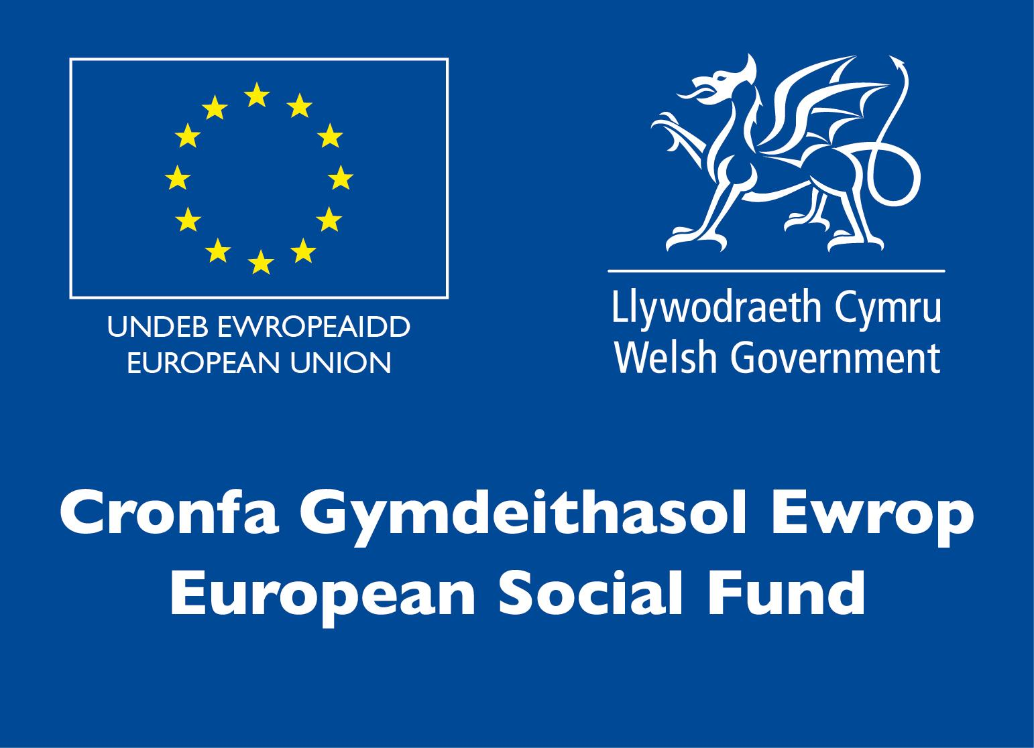
* Entries to be sent for passive heat judging by Monday 14th December. **Finalists will be informed by December 18th 2020**
* The competition final will take place on **Monday 18th January, 2021** as a remote event hosted by Zoom, delivered in partnership with University of South Wales.
* On the day of the Creative Final you will have the opportunity to discuss your ideas, techniques and answer questions from the judges. This will take place in the room with the other finalists. This will also take place remotely and will form part of the judging criteria.
* The work will be included on the competition Facebook page: www.facebook.com/SgiliauCyfryngauaChreadigol/

**Infrastructure List**

Technical information regarding submission of the work will be sent out to entrants after registration closes.

**Competition Rules**

For full terms and conditions of entry and competition rules visit [www.skillscompetitionwales.ac.uk/terms-and-conditions](http://www.skillscompetitionwales.ac.uk/terms-and-conditions)

**Competitors are to:**

* Work independently (without support from the outside)
* Submit all requirements listed in the brief
* Ensure that all images are self-generated and original
* Refrain from using offensive, sexual, controversial or inflammatory text or images
* Ensure that work is submitted by **December 14th 2020.**

**General competition rules:**

* Any questions during competition activity should be addressed to the competition judging panel.
* It is the responsibility of each competitor to arrive on time for each competition session. No additional time will be allowed if you arrive late.
* Technical failure of your equipment should be reported immediately to the judging panel. Additional time will be allocated if the fault is beyond the control of the competitor.

**Marking and Assessment**

Marking and judging of this competition will be done by a team of experts from Industry, Further Education or Training Provider, using a marking criteria and allocated marks to ensure consistency. Please note that for the 2021 final you will be asked to present your work in front of the other competitors as well as the competition judges.

The following criteria will be used by the judges to decide which project is the winner of the Skills Competition Wales, Photography category for 2021:

|  |  |  |
| --- | --- | --- |
| **Criterion ID** | **Description** | **Max. Marks** |
| A | **Concept / Idea** | 20 |
| B | **Quality of technical proficiency** | 40 |
| C | **Style and approach to the project** | 15 |
| D | **Clarity of message** | 15 |
| E | **Communication Skills**  ● Content: Your project aims and objectives in response to the given theme. How you managed your project. Your process in terms of creativity and technique.  ● Clear and audible communication  ● Questions answered appropriately  *(It is not a requirement to create a digital presentation eg. PowerPoint as no additional marks will be awarded).* | 10 |
|  | **Total Marks** | 100 |

**Feedback and Recognition**

Individual and Group verbal feedback will be provided at the end of the competition.

No results or awards will be awarded on the day, as marking will be quality assured.

Certificates of Participation will be issued on the day.

Medallists will be invited to a Celebration Event which will be held in March 2021, where the First, Second and Third Awards will be presented.

Marksheets will be made available to unsuccessful competitors after the quality assurance process has been completed. Further details will be provided to all competitors upon notification of outcomes.

**Competition Lead**

For general enquiries and technical advice about the competition please contact

Paul Edwards: [paul.edwards@gllm.ac.uk](mailto:paul.edwards@gllm.ac.uk)

**Other Enquiries**

Nia Rhys Jones: [n.jones@gllm.ac.uk](mailto:n.jones@gllm.ac.uk)

**Briff y Gystadleuaeth**

**Enw’r Gystadleuaeth**

Ffotograffiaeth

**Trosolwg o’r Gystadleuaeth**

Ffotograffiaeth yw'r grefft o ddal [delweddau](https://en.wikipedia.org/wiki/Image) ar [ffilm ffotograffig](https://en.wikipedia.org/wiki/Photographic_film). Caiff ei ddefnyddio mewn sawl maes o wyddoniaeth a busnes, ond yn bennaf caiff ei ddefnyddio ym myd celf, ffilm, a chynhyrchu fideo ac at ddibenion hamdden. Yn y gystadleuaeth hon, bydd yn rhaid i gystadleuwyr gyflwyno nifer o ddelweddau digidol sy'n ymwneud â thema benodol, gan sicrhau bod eu gwaith o'r safon uchaf ac yn arddangos creadigrwydd a thechneg

**Gofynion Mynediad**

Mae'r gystadleuaeth hon ar gyfer y rhai sy'n hyfforddi ar gyfer gyrfa ym maes Ffotograffiaeth ac sy’n astudio tuag at gymhwyster Lefel 2 neu Lefel 3.

Sicrhewch fod gan eich ymgeiswyr y sgiliau a'r gallu angenrheidiol i gwblhau'r dasg.

**Cyfyngiadau capasiti mynediad yn ôl sefydliad**

Dau ymgeisydd o bob sefydliad.

Bydd rhagbrofion goddefol yn digwydd ar gyfer y gystadleuaeth hon.

Rhaid anfon pob ymgais yn electronig at **Paul Edwards erbyn 5pm Dydd Llun 14 Rhagfyr.**

Dyma'r nifer mwyaf o gystadleuwyr a ganiateir o bob sefydliad ar gyfer y gystadleuaeth hon.

Penderfynir ar hyn yn ôl 'lleoliad' a 'sefydliad'. Mae 'sefydliad' yn cyfeirio at gyflogwr/darparwr hyfforddiant y cystadleuwyr.

**Brîff**

Y thema eleni yw **' Y Normal Newydd '**.

* Gofynnir i chi gyflwyno 5 delwedd ddigidol; Rhaid i bob un ohonynt ymateb i'r thema uchod fel cyfanwaith cydlynol. Derbynnir delweddau o amrywiaeth o ddyfeisiau. 
* Bydd rownd derfynol y gystadleuaeth yn cael ei chynnal fel digwyddiad anghysbell trwy Zoom, dan ofal USW.
* Ar ddiwrnod y Rownd Derfynol Greadigol bydd cyfle i chi drafod eich syniadau a’ch technegau ac i ateb cwestiynau gan y beirniaid. Bydd hyn yn digwydd yn yr un ystafell â'r cystadleuwyr eraill. Bydd hyn yn rhan o'r feirniadaeth. Bydd hyn hefyd yn digwydd o bell a bydd yn rhan o'r meini prawf beirniadu.
* Bydd y gwaith hefyd yn cael ei arddangos ar dudalen Facebook y gystadleuaeth: www.facebook.com/SgiliauCyfryngauaChreadigol/

**Rhestr Seilwaith**

Bydd gwybodaeth dechnegol o ran cyflwyno'r gwaith yn cael ei hanfon at y cystadleuwyr ar ôl i’r cyfnod cofrestru orffen

**Rheolau’r Gystadleuaeth**

I weld y telerau ac amodau mynediad a’r rheolau cystadlu yn eu cyfanrwydd ewch i [www.skillscompetitionwales.ac.uk/terms-and-conditions](http://www.skillscompetitionwales.ac.uk/terms-and-conditions)

**Dylai’r Cystadleuwyr:**

* Weithio'n annibynnol (heb fewnbwn allanol)
* Ateb yr holl ofynion a restrwyd yn y briff
* Sicrhau mai nhw a gynhyrchodd pob delwedd a’u bod yn wreiddiol
* Ymatal rhag cynnwys testunau neu ddelweddau sarhaus, rhywiol, dadleuol neu ymfflamychol
* Sicrhau bod gwaith yn cael ei gyflwyno erbyn **Rhagfyr 14 2020.**

**Rheolau Cystadlu Cyffredinol:**

* Os bydd unrhyw gwestiynau yn ystod y gweithgareddau cystadlu, dylid eu cyfeirio at banel beirniaid y gystadleuaeth.
* Cyfrifoldeb pob cystadleuydd yw cyrraedd yn brydlon ar gyfer pob sesiwn o'r gystadleuaeth. Ni fydd rhagor amser yn cael ei ganiatáu os byddwch yn cyrraedd yn hwyr.
* Os bydd methiant technegol ar eich offer dylech hysbysu’r panel beirniadu ar unwaith. Bydd amser ychwanegol yn cael ei ganiatau os yw'r nam y tu hwnt i reolaeth y cystadleuydd.

**Marcio ac Asesu**

Caiff y gwaith o farcio a beirniadu'r gystadleuaeth ei gynnal gan dîm o arbenigwyr o Ddarparwyr Hyfforddiant, Addysg Bellach, neu Ddiwydiant gan ddefnyddio meini prawf marcio a marciau wedi'u dyrannu i sicrhau cysondeb. Sylwch, ar gyfer rownd derfynol 2021, y bydd gofyn i chi gyflwyno eich gwaith o flaen y cystadleuwyr eraill yn ogystal â barnwyr y gystadleuaeth.

Bydd y beirniaid yn defnyddio'r meini prawf canlynol i benderfynu pa brosiect sy'n ennill categori Ffotograffiaeth, Cystadleuaeth Sgiliau Cymru 2021 :

|  |  |  |
| --- | --- | --- |
| **Cyf. Maen Prawf** | **Disgrifiad** | **Uchafswm Marciau** |
| A | **Cysyniad / Syniad** | 20 |
| B | **Ansawdd gallu technegol** | 40 |
| C | **Arddull a dull gweithio’r prosiect** | 15 |
| D | **Eglurder y neges** | 15 |
| E | **Sgiliau cyfathrebu**  ● Cynnwys: Nodau ac amcanion eich prosiect wrth ymateb i'r thema dan sylw. Sut y gwnaethoch chi reoli eich prosiect. Eich proses o ran creadigrwydd a thechneg.  ● Cyfathrebu clir a chlywadwy  ● Ateb y cwestiynau'n briodol  (Nid yw'n ofynnol creu cyflwyniad digidol, megis PowerPoint, gan na fydd marciau ychwanegol yn cael eu dyfarnu). | 10 |
|  | **Cyfanswm Marciau** | 100 |

**Adborth a Chydnabyddiaeth**

Bydd adborth llafar Unigol a Grŵp yn cael ei ddarparu ar ddiwedd y gystadleuaeth.

Ni roddir canlyniadau na gwobrau ar y diwrnod gan y bydd angen sicrhau ansawdd y gwaith marcio.

Bydd Tystysgrifau Cyfranogiad yn cael eu rhoi ar y diwrnod.

Bydd y rhai sy’n ennill medalau yn cael eu gwahodd i Ddigwyddiad Dathlu a fydd yn cael ei gynnal yn mis Mawrth 2021, lle bydd y Gwobrau Cyntaf, Ail a Thrydedd yn cael eu cyflwyno.

Bydd taflenni marcio’r cystadleuwyr aflwyddiannus ar gael ar ôl i'r broses sicrhau ansawdd gael ei chwblhau. Rhoddir manylion pellach i bob cystadleuydd ar ôl iddyn nhw glywed canlyniad y gystadleuaeth.

**Arweinydd Cystadleuaeth**

Am ymholiadau cyffredinol a chyngor technegol am y gystadleuaeth cysylltwch â

Paul Edwards: [paul.edwards@gllm.ac.uk](mailto:paul.edwards@gllm.ac.uk)

**Ymholiadau Eraill**

Nia Rhys Jones: [n.jones@gllm.ac.uk](mailto:n.jones@gllm.ac.uk)