**Competition Brief**

**Competition Title**

Personal Trainer

**Competition Overview**

This stage of the competition will be held virtually.

The competition provides competitors with an opportunity to show:

* Communication, coaching and physical skills
* Professionalism
* Originality and the ability to provide a compelling and enjoyable session to promote adherence and build business

There are many reasons why clients engage Personal Trainers but one of the most common is to gain maximum benefit from training when time is limited; people are busy and can find it difficult to train alone. They will invest in the results that well planned 1:1 training provides.

**Entry Criteria**

The competition is for those training for a career in Sports/Fitness and studying for a qualification in Level 2 Gym Instructors / Level 3 Personal training or BTEC Level 3.

Please ensure that your entrants have the skills and competences to complete the task.

Competition Video date submission - Between 25th January and 5th February.

You will be allocated a date and instructions to upload your video recording once registration has closed.

**Entry capacity restrictions by organisation**

Maximum of up to 3 per location.

This is the maximum number of entries permitted by an organisation for this competition.

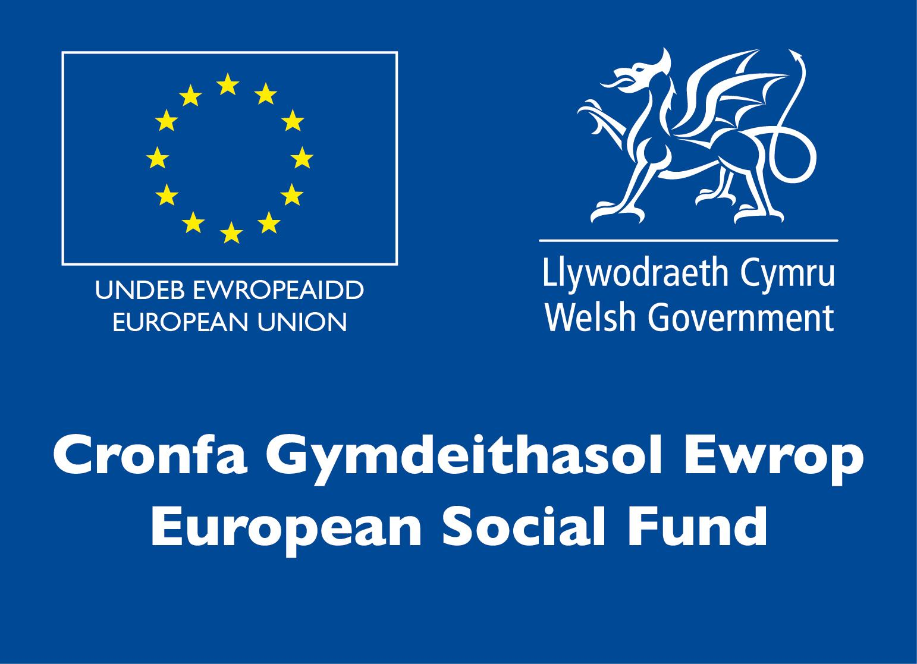This is determined by ‘location’ and ‘organisation’. ‘Organisation’ refers to the competitors training provider/employer. ‘Location’ refers to a site where the competitor studies / is employed. For further guidance on these capacities, click [here](https://www.skillscompetitionwales.ac.uk/terms/entry-capacity-restrictions-by-organisation)

**Brief**

An international pandemic has led to a lockdown situation in the UK as well as in other countries around the world. Many businesses where people congregate have been suspended to slow down the spread of the Covid-19 virus.

Although gyms, health clubs and sports centres have been closed, and restrictions remain in place, the vital benefits of exercise have been highlighted and many campaigns encourage the population to stay active.

Many fitness professionals and brands have moved large proportions of their businesses online and to other virtual platforms, to ensure continuity for their clients and to sustain a level of income for themselves. This is a trend that is looking increasingly likely to continue to develop and form a vital part of the role of the fitness professional in the 2020’s.

**Home Workout video**

You need to produce and submit a video (maximum 10 minutes) demonstrating at least 5 different exercises which can be performed in the home with common household items.

You should choose at least one piece of household equipment and devise a short (10-minute –max) home-based workout that incorporates the chosen equipment in at least one exercise.

Household equipment can be defined as an item that most households would normally have, such as tins, bottles of water, heavy books, broom handle etc. Dumbbells or other specifically designed weights would not be a valid equipment selection for this task.

The video should be designed and delivered to appeal to as many people as possible – however considerations should be given to ensure that the demo is also suitable for beginners.

The video needs to be compiled as one long shoot and cannot be cut or edited in any way.

**Competition Rules**

For full terms and conditions of entry and competition rules visit [www.skillscompetitionwales.ac.uk/terms-and-conditions](http://www.skillscompetitionwales.ac.uk/terms-and-conditions)

**Marking and Assessment**

Marking and judging of this competition will be done by a team of experts from Industry, Further Education or Training Provider, using a marking criteria and allocated marks to ensure consistency.

**Feedback and Recognition**

Verbal feedback will be given however will be timed at a strict 2 minutes.

No results or awards will be awarded on the day as marking will be quality assured.

Certificates of Participation will be issued on the day.

Medallists will be invited to a Celebration Event which will be held in March 2021, where the First, Second and Third Awards will be presented.

**Note: These competition materials were developed in partnership with the UK Competition Organising Partners, AoC Sport.** 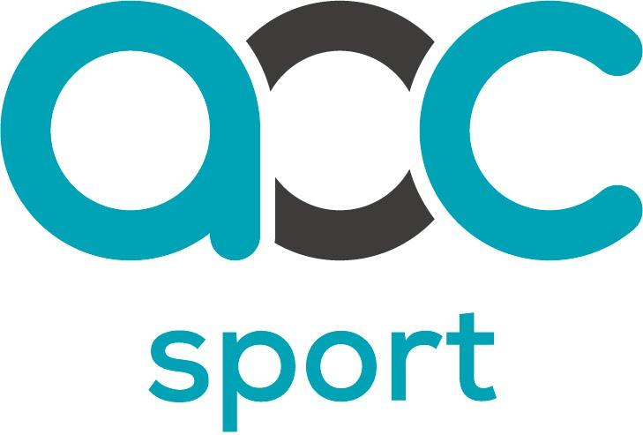

**Competition Lead**

**Lead Contact:** Cerys Rees

Cerys.rees@coleggwent.ac.uk

**Briff y Gystadleuaeth**

**Teitl y Gystadleuaeth**

Hyfforddwr Personol

**Trosolwg y Gystadleuaeth**

Bydd y cam hwn o'r gystadleuaeth yn cael ei gynnal yn rhithiol.

Mae'r gystadleuaeth yn rhoi cyfle i gystadleuwyr ddangos:

• Sgiliau cyfathrebu, sgiliau hyfforddi, a sgiliau corfforol

• Proffesiynoldeb

• Gwreiddioldeb a'r gallu i ddarparu sesiwn gymhellol a phleserus i hyrwyddo ymlyniad ac adeiladu busnes

Mae sawl rheswm i gleient ymgysylltu â Hyfforddwyr Personol, ond un o'r rhai mwyaf cyffredin yw cael y budd mwyaf posibl o hyfforddiant pan fo amser yn gyfyng; mae pobl yn brysur a gall fod yn anodd iddynt hyfforddi ar eu pen eu hunain. Byddant yn buddsoddi yn y canlyniadau a ddarperir gan hyfforddiant 1:1 sydd wedi'i gynllunio'n dda.

**Meini Prawf Mynediad**

Mae'r gystadleuaeth ar gyfer y rhai sy'n hyfforddi ar gyfer gyrfa mewn Chwaraeon/Ffitrwydd ac sy’n astudio ar gyfer cymhwyster mewn Hyfforddwyr Campfa Lefel 2 / Lefel 3 Hyfforddiant personol neu BTEC Lefel 3.

Sicrhewch fod gan eich ymgeiswyr y sgiliau a'r cymwyseddau i gyflawni'r dasg a ddarperir.

Dyddiad cyflwyno ar gyfer Fideo Cystadleuaeth - Rhwng 25 Ionawr a 5ed Chwefror.

Rhoddir dyddiad a chyfarwyddiadau i chi i uwchlwytho'ch recordiad fideo unwaith y bydd y cofrestriad wedi cau.

**Cyfyngiadau capasiti mynediad fesul sefydliad**

Uchafswm o hyd at 3 y lleoliad.

Dyma uchafswm nifer yr ymgeiswyr a ganiateir gan sefydliad ar gyfer y gystadleuaeth hon.

Pennir hyn gan 'leoliad' a 'sefydliad'. Mae 'sefydliad' yn cyfeirio at ddarparwr hyfforddiant/cyflogwr y cystadleuwyr. Mae 'lleoliad' yn cyfeirio at safle lle mae'r cystadleuydd yn astudio / yn cael ei gyflogi. I gael rhagor o arweiniad ar y capasiti hyn, cliciwch yma

**Briff**

Mae pandemig rhyngwladol wedi arwain at sefyllfa o gyfyngiadau symud yn y DU yn ogystal â gwledydd eraill ledled y byd. Mae llawer o fusnesau lle mae pobl yn ymgynnull wedi'u hatal i arafu lledaeniad firws Covid-19.

Er bod campfeydd, clybiau iechyd a chanolfannau chwaraeon wedi'u cau, a bod cyfyngiadau'n parhau, tynnwyd sylw at fanteision hanfodol ymarfer corff ac mae llawer o ymgyrchoedd yn annog y boblogaeth i barhau i fod yn egnïol.

Mae llawer o weithwyr ffitrwydd proffesiynol a brandiau wedi symud cyfrannau mawr o'u busnesau ar-lein ac i lwyfannau rhithwir eraill, er mwyn sicrhau parhad gwasanaeth i'w cleientiaid ac i gynnal lefel o incwm iddynt hwy eu hunain. Mae hon yn duedd sy'n edrych yn fwyfwy tebygol o barhau i ddatblygu a bod yn rhan hanfodol o rôl y gweithiwr ffitrwydd proffesiynol yn y 2020au.

**Fideo Ymarfer Corff Cartref**

Mae angen i chi gynhyrchu a chyflwyno fideo (uchafswm o 10 munud) sy'n dangos o leiaf 5 ymarfer gwahanol y gellir eu gwneud yn y cartref gydag eitemau cyffredin o'r cartref.

Dylech ddewis o leiaf un darn o offer cartref a dyfeisio sesiwn ymarfer corff cartref byr (10 munud – uchafswm) sy'n ymgorffori'r offer a ddewiswyd mewn o leiaf un ymarfer.

Gellir diffinio offer cartref fel eitem y byddai gan y rhan fwyaf o aelwydydd fel arfer, megis tuniau, poteli o ddŵr, llyfrau trwm, coes brwsh ac ati. Ni fyddai ‘dumbbells’ neu bwysau eraill a gynlluniwyd yn benodol yn ddewis offer dilys ar gyfer y dasg hon.

Dylid cynllunio a chyflwyno'r fideo i apelio at gynifer o bobl â phosibl – ond dylid rhoi ystyriaethau i sicrhau bod y demo hefyd yn addas i ddechreuwyr.

Mae angen recordio’r fideo yn ei chyfanrwydd mewn un saethiad parhaus, ac ni ellir ei dorri na'i olygu mewn unrhyw ffordd.

**Rheolau Cystadlu**

Am delerau ac amodau llawn rheolau mynediad a chystadlu ewch i https://inspiringskills.gov.wales/terms-and-conditions?lang=cy

**Marcio ac Asesu**

Bydd marcio a beirniadu'r gystadleuaeth hon yn cael ei wneud gan dîm o arbenigwyr o’r diwydiant, darparwyr addysg bellach neu hyfforddiant, gan ddefnyddio meini prawf marcio a marciau a ddyrannwyd i sicrhau cysondeb.

**Adborth a Chydnabyddiaeth**

Rhoddir adborth llafar ond bydd yn cael ei amseru’n llym am 2 funud.

Ni ddyfernir unrhyw ganlyniadau na dyfarniadau ar y diwrnod gan y bydd angen sicrhau ansawdd y marcio.

Cyflwynir Tystysgrifau Cyfranogi ar y diwrnod.

Gwahoddir enillwyr y medalau i Ddigwyddiad Dathlu a gynhelir ym mis Mawrth 2021, ble bydd y Wobr Gyntaf, Ail a Thrydedd yn cael eu cyflwyno.



Nodyn: Datblygwyd y deunyddiau cystadlu hyn mewn partneriaeth

â Phartneriaid Trefnu Cystadleuaeth y DU, AoC Sport.

**Arweinydd y Gystadleuaeth**

**Prif Gyswllt**

Cerys Rees

Cerys.rees@coleggwent.ac.uk