**Competition Brief**

**Competition Title**

Performing Arts

**Competition Overview**

Performing arts include a range of disciplines which are performed in front of a live audience, including drama, music, and dance.

In this competition, competitors will have the opportunity to develop and demonstrate a variety of performance skills that are essential within the Performing Arts industries.

**Entry Criteria**

The competition is for those enrolled on a Performing Arts course studying up to a level 3 qualification.

## 

## Entry capacity restrictions by organisation

Maximum of up to **1 team per location.** Teams can be made up of 3 to 7 participants. **Reserves** may also be registered to account for potential absences or withdrawals.

This is the maximum number of entries permitted by an organisation for this competition.

This is determined by ‘location’ and ‘organisation’. ‘Organisation’ refers to the competitors' training provider/employer. ‘Location’ refers to a site where the competitor studies / is employed.

This competition may be subject to a selection process if competitor registration numbers exceed the host venue capacity. Where capacity is identified in a competition the reserve competitors may be invited to compete.

The decision will be made following a consultation between Skills Competition Wales and the competition lead after registration closes. All parties will be notified of any changes.

For further guidance on these capacities, [click here.](https://inspiringskills.gov.wales/competitions/competition-registration-guide)

**Brief**

The theme this year will be **‘A World without WIFI’.**

* You are required to work together to create a performance lasting a **maximum of 10 minutes**. The development and choreography of this **must** be learner led.
* You will be required to produce a log/ mindmap of your creative process and development. This can be produced in any format - Powerpoint/ Google Slides/ Canva etc. ***This needs to be printed out in order to hand it to the judges.*** No printing or presentation facilities are available on the day.
* You will be required to answer questions by the judging panel about the development of your performance.
* The performance can combine existing text or song with its own work.
* The performance can be a mix of the three disciplines, dance, singing and acting – it can include one or a combination of all of the above.
* Can include opportunities for both ensemble and solo elements.
* Performers must be able to carry any props on and off stage within the allotted total stage time.
* Performances will take place in a circle (theatre-in-the-round). Please keep this in mind when developing and putting together your production.
* The competition will take place at University of Wales, Carmarthen, on February 4th 2026 (Awaiting confirmation).
* Total stage time is 25 minutes. Points will be deducted for going over the time allocated. Consideration must also be given to set-up and stage times.
* There will be an opportunity for competitors to vote for their favourite performance and the winners will receive a ‘Performer’s Performer’ award. Please note: The result will have no bearing on the actual competition results released where marking will be quality assured prior to the release of the result.

Previous competition briefs are available to view and download via the Skills Competition Wales website, please [click here](https://inspiringskills.gov.wales/competitions/performing-arts/archives) to access.

**Competition Rules**

For full terms and conditions of entry and competition rules [visit](https://inspiringskills.gov.wales/terms/registrations-terms-and-conditions).

**Competition specific rules**

The maximum number of teams each organisation may enter is three and teams must be made up of three competitors. The three teams scoring the highest points will be awarded first, second and third prize.

* No questions are allowed to be asked to the judges if it is related to the tasks given.
* No material is allowed to be removed from the competition area unless specified
* Work collaboratively and communicate effectively
* Competition will start promptly as advertised. Any team that arrives late will only be able to take part at the judges’ discretion.
* Mobile phones are to be switched off during the competition activity.
* Technical failure of equipment should be reported immediately to the judging panel/staff member. Additional time will be allocated if the fault is beyond the control of the competitor.

**Marking and Assessment**

| **Criterion ID** | **Description** | **Max Marks** |
| --- | --- | --- |
| **A** | **Concept/Idea**   * Interpretation of brief * Original idea * Demonstration of production process | 5 |
| **B** | **Clarity of message**   * Clarity and purpose of its intended aims and objectives * Storytelling - project delivers a clear beginning, middle and end | 5 |
| **C** | **Stagecraft & Awareness**   * Attitude and delivery, movement, visual presentation, balancing of the stage, time management. * Consistency of energy & focus. | 5 |
| **D** | **Accuracy**   * Timing, precision, intonation, phrasing, expression. | 5 |
| **E** | **Communication and Presentation**   * Connection to audience. * Clear and audible delivery – projection and diction. * Ensemble skills – unity as a group and support of solo performances within the piece. | 5 |
|  | **Total Marks** | 25 |

**Feedback and Recognition**

Individual and Group verbal feedback will be provided at the end of the competition. No results or awards will be awarded on the day, as marking will be quality assured.

All competitors will be issued with a Participation Certificate on the competition day. First, second, third and highly commended awards will be announced during the celebration event. The highly commended award recognises all competitors who have achieved above average. The celebration event will be held on Wednesday 18th March 2026, further details will be communicated to competitors and their points of contact by email.

Marksheets will be available upon request via [info@skillscompetitionwales.ac.uk](mailto:info@skillscompetitionwales.ac.uk) to competitors after the celebration event.

**Competition Lead**

**Lead Contacts:**

For general enquiries please contact

**Gwen Hartleb**:

[g.hartleb@gllm.ac.uk](mailto:g.hartleb@gllm.ac.uk)/ 07596868964

For technical advice about the competition contact

**Darren Stokes**:

d.stokes@gllm.ac.uk

**Our partners**

This competition is delivered in partnership with



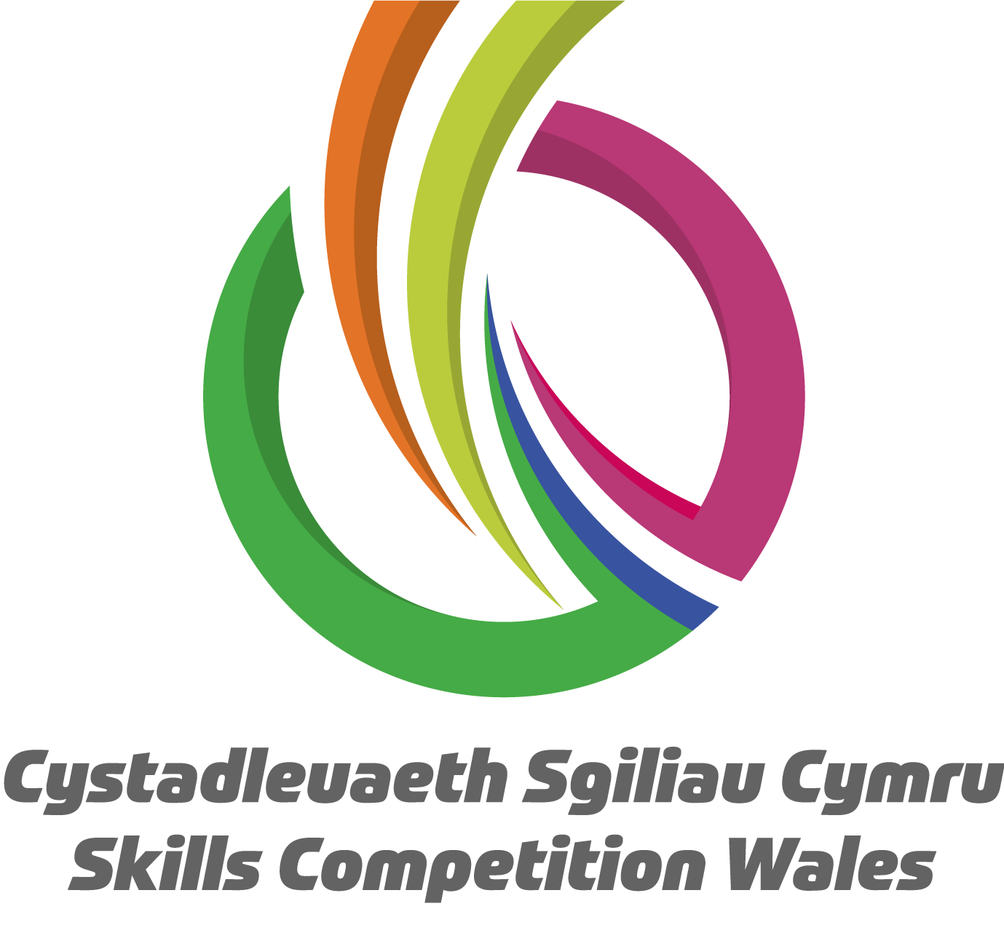

**Briff y Gystadleuaeth**

**Teitl y Gystadleuaeth**

Y Celfyddydau Perfformio

**Trosolwg o'r Gystadleuaeth**

Mae’r celfyddydau perfformio yn cynnwys ystod o ddisgyblaethau gaiff eu perfformio o flaen cynulleidfa fyw, ac yn eu plith ceir drama, cerddoriaeth a dawns.

Yn y gystadleuaeth hon, caiff y cystadleuwyr y cyfle i ddatblygu ac arddangos amrywiaeth o sgiliau perfformio sy’n hanfodol oddi mewn i ddiwydiannau’r Celfyddydau Perfformio.

**Meini Prawf Mynediad**

Mae'r gystadleuaeth ar gyfer y rhai sydd wedi cofrestru ar gwrs Celfyddydau Perfformio sy'n astudio hyd at gymhwyster lefel 3.

## Cyfyngiadau ar gapasiti mynediad fesul sefydliad

Gellir cofrestru uchafswm o hyd at **1 tîm fesul lleoliad.** Gall timau gynnwys rhwng 3 a 7 o gyfranogwyr. Gellir cofrestru **cronfeydd wrth gefn** hefyd i gyfrifon absenoldeb neu dynnu'n ôl os bydd angen

Os na fydd digon o gystadleuwyr, efallai y byddwn yn gofyn i un neu ddau o'r ymgeiswyr wrth gefn os hoffen nhw gymryd rhan. Ni fydd y penderfyniad hwn yn cael ei wneud tan ar ôl y dyddiad cau.

Dyma'r nifer uchaf o gynigion a ganiateir gan sefydliad ar gyfer y gystadleuaeth hon.

Mae hyn yn cael ei bennu gan ‘leoliad’ a ‘sefydliad’. Mae ‘sefydliad’ yn cyfeirio at ddarparwr hyfforddiant/cyflogwr y cystadleuwyr. Mae ‘lleoliad’ yn cyfeirio at safle lle mae’r cystadleuydd yn astudio / yn cael ei gyflogi.

Gall y gystadleuaeth hon fod yn destun proses ddethol os yw'r niferoedd cofrestru cystadleuwyr yn fwy na chapasiti'r lleoliad cynnal. Lle nodir bod capasiti ar gyfer y gystadleuaeth, gellir gwahodd cystadleuwyr wrth gefn i gystadlu.

Bydd y penderfyniad yn cael ei wneud yn dilyn ymgynghoriad rhwng Cystadleuaeth Sgiliau Cymru ac arweinydd y gystadleuaeth ar ôl i'r cofrestru gau. Bydd pob parti yn cael gwybod am unrhyw newidiadau.

I gael arweiniad pellach ar y galluoedd hyn, [cliciwch yma](https://inspiringskills.gov.wales/competitions/competition-registration-guide).

**Briff**

Y thema eleni fydd **‘Byd heb WIFI'’**

* Mae'n ofynnol i chi gydweithio i greu perfformiad sy'n para **hyd at 10 munud** **a dim mwy**.Rhaid i ddatblygiad a choreograffi hyn gael ei arwain gan y dysgwr.
* Bydd gofyn i chi gynhyrchu cofnod/ map meddwl o'ch proses a'ch datblygiad creadigol. Gellir cynhyrchu hyn mewn unrhyw fformat - Powerpoint/ Sleidiau Google/ Canva ac ati. **Mae angen argraffu hwn er mwyn ei roi i'r beirniaid**. Nid oes cyfleusterau argraffu na chyflwyno ar gael ar y diwrnod.
* Bydd gofyn i chi ateb cwestiynau gan y panel beirniadu am ddatblygiad eich perfformiad.
* Gall y perfformiad gyfuno testun neu gân sy'n bodoli eisoes gyda’i waith ei hun.
* Paratoi cofnod/map meddwl ysgrifenedig o'ch prosesau creadigol/datblygiad creadigol.
* Gall y perfformiad fod yn gymysgedd o’r tair disgyblaeth, sef dawnsio, canu ac actio – gall gynnwys un neu gyfuniad o’r uchod.
* Gall gynnwys cyfleoedd ar gyfer elfennau ensemble ac unigol fel ei gilydd.
* Rhaid i berfformwyr allu cario unrhyw bropiau i ac oddi ar y llwyfan, a hynny o fewn cyfanswm yr amser llwyfan a neilltuwyd.
* Bydd perfformiadau'n digwydd mewn cylch (theatr ar ffurf cylch). Cadwch hyn mewn cof wrth ddatblygu a llunio'ch cynhyrchiad.
* Bydd y gystadleuaeth yn cael ei chynnal ym Mhrifysgol Cymru, Caerfyrddin, ar 4 Chwefror 2026 (Aros am gadarnhad).
* 25 munud yw cyfanswm yr amser llwyfan. Bydd marciau’n cael eu tynnu am fynd dros yr amser a neilltuwyd. Rhaid hefyd ystyried amseroedd gosod a llwyfannu.
* Bydd cyfle i gystadleuwyr bleidleisio am eu hoff berfformiad a bydd yr enillwyr yn derbyn gwobr ‘Perfformiwr y Perfformwyr'. Sylwer: Ni fydd y canlyniad yn effeithio ar ganlyniadau'r gystadleuaeth go iawn a ryddheir pan fydd sicrwydd ansawdd wedi'i gymhwyso cyn rhyddhau'r canlyniad.

Mae briffiau cystadleuaeth flaenorol ar gael i'w gweld a'u llwytho o’r wefan Cystadleuaeth Sgiliau Cymru, [cliciwch yma](https://inspiringskills.gov.wales/competitions/performing-arts/archives) i gael mynediad iddynt.

**Rheolau’r Gystadleuaeth**

I gael y telerau ac amodau mynediad llawn a rheolau’r gystadleuaeth [ewch i](https://inspiringskills.gov.wales/terms/registrations-terms-and-conditions?lang=cy)

**Rheolau penodol y gystadleuaeth**

Uchafswm nifer y timau y gall pob sefydliad eu cofrestru i gymryd rhan yw tri a rhaid i’r timau gynnwys tri chystadleuydd. Bydd y tri thîm sy’n sgorio’r marciau uchaf yn ennill y wobr gyntaf, yr ail a’r drydedd wobr.

* Ni chaniateir gofyn cwestiynau i’r beirniaid os yw'n berthnasol i'r tasgau a roddwyd.
* Ni chaniateir symud unrhyw ddeunydd o ardal y gystadleuaeth oni nodir hynny’n benodol
* Dylid cydweithio a chyfathrebu'n effeithiol
* Bydd y gystadleuaeth yn cychwyn yn brydlon fel yr hysbysebwyd. Dim ond yn ôl disgresiwn y beirniaid y caiff unrhyw dîm sy’n cyrraedd yn hwyr gymryd rhan.
* Dylid diffodd ffonau symudol yn ystod gweithgaredd y gystadleuaeth.
* Dylid rhoi gwybod ar unwaith i'r panel beirniaid/aelod staff am unrhyw fethiant technegol mewn perthynas ag offer. Caiff amser ychwanegol ei neilltuo os yw'r nam y tu hwnt i reolaeth y cystadleuydd.

**Marcio ac Asesu**

| **Maen Prawf ID** | **Disgrifiad** | **Marciau Uchaf** |
| --- | --- | --- |
| **A** | **Cysyniad/Syniad**   * Dehongli'r briff * Syniad gwreiddiol | 5 |
| **B** | **Eglurder y neges**   * Eglurder a phwrpas ei nodau a'i amcanion arfaethedig * Adrodd stori - mae'r prosiect yn cynnig dechrau, canol a diwedd clir | 5 |
| **C** | **Crefft Llwyfan ac Ymwybyddiaeth**   * Agwedd a chyflwyniad, symudiad, cyflwyniad gweledol, cydbwyso'r llwyfan, rheoli amser. * Cysondeb egni a ffocws. | 5 |
| **D** | **Cywirdeb**   * Amseru, manwl gywirdeb, goslef, brawddegu, mynegiant. | 5 |
| **E** | **Cyfathrebu a Chyflwyno**   * Perthynas â'r gynulleidfa. * Cyflwyno clir a chlywadwy – taflu’r llais ac ynganiad. * Sgiliau Ensemble – undod fel grŵp a chefnogaeth i berfformiadau unigol oddi mewn i’r darn. | 5 |
|  | **Cyfanswm Marciau** | 25 |

**Adborth a Chydnabyddiaeth**

Darperir adborth llafar i Unigolion a Grwpiau ar ddiwedd y gystadleuaeth.

Ni chyhoeddir unrhyw ganlyniadau na gwobrau ar y diwrnod, gan y bydd ansawdd y marcio yn cael ei sicrhau.

Bydd pob cystadleuydd yn cael Tystysgrif Cyfranogi ar ddiwrnod y gystadleuaeth. Bydd gwobrau cyntaf, ail, trydydd a chanmoliaeth uchel yn cael eu cyhoeddi yn ystod y digwyddiad dathlu. Mae'r wobr canmoliaeth uchel yn cydnabod yr holl gystadleuwyr sydd wedi cyflawni sgôr uwch na'r cyfartaledd. Cynhelir y digwyddiad dathlu ar Dydd Mercher 18 Mawrth 2026, bydd manylion pellach yn cael eu rhoi i gystadleuwyr a'u pwyntiau cyswllt trwy e-bost.

Bydd taflenni marciau ar gael ar gais drwy info@skillscompetitionwales.ac.uk i gystadleuwyr ar ôl y digwyddiad dathlu.

**Arweinydd y Gystadleuaeth**

**Cysylltiadau Arweiniol:**

Am gyngor technegol am y gystadleuaeth cysylltwch â

**Darren Stokes**:

d.stokes@gllm.ac.uk

**Ymholiadau eraill**

Gwen Hartleb: [g.hartleb@gllm.ac.uk](mailto:g.hartleb@gllm.ac.uk)

**Ein partneriaid**

Mae'r gystadleuaeth hon yn cael ei chyflwyno mewn partneriaeth â

