**Competition Brief**

**Competition Title**

Painting & Decorating

**Competition Overview**

Painting and Decorating is one of the most in-demand construction trades. A Painter/Decorator must master a wide range of skills and techniques, ranging from house renovations to painting bridges, or maintaining historic buildings. They use a variety of systems to achieve the best results, and apply finishes such as stencils, colour glaze, graining, marbling and lettering.

In this competition, competitors have to complete a specific project designed to challenge their ability to follow detailed instructions, produce accurate and neat work outputs, be economical with materials while working to strict timescales and complying with Health and Safety – all essential requirements for today’s construction industry.

Live competition heats will be held at various venues across Wales.

**Entry Criteria**

The competition is for those training for a career in the Construction Industry and studying towards but not yet achieved a Level 3 qualification or apprenticeship.

Entrants must not have previously competed at any national finals.

Please ensure that your entrants have attempted the competition drawing and have the required skills and competences to complete the task.

**Entry capacity restrictions by organisation**  
Each organisation may register a **maximum of 4 competitors per location** for this competition. **Reserves** may also be registered to account for potential absences or withdrawals.

This is the maximum number of entries permitted by an organisation for this competition. This is determined by ‘location’ and ‘organisation’. ‘Organisation’ refers to the competitors’ training provider/employer. ‘Location’ refers to a site where the competitor studies / is employed.

This competition may be subject to a selection process if competitor registration numbers exceed the host venue capacity. Where capacity is identified in a competition the reserve competitors may be invited to compete.

The decision will be made following a consultation between Skills Competition Wales and the competition lead after registration closes. All parties will be notified of any changes.

For further guidance on these capacities, [click here](https://inspiringskills.gov.wales/competitions/competition-registration-guide).

**Task Duration**

6 Hours.

**Brief**

All competitors are expected to be able to follow drawings, measure accurately, effectively plan their time, demonstrate competence with tools and keep work stations clean and tidy.

Also, they will have to demonstrate the following skills:

* Hand/eye coordination
* Use of different types of materials
* Preparing surfaces
* The use of Frisk

Marks will be awarded based on the following criteria:

* Setting out
* Banding
* Finish
* Precision
* Application of materials
* Cleanliness of workmanship
* Showing awareness of Health & Safety

Previous competition briefs are available to view and download via the Skills Competition Wales website, please [click here](https://inspiringskills.gov.wales/competitions/painting-and-decorating/archives) to access.

**Infrastructure List**

Competitors are expected to bring their own tools. Paste tables, buckets for paste and waste, lint free rags, sponges and paint kettles will be available at the venue.

**Competition Rules**

For full terms and conditions of entry and competition rules [visit](https://inspiringskills.gov.wales/terms/registrations-terms-and-conditions).

**Generic competition rules**

* Mobile phones are to be switched off during competition activity.
* Listening to music via headphones is not permitted during competition activity.
* Any questions during competition activity should be addressed to the competition judging panel.
* Competitors should not communicate with other competitors during competition activity.
* It is the responsibility of each competitor to arrive on time for each competition session. No additional time will be allowed if you arrive late.
* Technical failure of your equipment should be reported immediately to the judging panel. Additional time will be allocated if the fault is beyond the control of the competitor.

**Marking and Assessment**

Marking and judging of this competition will be done by a team of experts from industry, further education or training providers, using a marking criteria and allocated marks to ensure consistency.

All marks are objective and will be awarded by the judges as follows. Task 1 equates to 65% of the overall mark and Task 2 equates to 35%. Please see below a brief breakdown of marking and assessment.

Breakdown of marking and assessment.

|  | **Criteria** | **Marks** |
| --- | --- | --- |
| A | Setting out measurements | 20% |
| B | Setting out and decorating - stencils | 15% |
| C | Decorating - all circles | 28% |
| D | Wallpapering | 12% |
| E | Neatness of Workmanship | 5% |
| F | Health & Safety | 5% |
| G | Speed Test | 15% |
|  | **Total** | **100%** |

**Feedback and Recognition**

Individual and Group verbal feedback will be provided at the end of the competition.

No results or awards will be awarded on the day as marking will be quality assured.

All competitors will be issued with a Participation Certificate on the competition day. First, second, third and highly commended awards will be announced during the celebration event. The highly commended award recognises all competitors who have achieved above average. The celebration event will be held on Wednesday 18th March 2026, further details will be communicated to competitors and their points of contact by email.

Marksheets will be available upon request via [info@skillscompetitionwales.ac.uk](mailto:info@skillscompetitionwales.ac.uk) to competitors after the celebration event.

**Competition Lead**

**Lead Contact:** Lewis Jones

Email address - [LJones1@merthyr.ac.uk](mailto:LJones1@merthyr.ac.uk)

**Our partners**

This competition is delivered in partnership with

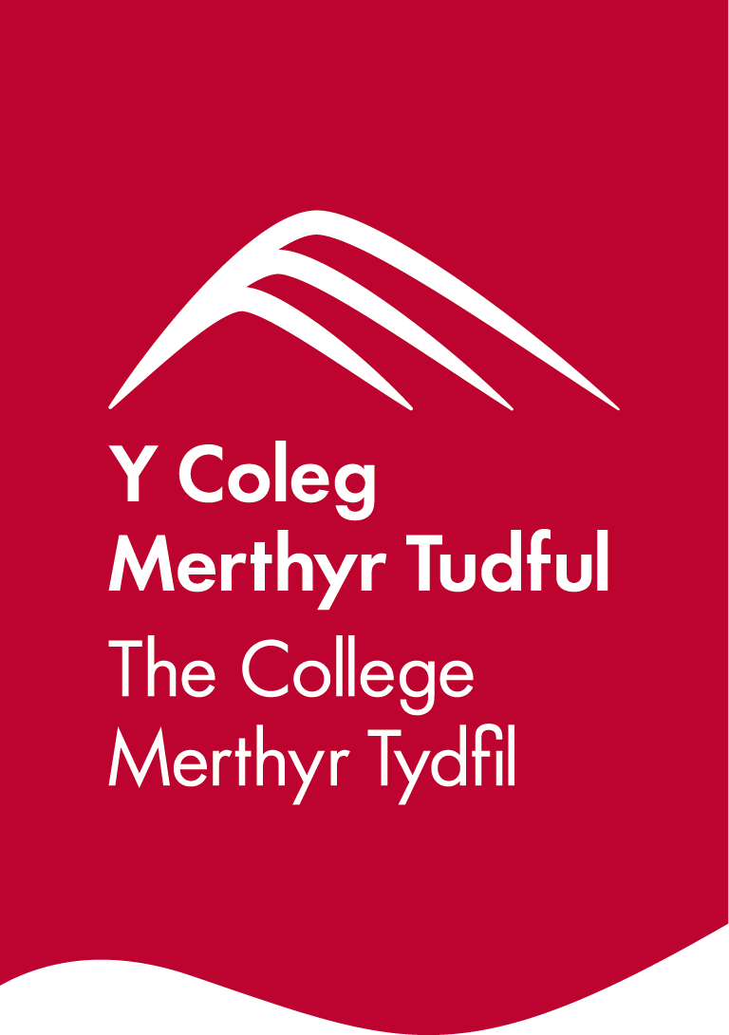

**Briff y gystadleuaeth**

**Teitl y gystadleuaeth**

Paentio ac addurno

**Trosolwg o'r gystadleuaeth**

Paentio ac addurno yw un o'r crefftau adeiladu y mae’r mwyaf o alw amdani. Mae'n rhaid i Beintiwr/Addurnwr feistroli amrywiaeth eang o sgiliau a thechnegau, sy’n amrywio o adnewyddu tai i beintio pontydd, neu gynnal a chadw adeiladau hanesyddol. Mae’n defnyddio amrywiaeth o systemau i gyflawni'r canlyniadau gorau, ac yn defnyddio gorffeniadau fel stensiliau, sglein lliw, graenio, marblo a llythrennu.

Yn y gystadleuaeth hon, mae'n rhaid i gystadleuwyr gwblhau prosiect penodol a gynlluniwyd i herio eu gallu i ddilyn cyfarwyddiadau manwl, cynhyrchu gwaith cywir a thaclus, bod yn ddarbodus gyda deunyddiau wrth weithio i amserlenni caeth – gofynion hanfodol ar gyfer y diwydiant adeiladu heddiw. Bydd y cystadleuydd yn cael ei farcio ar Iechyd a Diogelwch.

Cynhelir rowndiau rhagbrofol byw mewn sawl lleoliad ledled Cymru.

**Meini prawf mynediad**

Mae’r gystadleuaeth hon ar gyfer y rheini sy’n hyfforddi ar gyfer gyrfa yn y diwydiant adeiladu ac sy’n astudio tuag at gymhwyster Lefel 3 neu brentisiaeth ond nad ydynt eto wedi’u cyflawni.

Gwnewch yn siŵr bod eich ymgeiswyr wedi rhoi tro ar y gystadleuaeth ac fod ganddyn nhw’r sgiliau a'r cymwyseddau angenrheidiol i gwblhau'r dasg.

**Cyfyngiadau capasiti mynediad yn ôl sefydliad**

Gall pob sefydliad gofrestru **uchafswm o 4 cystadleuydd ym mhob lleoliad** ar gyfer y gystadleuaeth hon. Gellir cofrestru **cronfeydd wrth gefn** hefyd i gyfrifon absenoldeb neu dynnu'n ôl os bydd ange.

Dyma'r nifer mwyaf o geisiadau a ganiateir gan sefydliad ar gyfer y gystadleuaeth hon.

Penderfynir ar hyn yn ôl 'lleoliad' a 'sefydliad'. Mae 'sefydliad' yn cyfeirio at ddarparwr hyfforddiant/cyflogwr y cystadleuwyr. Mae 'lleoliad' yn cyfeirio at safle lle mae'r cystadleuydd yn astudio/cael ei gyflogi.

Gall y gystadleuaeth hon fod yn destun proses ddethol os yw'r niferoedd cofrestru cystadleuwyr yn fwy na chapasiti'r lleoliad cynnal. Lle nodir bod capasiti ar gyfer y gystadleuaeth, gellir gwahodd cystadleuwyr wrth gefn i gystadlu.

Bydd y penderfyniad yn cael ei wneud yn dilyn ymgynghoriad rhwng Cystadleuaeth Sgiliau Cymru ac arweinydd y gystadleuaeth ar ôl i'r cofrestru gau. Bydd pob parti yn cael gwybod am unrhyw newidiadau.

I gael rhagor o arweiniad ar y galluoedd hyn, [cliciwch yma](https://inspiringskills.gov.wales/competitions/competition-registration-guide).

**Hyd y dasg**

6 awr.

**Briff**

Disgwylir i bob cystadleuydd allu dilyn lluniau, mesur yn gywir, cynllunio eu hamser yn effeithiol, dangos cymhwysedd gydag offer a chadw gorsafoedd gwaith yn lân ac yn daclus.

Hefyd, bydd yn rhaid iddynt ddangos y sgiliau canlynol:

● Cydsymud llaw/llygad

● Defnyddio gwahanol fathau o ddefnyddiau

● Paratoi arwynebau

* Y defnydd o Frisk

Dyfernir marciau yn seiliedig ar y meini prawf canlynol :

● Gosod

● Bandio

● Gorffen

● Manylder

● Defnyddio deunyddiau

● Glendid crefftwaith

● Dangos ymwybyddiaeth o Iechyd a Diogelwch

Mae briffiau cystadleuaeth flaenorol ar gael i'w gweld a'u llwytho o’r wefan Cystadleuaeth Sgiliau Cymru, [cliciwch yma](https://inspiringskills.gov.wales/competitions/painting-and-decorating/archives) i gael mynediad iddynt.

**Rhestr seilwaith**

Disgwylir i gystadleuwyr ddod â'u hoffer eu hunain. Bydd byrddau pastio, bwcedi ar gyfer past a gwastraff, cadachau heb lint, sbyngau a thegellau paent ar gael yn y lleoliad.

**Rheolau cystadlu**

Am y telerau ac amodau mynediad llawn a rheolau cystadlu [ewch i](https://inspiringskills.gov.wales/terms/registrations-terms-and-conditions?lang=cy).

**Rheolau cystadlu cyffredinol**

* Mae’n rhaid diffodd ffonau symudol yn ystod gweithgareddau cystadlu.
* Ni chaniateir gwrando ar gerddoriaeth drwy glustffonau yn ystod gweithgareddau cystadlu.
* Dylid cyfeirio unrhyw gwestiynau yn ystod gweithgareddau cystadlu at banel beirniadu’r gystadleuaeth.
* Ni ddylai cystadleuwyr gyfathrebu â chystadleuwyr eraill yn ystod gweithgareddau cystadlu.
* Cyfrifoldeb pob cystadleuydd yw cyrraedd yr amser ar gyfer pob sesiwn cystadlu. Ni chaniateir amser ychwanegol os byddwch yn cyrraedd yn hwyr.
* Dylech roi gwybod i'r panel beirniadu ar unwaith am unrhyw fethiant technegol yn eich offer. Bydd amser ychwanegol yn cael ei neilltuo os yw'r nam y tu hwnt i reolaeth y cystadleuydd.

**Marcio ac asesu**

Caiff y gwaith o farcio a beirniadu'r gystadleuaeth hon ei wneud gan dîm o arbenigwyr o'r Diwydiant, Addysg Bellach neu Ddarparwr Hyfforddiant, gan ddefnyddio meini prawf marcio a marciau wedi'u dyrannu i sicrhau cysondeb.

Mae'r holl farciau yn wrthrychol a byddant yn cael eu dyfarnu gan y beirniaid fel a ganlyn. Mae Tasg 1 yn cyfateb i 65% o'r marc cyffredinol ac mae Tasg 2 yn cyfateb i 35%. Gweler isod ddadansoddiad byr o'r marcio a'r asesu.

Dadansoddiad byr o farcio ac asesu.

| A | Gosod mesuriadau | 20% |
| --- | --- | --- |
| B | Gosod ac addurno – stensiliau | 15% |
| C | Addurno – pob cylch | 28% |
| D | Papuro | 12% |
| E | Taclusrwydd eu gwaith | 5% |
| F | Iechyd a Diogelwch | 5% |
| G | Prawf Cyflymder | 15% |
|  | **Cyfanswm** | **100%** |

**Adborth a Chydnabyddiaeth**

Bydd adborth llafar Unigol a Grŵp yn cael ei roi ar ddiwedd y gystadleuaeth. Ni roddir canlyniadau na gwobrau ar y diwrnod gan y bydd ansawdd y marcio yn cael ei sicrhau.

Bydd pob cystadleuydd yn cael Tystysgrif Cyfranogi ar ddiwrnod y gystadleuaeth. Bydd gwobrau cyntaf, ail, trydydd a chanmoliaeth uchel yn cael eu cyhoeddi yn ystod y digwyddiad dathlu. Mae'r wobr canmoliaeth uchel yn cydnabod yr holl gystadleuwyr sydd wedi cyflawni sgôr uwch na'r cyfartaledd. Cynhelir y digwyddiad dathlu ar Dydd Mercher 18 Mawrth 2026, bydd manylion pellach yn cael eu rhoi i gystadleuwyr a'u pwyntiau cyswllt trwy e-bost.

Bydd taflenni marciau ar gael ar gais drwy info@skillscompetitionwales.ac.uk i gystadleuwyr ar ôl y digwyddiad dathlu.

**Arweinydd y Gystadleuaeth**

**Prif Gyswllt:**Lewis Jones

Email address - [LJones1@merthyr.ac.uk](mailto:LJones1@merthyr.ac.uk)

**Ein partneriaid**

Mae'r gystadleuaeth hon yn cael ei chyflwyno mewn partneriaeth â

