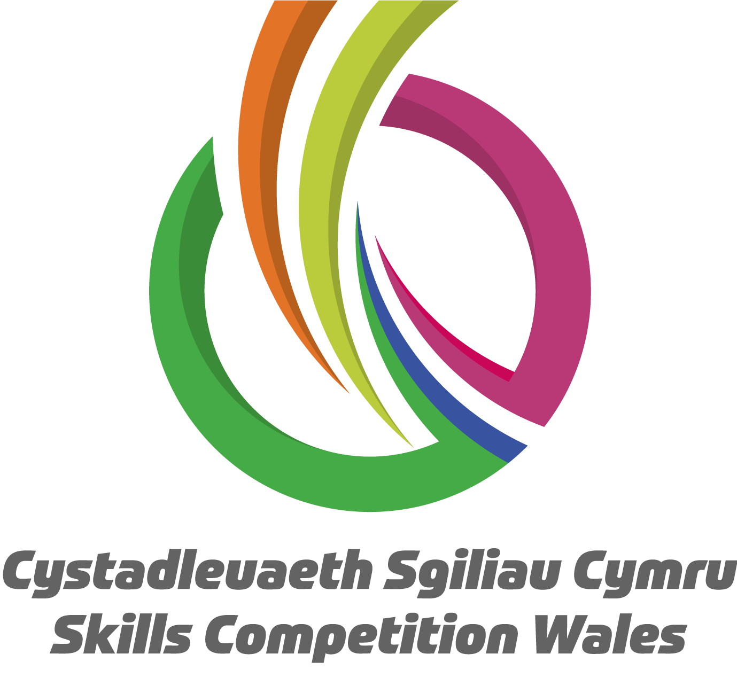

Renewable Energy 2024 Pre Competition Resources

Please find below the links to access documents you will need prior to the Renewable Energy Competition.

- Practice Competition - Welsh
- Practice Competition - English
- Renewable Energy Video - Welsh
- Renewable Energy Video - English
- Renewable Energy Power Point

