**Competition Brief**

**Competition Title**

Light Vehicle Automotive Technology

**Competition Overview**

Light Vehicle Automotive Technicians require a wide variety of specialised skills. They carry out inspections and maintenance on cars and light vans, test vehicle systems and diagnose faults, as well as advise customers on repair work. They are responsible for producing estimates and maintaining service and maintenance records. Today’s technicians use a range of equipment to assist them in their role, from advanced diagnostics to the more traditional spanner and wrench.

In this competition, competitors will be assessed on their skills, knowledge and abilities against current industry standards and working practices. They will need to demonstrate good time management, problem solving and planning skills, as well as prove their ability to collect and analyse information and apply logical techniques to solve problems.

**Entry Criteria**

This competition is for those training for a career in the Automotive Industry and studying towards a Level 2 - 3 qualification or apprenticeship.

Please ensure your entrants have the skills and competencies to complete the task.

**Entry capacity restrictions by organisation**

Maximum of up to 6 per location.

This is the maximum number of entries permitted by an organisation for this competition. This is determined by ‘location’ and ‘organisation’. ‘Organisation’ refers to the competitors’ training provider/employer. ‘Location’ refers to a site where the competitor studies / is employed. For further guidance on these capacities, click [here](https://www.skillscompetitionwales.ac.uk/terms/entry-capacity-restrictions-by-organisation) 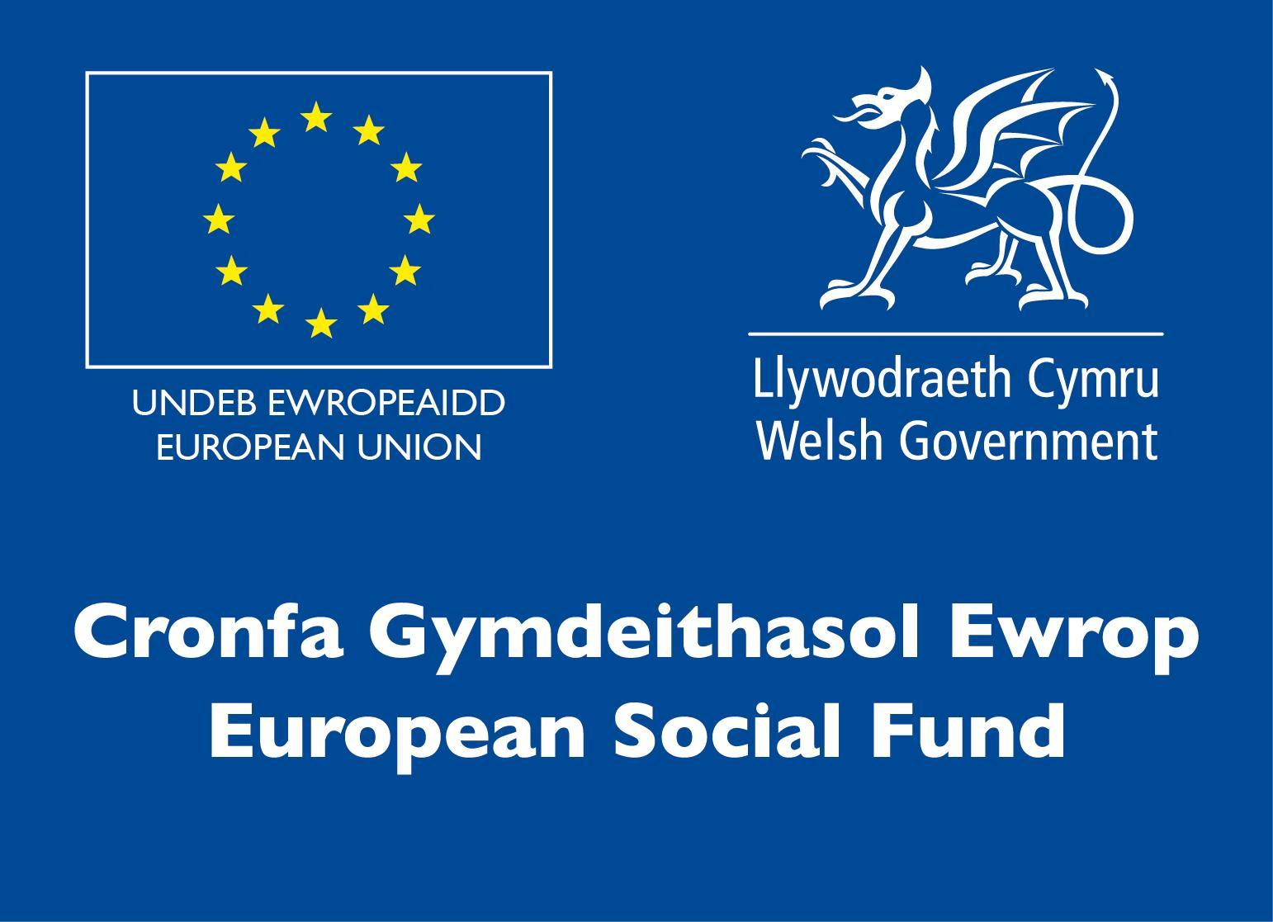

**Brief**

The Competition consists of five practical tasks in the areas below:

• Electrical

• Transmission

• Brakes

• Engine

• Inspection

Each task is 45 minutes and will be timetabled through the day; there will usually be down time in between tasks for refreshments. For further information please refer to the Skills Competition Wales website.

Due to the current situation these tasks will be conducted at your own college and will be judged by your tutors. After completing these tasks the marking sheets will need to be provided to the Competition Lead, the results will then be collated.

The Final part of the competition will involve the top two competitors from each college competing on an online platform. These tasks will be a combination of questions and fault simulations, the top three from this stage will be awarded gold silver and bronze.

*The online platform for the final part of the competition will be through Electude. Shortly after registration competitors will receive access to the online platform for familiarisation.*

**Infrastructure List**

All Equipment needed to complete the task will be available at the competition venue.

**Competition Rules**

For full terms and conditions of entry and competition rules visit [www.skillscompetitionwales.ac.uk/terms-and-conditions](http://www.skillscompetitionwales.ac.uk/terms-and-conditions)

**Competition specific rules**

The competitor who is awarded 1st overall will automatically gain a place in the UK regional without having to do the online test. Please note that this is for automotive competitions only.

**Generic competition rules**

• Mobile phones are to be switched off during competition activity.

• Listening to music via headphones is not permitted during competition activity.

• Any questions during competition activity should be addressed to the competition judging panel.

• Competitors should not communicate with other competitors during competition activity.

• It is the responsibility of each competitor to arrive on time for each competition session. No additional time will be allowed if you arrive late.

• Technical failure of your equipment should be reported immediately to the judging panel. Additional time will be allocated if the fault is beyond the control of the competitor.

**Marking and Assessment**

Marking and judging of this competition will be done by a team of experts from Industry, Further Education or Training Provider, using a marking criteria and allocated marks to ensure consistency; at least 1 marker will attend all regionals.

Brief breakdown of marking and assessment.

|  |  |  |
| --- | --- | --- |
| A | Health & Safety | 15% |
| B | Interpreting Manufacturers Data | 10% |
| C | Correct Completion of Task | 60% |
| D | Knowledge Questions | 15% |
|  | Total | 100% |

**Feedback and Recognition**

Individual and Group verbal feedback will be provided at the end of the competition.

No results or awards will be awarded on the day, as marking will be quality assured.

Certificates of Participation will be issued on the day.

Medallists will be invited to a Celebration Event which will be held in March 2021, where the First, Second and Third Awards will be presented.

Marksheets will be made available to unsuccessful competitors after the quality assurance process has been completed. Further details will be provided to all competitors upon notification of outcomes.

**Competition Lead**

**Lead Contact**

Robert Morse

[robert.morse@coleggwent.ac.uk](mailto:robert.morse@coleggwent.ac.uk)

01633 466091

**Briff y Gystadleuaeth**

**Teitl y Gystadleuaeth**

Technoleg Fodurol Cerbydau Ysgafn

**Trosolwg o'r gystadleuaeth**

Mae angen amrywiaeth eang o sgiliau arbenigol ar dechnegwyr Modurol Cerbydau Ysgafn. Maen nhw’n cynnal archwiliadau a gwaith cynnal a chadw ar geir a faniau ysgafn, yn profi systemau cerbydau ac yn dadansoddi diffygion, yn ogystal â chynghori cwsmeriaid ynglŷn â gwaith trwsio. Maen nhw’n gyfrifol am gynhyrchu amcangyfrifon a chynnal cofnodion gwasanaethau a chynnal a chadw. Mae technegwyr heddiw yn defnyddio amrywiaeth eang o offer i’w cynorthwyo yn eu gwaith, o ddiagnosteg uwch i’r sbaner a thyndro mwy traddodiadol.

Yn y gystadleuaeth hon, caiff cystadleuwyr eu hasesu ar eu sgiliau, gwybodaeth a gallu yn erbyn safonau diwydiannol ac arferion gwaith cyfredol. Bydd angen iddyn nhw arddangos eu bod yn gallu rheoli eu hamser, datrys problemau a bod ganddyn nhw sgiliau cynllunio da yn ogystal â phrofi eu gallu i gasglu a dadansoddi gwybodaeth a defnyddio technegau rhesymegol i ddatrys problemau.

**Meini Prawf**

Mae’r gystadleuaeth hon ar gyfer y rhai hynny sy’n hyfforddi ar gyfer gyrfa yn y Diwydiant Modurol ac yn astudio ar gyfer cymhwyster Lefel 2-3 neu brentisiaeth.

Gwnewch yn siŵr fod gan eich ymgeiswyr y sgiliau a’r gallu i gyflawni’r dasg.

**Cyfyngiadau ymgeisio gan sefydliad**

Cyfanswm o hyd at 6 i bob lleoliad.

Dyma’r mwyafswm o gystadleuwyr a ganiateir gan sefydliad ar gyfer y gystadleuaeth hon.



Caiff hyn ei benderfynu ar sail ‘lleoliad’ a ‘sefydliad’. Mae ‘sefydliad’ yn cyfeirio at ddarparwr hyfforddiant/cyflogwr y cystadleuwyr. Mae ‘lleoliad’ yn cyfeirio at y safle lle mae’r cystadleuydd yn astudio/cael ei gyflogi. Am ragor o arweiniad ar y canllawiau hyn, cliciwch yma <https://www.skillscompetitionwales.ac.uk/terms/entry-capacity-restrictions-by-organisation>

**Briff**

Mae’r gystadleuaeth yn cynnwys 5 tasg ymarferol yn y meysydd isod:

• Trydanol

• Trawsyrru (*Transmission*)

• Brêcs

• Injan

• Archwilio

Mae pob tasg yn 45 munud o hyd a bydd amserlen ar eu cyfer drwy’r dydd; fel arfer bydd amser rhydd rhwng pob tasg er mwyn cael bwyd a diod. Am ragor o wybodaeth ewch i wefan Cystadleuaeth Sgiliau Cymru.

Oherwydd y sefyllfa bresennol, bydd tasgau hyn yn cael eu cynnal yn eich coleg eich hun a bydd yn cael ei beirniadu gan eich tiwtoriaid. Ar ôl cwblhau'r tasgau hyn bydd angen llwytho taflenni marcio, bydd y canlyniadau wedyn yn cael eu coladu.

Bydd rhan olaf y gystadleuaeth yn cynnwys y ddau gystadleuydd gorau o bob coleg yn cystadlu ar blatfform ar-lein. Bydd y tasgau hyn yn gyfuniad o gwestiynau ac efelychiadau o ddiffygion, bydd y tri uchaf o'r cam hwn yn cael arian aur ac efydd.

**Rhestr Seilwaith**

Bydd yr holl offer sydd ei angen i gyflawni’r dasg gar gael yn lleoliad y gystadleuaeth.

**Rheolau’r Gystadleuaeth**

I weld y telerau ac amodau cystadlu a rheolau’r gystadleuaeth ewch i: www.skillscompetitionwales.ac.uk/terms-and-conditions <http://www.skillscompetitionwales.ac.uk/terms-and-conditions>

**Rheolau penodol ar gyfer y gystadleuaeth hon**

Bydd y cystadleuydd sy’n fuddugol yn ennill lle yn rownd ranbarthol y DU heb orfod gwneud y prawf ar-lein. Sylwch mai ar gyfer cystadlaethau modurol yn unig y mae hyn.

**Rheolau cyffredinol**

• Rhaid diffodd ffonau symudol yn ystod y gystadleuaeth ei hun.

• Ni chaniateir gwrando ar gerddoriaeth drwy glustffonau yn ystod y gystadleuaeth ei hun.

• Dylid cyfeirio unrhyw gwestiynau yn ystod gweithgaredd y gystadleuaeth i banel beirniadu’r gystadleuaeth.

• Ni ddylai cystadleuwyr gyfathrebu gyda chystadleuwyr eraill yn ystod y gystadleuaeth ei hun.

• Cyfrifoldeb pob cystadleuydd yw cyrraedd ar amser ar gyfer pob sesiwn gystadlu. Ni chaniateir rhagor o amser os byddwch yn cyrraedd yn hwyr.

• Dylid adrodd am unrhyw fethiant technegol yn eich offer ar unwaith i’r panel beirniadu. Caiff y cystadleuydd amser ychwanegol os yw’r nam y tu hwnt i’w reolaeth.

**Marcio ac Asesu**

Bydd tîm o arbenigwyr yn y byd Diwydiant, Addysg Bellach neu Ddarparwr Hyfforddiant yn marcio a beirniadu’r gystadleuaeth hon a byddant yn defnyddio meini prawf marcio a marciau sydd wedi eu pennu er mwyn sicrhau cysondeb; bydd o leiaf 1 marciwr yn mynychu pob rownd ranbarthol.

Dadansoddiad cryno o’r marcio ac asesu.

|  |  |  |
| --- | --- | --- |
| A | Iechyd a Diogelwch | 15% |
| B | Dehongli Data Gwneuthurwyr | 10% |
| C | Cwblhau Tasg yn Gywir | 60% |
| Ch | Cwestiynau Gwybodaeth | 15% |
|  | Cyfanswm | 100% |

**Adborth a Chydnabyddiaeth**

Bydd adborth ar lafar yn cael ei roi i Unigolion a Grwpiau ar ddiwedd y gystadleuaeth.

Ni chaiff unrhyw ganlyniadau na dyfarniadau eu cyflwyno ar y diwrnod gan y byddwn yn marcio drwy sicrhau ansawdd.

Caiff Tystysgrifau Cyfranogi eu cyflwyno ar y dydd.

Bydd enillwyr yn cael eu gwahodd i Ddigwyddiad Dathlu a gaiff ei gynnal ym mis Mawrth 2021, lle caiff y Gwobrau ar gyfer y Cyntaf, Ail a Thrydedd eu cyflwyno.

Bydd taflenni marcio ar gael i gystadleuwyr aflwyddiannus ar ôl i’r broses sicrhau ansawdd gael ei chwblhau. Caiff manylion pellach eu darparu i bob cystadleuydd ar ôl iddyn nhw gael gwybod beth yw’r canlyniadau.

**Arweinydd y Gystadleuaeth**

**Prif Gyswllt**:

Robert Morse

robert.morse@coleggwent.ac.uk

01633 466091