**Competition Brief**

**Competition Title**

Laboratory Technician

**Competition Overview**

Laboratory Technicians have specialist skills that allow them to work in a wide range of organisations, including chemical, biomedical, pharmaceutical, biotechnology and other industries in educational institutions. They are able to work within a laboratory team but also individually, taking responsibility for the quality and accuracy of the undertaken work.

In this competition, competitors will be assessed on the skills and abilities of technicians entering the field of laboratory technology in science. They are expected to have a core set of technical skills and abilities that they would like to demonstrate in a competitive environment and further develop through competition.

Competitors taking part in this competition should demonstrate their abilities in:

• Reading and application of technical documents such as instructions related to analysis or procedures, formulations and specifications of substances, diagrams and manuals for equipment.

• Handling of the laboratory devices, apparatus and equipment to be used, also handling of the chemicals used in laboratories by implementing safety data sheets and the measures and procedures to be derived from them.

• Preparation and processing of samples as well as separation processes for mixtures of liquids and solids.

• Performance of cleaning and concentration processes such as centrifugation, distillation, extraction, evaporation and crystallisation.

• Determination of physical parameters and matter constants such as temperature, density, pH value, refraction index, melting point and conductivity.

• Application of titrimetric and gravimetric methods.

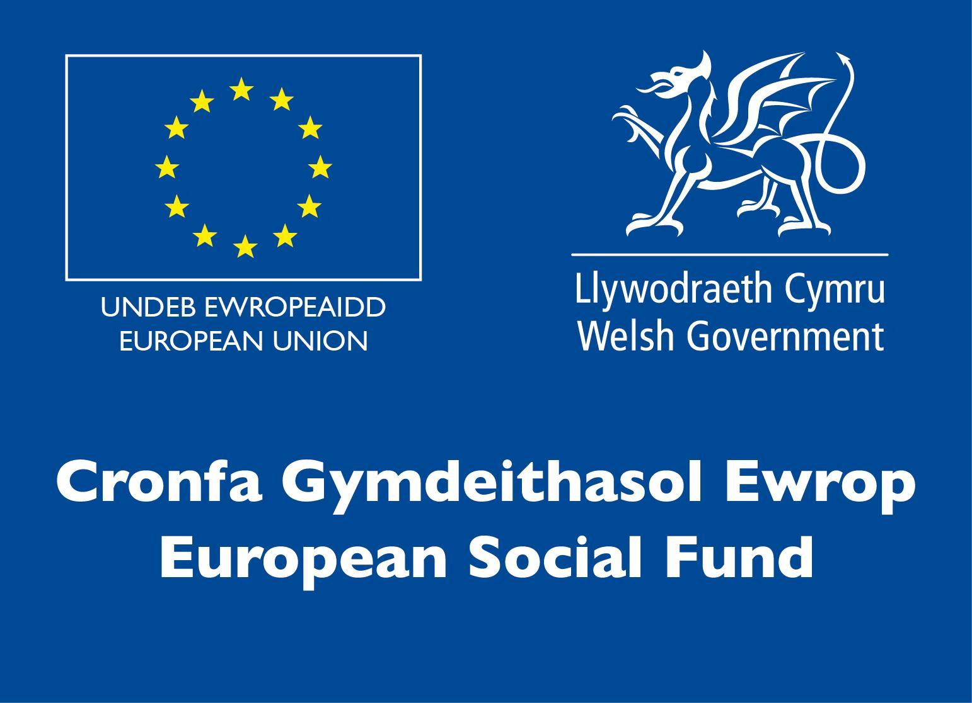• Application of instrumental and electroanalytical methods such as Spectrophotometry, Chromatography, Potentiometry and Conductometry.

• Logging, graphic evaluation and interpretation of the results of work and their documentation by using IT and statistical methods.

• Performance of work taking into consideration relevant norms as well as quality, safety and environmental standards.

• Appropriate written and oral command of language and specialist terminology as well as use of job-related foreign languages.

This competition takes 2.5 hours (including Health & Safety brief and report writing).

**Entry Criteria**

The competition is for those training for a career in Laboratory Science/Chemistry, and studying toward a Level 3 qualification, or relevant HE Degree (e.g. BSc Chemistry).

## Please ensure your entrants have the skills and competencies to complete the task.

## Entry capacity restrictions by organisation

Maximum of up to 3 per organisation.

This is the maximum number of entries permitted by an organisation for this competition.

This is determined by ‘location’ and ‘organisation’. ‘Organisation’ refers to the competitors’ training provider/employer. ‘Location’ refers to a site where the competitor studies / is employed. For further guidance on these capacities, click [here](https://www.skillscompetitionwales.ac.uk/terms/entry-capacity-restrictions-by-organisation)

**Brief**

This competition consists of a laboratory practical task that will be issued at the venue on the day. Competitors will be provided with instructions for the experimental or analytical task and all materials required.

Competitors are expected to risk assess the activity and communicate this in writing or verbally. Data analysis and reporting on results forms part of the assessment but the main focus lies in the practical skills and ability to carry out experimental or analytical laboratory work in an independent, safe and efficient manner.

**Infrastructure List**

You will be provided with all the required PPE, equipment and materials needed for the tasks.

Computers, any specific software and other IT will also be provided if necessary. You will also be provided with a notebook and essential stationary.

You may, but don’t have to, bring the following items:

• Your own (company branded) lab coat (must be clean!).

• Your own goggles (essential if you wear goggles with eye corrections).

• A scientific calculator (not mobile phone app, no formulae etc. on the cover).

• Your own stationary.

Competitors will not be permitted to use the following during the competition:

• Mobile phones or any other devices with internet access (permitted during lunch break).

• Headphones.

Safe storage space or lockers for personal items, coats, bags, etc. that are not permitted in the laboratory will be provided, however space may be limited.

If you have any allergies, e.g. to gloves, please advise the organisers well in advance so that they can arrange alternatives or grant permission for you to bring your own. It is at the discretion of the laboratory manager and lead judge to disallow competitors from entering the laboratory or exclude them from the competition, for example for any serious breaches of laboratory safety or inadequate clothing (e.g. flip-flops), or if there are health concerns.

**Competition Rules**

For full terms and conditions of entry and competition rules visit [www.inspiringskills.gov.wales/terms-and-conditions](http://www.skillscompetitionwales.ac.uk/terms-and-conditions)

**Generic competition rules:**

• Mobile phones are to be switched off during competition activity.

• Listening to music via headphones is not permitted during competition activity.

• Any questions during competition activity should be addressed to the competition judging panel.

• Competitors should not communicate with other competitors during competition activity.

• It is the responsibility of each competitor to arrive on time for each competition session. No additional time will be allowed if you arrive late.

• failure of your equipment should be reported immediately to the judging panel. Additional time will be allocated if the fault is beyond the control of the competitor.

**Marking and Assessment**

Marking and judging of this competition will be done by a team of experts from Industry, Higher / Further Education or Training Provider, using a marking criteria and allocated marks to ensure consistency.

**Brief breakdown of marking and assessment**

All marks are objective and will be awarded by the judges as follows

|  |  |
| --- | --- |
| Work organisation and management | 10% |
| Communication and interpersonal skills | 10% |
| Techniques, procedures and methods | 35% |
| Data processing and record keeping | 15% |
| Analysis , interpretation and evaluation | 10% |
| Problem solving through scientific methods | 10% |
| Trends in applied science | 10% |
| Total | 100% |

**Feedback and Recognition**

Individual and Group verbal feedback will be provided at the end of the competition.

No results or awards will be awarded on the day as marking will be quality assured.

All competitors will be issued with a Participation Certificate and invited to an online Celebration Event which will be held Thursday 17th March 2022, where the First, Second and Third Awards will be announced. Further details will be communicated to competitors and their points of contacts by email.

Marksheets will be made available to competitors after the quality assurance process has been completed.

**Competition Lead**

**Lead Contact and Expert Contact**

Dr Amy Herbert

amy.herbert@gowercollegeswansea.ac.uk

**Briff y Gystadleuaeth**

**Teitl y Gystadleuaeth**

Technegydd Labordy

**Trosolwg o’r Gystadleuaeth**

Mae gan Dechnegwyr Labordy sgiliau arbenigol sy'n eu galluogi i weithio mewn amrywiaeth o sefydliadau, gan gynnwys y diwydiannau cemegol, biofeddygol, fferyllol, biotechnoleg a diwydiannau eraill mewn sefydliadau addysgol. Maen nhw’n gallu gweithio fel aelod o dîm labordy neu fel unigolyn, gan gymryd cyfrifoldeb am ansawdd a chywirdeb y gwaith sy’n cael ei wneud.  
  
Yn y gystadleuaeth hon, bydd cystadleuwyr yn cael eu hasesu ar sail eu sgiliau a’u gallu fel technegwyr sy’n camu i faes gwyddonol technoleg labordy. Disgwylir iddyn nhw fod â set graidd o sgiliau a gallu technegol yr hoffen nhw eu dangos mewn sefyllfa gystadleuol a meithrin eu sgiliau ymhellach drwy gystadlu.

Dylai cystadleuwyr sy’n cymryd rhan yn gystadleuaeth hon arddangos eu galluoedd:

• Darllen a defnyddio dogfennau technegol megis cyfarwyddiadau sy’n ymwneud â dadansoddi neu weithdrefnau, fformwleiddiadau a manylion sylweddau, diagramau a llawlyfrau offer.

• Trin y dyfeisiau, cyfarpar ac offer labordy a ddefnyddir, yn ogystal â thrin y cemegion a ddefnyddir mewn labordai drwy ddefnyddio taflenni data diogelwch a’r mesurau a’r gweithdrefnau sy’n deillio ohonynt.

• Paratoi a phrosesu samplau yn ogystal â phrosesau gwahanu ar gyfer cymysgeddau o hylifau a solidau.

• Ymgymryd â phrosesau glanhau a chrynodi fel allgyrchu, distyllu, echdynnu, anweddu a chrisialu.

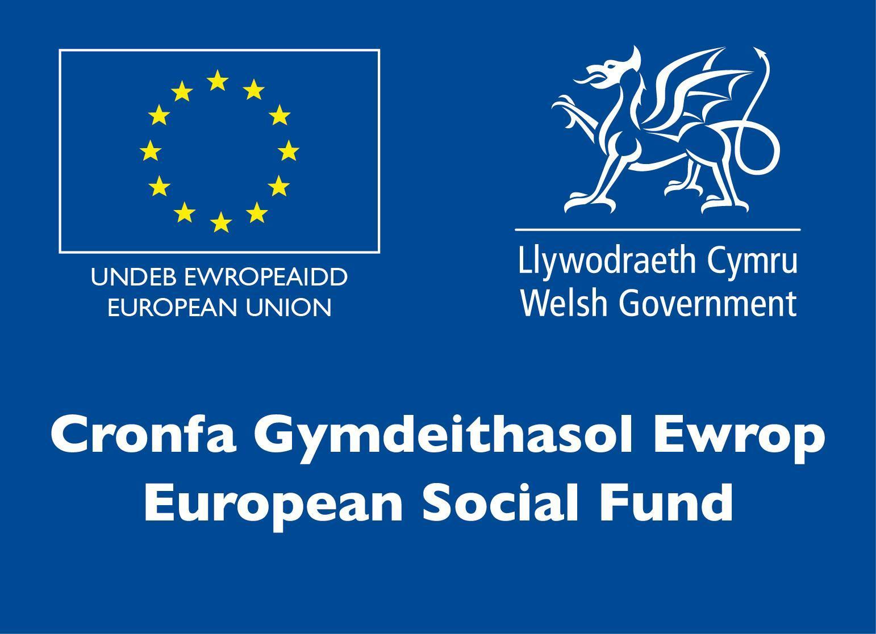• Penderfynu ar baramedrau ffisegol a chysonion mater megis tymheredd, dwysedd, gwerth pH, indecs plygiant, pwynt toddi a dargludedd.

• Defnyddio dulliau titradaethol a grafimetrig.

• Defnyddio dulliau offerynnol ac electroddadansoddol megis Sbectroffotometreg, Cromatograffi, Potensiometreg a Dargludometreg.

• Cofnodi, gwerthuso graffig a dehongli canlyniadau gwaith a’u dogfennu gan ddefnyddio dulliau TG ac ystadegol.

• Cyflawni gwaith gan ystyried normau perthnasol yn ogystal ag ansawdd, diogelwch a safonau amgylcheddol.

• Defnyddio iaith lafar ac ysgrifenedig briodol a therminoleg arbenigol yn ogystal â thermau o ieithoedd eraill sy’n ymwneud â’r gwaith.

Mae’r gystadleuaeth hon yn para 2.5 awr (sy’n cynnwys sesiwn briffio Iechyd a Diogelwch ac ysgrifennu adroddiad).

**Meini Prawf Cystadlu**

Mae’r gystadleuaeth hon ar gyfer y rheini sy’n hyfforddi am yrfa ym maes Technoleg Labordy Gwyddoniaeth/Cemeg, ac sy’n astudio tuag at gymhwyster Lefel 3, neu Radd Addysg Uwch berthnasol (e.e. BSc Cemeg).

Sicrhewch fod gan eich ymgeiswyr y sgiliau a’r cymwyseddau i gyflawni’r dasg.

**Cyfyngiadau ar nifer y ceisiadau fesul sefydliad**

Uchafswm o hyd at 3 fesul sefydliad.

Dyma’r uchafswm o geisiadau a ganiateir gan unrhyw sefydliad am y gystadleuaeth hon.

Mae hyn yn cael ei bennu fesul ‘lleoliad’ a ‘sefydliad’.  Mae ‘Sefydliad’ yn cyfeirio at ddarparwr hyfforddiant/cyflogwr y cystadleuydd. Mae ‘Lleoliad’ yn cyfeirio at le mae’r cystadleuydd yn astudio / cael ei gyflogi. Am fwy o arweiniad ar y niferoedd hyn, cliciwch [yma](https://www.skillscompetitionwales.ac.uk/terms/entry-capacity-restrictions-by-organisation)

**Briff**

Mae’r gystadleuaeth hon yn cynnwys tasg labordy ymarferol a gyflwynir yn y lleoliad ar y diwrnod. Rhoddir cyfarwyddiadau i’r cystadleuwyr ar gyfer y dasg arbrofol neu ddadansoddol ynghyd â’r holl ddeunyddiau angenrheidiol.

Mae disgwyl i’r cystadleuwyr gyflawni asesiad risg o’r gweithgaredd a’i rannu’n ysgrifenedig neu ar lafar. Mae dadansoddi data ac adrodd y canlyniadau’n rhan o’r asesiad ond y prif ffocws yw’r sgiliau ymarferol a’r gallu i gyflawni gwaith labordy arbrofol neu ddadansoddol mewn modd annibynnol, diogel ac effeithlon.

**Rhestr Seilwaith**

Darperir yr holl Gyfarpar Diogelu Personol (PPE), offer a deunyddiau angenrheidiol ar gyfer y tasgau. Darperir cyfrifiaduron, unrhyw feddalwedd benodol a TG arall os oes angen. Byddwch hefyd yn cael llyfr nodiadau ac offer ysgrifennu angenrheidiol.

Cewch hefyd ddod â’r eitemau canlynol gyda chi (ond nid yw’n angenrheidiol):

• Eich cot labordy (lân!) eich hun (gyda logo eich cwmni).

• Eich goglau eich hun (angenrheidiol os ydych chi’n gwisgo goglau sy’n cywiro eich llygaid).

• Cyfrifiannell wyddonol (dim ap ffôn symudol, dim fformiwlâu a.y.b. ar y clawr).

• Eich offer ysgrifennu eich hun.

Ni chaniateir i gystadleuwyr ddefnyddio’r offer canlynol yn ystod y gystadleuaeth:

• Ffonau symudol neu unrhyw ddyfeisiau eraill sy’n gallu cyrchu’r we (caniateir yn ystod yr awr ginio).

• Clustffonau.

Darperir lle storio diogel neu loceri ar gyfer eitemau personol, cotiau, bagiau a.y.b. na chaniateir yn y labordy, ond efallai na fydd lle i bethau pawb.

Os oes gennych unrhyw alergeddau e.e. i fenyg, dywedwch wrth y trefnwyr ymhell ymlaen llaw fel y gallan nhw wneud trefniadau eraill neu roi caniatâd i chi ddod â’ch rhai eich hun. Cyfrifoldeb rheolwr y labordy a’r prif feirniad yw penderfynu gwahardd cystadleuwyr rhag dod i mewn i’r labordy neu eu diarddel o’r gystadleuaeth, e.e. am dorri rheolau diogelwch y labordy neu am ddillad anaddas (e.e. fflip-fflops), neu os oes pryderon am iechyd.

**Rheolau’r Gystadleuaeth**

Am restr gyflawn o delerau ac amodau cystadlu a rheolau’r gystadleuaeth ewch i [www.inspiringskills.gov.wales/terms-and-conditions](http://www.skillscompetitionwales.ac.uk/terms-and-conditions)

**Rheolau cyffredinol y gystadleuaeth**

* Dylid diffodd ffonau symudol yn ystod y gystadleuaeth.
* Ni chaniateir gwrando ar gerddoriaeth gyda chlustffonau yn ystod y gystadleuaeth.
* Dylid cyfeirio unrhyw gwestiynau yn ystod y gystadleuaeth at y panel beirniaid.
* Ni ddylai’r cystadleuwyr gyfathrebu gyda chystadleuwyr eraill yn ystod y gystadleuaeth.
* Cyfrifoldeb pob cystadleuydd fydd cyrraedd ar amser ar gyfer pob rhan o’r gystadleuaeth. Pe baech yn cyrraedd yn hwyr, ni roddir amser ychwanegol ichi.
* Pe bai rhyw wall ar eich offer, dylid rhoi gwybod i’r panel beirniaid yn syth. Bydd amser ychwanegol yn cael ei roi os bydd y gwall y tu hwnt i reolaeth y cystadleuydd.

**Marcio ac Asesu**

Bydd tîm o arbenigwyr o Ddiwydiant, Addysg Uwch/Addysg Bellach neu Ddarparwyr Hyfforddiant yn marcio a beirniadu’r gystadleuaeth hon, gan ddefnyddio meini prawf marcio a marciau a dyrennir er mwyn sicrhau cysondeb.

**Manylion cryno marcio ac asesu.**

Mae’r holl farciau’n wrthrychol a chânt eu dyfarnu gan y beirniaid fel a ganlyn

|  |  |
| --- | --- |
| Trefnu a rheoli gwaith | 10% |
| Sgiliau cyfathrebu a rhyngbersonol | 10% |
| Technegau, gweithdrefnau a dulliau | 35% |
| Prosesu data a chadw cofnodion | 15% |
| Dadansoddi, dehongli a gwerthuso | 10% |
| Datrys problemau trwy ddulliau gwyddonol | 10% |
| Tueddiadau gwyddoniaeth gymhwysol | 10% |
| Cyfanswm | 100% |

**Adborth a Chydnabyddiaeth**

Bydd adborth llafar, yn unigol ac mewn grŵp, yn cael ei roi ar ddiwedd y gystadleuaeth.

Ni fydd unrhyw ganlyniadau na gwobrau’n cael eu dyfarnu ar y diwrnod oherwydd bydd angen sicrhau ansawdd y marcio.

Bydd pob ymgeisydd yn derbyn Tystysgrif Cyfranogi ynghyd â gwahoddiad i Achlysur Dathlu ar-lein a gynhelir ar Ddydd Iau 17 Mawrth 2022, lle y bydd y Gwobrau Cyntaf, Ail a Thrydydd yn cael eu cyhoeddi.  Bydd manylion pellach yn cael eu cyfathrebu i gystadleuwyr a’u personau cyswllt trwy e-bost.

Bydd taflenni marciau ar gael i gystadleuwyr ar ôl cwblhau’r broses sicrhau ansawdd.

**Arweinwyr y Gystadleuaeth**

**Prif Gyswllt a Chysylltiad Arbenigol**

Dr Amy Herbert

amy.herbert@gowercollegeswansea.ac.uk