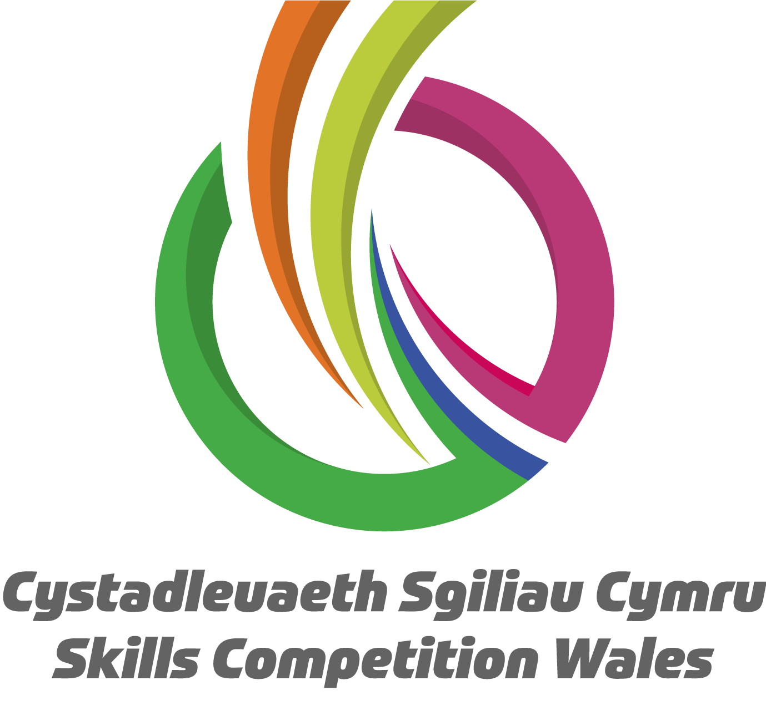

Competition Brief

Competition Title

Laboratory Technician

Competition Overview
Laboratory Technicians have specialist skills that allow them to work in a wide range of organisations, including chemical, biomedical, pharmaceutical, biotechnology and other industries in educational institutions. They are able to work within a laboratory team but also individually, taking responsibility for the quality and accuracy of the undertaken work.

In this competition, competitors will be assessed on the skills and abilities of technicians entering the field of laboratory technology in science. They are expected to have a core set of technical skills and abilities that they would like to demonstrate in a competitive environment and further develop through competition.

Competitors taking part in this competition should demonstrate their abilities in:
- Reading and application of technical documents such as instructions related to analysis or procedures, formulations and specifications of substances, diagrams and manuals for equipment.
- Handling of the laboratory devices, apparatus and equipment to be used, also handling of the chemicals used in laboratories by implementing safety data sheets and the measures and procedures to be derived from them.
- Preparation and processing of samples as well as separation processes for mixtures of liquids and solids.
- Performance of cleaning and concentration processes such as centrifugation, distillation, extraction, evaporation and crystallisation.
- Determination of physical parameters and matter constants such as temperature, density, pH value, refraction index, melting point and conductivity.
- Application of titrimetric and gravimetric methods.
- Application of instrumental and electroanalytical methods such as Spectrophotometry, Chromatography, Potentiometry and Conductometry.
- Logging, graphic evaluation and interpretation of the results of work and their documentation by using IT and statistical methods.
- Performance of work taking into consideration relevant norms as well as quality, safety and environmental standards.
- Appropriate written and oral command of language and specialist terminology as well as use of job-related foreign languages.

This competition is an all day event. The event will be split into a morning activity (2 hours) and an afternoon activity (2 hours). (including Health & Safety brief and report writing).

Entry Criteria
The competition is for those training for a career in Laboratory Science/Chemistry, and studying up to a Level 3 qualification or apprenticeship; including students who have completed Level 3 Qualification in the last 12 months. Please ensure your entrants have the skills and competencies to complete the task.

Entry capacity restrictions by organisation
Maximum of up to 3 per location. Reserves may also be registered to account for potential absences or withdrawals.

This is the maximum number of entries permitted by an organisation for this competition. This is determined by ‘location’ and ‘organisation’. ‘Organisation’ refers to the competitors’ training provider/employer. ‘Location’ refers to a site where the competitor studies / is employed.

This competition may be subject to a selection process if competitor registration numbers exceed the host venue capacity. Where capacity is identified in a competition the reserve competitors may be invited to compete.
The decision will be made following a consultation between Skills Competition Wales and the competition lead after registration closes. All parties will be notified of any changes.

For further guidance on these capacities, click here.

Brief
This competition consists of two laboratory practical tasks that will be issued at the venue on the day. Competitors will be provided with instructions for the experimental or analytical task and all materials required.

Competitors are expected to risk assess the activity and communicate this in writing or verbally. Data analysis and reporting on results forms part of the assessment but the main focus lies in the practical skills and ability to carry out experimental or analytical laboratory work in an independent, safe and efficient manner.

Previous competition briefs are available to view and download via the Skills Competition Wales website, please click here to access.

Infrastructure List
You will be provided with all the required PPE, equipment and materials needed for the tasks.
Computers, any specific software and other IT will also be provided if necessary. You will also be provided with a notebook and essential stationary.

You may, but don’t have to, bring the following items:
- Your own (company branded) lab coat (must be clean!).
- Your own goggles (essential if you wear goggles with eye corrections).
- A scientific calculator (not mobile phone app, no formulae etc. on the cover).
- Your own stationary.

Competitors will not be permitted to use the following during the competition:
- Mobile phones or any other devices with internet access (permitted during lunch break).
- Headphones.

Safe storage space or lockers for personal items, coats, bags, etc. that are not permitted in the laboratory will be provided, however space may be limited.

If you have any allergies, e.g. to gloves, please advise the organisers well in advance so that they can arrange alternatives or grant permission for you to bring your own. It is at the discretion of the laboratory manager and lead judge to disallow competitors from entering the laboratory or exclude them from the competition, for example any serious breaches of laboratory safety or inadequate clothing (e.g. flip-flops), or if there are health concerns.

Competition Rules
For full terms and conditions of entry and competition rules visit.

Generic competition rules:
- Mobile phones are to be switched off during competition activity.
- Listening to music via headphones is not permitted during competition activity.
- Any questions during competition activity should be addressed to the competition judging panel.
- Competitors should not communicate with other competitors during competition activity.
- It is the responsibility of each competitor to arrive on time for each competition session. No additional time will be allowed if you arrive late.
- failure of your equipment should be reported immediately to the judging panel. Additional time will be allocated if the fault is beyond the control of the competitor.

Marking and Assessment
Marking and judging of this competition will be done by a team of experts from Industry, Higher / Further Education or Training Provider, using a marking criteria and allocated marks to ensure consistency.

Brief breakdown of marking and assessment
All marks are objective and will be awarded by the judges as follows

Work organisation and management | 10%
Techniques, procedures and methods | 35%
Data processing and record keeping | 25%
Analysis, interpretation and evaluation | 15%
Problem solving through scientific methods | 15%
Total | 100%

Feedback and Recognition
Individual and Group verbal feedback will be provided at the end of the competition. No results or awards will be awarded on the day as marking will be quality assured.
All competitors will be issued with a Participation Certificate on the competition day. First, second, third and highly commended awards will be announced during the celebration event. The highly commended award recognises all competitors who have achieved above average. The celebration event will be held on Wednesday 18th March 2026, further details will be communicated to competitors and their points of contact by email.
Marksheets will be available upon request via info@skillscompetitionwales.ac.uk to competitors after the celebration event.

Competition Lead
Lead Contact and Expert Contact
Hannah Seale
Hannah.seale@southwales.ac.uk

Our partners

This competition is delivered in partnership with



Briff y Gystadleuaeth

Teitl y Gystadleuaeth

Technegydd Labordy

Trosolwg o’r Gystadleuaeth
Mae gan Dechnegwyr Labordy sgiliau arbenigol sy'n eu galluogi i weithio mewn amrywiaeth o sefydliadau, gan gynnwys y diwydiannau cemegol, biofeddygol, fferyllol, biotechnoleg a diwydiannau eraill mewn sefydliadau addysgol. Maen nhw’n gallu gweithio fel aelod o dîm labordy neu fel unigolyn, gan gymryd cyfrifoldeb am ansawdd a chywirdeb y gwaith sy’n cael ei wneud.
Yn y gystadleuaeth hon, bydd cystadleuwyr yn cael eu hasesu ar sail eu sgiliau a’u gallu fel technegwyr sy’n camu i faes gwyddonol technoleg labordy. Disgwylir iddyn nhw fod â set graidd o sgiliau a gallu technegol yr hoffen nhw eu dangos mewn sefyllfa gystadleuol a meithrin eu sgiliau ymhellach drwy gystadlu.

Dylai cystadleuwyr sy’n cymryd rhan yn gystadleuaeth hon arddangos eu galluoedd:
- Darllen a defnyddio dogfennau technegol megis cyfarwyddiadau sy’n ymwneud â dadansoddi neu weithdrefnau, fformwleiddiadau a manylion sylweddau, diagramau a llawlyfrau offer.
- Trin y dyfeisiau, cyfarpar ac offer labordy a ddefnyddir, yn ogystal â thrin y cemegion a ddefnyddir mewn labordai drwy ddefnyddio taflenni data diogelwch a’r mesurau a’r gweithdrefnau sy’n deillio ohonynt.
- Paratoi a phrosesu samplau yn ogystal â phrosesau gwahanu ar gyfer cymysgeddau o hylifau a solidau.
- Ymgymryd â phrosesau glanhau a chrynodi fel allgyrchu, distyllu, echdynnu, anweddu a chrisialu.
- Penderfynu ar baramedrau ffisegol a chysonion mater megis tymheredd, dwysedd, gwerth pH, indecs plygiant, pwynt toddi a dargludedd.
- Defnyddio dulliau titradaethol a grafimetrig.
- Defnyddio dulliau offerynnol ac electroddadansoddol megis Sbectroffotometreg, Cromatograffi, Potensiometreg a Dargludometreg.
- Cofnodi, gwerthuso graffig a dehongli canlyniadau gwaith a’u dogfennu gan ddefnyddio dulliau TG ac ystadegol.
- Cyflawni gwaith gan ystyried normau perthnasol yn ogystal ag ansawdd, diogelwch a safonau amgylcheddol.
- Defnyddio iaith lafar ac ysgrifenedig briodol a therminoleg arbenigol yn ogystal â thermau o ieithoedd eraill sy’n ymwneud â’r gwaith.

Mae'r gystadleuaeth hon yn cael ei chynnal drwy gydol y dydd. Bydd y digwyddiad yn cael ei rannu'n un weithgaredd yn y bore (2 awr) ac un weithgaredd yn ystod y prynhawn (2 awr) (hyn i gynnwys paratoi briff Iechyd a Diogelwch ac ysgrifennu adroddiad).

Meini Prawf Cystadlu
Mae'r gystadleuaeth ar gyfer y rhai sy'n hyfforddi ar gyfer gyrfa mewn Gwyddoniaeth Labordai/Cemeg, ac mae astudio hyd at y gystadleuaeth hon ar gyfer y rhai sy'n hyfforddi ar gyfer gyrfa mewn Gwyddoniaeth Fforensig ac yn astudio hyd at gymhwyster neu brentisiaeth Lefel 3; gan gynnwys myfyrwyr sydd wedi cwblhau Cymhwyster Lefel 3 yn ystod y 12 mis diwethaf.
Cyfyngiadau ar nifer y ceisiadau fesul sefydliad
Uchafswm o hyd at 3 fesul lleoliad. Gellir cofrestru cronfeydd wrth gefn hefyd i gyfrifon absenoldeb neu dynnu'n ôl os bydd angen.

Dyma’r uchafswm o geisiadau a ganiateir gan unrhyw sefydliad am y gystadleuaeth hon.
Mae hyn yn cael ei bennu fesul ‘lleoliad’ a ‘sefydliad’. Mae ‘Sefydliad’ yn cyfeirio at ddarparwr hyfforddiant/cyflogwr y cystadleuydd. Mae ‘Lleoliad’ yn cyfeirio at le mae’r cystadleuydd yn astudio / cael ei gyflogi.

Gall y gystadleuaeth hon fod yn destun proses ddethol os yw'r niferoedd cofrestru cystadleuwyr yn fwy na chapasiti'r lleoliad cynnal. Lle nodir bod capasiti ar gyfer y gystadleuaeth, gellir gwahodd cystadleuwyr wrth gefn i gystadlu.
Bydd y penderfyniad yn cael ei wneud yn dilyn ymgynghoriad rhwng Cystadleuaeth Sgiliau Cymru ac arweinydd y gystadleuaeth ar ôl i'r cofrestru gau. Bydd pob parti yn cael gwybod am unrhyw newidiadau

Am fwy o arweiniad ar y niferoedd hyn, cliciwch yma.

Briff
Mae’r gystadleuaeth hon dau cynnwys tasg labordy ymarferol a gyflwynir yn y lleoliad ar y diwrnod. Rhoddir cyfarwyddiadau i’r cystadleuwyr ar gyfer y dasg arbrofol neu ddadansoddol ynghyd â’r holl ddeunyddiau angenrheidiol.

Mae disgwyl i’r cystadleuwyr gyflawni asesiad risg o’r gweithgaredd a’i rannu’n ysgrifenedig neu ar lafar. Mae dadansoddi data ac adrodd y canlyniadau’n rhan o’r asesiad ond y prif ffocws yw’r sgiliau ymarferol a’r gallu i gyflawni gwaith labordy arbrofol neu ddadansoddol mewn modd annibynnol, diogel ac effeithlon.

Mae briffiau cystadleuaeth flaenorol ar gael i'w gweld a'u llwytho o’r wefan Cystadleuaeth Sgiliau Cymru, cliciwch yma i gael mynediad iddynt.

Rhestr Seilwaith
Darperir yr holl Gyfarpar Diogelu Personol (PPE), offer a deunyddiau angenrheidiol ar gyfer y tasgau. Darperir cyfrifiaduron, unrhyw feddalwedd benodol a TG arall os oes angen. Byddwch hefyd yn cael llyfr nodiadau ac offer ysgrifennu angenrheidiol.

Cewch hefyd ddod â’r eitemau canlynol gyda chi (ond nid yw’n angenrheidiol):
- Eich cot labordy (lân!) eich hun (gyda logo eich cwmni).
- Eich goglau eich hun (angenrheidiol os ydych chi’n gwisgo goglau sy’n cywiro eich llygaid).
- Cyfrifiannell wyddonol (dim ap ffôn symudol, dim fformiwlâu a.y.b. ar y clawr).
- Eich offer ysgrifennu eich hun.

Ni chaniateir i gystadleuwyr ddefnyddio’r offer canlynol yn ystod y gystadleuaeth:
- Ffonau symudol neu unrhyw ddyfeisiau eraill sy’n gallu cyrchu’r we (caniateir yn ystod yr awr ginio).
- Clustffonau.

Darperir lle storio diogel neu loceri ar gyfer eitemau personol, cotiau, bagiau a.y.b. na chaniateir yn y labordy, ond efallai na fydd lle i bethau pawb.

Os oes gennych unrhyw alergeddau e.e. i fenyg, dywedwch wrth y trefnwyr ymhell ymlaen llaw fel y gallan nhw wneud trefniadau eraill neu roi caniatâd i chi ddod â’ch rhai eich hun. Cyfrifoldeb rheolwr y labordy a’r prif feirniad yw penderfynu gwahardd cystadleuwyr rhag dod i mewn i’r labordy neu eu diarddel o’r gystadleuaeth, e.e. am dorri rheolau diogelwch y labordy neu am ddillad anaddas (e.e. fflip-fflops), neu os oes pryderon am iechyd.

Rheolau’r Gystadleuaeth
Am restr gyflawn o delerau ac amodau cystadlu a rheolau’r gystadleuaeth ewch i.

Rheolau cyffredinol y gystadleuaeth
- Dylid diffodd ffonau symudol yn ystod y gystadleuaeth.
- Ni chaniateir gwrando ar gerddoriaeth gyda chlustffonau yn ystod y gystadleuaeth.
- Dylid cyfeirio unrhyw gwestiynau yn ystod y gystadleuaeth at y panel beirniaid.
- Ni ddylai’r cystadleuwyr gyfathrebu gyda chystadleuwyr eraill yn ystod y gystadleuaeth.
- Cyfrifoldeb pob cystadleuydd fydd cyrraedd ar amser ar gyfer pob rhan o’r gystadleuaeth. Pe baech yn cyrraedd yn hwyr, ni roddir amser ychwanegol ichi.
- Pe bai rhyw wall ar eich offer, dylid rhoi gwybod i’r panel beirniaid yn syth. Bydd amser ychwanegol yn cael ei roi os bydd y gwall y tu hwnt i reolaeth y cystadleuydd.

Marcio ac Asesu
Bydd tîm o arbenigwyr o Ddiwydiant, Addysg Uwch/Addysg Bellach neu Ddarparwyr Hyfforddiant yn marcio a beirniadu’r gystadleuaeth hon, gan ddefnyddio meini prawf marcio a marciau a dyrennir er mwyn sicrhau cysondeb.

Manylion cryno marcio ac asesu.
Mae’r holl farciau’n wrthrychol a chânt eu dyfarnu gan y beirniaid fel a ganlyn

Trefnu a rheoli gwaith | 10%
Technegau, gweithdrefnau a dulliau | 35%
Prosesu data a chadw cofnodion | 25%
Dadansoddi, dehongli a gwerthuso | 15%
Datrys problemau trwy ddulliau gwyddonol | 15%
Cyfanswm | 100%

Adborth a Chydnabyddiaeth
Bydd adborth llafar, yn unigol ac mewn grŵp, yn cael ei roi ar ddiwedd y gystadleuaeth. Ni fydd unrhyw ganlyniadau na gwobrau’n cael eu dyfarnu ar y diwrnod oherwydd bydd angen sicrhau ansawdd y marcio.

Bydd pob cystadleuydd yn cael Tystysgrif Cyfranogi ar ddiwrnod y gystadleuaeth. Bydd gwobrau cyntaf, ail, trydydd a chanmoliaeth uchel yn cael eu cyhoeddi yn ystod y digwyddiad dathlu. Mae'r wobr canmoliaeth uchel yn cydnabod yr holl gystadleuwyr sydd wedi cyflawni sgôr uwch na'r cyfartaledd. Cynhelir y digwyddiad dathlu ar Dydd Mercher 18 Mawrth 2026, bydd manylion pellach yn cael eu rhoi i gystadleuwyr a'u pwyntiau cyswllt trwy e-bost.
Bydd taflenni marciau ar gael ar gais drwy info@skillscompetitionwales.ac.uk i gystadleuwyr ar ôl y digwyddiad dathlu.

Arweinwyr y Gystadleuaeth
Prif Gyswllt a Chysylltiad Arbenigol
Hannah Seale
Hannah.seale@southwales.ac.uk

Ein partneriaid

Mae'r gystadleuaeth hon yn cael ei chyflwyno mewn partneriaeth â

