**Competition Brief**

**Competition Title**

Inclusive Skills: Hairdressing

**Competition Overview**

A hairdresser has the training and skills to cut or style hair in order to change or maintain a person's image. This is carried out using a combination of hair coloring, haircutting, and hair texturing techniques.

In this competition, competitors will be assessed on the skills and abilities required for this industry. They are expected to present themselves as a professional and be able to work safely and methodically through the task.

As a result of COVID-19, the competitions will take place remotely at the competitors organisation. The tasks set within the competition brief will continue to be delivered and competitors will be required to submit photographic evidence of their work for judging.

**Entry Criteria**

This competition is for those training for a career in the Hairdressing Industry and working at Entry Level 3. 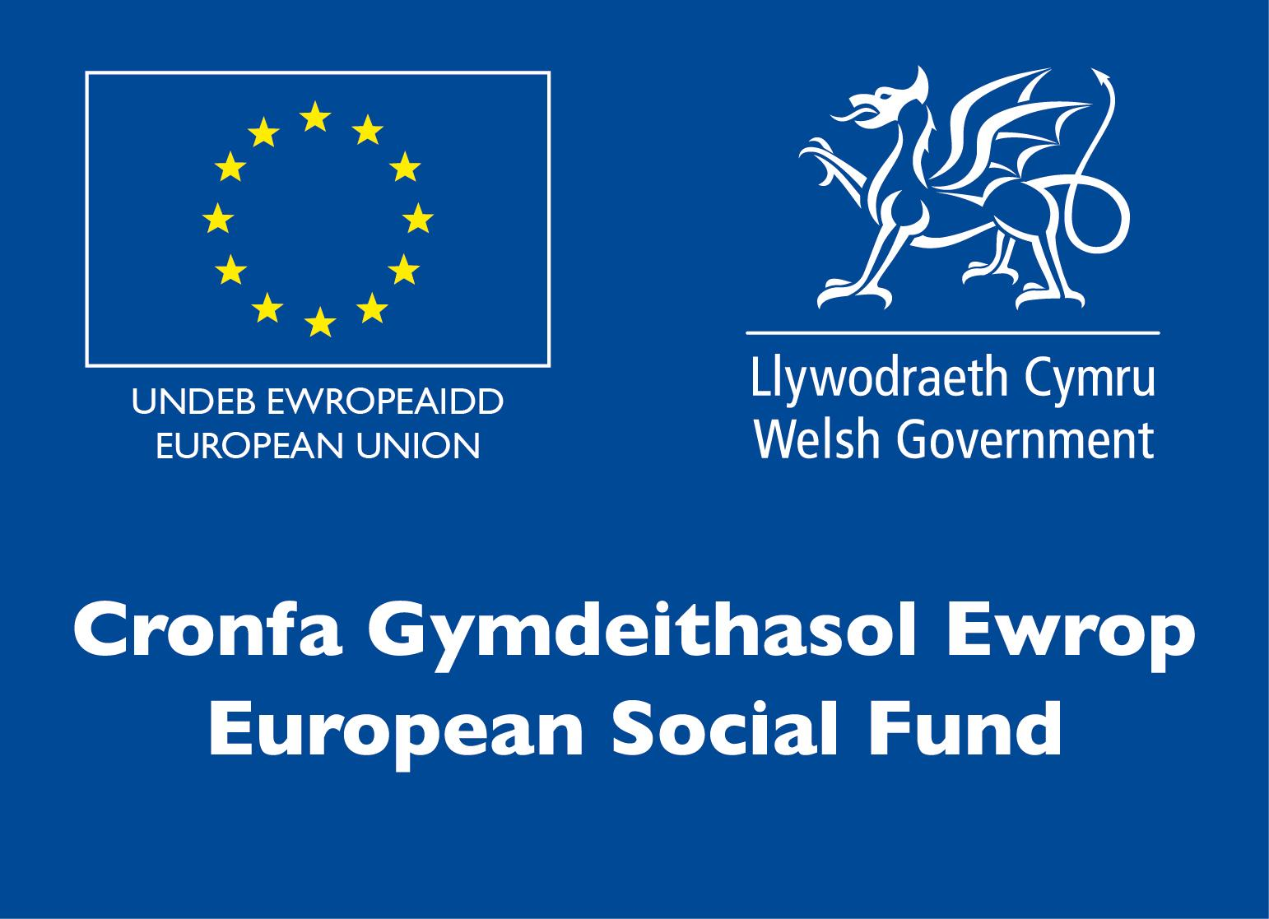

Please ensure your entrants have the skills and competences to complete the task.

**Entry capacity restrictions by organisation**

Maximum of up to 2 per location.

This is the maximum number of entries permitted by an organisation for this competition.

This is determined by ‘location’ and ‘organisation’. ‘Organisation’ refers to the competitors’ training provider/employer. ‘Location’ refers to a site where the competitor studies / is employed. For further guidance on these capacities, click [here](https://www.skillscompetitionwales.ac.uk/terms/entry-capacity-restrictions-by-organisation)

**Brief**

Competitors will be required to dress long hair during the competition. They have a free choice of design, which may consist of up-style, down-style or combination of both. All competitors will be required to bring ALL required tools and equipment, including all styling products.

Competitors will be expected to undertake task one within their organisation, in a controlled and timed environment. Competitors will be required to submit photographic evidence of their work for judging. Photographic evidence must be sent to the competition leads via email at [skillscompetitions@cavc.ac.uk](mailto:skillscompetitions@cavc.ac.uk) by Friday 22nd January. More information on photographic skills can be found in Richard Howell’s recorded CPD session located on Slack.

Each competitor will require a Banbury Postiche mannequin to carry out the competition task (**1 x TH1137)** and a suitable Tripod. All mannequin heads are available from [www.banburypostiche.co.uk](http://www.banburypostiche.co.uk)

The competition lead will allocate funding to the organisations participating to support with the purchase of mannequin heads, photography and marketing. Further information on this can be requested from Emma Andrews at [skillscompetitions@cavc.ac.uk](mailto:skillscompetitions@cavc.ac.uk).

**Task 1: Long Hair Fashion Style 2 HOURS**

- Competitors will be required to dress long hair during the competition.

- Competitors have a free choice of Long Hair Design, which may consist of up-style, down-style or combination of both.

**- NO** colour is to be used for this skill test

- Competitors will be required to carry out their look on mannequin head **TH1137**

- No dressing or draping of the mannequin is allowed.

- No cutting of the mannequin is allowed.

**Judges will award points for:**

• Hairstyle

• Ornamentation

• Styling & Finishing

• Continuity of Design

**Hairstyle**

• Shape

• Style

• Balance

• Creativity

• Reflecting current fashion trend

**Finish**

• Cleanliness of finish

• Balance & Shape

**Continuity of Design**

• Overall design shows a continuity in all aspects (textures/shape) and a degree of difficulty.

• Balance

• Total Look

**Infrastructure List**

PPE required to be provided by competitor.

**Competition Rules**

For full terms and conditions of entry and competition rules visit [www.skillscompetitionwales.ac.uk/terms-and-conditions](http://www.skillscompetitionwales.ac.uk/terms-and-conditions)

**Competition specific rules**

Competitors **MUST** bring the correct mannequin head for the competitions, as referenced in the competition description, from Banbury Postiche. No other mannequin heads are allowed to be used.

• Health and safety must be adhered to at all times throughout the competition.

• No backcombing should be showing except the effect forms part of the finished look and this is clearly reflected.

• No pins or bands showing.

• The hair may be styled using a free choice of tools.

• All styling products are allowed.

• All styling tools are allowed.

• All finishing techniques are accepted.

• Finish should reflect the style created.

• No added hair is allowed or ornamentation made from added hair.

• No makeup may be added to the mannequins.

• No jewellery may be added at any time.

• No dressing or draping of the mannequin is allowed.

• No cutting of the mannequin is allowed.

• On completion of the style, only ends may be cleaned with scissors, if desired.

• Competitors will have 2 hours to complete their task.

• Verbal support can be given to competitors at the start of the task, but no physical help can be given.

• The judges’ decision is final.

**Generic competition rules**

• Mobile phones are to be switched off during competition activity.

• Listening to music via headphones is not permitted during competition activity.

• Any questions during competition activity should be addressed to the competition judging panel.

• Competitors should not communicate with other competitors during competition activity.

• It is the responsibility of each competitor to arrive on time for each competition session. No additional time will be allowed if you arrive late.

• Technical failure of your equipment should be reported immediately to the judging panel. Additional time will be allocated if the fault is beyond the control of the competitor.

**Marking and Assessment**

The competitions will be marked by external UK Skills Judges. As the competition is now taking place remotely, the judges will award each competitor with full marks for the Health & Safety element as this cannot be scrutinised online. The judges will also provide 5 minutes of feedback to each provider after judging has taken place.

**Brief breakdown of marking and assessment**

|  |  |  |
| --- | --- | --- |
| **Ladies Long Hair Fashion** | Style/Design  Finish  Continuity of Design  **Total** | 40%  40%  20%  **100%** |

The tests will be assessed and marked in accordance with the general and specific competition rules.

The criteria for assessment are as set out on the attached forms. For all criteria and their

aspects the following marking scale will be used:

1. Does not represent Industry Standard in any aspect

2. Represents minimum Industry Standard in all aspects

3. Mostly represents minimum Industry Standards, with a few areas of exceptional performance above Industry Standard

4. Fully represents exceptional performance above Industry Standard in all aspects

Once marks have been agreed for each aspect of criterion, for each competitor, these will be

converted to obtain an individual weighted score.

**Feedback and Recognition**

Individual and Group verbal feedback will be provided at the end of the competition.

No results or awards will be awarded on the day, as marking will be quality assured.

Certificates of Participation will be issued on the day.

Medallists will be invited to a Celebration Event which will be held in March 2021, where the First, Second and Third Awards will be presented.

Marksheets will be made available to unsuccessful competitors after the quality assurance process has been completed. Further details will be provided to all competitors upon notification of outcomes.

**Competition Lead**

**Lead Contact:**

Rachel Jones -[**RJones2@cavc.ac.uk**](mailto:RJones2@cavc.ac.uk)

Emma Andrews -[**eandrews@cavc.ac.uk**](mailto:eandrews@cavc.ac.uk)

**Briff y Gystadleuaeth**

**Teitl y Gystadleuaeth**

Sgiliau Cynhwysol: Trin Gwallt

**Trosolwg o’r Gystadleuaeth**

Mae gan driniwr gwallt yr hyfforddiant a’r sgiliau i dorri neu steilio gwallt er mwyn newid neu gynnal delwedd rhywun. Mae hyn yn digwydd gan ddefnyddio cyfuniad o liwio gwallt, ei dorri a thechnegau creu gwead.

Yn y gystadleuaeth hon, asesir cystadleuwyr ar y sgiliau a’r gallu sy’n ofynnol ar gyfer y diwydiant hwn. Disgwylir iddyn nhw gyflwyno’u hunan fel gweithwyr proffesiynol a bod yn gallu gweithio’n ddiogel a threfnus drwy’r dasg.

O ganlyniad i COVID-19, cynhelir y cystadlaethau o bell yn sefydliad y cystadleuwyr. Bydd y tasgau a osodir o fewn briff y gystadleuaeth yn parhau i gael eu cyflawni a bydd gofyn i gystadleuwyr gyflwyno tystiolaeth ffotograffig o'u gwaith i'w beirniadu.

**Meini Prawf Ymgeisio**

Mae’r gystadleuaeth ar gyfer pobl sy’n hyfforddi ar gyfer gyrfa yn y Diwydiant Trin Gwallt ac sy’n astudio tuag at gymhwyster Lefel Mynediad 3.

A wnewch chi sicrhau fod gan eich ymgeiswyr y sgiliau a’r cymwyseddau angenrheidiol ar gyfer cwblhau’r dasg os gwelwch yn dda.



**Cyfyngiadau ar niferoedd ymgeisio fesul sefydliad**

Uchafswm o 2 ar gyfer pob lleoliad.

Dyma’r nifer uchaf o geisiadau a ganiateir gan sefydliad ar gyfer y gystadleuaeth hon.

Penderfynir ar hyn drwy gyfrwng ‘lleoliad’ a ‘sefydliad’. Mae ‘sefydliad’ yn cyfeirio at ddarparwr hyfforddiant / cyflogwr y cystadleuwyr. Mae ‘lleoliad’ yn cyfeirio at safle ble mae’r cystadleuydd yn astudio / gweithio. I gael mwy o arweiniad am y diffiniadau hyn, cliciwch yma.

**Briff**

Bydd gofyn i gystadleuwyr baratoi gwallt hir yn ystod y gystadleuaeth. Mae ganddynt ddewis agored o gynllun, a allai gynnwys steil i fyny, steil i lawr neu gyfuniad o’r ddau.

Mae gofyn i bob cystadleuydd ddod â’r HOLL offer a thŵls angenrheidiol gyda nhw, gan gynnwys pob cynnyrch steilio.

Disgwylir i gystadleuwyr ymgymryd â thasg un yn eu sefydliad, mewn amgylchedd rheoledig ac wedi'i amseru. Bydd gofyn i gystadleuwyr gyflwyno tystiolaeth ffotograffig o'u gwaith i'w beirniadu. Rhaid anfon tystiolaeth ffotograffig at arweinwyr y gystadleuaeth trwy e-bost yn sgiliaucompetitions@cavc.ac.uk erbyn dydd Gwener 22ain Ionawr. Gellir dod o hyd i ragor o wybodaeth am sgiliau ffotograffig yn sesiwn DPP wedi'i recordio Richard Howell ar Slack.

Bydd angen cystadleuydd Banbury Postiche ar bob cystadleuydd i gyflawni tasg y gystadleuaeth (1 x TH1137) a Tripod addas. Mae holl bennau mannequin ar gael o www.banburypostiche.co.uk.

Bydd arweinydd y gystadleuaeth yn dyrannu cyllid i'r sefydliadau sy'n cymryd rhan i gefnogi gyda phrynu pennau mannequin, ffotograffiaeth a marchnata. Gellir gofyn am ragor o wybodaeth am hyn gan Emma Andrews yn [skillscompetitions@cavc.ac.uk](mailto:skillscompetitions@cavc.ac.uk).

**Prawf 1: Steil Ffasiwn Gwallt Hir 2 AWR**

* Bydd gofyn i gystadleuwyr drin gwallt hir yn ystod y gystadleuaeth.
* Mae gan gystadleuwyr ddewis agored o gynllun gwallt hir, a all gynnwys steil i fyny, steil i lawr neu gyfuniad o’r ddau.
* **NI DDYLID** defnyddio lliw ar gyfer y prawf sgiliau hwn
* Bydd gofyn i gystadleuwyr wneud eu gwaith ar ben mannequin **TH1137**
* Ni chaniateir gwisgo na rhoi llen ar y mannequin.
* Ni chaniateir torri’r mannequin.

**Bydd beirniaid yn rhoi pwyntiau am:**

• Steil y gwallt

• Addurnwaith

• Steilio a Gorffen

• Cysondeb y Dyluniad

**Steil y Gwallt**

* Siâp
* Steil
* Cydbwysedd
* Creadigrwydd
* Adlewyrchu tuedd ffasiwn gyfredol

**Gorffeniad**

* Pa mor lân yw’r gorffeniad
* Cydbwysedd a Siâp

**Cysondeb y Dyluniad**

* Mae’r dyluniad cyffredinol yn dangos cysondeb ymhob agwedd (gwead / siâp) ac elfen o anhawster.
* Cydbwysedd
* Yr olwg gyffredinol

**Rhestr Seilwaith**

Rhaid i unrhyw PPE gofynnol gael ei ddarparu gan y cystadleuydd

**Rheolau’r Gystadleuaeth**

I gael telerau ac amodau ymgeisio a rheolau cystadlu llawn, ewch i [www.skillscompetitionwales.ac.uk/terms-and-conditions](http://www.skillscompetitionwales.ac.uk/terms-and-conditions)

**Rheolau penodol**

**RHAID** i gystadleuwyr ddod â’r pen mannequin cywir ar gyfer y cystadlaethau, fel y cyfeirir ato yn nisgrifiad y gystadleuaeth, o Banbury Postiche. Ni chaniateir defnyddio unrhyw ben mannequin arall.

* Rhaid glynu wrth iechyd a diogelwch ar bob adeg drwy gydol y gystadleuaeth
* Ni ddylai unrhyw gribo’n ôl ddangos oni bai fod yr effaith yn rhan o’r olwg derfynol, ac yr adlewyrchir hyn yn glir
* Ni ddylai unrhyw binnau na bandiau fod yn dangos
* Gellir steilio’r gwallt gan ddefnyddio dewis agored o dŵls.
* Caniateir pob cynnyrch steilio
* Caniateir pob offer steilio
* Mae pob techneg gorffen yn dderbyniol
* Dylai’r gorffeniad adlewyrchu’r steil a grëwyd
* Ni chaniateir unrhyw wallt ychwanegol nag unrhyw addurn a wnaed o wallt ychwanegol
* Ni chaniateir rhoi colur ar y mannequins
* Ni chaniateir ychwanegu gemwaith ar unrhyw adeg
* Ni chaniateir gwisgo na rhoi llen ar y mannequin
* Ni chaniateir torri’r mannequin
* Ar ôl i’r steil gael ei orffen, dim ond y blaenau all gael eu glanhau â siswrn, os dymunir.
* Bydd gan gystadleuwyr 2 awr i gwblhau’r dasg
* Gellir rhoi cefnogaeth ar lafar i gystadleuwyr ar ddechrau’r dasg, ond ni ellir rhoi unrhyw gymorth corfforol.
* Mae penderfyniad y beirniaid yn derfynol.

**Rheolau cyffredinol y gystadleuaeth**

* Dylid diffodd ffonau symudol yn ystod y gystadleuaeth.
* Ni chaniateir gwrando ar gerddoriaeth gyda chlustffonau yn ystod y gystadleuaeth.
* Dylid cyfeirio unrhyw gwestiynau yn ystod y gystadleuaeth at y panel beirniaid.
* Ni ddylai’r cystadleuwyr gyfathrebu gyda chystadleuwyr eraill yn ystod y gystadleuaeth.
* Cyfrifoldeb pob cystadleuydd fydd cyrraedd yn brydlon ar gyfer pob rhan o’r gystadleuaeth. Pe baech yn cyrraedd yn hwyr, ni roddir amser ychwanegol i chi.
* Pe bai rhyw wall technegol ar eich offer, dylid rhoi gwybod i’r panel beirniaid yn syth. Bydd amser ychwanegol yn cael ei roi os bydd y gwall y tu hwnt i reolaeth y cystadleuydd.

**Marcio ac Asesu**

Bydd y cystadlaethau'n cael eu marcio gan Farnwyr Sgiliau allanol y DU. Gan fod y gystadleuaeth bellach yn cael ei chynnal o bell, bydd y beirniaid yn dyfarnu marciau llawn i bob cystadleuydd am yr elfen Iechyd a Diogelwch gan na ellir craffu ar hyn ar-lein. Bydd y beirniaid hefyd yn darparu 5 munud o adborth i bob darparwr ar ôl i'r beirniadu ddigwydd.

Dadansoddiad cryno o’r marcio ac asesu.

|  |  |  |
| --- | --- | --- |
| **Gwallt Hir Ffasiwn Merched** | Steil/Cynllun  Gorffeniad  Cysondeb y Dyluniad  **Cyfanswm** | 40%  40%  20%  **100%** |

Asesir a marcir y profion yn unol â rheolau cyffredinol a phenodol y gystadleuaeth.

Amlinellir meini prawf ar gyfer asesu ar y ffurflenni atodol. Ar gyfer pob maen prawf a’u hagweddau, defnyddir y raddfa farcio isod:

1. Nid yw’n cwrdd â safon y diwydiant mewn unrhyw agwedd

2. Mae’n cwrdd ag isafbwynt safon y diwydiant ymhob agwedd

3. Mae’n cynrychioli isafbwynt y diwydiant ar y cyfan, gydag ambell faes o berfformiad eithriadol uwchlaw Safon y Diwydiant.

4. Mae’n cynrychioli perfformiad eithriadol uwchlaw Safon y Diwydiant ymhob agwedd

Ar ôl i farciau gael eu cytuno ar gyfer pob agwedd o’r meini prawf, ar gyfer pob cystadleuydd, cânt eu trosglwyddo i ganfod sgôr unigol wedi’i bwyso.

**Adborth a Chydnabyddiaeth**

Bydd adborth llafar Unigol a Grŵp yn cael ei ddarparu ar ddiwedd y gystadleuaeth.

Ni roddir canlyniadau na gwobrau ar y diwrnod gan y bydd angen sicrhau ansawdd y gwaith marcio.

Bydd Tystysgrifau Cyfranogiad yn cael eu rhoi ar y diwrnod.

Bydd y rhai sy’n ennill medalau yn cael eu gwahodd i Ddigwyddiad Dathlu a fydd yn cael ei gynnal yn mis Mawrth 2021, lle bydd y Gwobrau Cyntaf, Ail a Thrydedd yn cael eu cyflwyno.

Bydd taflenni marcio ar gael i gystadleuwyr aflwyddiannus ar ôl i’r broses sicrhau ansawdd gael ei chwblhau. Caiff manylion pellach eu darparu i bob cystadleuydd ar ôl iddynt gael gwybod beth yw’r canlyniadau.

**Arweinydd y Gystadleuaeth**

**Prif gyswllt:**

Rachel Jones -[**RJones2@cavc.ac.uk**](mailto:RJones2@cavc.ac.uk)

Emma Andrews -[**eandrews@cavc.ac.uk**](mailto:eandrews@cavc.ac.uk)