Competition Brief

Competition Title

Inclusive Skills: Fitness Assistant

Competition Overview
This competition will be a straight final and will be held at one venue.

The Fitness Assistant competition has been developed over several years to ensure that students working at lower levels and with additional learning needs are able to show off their skills in the health & fitness industry.

Entry Criteria
- Competitors must be enrolled - at the point of registration - on a certificate/qualification with a recognised Awarding Organisation (AO) which is relevant to the competition.
- The certificate/qualification must not be higher than RQF/CQFW Level 1.
- Learners working towards Entry Level 3 qualifications.
- Competitors must have a cognitive impairment or physical disability which would prevent them from ever being likely to be able to study for an RQF/CQFW Level 3, SCQF Level 6 or other equivalent level certificate/qualification in exercise/sport/fitness etc.
- A statement of support which outlines the individual needs of the competitor within the competition must be submitted prior to attendance.

Please be aware that this is a Personal Training Competition.

Example qualifications recommended for entry (a representative, not exhaustive list):
- JSLA Level 1
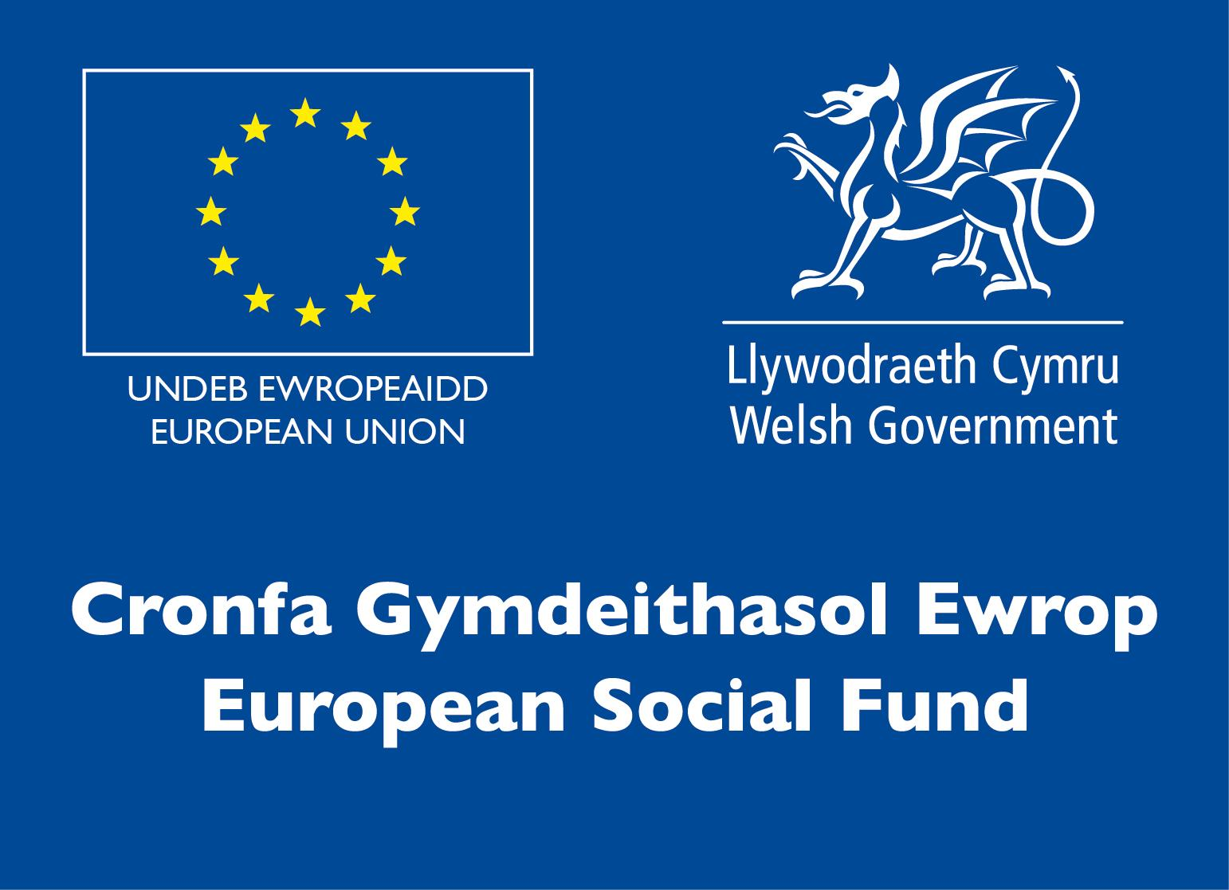
- Entry level 3
- BTEC Level 1 Sport & Active Leisure
- NVQ Level 1 Sport & Active Leisure
- NCFE Level 1 in Health & Fitness

- YMCA Awards Level 1 Fitness & Physical Activity
- Active IQ Level 1 Fitness & Physical Activity
- YMCA Level 1 Diploma in Introduction to the Active Leisure Sector
- BTEC Level 1 Introductory Diploma to Sport

Competition Video date submission - Between 25th January and 5th February.
You will be allocated a date and instructions to upload your video recording once registration has closed.

Entry capacity restrictions by organisation
Maximum of up to 3 per location.
This is the maximum number of entries permitted by an organisation for this competition. Please ensure that all entries include a statement of support so we can ensure that the students’ needs are met – this needs to be sent on application.

This is determined by ‘location’ and ‘organisation’. ‘Organisation’ refers to the competitors training provider/employer. ‘Location’ refers to a site where the competitor studies / is employed. For further guidance on these capacities, click here

Brief
An international pandemic has led to a lockdown situation in the UK as well as in other countries around the world. Many businesses where people congregate have been suspended to slow down the spread of the Covid-19 virus.

Although gyms, health clubs and sports centres have been closed, and restrictions remain in place, the vital benefits of exercise have been highlighted and many campaigns encourage the population to stay active.

Many fitness professionals and brands have moved large proportions of their businesses online and to other virtual platforms to ensure continuity for their clients and to sustain a level of income for themselves. This is a trend that is looking increasingly likely to continue to develop and form a vital part of the role of the fitness professional in the 2020’s.

Home Workout video
You need to produce and submit a video (maximum 10 minutes) demonstrating at least 4 different exercises which can be performed by completing body weight exercises.

The video should be designed and delivered to appeal to as many people as possible – however considerations should be given to ensure that the demo is also suitable for beginners.
The video needs to be compiled as one long shoot and cannot be cut or edited in anyway. Please see criteria for more information.

Competition Rules
For full terms and conditions of entry and competition rules visit www.skillscompetitionwales.ac.uk/terms-and-conditions

Marking and Assessment
Marking and judging of this competition will be done by a team of experts from Industry, Further Education or Training Provider, using a marking criteria and allocated marks to ensure consistency.

Feedback and Recognition
Verbal feedback will be given however will be timed at a strict 2 minutes.
No results or awards will be awarded on the day as marking will be quality assured.
Certificates of Participation will be issued on the day. This competition will be a straight final and will be held at one venue.
Medallists will be invited to a Celebration Event which will be held in March 2021, where the First, Second and Third Awards will be presented.

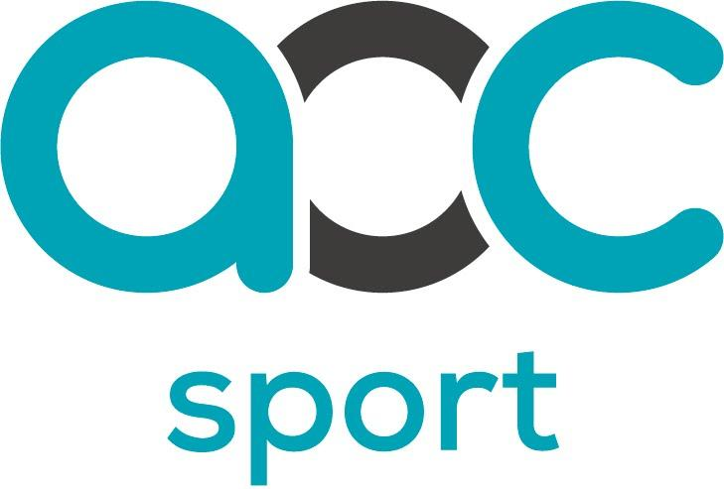
Note: These competition materials were developed in partnership with the UK Competition Organising Partners, AoC Sport.

Competition Lead
Lead Contact
Cerys Rees
Cerys.rees@coleggwent.ac.uk

Briff y Gystadleuaeth

Teitl y Gystadleuaeth

Sgiliau Cynhwysol: Cynorthwyydd Ffitrwydd

Trosolwg y Gystadleuaeth
Bydd y gystadleuaeth hon yn mynd i’r rownd derfynol yn syth a chaiff ei chynnal mewn un lleoliad.

Datblygwyd cystadleuaeth y Cynorthwyydd Ffitrwydd dros nifer o flynyddoedd i sicrhau bod myfyrwyr sy'n gweithio ar lefelau is a chydag anghenion dysgu ychwanegol yn gallu dangos eu sgiliau yn y diwydiant iechyd a ffitrwydd.

Meini Prawf Mynediad
● Rhaid cofrestru cystadleuwyr - yn y man cofrestru - ar dystysgrif/cymhwyster gyda Sefydliad Dyfarnu cydnabyddedig sy'n berthnasol i'r gystadleuaeth.
- Ni ddylai'r dystysgrif/cymhwyster fod yn uwch na Lefel 1 RQF/FfCChC.
- Dysgwyr sy'n gweithio tuag at gymwysterau Lefel Mynediad 3.
- Rhaid i gystadleuwyr fod â nam gwybyddol neu anabledd corfforol sy’n golygu nad ydynt yn debygol o allu astudio ar gyfer RQF/FfCChC Lefel 3, SCQF Lefel 6 neu dystysgrif/cymhwyster cyfatebol arall mewn ymarfer corff/chwaraeon/ffitrwydd ac ati.
● Rhaid cyflwyno datganiad o gefnogaeth sy'n amlinellu anghenion unigol y cystadleuydd yn y gystadleuaeth cyn bod yn bresennol.

Byddwch yn ymwybodol mai Cystadleuaeth Hyfforddiant Personol yw hon.

Cymwysterau enghreifftiol a argymhellir ar gyfer mynediad (rhestr enghreifftiol, nid yw’n gynhwysfawr):
● JSLA Lefel 1
● Lefel mynediad 3
● BTEC Lefel 1 Chwaraeon a Hamdden Egnïol

● NVQ Lefel 1 Chwaraeon a Hamdden Egnïol
● NCFE Lefel 1 mewn Iechyd a Ffitrwydd
● Gwobrau YMCA Lefel 1 Ffitrwydd a Gweithgarwch Corfforol
● IQ Lefel 1 gweithredol Ffitrwydd a Gweithgarwch Corfforol
● Diploma Lefel 1 YMCA yng Nghyflwyniad i'r Sector Hamdden Egnïol
● Diploma Rhagarweiniol BTEC Lefel 1 i Chwaraeon

Dyddiad cyflwyno ar gyfer Fideo Cystadleuaeth - Rhwng 25 Ionawr a 5ed Chwefror.
Rhoddir dyddiad a chyfarwyddiadau i chi i uwchlwytho'ch recordiad fideo unwaith y bydd y cofrestriad wedi cau.

Cyfyngiadau capasiti mynediad fesul sefydliad
Uchafswm o hyd at 3 y lleoliad.
Dyma uchafswm nifer yr ymgeiswyr a ganiateir gan sefydliad ar gyfer y gystadleuaeth hon. Gwnewch yn siŵr bod gan bob cystadleuydd ddatganiad o gymorth fel y gallwn sicrhau bod anghenion y myfyrwyr yn cael eu diwallu – mae angen anfon hyn wrth wneud cais.

Pennir hyn gan 'leoliad' a 'sefydliad'. Mae 'sefydliad' yn cyfeirio at ddarparwr hyfforddiant/cyflogwr y cystadleuwyr. Mae 'lleoliad' yn cyfeirio at safle lle mae'r cystadleuydd yn astudio / yn cael ei gyflogi. I gael rhagor o arweiniad ar y capasiti hyn, cliciwch yma

Briff
Mae pandemig rhyngwladol wedi arwain at sefyllfa o gyfyngiadau symud yn y DU yn ogystal â gwledydd eraill ledled y byd. Mae llawer o fusnesau lle mae pobl yn ymgynnull wedi'u hatal i arafu lledaeniad firws Covid-19.

Er bod campfeydd, clybiau iechyd a chanolfannau chwaraeon wedi'u cau, a bod cyfyngiadau'n parhau, tynnwyd sylw at fanteision hanfodol ymarfer corff ac mae llawer o ymgyrchoedd yn annog y boblogaeth i barhau i fod yn egnïol.

Mae llawer o weithwyr ffitrwydd proffesiynol a brandiau wedi symud cyfrannau mawr o'u busnesau ar-lein ac i lwyfannau rhithwir eraill er mwyn sicrhau parhad gwasanaeth i'w cleientiaid ac i gynnal lefel o incwm iddynt hwy eu hunain. Mae hon yn duedd sy'n edrych yn fwyfwy tebygol o barhau i ddatblygu a bod yn rhan hanfodol o rôl y gweithiwr ffitrwydd proffesiynol yn y 2020au.

Fideo Ymarfer Corff Cartref
Mae angen i chi gynhyrchu a chyflwyno fideo (uchafswm o 10 munud) sy'n dangos o leiaf 4 ymarfer gwahanol y gellir eu cyflawni drwy gwblhau ymarferion pwysau corff.

Dylid cynllunio a chyflwyno'r fideo i apelio at gynifer o bobl â phosibl – ond dylid rhoi ystyriaethau i sicrhau bod y demo hefyd yn addas i ddechreuwyr.
Dylid recordio’r fideo yn ei gyfanrwydd, ac ni ellir ei dorri na'i olygu mewn unrhyw ffordd. Gweler y meini prawf am ragor o wybodaeth.

Rheolau Cystadlu
Am delerau ac amodau llawn rheolau mynediad a chystadlu ewch i https://inspiringskills.gov.wales/terms-and-conditions?lang=cy

Marcio ac Asesu
Bydd marcio a beirniadu'r gystadleuaeth hon yn cael ei wneud gan dîm o arbenigwyr o’r diwydiant, darparwyr addysg bellach neu hyfforddiant, gan ddefnyddio meini prawf marcio a marciau a ddyrannwyd i sicrhau cysondeb.

Adborth a Chydnabyddiaeth
Rhoddir adborth llafar ond bydd yn cael ei amseru’n llym am 2 funud.

Ni ddyfernir unrhyw ganlyniadau na dyfarniadau ar y diwrnod gan y bydd angen sicrhau ansawdd y marcio.

Cyflwynir Tystysgrifau Cyfranogi ar y diwrnod. Rownd derfynol yn unig sydd i’r gystadleuaeth a chaiff ei chynnal mewn un lleoliad.

Gwahoddir enillwyr y medalau i Ddigwyddiad Dathlu a gynhelir ym mis Mawrth 2021, ble bydd y Wobr Gyntaf, Ail a Thrydedd yn cael eu cyflwyno.
Nodyn: Datblygwyd y deunyddiau cystadlu hyn mewn partneriaeth â Phartneriaid Trefnu Cystadleuaeth y DU, AoC Sport.

Arweinydd y Gystadleuaeth
Prif Gyswllt
Cerys Rees
Cerys.rees@coleggwent.ac.uk

