Competition Brief

Competition Title

Inclusive Skills: Childcare

Competition Overview

A child care assistant is typically involved with the physical care of children. With young children, this involves feeding,holding, comforting and playing with them.

The competition comprises of 3 activities over 2 hours.

Live competition heats will be held at various venues across Wales.

Entry Criteria

The competition is for those training for a career in Childcare and Play Work studying towards a Level 1 qualification with a recognised Additional Learning Need and/or barrier to learning. Please ensure your entrants have the skills and competencies to complete the task.

For further guidance on Inclusive Skills competitions please review the guidance available [here.](https://inspiringskills.gov.wales/competitions/competitor-support-guidance)

## Entry capacity restrictions by organisation

## Maximum of up to 2 per location. Reserves may also be registered to account for potential absences or withdrawals.

This is the maximum number of entries permitted by an organisation for this competition.

This is determined by ‘location’ and ‘organisation’. ‘Organisation’ refers to the competitors’ training provider/employer. ‘Location’ refers to a site where the competitor studies / is employed.

This competition may be subject to a selection process if competitor registration numbers exceed the host venue capacity. Where capacity is identified in a competition the reserve competitors may be invited to compete.

The decision will be made following a consultation between Skills Competition Wales and the competition lead after registration closes. All parties will be notified of any changes.

For further guidance on these capacities, [click here.](https://inspiringskills.gov.wales/competitions/competition-registration-guide)

Brief

Competitors will have 10 minutes introduction to the environment to ask questions then a further 2 hours to complete all three activities.

Please note: Competitors must specify the age range they are focusing on before starting the activities within the competition.

Activity 1: Plan a Play Activity

Individual task: up to 30 minutes

You are working in a childcare setting. One of the children enjoys playing with water. This child also has sensory needs and likes calm, quiet activities. Your task is to plan a simple water play activity using the materials provided. The activity should help the child explore and have fun in a safe way.

Task Instructions:

* Choose and set up resources the child can use to play with water.
* Explain why you chose these resources and how they help the child.
* Keep the area safe and tidy during and after the activity.
* Talk about what went well and what you might do differently next time.

You will be judged on:

* Health and safety.
* Choice of resources.
* How well you explain your choices.
* Tidiness and organisation.

Activity 2: Nutrition and Hydration activity. Choose and prepare an appropriate snack and drink for a young child.

Individual task: up to 30 minutes.

You have been asked to prepare a snack (food and drink) for a young child (up to the age of three years) The parents have advised you that the child has a lactose intolerance. Good hygiene is very important. A food and drink selection will be provided at each host venue.

You will need to:

* Collect equipment needed.
* Wash hands.
* Take care to follow [Government guidelines](https://help-for-early-years-providers.education.gov.uk/health-and-wellbeing/nutrition/children-aged-one-to-five-guidance) on nutrition and hydration for children.
* Prepare items for the child.
* Clean area.

You will be judged on Health & safety and the appropriate items choices.

Activity 3: Plan and make a sensory musical instrument from recycled materials for a young child.

Individual task: up to 60 minutes

You have been asked to make a musical instrument to use with a young child. Think about their senses of touch, sight and sound. You will be provided with a range of recycled/junk materials to create your instrument. You will need to answer questions (written or with Q&A)

about the choices you make, it’s safety and if it’s appropriate for age and stage of development.

You will need to:

* Choose appropriate resources.
* Create a musical instrument.
* Clear up your work space.
* Explain why you made your choices.

You will be judged on health and safety and links to development

Previous competition briefs are available to view and download via the Skills Competition Wales website, please [click here](https://inspiringskills.gov.wales/competitions/inclusive-skills-childcare/archives) to access.

Infrastructure List

Childcare equipment will be brought to each heat.

Competition Rules

For full terms and conditions of entry and competition rules [visit.](https://inspiringskills.gov.wales/terms/registrations-terms-and-conditions)

Marking and Assessment

Marking and judging of this competition will be done by a team of experts from Industry, Further Education or Training Provider, using a marking criteria and allocated marks to ensure consistency.

| Activity | Description | Marks awarded |
| --- | --- | --- |
| Activity 1: Plan a play activity | Health and safety, choice of resources, explanation of your choices, tidiness and organisation. | 40% |
| Activity 2: Prepare snack and drink | Health and safety, hand washing, equipment, appropriate item choices and preparation. | 20% |
| Activity 3: Sensory musical instrument | Health and safety, appropriateness, explanation and links to development | 40% |
|  | Total | 100% |

Feedback and Recognition

Individual and group verbal feedback will be provided at the end of the competition.

No results or awards will be awarded on the day as marking will be quality assured.

All competitors will be issued with a Participation Certificate on the competition day. First, second, third and highly commended awards will be announced during the celebration event. The highly commended award recognises all competitors who have achieved above average. The celebration event will be held on Wednesday 18th 2026, further details will be communicated to competitors and their points of contact by email.

Marksheets will be available upon request via [info@skillscompetitionwales.ac.uk](mailto:info@skillscompetitionwales.ac.uk) to competitors after the celebration event.

Competition Lead

Becky Morris

beckymorris@acttraining.org.uk

Our partners

This competition is delivered in partnership with



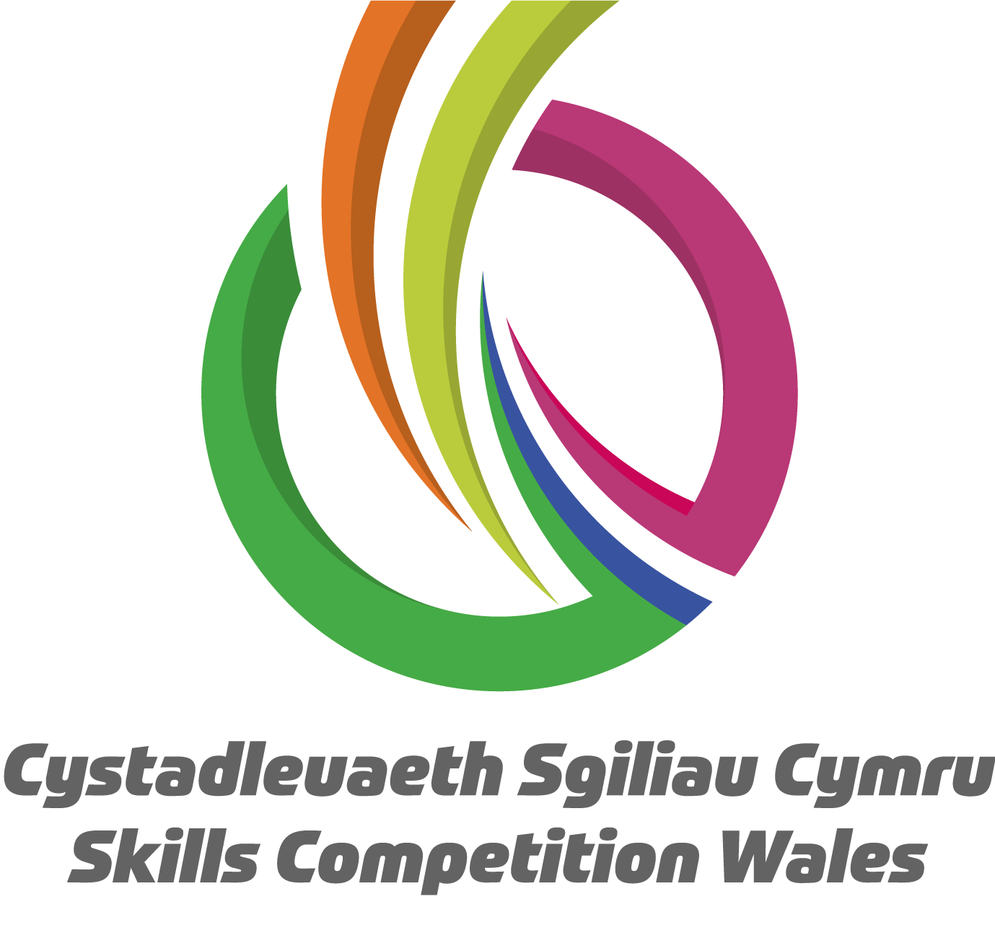

Briff y Gystadleuaeth

Teitl y Gystadleuaeth

Sgiliau Cynhwysol: Gofal Plant

Trosolwg o'r Gystadleuaeth

Mae cynorthwyydd gofal plant fel arfer yn ymwneud â gofal corfforol plant. Gyda phlant ifanc, mae hyn yn cynnwys eu bwydo, eu dal, eu cysuro a chwarae gyda nhw.

Bydd y gystadleuaeth yn cynnwys 3 gweithgaredd dros 2 awr.

Cynhelir rowndiau rhagbrofol byw mewn sawl lleoliad ledled Cymru.

Meini Prawf Cystadlu

Mae'r gystadleuaeth ar gyfer y rhai sy'n hyfforddi ar gyfer gyrfa mewn Gofal Plant a Gwaith Chwarae yn astudio tuag at gymhwyster Lefel 1 ag Angen Dysgu Ychwanegol cydnabyddedig a/neu rwystr i ddysgu.

Am arweiniad pellach ar gystadlaethau Sgiliau Cynhwysol, edrychwch ar y canllawiau sydd ar gael [yma](https://inspiringskills.gov.wales/competitions/competitor-support-guidance).

## Cyfyngiadau capasati mynediad fesul sefydliad

## Gellir cofrestru uchafswm o hyd at 3 fesul lleoliad. Gellir cofrestru cronfeydd wrth gefn hefyd i gyfrifon absenoldeb neu dynnu'n ôl os bydd angen.

Dyma uchafswm y nifer o gystadleuwyr a ganiateir o un sefydliad ar gyfer y gystadleuaeth hon. Caiff hyn ei benderfynu ar sail 'lleoliad' a 'sefydliad'. Mae’r 'sefydliad' yn cyfeirio at ddarparwr/cyflogwr hyfforddi'r cystadleuwyr. Mae’r 'lleoliad' yn cyfeirio at safle ble mae'r cystadleuydd yn astudio / cael ei gyflogi.

Gall y gystadleuaeth hon fod yn destun proses ddethol os yw'r niferoedd cofrestru cystadleuwyr yn fwy na chapasiti'r lleoliad cynnal. Lle nodir bod capasiti ar gyfer y gystadleuaeth, gellir gwahodd cystadleuwyr wrth gefn i gystadlu.

Bydd y penderfyniad yn cael ei wneud yn dilyn ymgynghoriad rhwng Cystadleuaeth Sgiliau Cymru ac arweinydd y gystadleuaeth ar ôl i'r cofrestru gau. Bydd pob parti yn cael gwybod am unrhyw newidiadau.

I gael rhagor o arweiniad ar y capasiti hyn, [cliciwch yma](https://inspiringskills.gov.wales/competitions/competition-registration-guide).

Briff

Bydd y cystadleuwyr yn cael cyflwyniad 10 munud gyda chyfle i ofyn cwestiynau ac yna bydd 1 awr ar gyfer cwblhau'r tri gweithgaredd

Sylwer: Rhaid i gystadleuwyr nodi'r ystod oedran y maent yn canolbwyntio arno cyn dechrau'r gweithgareddau yn y gystadleuaeth.

Gweithgaredd 1: Cynlluniwch Weithgaredd Chwarae

Tasg unigol: hyd at 30 munud

Rydych chi'n gweithio mewn lleoliad gofal plant. Mae un o'r plant yn mwynhau chwarae gyda dŵr. Mae gan y plentyn hwn anghenion synhwyraidd hefyd ac mae'n hoffi gweithgareddau tawel, digynnwrf. Eich tasg yw cynllunio gweithgaredd chwarae dŵr syml gan ddefnyddio'r deunyddiau a ddarperir. Dylai'r gweithgaredd helpu'r plentyn i archwilio a chael hwyl mewn ffordd ddiogel.

Cyfarwyddiadau’r Dasg:

* Dewiswch a sefydlwch adnoddau y gall y plentyn ei ddefnyddio i chwarae gyda dŵr.
* Esboniwch pam y gwnaethoch chi ddewis yr adnoddau hyn a sut maen nhw'n helpu'r plentyn.
* Cadwch yr ardal yn ddiogel ac yn daclus yn ystod ac ar ôl y gweithgaredd.
* Siaradwch am yr hyn a aeth yn dda a beth allech chi ei wneud yn wahanol y tro nesaf.

Byddwch yn cael eich beirniadu ar:

* Iechyd a Diogelwch.
* Dewis adnoddau.
* Pa mor dda rydych chi'n esbonio'ch dewisiadau.
* Taclusrwydd a threfniadaeth

Gweithgaredd 2: Gweithgaredd Maeth a Hydradu (*Hydration*). Dewiswch a pharatowch fyrbryd a diod addas ar gyfer plentyn bach.

Tasg unigol: hyd at 30 munud

Gofynnwyd i chi baratoi byrbryd (bwyd a diod) ar gyfer plentyn ifanc (hyd at dair oed). Mae'r rhieni wedi eich cynghori bod gan y plentyn anoddefiad lactos (*lactose intolerance*). Mae hylendid da yn bwysig iawn. Bydd dewis o fwyd a diod ar gael ym mhob lleoliad cystadlu.

Mae angen i chi:

* Gasglu’r offer sydd ei angen
* Golchi dwylo.
* Cymryd gofal i ddilyn [canllawiau Llywodraeth](https://help-for-early-years-providers.education.gov.uk/health-and-wellbeing/nutrition/children-aged-one-to-five-guidance) ar faeth a hydradu i blant
* Paratoi eitemau ar gyfer y plentyn
* Glanhau’r ardal

Byddwch yn cael eich beirniadau ar Iechyd a Diogelwch a’ch dewis o eitemau priodol.

Gweithgaredd 3: Cynllunio a gwneud offeryn cerdd synhwyraidd o ddeunyddiau wedi'u hailgylchu ar gyfer plentyn bach.

Tasg unigol: hyd at 60 munud

Gofynnir i chi wneud offeryn cerdd i'w ddefnyddio gyda phlentyn ifanc. Meddyliwch am eu synhwyrau cyffwrdd, golwg a sain. Rhoddir amrywiaeth o ddeunyddiau wedi'u hailgylchu/hen bethau i chi i greu eich offeryn. Bydd angen i chi ateb cwestiynau (ysgrifenedig neu ar ffurf cwestiwn ac ateb) am y dewisiadau a wnewch - ei ddiogelwch, a yw'n briodol ar gyfer yr oedran a chyfnod datblygu.

Bydd angen i chi:

* Ddewis adnoddau priodol
* Creu offeryn cerdd
* clirio eich man gwaith
* esbonio pam y gwnaethoch eich dewisiadau

Cewch eich beirniadu yn seiliedig ar iechyd a diogelwch a chyswllt â datblygiad.

Mae briffiau cystadleuaeth flaenorol ar gael i'w gweld a'u llwytho o’r wefan Cystadleuaeth Sgiliau Cymru, [cliciwch yma](https://inspiringskills.gov.wales/competitions/inclusive-skills-childcare/archives) i gael mynediad iddynt.

Rhestr Seilwaith

Bydd offer gofal plant yn cael ei ddarparu ym mhob rhagbrawf.

Rheolau’r Gystadleuaeth

Am yr holl delerau ac amodau ynghylch ymgeisio a rheolau cystadlu [ewch i](https://inspiringskills.gov.wales/terms/registrations-terms-and-conditions?lang=cy)

Marcio ac Asesu

Bydd tîm o arbenigwyr o'r Diwydiant, Addysg Bellach neu o’r Darparwr Hyfforddiant yn marcio ac yn beirniadu'r gystadleuaeth hon, gan ddefnyddio meini prawf marcio a marciau sydd wedi'u gosod i sicrhau cysondeb.

| Gweithgaredd | Disgrifiad | Marciau a ddyfarnwyd |
| --- | --- | --- |
| Gweithgaredd 1: Cynlluniwch Weithgaredd Chwarae | Iechyd a diogelwch, dewis adnoddau, esboniad o'ch dewisiadau, taclusrwydd a threfniadaeth | 40% |
| Gweithgaredd 2: Paratoi byrbryd ac yfed | Iechyd a diogelwch, golchi dwylo, offer, dewis eitemau yn briodol a’u paratoi. | 20% |
| Gweithgaredd 3: Offeryn cerdd synhwyraidd | Iechyd a diogelwch, priodoldeb, esboniad a chysylltiadau â datblygiad | 40% |
|  | Cyfanswm | 100% |

Adborth a Chydnabyddiaeth

Darperir adborth llafar yn unigol ac mewn grŵp ar ddiwedd y gystadleuaeth.

Ni fydd unrhyw ganlyniadau na gwobrau yn cael eu rhoi ar y diwrnod gan y bydd y marcio’n cynnwys elfen sicrwydd ansawdd.

Bydd pob cystadleuydd yn cael Tystysgrif Cyfranogi ar ddiwrnod y gystadleuaeth. Bydd gwobrau cyntaf, ail, trydydd a chanmoliaeth uchel yn cael eu cyhoeddi yn ystod y digwyddiad dathlu. Mae'r wobr canmoliaeth uchel yn cydnabod yr holl gystadleuwyr sydd wedi cyflawni sgôr uwch na'r cyfartaledd. Cynhelir y digwyddiad dathlu ar Dydd Mercher 18 Mawrth 2026, bydd manylion pellach yn cael eu rhoi i gystadleuwyr a'u pwyntiau cyswllt trwy e-bost.

Bydd taflenni marciau ar gael ar gais drwy info@skillscompetitionwales.ac.uk i gystadleuwyr ar ôl y digwyddiad dathlu.

Arweinydd y Gystadleuaeth

Becky Morris

[beckymorris@acttraining.org.uk](mailto:beckymorris@acttraining.org.uk)

Ein partneriaid

Mae'r gystadleuaeth hon yn cael ei chyflwyno mewn partneriaeth â

