Competition Brief

Competition Title

Inclusive Skills: Child Care

Competition Overview

A child care assistant is typically involved with the physical care of children. With infants, this involves feeding, changing, holding and comforting them. For toddlers, this may include toilet training and assisting with personal hygiene, like washing hands.

The competition will consist of 2 activities over 1½ hours, based on child development.

Entry Criteria

The competition is for the learners working towards Level 1.

Competitors must be 16 years of age or over.

## Please ensure your entrants have the skills and competencies to complete the task.

## Date - Between 25th January and 5th February.

## You will be allocated a date and further instructions once registration has closed.

## 

## Entry capacity restrictions by organisation

Maximum of up to 2 per location.

This is the maximum number of entries permitted by an organisation for this competition.

‘Organisation’ refers to the competitors’ training provider/employer. ‘Location’ refers to a site where the competitor studies / is employed. For further guidance on these capacities, click [here](https://www.skillscompetitionwales.ac.uk/terms/entry-capacity-restrictions-by-organisation)

Brief

The competition consists of two activities:

Activity 1: Create a poster on your favourite childhood book

Individual task: up to 30 minutes

Plan, prepare and create a Poster based on your favourite childhood book.

You will need to:

* 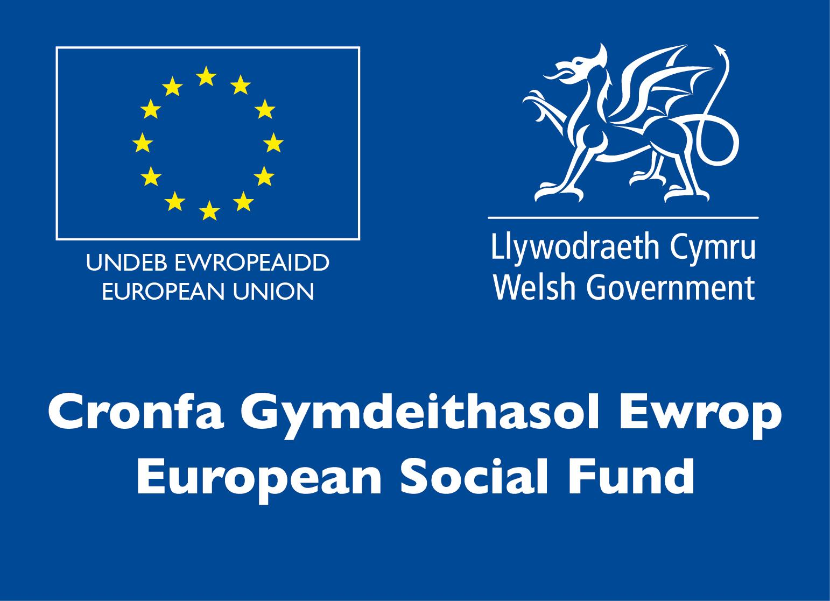Complete a plan
* Create a Poster

All necessary materials will be provided for you

Activity 2: Plan, prepare and create a Story Aid to go with your Poster

Individual task: up to 1 hour

You have been asked to create a story aid out of junk material to go with your poster.

You will need to:

* Complete a plan
* Create a story aid

The size of the story aid must fit in a small box of approx size 25cm (w) x 25cm (d) x 20 cm (h). All necessary materials will be provided for you.

Infrastructure List

Competitions will be undertaken at the competitors place of study, organisation and/or remotely. Funding will be available to support the provision of materials to all competitors.

Competition Rules

For full terms and conditions of entry and competition rules visit [www.skillscompetitionwales.ac.uk/terms-and-conditions](http://www.skillscompetitionwales.ac.uk/terms-and-conditions)

Marking and Assessment

Marking and judging of this competition will be carried out by a team of impartial judges, typically from industry, Further Education or Training Provider.

Feedback and Recognition

Individual and group verbal feedback will be provided at the end of the competition.

No results or awards will be awarded on the day as marking will be quality assured.

Certificates of Participation will be issued on the day.

Medallists will be invited to a Celebration Event which will be held in March 2021, where the First, Second and Third Awards will be presented.

Marksheets will be made available to unsuccessful competitors after the quality assurance process has been completed. Further details will be provided to all competitors upon notification of outcomes.

Competition Lead

Sarah Howells

Childcare Competition Lead

Coleg Sir Gar, Ammanford Campus, Dyffryn Road, Ammanford, SA18 3TA

01554 748322 [sarah.howells@colegsirgar.ac.uk](mailto:sarah.howells@colegsirgar.ac.uk)

Briff y Gystadleuaeth

Teitl y Gystadleuaeth

Sgiliau Cynhwysol: Gofal Plant

Trosolwg y Gystadleuaeth

Mae cynorthwyydd gofal plant fel arfer yn ymwneud â gofal corfforol plant. Gyda babanod, mae hyn yn cynnwys eu bwydo, eu newid, eu dal a'u cysuro. Ar gyfer plant bach, gall hyn gynnwys hyfforddiant toiled a chynorthwyo gyda hylendid personol, fel golchi dwylo.

Bydd y gystadleuaeth yn cynnwys dau weithgaredd dros gyfnod o 1½ awr, yn seiliedig ar ddatblygiad plant.

Meini Prawf Mynediad

Mae'r gystadleuaeth ar gyfer dysgwyr sy'n gweithio ar gyfer Lefel 1.

Rhaid i gystadleuwyr fod yn 16 oed neu hŷn.

Sicrhewch fod gan eich ymgeiswyr y sgiliau a'r cymwyseddau i gyflawni'r dasg a ddarperir.

Dyddiad - Rhwng 25 Ionawr a 5ed Chwefror.

Rhoddir dyddiad a chyfarwyddiadau pellach ichi ar ôl i'r cofrestriad gau.

Cyfyngiadau capasiti mynediad fesul sefydliad

Uchafswm o hyd at 2 y lleoliad.

Dyma uchafswm nifer yr ymgeiswyr a ganiateir gan sefydliad ar gyfer y gystadleuaeth hon.

Pennir hyn gan 'leoliad' a 'sefydliad'. Mae 'sefydliad' yn cyfeirio at ddarparwr hyfforddiant/cyflogwr y cystadleuwyr. Mae 'lleoliad' yn cyfeirio at safle lle mae'r cystadleuydd yn astudio / yn cael ei gyflogi. I gael rhagor o arweiniad ar y capasiti hyn, cliciwch yma

Briff

Mae'r gystadleuaeth yn cynnwys dau weithgaredd.

Gweithgaredd 1: Creu poster ar gyfer hoff lyfr o’ch plentyndod

Tasg unigol: hyd at 30 munud

Cynlluniwch, paratowch a chreu Poster yn seiliedig ar eich hoff lyfr pan yn blentyn.

Mae angen i chi:

● Gwblhau cynllun

● Creu Poster

Darperir yr holl ddeunyddiau angenrheidiol i chi

Gweithgaredd 2: Cynlluniwch, paratowch a chreu Cymorth Stori i gyd-fynd â’ch Poster

Tasg unigol: hyd at 1 awr

Gofynnir i chi greu cymorth stori allan o ddeunydd sbwriel i gyd-fynd â’ch poster.

Bydd angen i chi:

● Gwblhau cynllun

● Creu cymorth stori

Rhaid i’r cymorth stori allu ffitio mewn bocs bychan oddeutu 25cm (lled) x 25cm (dyfnder) x 20cm (taldra). Bydd yr holl ddeunyddiau angenrheidiol yn cael eu darparu ar eich cyfer.

Rhestr Seilwaith

Bydd cystadlaethau'n cael eu cynnal yn y man astudio, y sefydliad a/neu o bell. Bydd cyllid ar gael i gefnogi'r gwaith o ddarparu deunyddiau i bob cystadleuydd.

Rheolau Cystadlu

Am delerau ac amodau llawn rheolau mynediad a chystadlu ewch i https://inspiringskills.gov.wales/terms-and-conditions?lang=cy

Marcio ac Asesu

Fel arfer, tîm o feirniaid diduedd o feysydd Diwydiant, Addysg Bellach neu Ddarparwr Hyfforddiant fydd yn marcio ac yn barnu'r gystadleuaeth hon.

Adborth a Chydnabyddiaeth

Darperir adborth llafar i unigolion a grwpiau ar ddiwedd y gystadleuaeth.

Ni ddyfernir unrhyw ganlyniadau na dyfarniadau ar y diwrnod gan y bydd angen sicrhau ansawdd y marcio.

Cyflwynir Tystysgrifau Cyfranogi ar y diwrnod.

Gwahoddir enillwyr y medalau i Ddigwyddiad Dathlu a gynhelir ym mis Mawrth 2021, ble bydd y Wobr Gyntaf, Ail a Thrydedd yn cael eu cyflwyno.

Bydd taflenni marcio ar gael i gystadleuwyr aflwyddiannus ar ôl i'r broses sicrhau ansawdd gael ei chwblhau. Rhoddir rhagor o fanylion i bob cystadleuydd pan fyddant yn cael gwybod am ganlyniadau.

Arweinydd y Gystadleuaeth

Sarah Howells

Arweinydd Cystadleuaeth Gofal Plant

Coleg Sir Gâr, Campws Rhydaman, Ffordd Dyffryn, Rhydaman, SA18 3TA

01554 748322 sarah.howells@colegsirgar.ac.uk