**Competition Brief**

**Competition Title**

Forensic Science

**Competition Overview**

## Forensic scientists examine crime scenes to collect, preserve, and analyse scientific evidence during the course of an investigation. In addition to their laboratory role, forensic scientists testify as [expert witnesses](https://en.wikipedia.org/wiki/Expert_witness) by providing factual evidence in court, relating to both deliberate and accidental incidents. Their expertise and high standards are vital to ensure the guilty are prosecuted.

## 

## In this competition, competitors will be assessed on their understanding and knowledge of Forensic Science and its use within the United Kingdom criminal justice system. They will need to demonstrate the ability to maintain integrity and continuity throughout the examination, ensuring appropriate examination techniques and procedures are conducted at all times.

## Entry Criteria

## This competition is for those training for a career in Forensic Science and studying towards a Level 3 qualification or apprenticeship; including students who have completed Level 3 Qualification in the last 12 months.

## Please ensure your entrants have the skills and competencies to complete the tasks.

## 

## Entry capacity restrictions by organisation

Maximum of 3 entries per organisation.

This is the maximum number of entries permitted by an organisation for this competition.

This is determined by ‘location’ and ‘organisation’. ‘Organisation’ refers to the competitors’ training provider/employer. ‘Location’ refers to a site where the competitor studies / is employed. For further guidance on these capacities, click [here](https://www.skillscompetitionwales.ac.uk/terms/entry-capacity-restrictions-by-organisation)

**Brief**

## Cronfa Gymdeithasol Ewrop - European Social FundThis is an individual competition and will take 3 hours. The competition requires individuals to:

• Understand processes and systems used in the Forensic Science industry

• Identify and analyse evidence

• Understand evidential significance

• Use specialist equipment

• Utilise time management skills

• Consider all personal safety measures when working with crime scenes

The challenge will be based on a crime scenario where forensic opportunities exist to support the investigation. Competitors will be asked to complete two tasks during the competition. For the first task (lasting one hour) competitors will be based at the crime scene, and for the second task (two hour) they will work in a laboratory.

At the crime scene, Competitors will be required to maintain integrity and continuity throughout examination of the scene, ensuring appropriate examination techniques and procedures are conducted in accordance with the National Occupational Skills (NOS) competency framework.

The competitors must be mindful of the rules of evidence, chain of continuity and cross contamination as they identify evidence at the scene, and create a sketch of a standard that could be used in court.

Forensic scientific analysis of exhibits from the crime scene will take place in the second, laboratory based, task. Competitors are expected to risk assess this activity, and interpret their findings.

All exhibits will be entered onto Scene Logs, and analyses conducted on exhibits reported in the laboratory books as provided.

The use of outside influences or conferring with other competitors during this stage of the competition will result in disqualification.

**Infrastructure List**

All equipment, including protective clothing, will be provided for the tasks. You will also be provided with a notebook and essential stationary.

You may, but don’t have to, bring the following items:

• Your own (company branded) lab coat (must be clean!).

• Your own goggles (essential if you wear goggles with eye corrections).

Competitors will not be permitted to use the following during the competition:

• Mobile phones or any other devices with internet access (permitted during lunch break).

• Headphones.

If you have any allergies, e.g. to gloves, please advise the organisers well in advance so that they can arrange alternatives or grant permission for you to bring your own. It is at the discretion of the laboratory manager and lead judge to disallow competitors from entering the laboratory or exclude them from the competition, for example for any serious breaches of laboratory safety or inadequate clothing (e.g. flip-flops), or if there are health concerns.

**Competition Rules**

For full terms and conditions of entry and competition rules visit [www.inspiringskills.gov.wales/terms-and-conditions](http://www.skillscompetitionwales.ac.uk/terms-and-conditions)

**Generic competition rules**

• Mobile phones are to be switched off during competition activity.

• Listening to music via headphones is not permitted during competition activity.

• Any questions during competition activity should be addressed to the competition judging panel.

• Competitors should not communicate with other competitors during competition activity.

• It is the responsibility of each competitor to arrive on time for each competition session. No additional time will be allowed if you arrive late.

• Technical failure of your equipment should be reported immediately to the judging panel. Additional time will be allocated if the fault is beyond the control of the competitor.

**Marking and Assessment**

Marking and judging of this competition will be done by a team of experts from Industry, Further Education or Training Provider, using a marking criteria and allocated marks to ensure consistency.

The scene log/laboratory notebook needs to be completed with as much detail as possible, in English and in ink. It must be legible and all pages must be numbered with the total number of pages being inserted onto the bottom of each page. You will be handed this during the brief at the start of the competition.

**Breakdown of marking and assessment**

|  |  |  |
| --- | --- | --- |
| **Aspect** | **Criterion** | **Max Mark** |
| Organisation and Management | Clear understanding of correct use of crime scene logs, Maintenance of evidence continuity throughout the exercise, safety considered (including correct PPE), accurate laboratory record keeping | 10 |
| Evidence Selection | Ability to identify all the available forensic opportunities from the crime scene | 20 |
| Rough sketch | Date, time, names, location, measurements or log, clear sketch, key | 20 |
| Laboratory Techniques | Ability to analyse exhibits using correct scientific protocol | 40 |
| Analysis, Interpretation and evaluation | Ability to analyse, interpret and evaluate results of laboratory forensic analysis of exhibits | 10 |
|  | Total Marks | 100 |

**Feedback and Recognition**

Individual and Group verbal feedback will be provided at the end of the competition.

No results or awards will be awarded on the day as marking will be quality assured.

All competitors will be issued with a Participation Certificate and invited to an online Celebration Event which will be held Thursday 17th March 2022, where the First, Second and Third Awards will be announced. Further details will be communicated to competitors and their points of contacts by email.

Marksheets will be made available to competitors after the quality assurance process has been completed.

**Competition Lead**

**Lead Contact and Expert Contact**

Dr Amy Herbert

amy.herbert@gowercollegeswansea.ac.uk

**Briff y Gystadleuaeth**

**Teitl y Gystadleuaeth**

Gwyddoniaeth Fforensig

**Trosolwg o’r Gystadleuaeth**

## Mae gwyddonwyr fforensig yn archwilio safleoedd trosedd i gasglu, cadw a dadansoddi tystiolaeth wyddonol ar gyfer cynnal ymchwiliad. Yn ogystal â'u rôl mewn labordai, mae gwyddonwyr fforensig yn cyflwyno tystiolaeth fel tystion arbenigol drwy ddarparu tystiolaeth ffeithiol mewn llys barn. Bydd y dystiolaeth hon yn ymwneud â digwyddiadau bwriadol a damweiniol. Mae eu harbenigedd a'u safonau uchel yn hanfodol er mwyn sicrhau bod yr euog yn cael eu herlyn.

## Yn y gystadleuaeth hon, bydd cystadleuwyr yn cael eu hasesu ar eu dealltwriaeth a'u gwybodaeth o Wyddor Fforensig a'r defnydd o’r wyddor honno o fewn system cyfiawnder troseddol yn y Deyrnas Unedig. Bydd angen iddyn nhw ddangos y gallu i gynnal cywirdeb a dilyniant drwy gydol y gwaith archwilio, gan sicrhau bod technegau a gweithdrefnau archwilio priodol yn cael eu defnyddio bob amser.

**Meini Prawf Cystadlu**

Mae’r gystadleuaeth hon ar gyfer y rheini sy’n hyfforddi am yrfa mewn Gwyddoniaeth Fforensig ac sy’n astudio tuag at gymhwyster Lefel 3 neu brentisiaeth; gan gynnwys myfyrwyr sydd wedi cyflawni Cymhwyster Lefel 3 yn y 12 mis diwethaf.

Sicrhewch fod gan eich ymgeiswyr y sgiliau a’r cymwyseddau i gyflawni’r tasgau.

**Cyfyngiadau ar nifer y ceisiadau fesul sefydliad**

Uchafswm o hyd at 3 fesul sefydliad.

Dyma’r uchafswm o geisiadau a ganiateir gan unrhyw sefydliad am y gystadleuaeth hon.

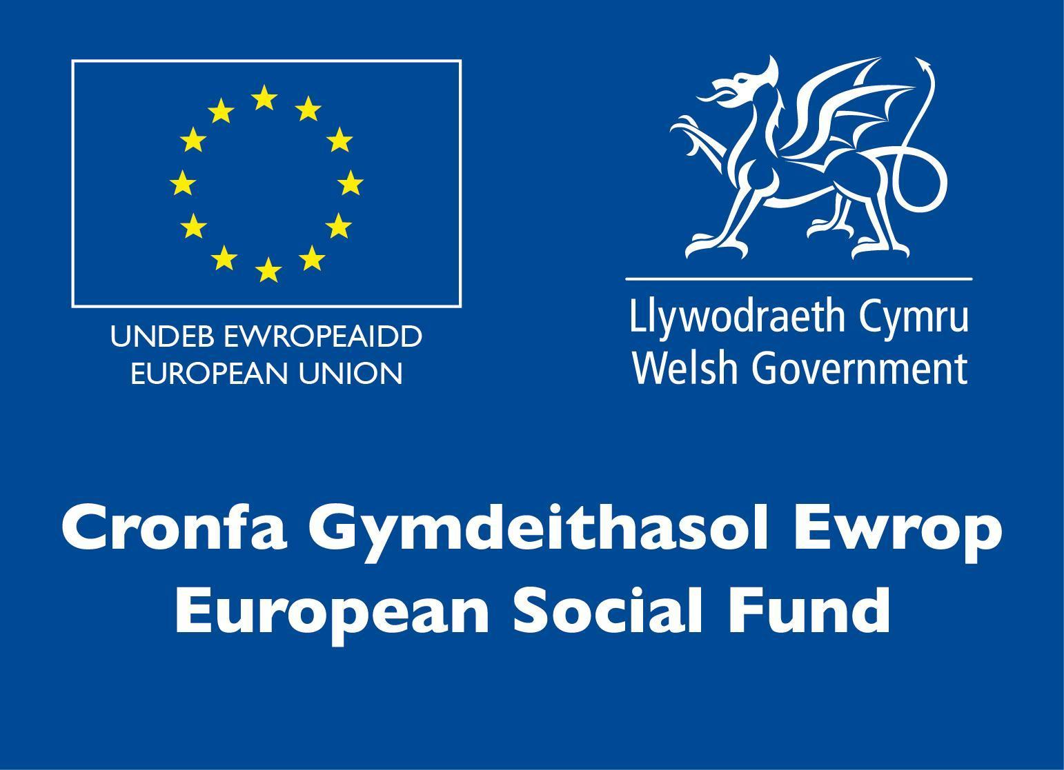Mae hyn yn cael ei bennu fesul ‘lleoliad’ a ‘sefydliad’.  Mae ‘Sefydliad’ yn cyfeirio at ddarparwr hyfforddiant/cyflogwr y cystadleuydd. Mae ‘Lleoliad’ yn cyfeirio at le mae’r cystadleuydd yn astudio / cael ei gyflogi. Am fwy o arweiniad ar y niferoedd hyn, cliciwch [yma](https://www.skillscompetitionwales.ac.uk/terms/entry-capacity-restrictions-by-organisation)

**Briff**

## Cystadleuaeth ar gyfer unigolion yw hon ac mae’n para 3 awr. Mae’r gystadleuaeth hon yn gofyn bod unigolion yn:

• Deall y prosesau a’r systemau a ddefnyddir yn y diwydiant Gwyddoniaeth Fforensig

• Nodi a dadansoddi tystiolaeth

• Deall arwyddocâd tystiolaethol

• Defnyddio offer arbenigol

• Defnyddio sgiliau rheoli amser

• Ystyried pob mesur diogelwch wrth weithio gyda safleoedd trosedd

Bydd yr her yn seiliedig ar senario o drosedd ble mae cyfleoedd fforensig yn bodoli i helpu’r ymchwiliad. Gofynnir i gystadleuwyr gyflawni dwy dasg yn ystod y gystadleuaeth. Am y dasg gyntaf (sy’n para un awr) bydd y cystadleuwyr wedi’u lleoli wrth y safle trosedd, ac am yr ail dasg (dwy awr) byddant yn gweithio mewn labordy.

Wrth y safle trosedd, bydd angen i’r cystadleuwyr gynnal cywirdeb a dilyniant drwy gydol yr archwiliad, gan sicrhau y caiff technegau a gweithdrefnau archwilio priodol eu defnyddio yn unol â fframwaith cymhwysedd y Safonau Galwedigaethol Cenedlaethol (NOS).

Mae’n rhaid i gystadleuwyr fod yn ystyriol o’r rheolau tystiolaeth, cadwyn cystodaeth a chroes-halogi wrth iddynt nodi tystiolaeth o’r safle trosedd, a chreu braslun o safon y gellid ei defnyddio mewn llys.

Am yr ail dasg, mewn labordy, cynhelir dadansoddiad gwyddonol fforensig ar arddangosion o’r safle trosedd. Bydd disgwyl i gystadleuwyr gynnal asesiad risg am y gweithgaredd hwn a dehongli’r canlyniadau.

Mae’n rhaid cofnodi pob arddangosyn yn y Cofnodion Safle a chofnodi unrhyw ddadansoddi a gynhaliwyd o’r arddangosion yn y llyfrau labordy a ddarperir.

Bydd defnyddio dylanwadau allanol neu ymgynghori â chystadleuwyr eraill yn ystod y cam hwn o’r gystadleuaeth yn arwain at waharddiad.

**Rhestr Seilwaith**

Darperir yr holl offer, gan gynnwys dillad diogelwch, ar gyfer y tasgau. Byddwch hefyd yn cael llyfr nodiadau ac offer ysgrifennu angenrheidiol.

Cewch hefyd ddod â’r eitemau canlynol gyda chi (ond nid yw’n angenrheidiol):

• Eich cot labordy (lân!) eich hun (gyda logo eich cwmni).

• Eich goglau eich hun (angenrheidiol os ydych chi’n gwisgo goglau sy’n cywiro

eich llygaid).

Ni chaniateir i gystadleuwyr ddefnyddio’r offer canlynol yn ystod y gystadleuaeth:

• Ffonau symudol neu unrhyw ddyfeisiau eraill sy’n gallu cyrchu’r we (caniateir yn ystod yr awr ginio).

• Clustffonau.

Os oes gennych unrhyw alergeddau e.e. i fenyg, dywedwch wrth y trefnwyr ymhell ymlaen llaw fel y gallan nhw wneud trefniadau eraill neu roi caniatâd i chi ddod â’ch rhai eich hun. Cyfrifoldeb rheolwr y labordy a’r prif feirniad yw penderfynu gwahardd cystadleuwyr rhag dod i mewn i’r labordy neu eu diarddel o’r gystadleuaeth, e.e. am dorri rheolau diogelwch y labordy neu am ddillad anaddas (e.e. fflip-fflops), neu os oes pryderon am iechyd.

**Rheolau’r Gystadleuaeth**

Am restr gyflawn o delerau ac amodau cystadlu a rheolau’r gystadleuaeth ewch i [www.inspiringskills.gov.wales/terms-and-conditions](http://www.skillscompetitionwales.ac.uk/terms-and-conditions)

**Rheolau cyffredinol y gystadleuaeth**

* Dylid diffodd ffonau symudol yn ystod y gystadleuaeth.
* Ni chaniateir gwrando ar gerddoriaeth gyda chlustffonau yn ystod y gystadleuaeth.
* Dylid cyfeirio unrhyw gwestiynau yn ystod y gystadleuaeth at y panel beirniaid.
* Ni ddylai’r cystadleuwyr gyfathrebu gyda chystadleuwyr eraill yn ystod y gystadleuaeth.
* Cyfrifoldeb pob cystadleuydd fydd cyrraedd ar amser ar gyfer pob rhan o’r gystadleuaeth. Pe baech yn cyrraedd yn hwyr, ni roddir amser ychwanegol ichi.
* Pe bai rhyw wall technegol ar eich offer, dylid rhoi gwybod i’r panel beirniaid yn syth. Bydd amser ychwanegol yn cael ei roi os bydd y gwall y tu hwnt i reolaeth y cystadleuydd.

**Marcio ac Asesu**

Bydd tîm o arbenigwyr o Ddiwydiant, Addysg Bellach neu Ddarparwyr Hyfforddiant yn marcio a beirniadu’r gystadleuaeth hon, gan ddefnyddio meini prawf marcio a marciau a dyrennir er mwyn sicrhau cysondeb.

Mae’n rhaid llenwi’r cofnod safle/llyfr labordy gyda chymaint o fanylion â phosibl, yn Saesneg ac mewn inc. Mae’n rhaid iddo fod yn ddarllenadwy ac mae’n rhaid rhifo pob tudalen a rhoi cyfanswm nifer y tudalennau ar waelod pob tudalen. Caiff hwn ei roi i chi yn ystod y sesiwn briffio ar ddechrau’r gystadleuaeth.

**Manylion marcio ac asesu**

|  |  |  |
| --- | --- | --- |
| **Elfen** | **Maen Prawf** | **Marc Mwyaf** |
| Trefnu a Rheoli | Dealltwriaeth glir o sut mae defnyddio cofnodion safle trosedd yn gywir, Cadw dilyniant tystiolaeth drwy gydol yr archwiliad, ystyried diogelwch (gan gynnwys y Cyfarpar Diogelwch Personol priodol), cadw cofnodion labordy cywir | 10 |
| Dewis Tystiolaeth | Gallu nodi’r holl gyfleoedd fforensig sydd ar gael yn y safle trosedd | 20 |
| Braslun | Dyddiad, amser, enwau, lleoliad, mesurau neu gofnod, braslun clir, allwedd | 20 |
| Techneg Labordy | Gallu dadansoddi arddangosion gan ddefnyddio’r protocol gwyddonol cywir | 40 |
| Dadansoddi, Dehongli a gwerthuso | Gallu dadansoddi, dehongli a gwerthuso canlyniadau sy’n deillio o ddadansoddiad fforensig labordy yr arddangosion | 10 |
|  | Cyfanswm y Marciau | 100 |

**Adborth a Chydnabyddiaeth**

Bydd adborth llafar, yn unigol ac mewn grŵp, yn cael ei roi ar ddiwedd y gystadleuaeth.

Ni fydd unrhyw ganlyniadau na gwobrau’n cael eu dyfarnu ar y diwrnod oherwydd bydd angen sicrhau ansawdd y marcio.

Bydd pob ymgeisydd yn derbyn Tystysgrif Cyfranogi ynghyd â gwahoddiad i Achlysur Dathlu ar-lein a gynhelir ar Ddydd Iau 17 Mawrth 2022, lle y bydd y Gwobrau Cyntaf, Ail a Thrydydd yn cael eu cyhoeddi.  Bydd manylion pellach yn cael eu cyfathrebu i gystadleuwyr a’u personau cyswllt trwy e-bost.

Bydd taflenni marciau ar gael i gystadleuwyr ar ôl cwblhau’r broses sicrhau ansawdd.

**Arweinwyr y Gystadleuaeth**

**Prif Gyswllt a Chysylltiad Arbenigol**

Dr Amy Herbert

amy.herbert@gowercollegeswansea.ac.uk