**Competition Brief**

**Competition Title**

Forensic Science

**Competition Overview**

## Forensic scientists examine crime scenes to collect, preserve, and analyse scientific evidence during the course of an investigation. In addition to their laboratory role, forensic scientists testify as [expert witnesses](https://en.wikipedia.org/wiki/Expert_witness) by providing factual evidence in court, relating to both deliberate and accidental incidents. Their expertise and high standards are vital to ensure the guilty are prosecuted.

## 

## In this competition, competitors will be assessed on their understanding and knowledge of Forensic Science and its use within the United Kingdom criminal justice system. They will need to demonstrate the ability to maintain integrity and continuity throughout the examination, ensuring appropriate examination techniques and procedures are conducted at all times.

## 

## Entry Criteria

## This competition is for those training for a career in Forensic Science and studying towards a Level 3 qualification or apprenticeship; including students who have completed Level 3 Qualification in the last 12 months.

## Please ensure your entrants have the skills and competencies to complete the tasks.

## 

## Entry capacity restrictions by organisation

Maximum of 3 entries per organisation.

This is the maximum number of entries permitted by an organisation for this competition.

This is determined by ‘location’ and ‘organisation’. ‘Organisation’ refers to the competitors’ training provider/employer. ‘Location’ refers to a site where the competitor studies / is employed. For further guidance on these capacities, click [here](https://www.skillscompetitionwales.ac.uk/terms/entry-capacity-restrictions-by-organisation)

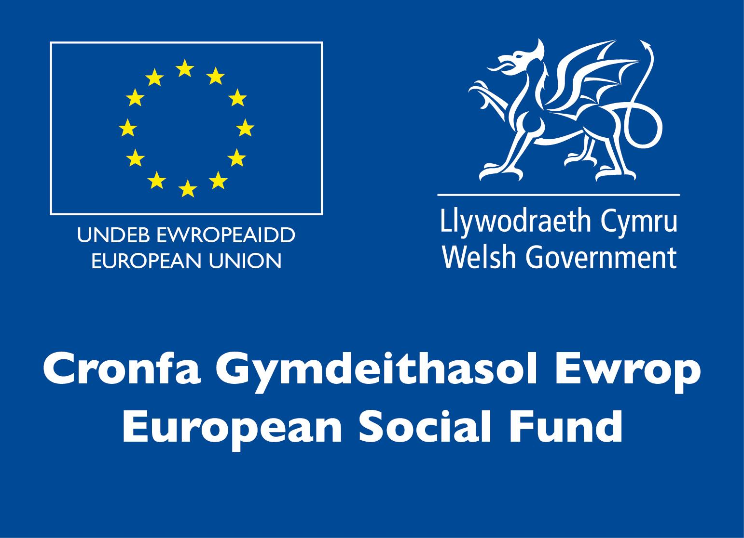**Brief**

## This is an individual competition and will take 3 hours. The competition requires individuals to:

• Understand processes and systems used in the Forensic Science industry

• Identify and analyse evidence

• Understand evidential significance

• Use specialist equipment

• Utilise time management skills

• Consider all personal safety measures when working with crime scenes

The challenge will be based on a crime scenario where forensic opportunities exist to support the investigation. Competitors will be asked to complete two tasks during the competition. Both tasks will be based around a virtual crime scene.

At the virtual crime scene, Competitors will need to consider how integrity and continuity could be maintained throughout examination of the scene, and describe how they would use appropriate examination techniques and procedures in accordance with the National Occupational Skills (NOS) competency framework.

The competitors must be mindful of the rules of evidence, chain of continuity and cross contamination as they identify evidence for collection at the scene, and create a sketch of a standard that could be used in court.

All exhibits will be entered onto digital Scene Logs, along with a description of the analyses that would be conducted on exhibits.

The use of outside influences or conferring with other competitors during this stage of the competition will result in disqualification.

**Infrastructure List**

You will require a computer or digital device with internet access (to view videos and photographs of the crime scene) on the day. You will also need Microsoft Word to complete your crime scene report and a camera, graph paper/paper, ruler & pencil (should you wish to upload a hand drawn sketch of the crime scene into your report).

**Competition Rules**

For full terms and conditions of entry and competition rules visit [www.skillscompetitionwales.ac.uk/terms-and-conditions](http://www.skillscompetitionwales.ac.uk/terms-and-conditions)

**Generic competition rules**

• Mobile phones are to be switched off during competition activity.

• Any questions during competition activity should be addressed to the competition judging panel.

• Competitors should not communicate with other competitors during competition activity.

• It is the responsibility of each competitor to arrive on time for each competition session. No additional time will be allowed if you arrive late.

• Technical failure of your equipment should be reported immediately to the judging panel. Additional time will be allocated if the fault is beyond the control of the competitor.

**Marking and Assessment**

Marking and judging of this competition will be done by a team of experts from Industry, Further Education or Training Provider, using a marking criteria and allocated marks to ensure consistency.

The scene report/sketch needs to be completed with as much detail as possible, in English. It must be legible and all pages must be numbered with the total number of pages being inserted onto the bottom of each page. You will be given the crime scene report template during the brief at the start of the competition.

**Breakdown of marking and assessment**

|  |  |  |
| --- | --- | --- |
| **Aspect** | **Criterion** | **Max Mark** |
| Organisation and Management | Clear understanding of correct use of crime scene logs, Maintenance of evidence continuity throughout the exercise, safety considered (including correct PPE), accurate laboratory record keeping | 30 |
| Evidence Selection | Ability to identify all the available forensic opportunities from the crime scene | 20 |
| Rough sketch | Date, time, names, location, measurements or log, clear sketch, key | 20 |
| LaboratoryTechniques | Ability to identify correct scientific protocol for analysis of exhibits | 20 |
| Analysis, Interpretation and evaluation | Ability to analyse, interpret and evaluate results of laboratory forensic analysis of exhibits | 10 |
|  | Total Marks | 100 |

**Feedback and Recognition**

Individual and Group verbal feedback will be provided at the end of the competition.

No results or awards will be awarded on the day, as marking will be quality assured.

Certificates of Participation will be issued on the day.

Medallists will be invited to a Celebration Event which will be held in March 2021, where the First, Second and Third Awards will be presented.

Marksheets will be made available to unsuccessful competitors after the quality assurance process has been completed. Further details will be provided to all competitors upon notification of outcomes.

**Competition Lead**

**Lead Contact and Expert Contact**

Dr Amy Herbert

[amy.herbert@gowercollegeswansea.ac.uk](mailto:amy.herbert@gowercollegeswansea.ac.uk)

**Briff y Gystadleuaeth**

**Teitl y Gystadleuaeth**

Gwyddoniaeth Fforensig

**Trosolwg o'r Gystadleuaeth**

Mae gwyddonwyr fforensig yn archwilio safleoedd troseddu i gasglu, cadw a dadansoddi tystiolaeth wyddonol yn ystod ymchwiliad. Yn ogystal â'u rôl labordy, mae gwyddonwyr fforensig yn tystio fel tystion arbenigol <https://en.wikipedia.org/wiki/Expert_witness> drwy ddarparu tystiolaeth ffeithiol yn y llys, sy'n ymwneud â digwyddiadau bwriadol a damweiniol. Mae eu harbenigedd a'u safonau uchel yn hanfodol er mwyn sicrhau bod yr euog yn cael ei erlyn.

Yn y gystadleuaeth hon, bydd cystadleuwyr yn cael eu hasesu ar eu dealltwriaeth a'u gwybodaeth o Wyddoniaeth Fforensig a'i defnydd o fewn system cyfiawnder troseddol y Deyrnas Unedig. Bydd angen iddyn nhw arddangos y gallu i gynnal uniondeb a pharhad drwy gydol yr archwilio, gan sicrhau bod technegau a gweithdrefnau archwilio priodol yn cael eu cynnal bob amser.

**Meini Prawf Mynediad**

Mae'r gystadleuaeth hon ar gyfer y rhai sy'n hyfforddi ar gyfer gyrfa mewn Gwyddoniaeth Fforensig ac yn astudio tuag at gymhwyster Lefel 3 neu brentisiaeth; gan gynnwys myfyrwyr sydd wedi cwblhau Cymhwyster Lefel 3 yn ystod y 12 mis diwethaf.

Sicrhewch fod gan eich ymgeiswyr y sgiliau a'r cymwyseddau i gyflawni'r dasg a ddarperir.

**Cyfyngiadau capasiti mynediad fesul sefydliad**

Uchafswm o 3 ymgeisydd fesul sefydliad.

Dyma uchafswm nifer yr ymgeiswyr a ganiateir gan sefydliad ar gyfer y gystadleuaeth hon.



Pennir hyn gan 'leoliad' a 'sefydliad'. Mae 'sefydliad' yn cyfeirio at ddarparwr/cyflogwr hyfforddiant y cystadleuwyr. Mae 'lleoliad' yn cyfeirio at safle lle mae'r cystadleuydd yn astudio / yn cael ei gyflogi. I gael rhagor o arweiniad ar y capasiti hyn, cliciwch [here](https://www.skillscompetitionwales.ac.uk/terms/entry-capacity-restrictions-by-organisation)

**Briff**

## Cystadleuaeth unigol yw hon a bydd yn cymryd 3 awr. Mae'r gystadleuaeth yn ei gwneud yn ofynnol i unigolion:

• Deall prosesau a systemau a ddefnyddir yn y diwydiant Gwyddoniaeth Fforensig

• Nodi a dadansoddi tystiolaeth

• Deall arwyddocâd tystiolaethol

• Defnyddio offer arbenigol

• Defnyddio sgiliau rheoli amser

• Ystyried yr holl fesurau diogelwch personol wrth weithio gyda safleoedd troseddu

Bydd yr her yn seiliedig ar safle troseddu lle mae cyfleoedd fforensig yn bodoli i gefnogi'r ymchwiliad. Gofynnir i gystadleuwyr gwblhau dwy dasg yn ystod y gystadleuaeth. Bydd y ddwy dasg yn seiliedig ar safle troseddau rhithwir.

Yn y maes troseddau rhithwir, bydd cystadleuwyr angen ystyried sut gall uniondeb a pharhad gael eu cynnal drwy gydol archwiliad o'r safle, a disgrifio sut y byddent yn defnyddio technegau a gweithdrefnau archwilio priodol yn unol â fframwaith cymwyseddau'r Sgiliau Galwedigaethol Cenedlaethol.

Rhaid i'r cystadleuwyr gofio rheolau tystiolaeth, cadwyn o barhad a chroes-halogi wrth iddynt nodi tystiolaeth i'w gasglu yn y fan a'r lle, a chreu braslun o safon y gellid ei defnyddio yn y llys.

Bydd yr holl arddangosion yn cael eu cofnodi ar Gofnodion Safle, ynghyd â disgrifiad o'r dadansoddiadau a fyddai'n cael eu cynnal ar arddangosion.

Bydd defnyddio dylanwadau allanol neu drafod gyda chystadleuwyr eraill yn ystod y cam hwn o'r gystadleuaeth yn arwain at anghymhwyso.

**Rhestr Seilwaith**

Bydd angen cyfrifiadur neu ddyfais ddigidol arnoch gyda mynediad i'r rhyngrwyd (i weld fideos a ffotograffau o'r safle troseddu) ar y diwrnod. Bydd hefyd angen Microsoft Word arnoch i gwblhau eich adroddiad ar y safle trosedd a chamera, papur graff/papur, mesurydd a phensil (os hoffech lanlwytho braslun llaw o'r safle droseddu yn eich adroddiad).

**Rheolau Cystadlu**

Am delerau ac amodau llawn rheolau mynediad a chystadleuaeth ewch i <http://www.skillscompetitionwales.ac.uk/terms-and-conditions>

**Rheolau cystadleuaeth gyffredinol**

* Rhaid diffodd ffonau symudol yn ystod y gystadleuaeth.
* Dylid cyfeirio unrhyw gwestiynau yn ystod gweithgaredd cystadlu at banel beirniaid y gystadleuaeth.
* Ni ddylai cystadleuwyr gyfathrebu â chystadleuwyr eraill yn ystod y gystadleuaeth.
* Cyfrifoldeb pob cystadleuydd yw cyrraedd mewn pryd ar gyfer pob sesiwn gystadlu. Ni chaniateir unrhyw amser ychwanegol os byddwch chi'n cyrraedd yn hwyr.
* Pe bai unrhyw nam technegol ar eich offer, dylid rhoi gwybod i’r panel beirniaid yn syth. Dyrennir amser ychwanegol os yw'r nam y tu hwnt i reolaeth y cystadleuydd.

**Marcio ac Asesu**

Bydd marcio a beirniadu'r gystadleuaeth hon yn cael ei wneud gan dîm o arbenigwyr o’r diwydiant, darparwyr addysg bellach neu hyfforddiant, gan ddefnyddio meini prawf marcio a marciau a ddyrannwyd i sicrhau cysondeb.

Mae angen cwblhau'r adroddiad/braslun o'r cefndir gyda chymaint o fanylion â phosibl, yn Saesneg. Rhaid iddo fod yn ddarllenadwy a rhaid rhifo pob tudalen gyda chyfanswm nifer y tudalennau'n cael eu mewnosod ar waelod pob tudalen. Cewch dempled adroddiad safle trosedd yn ystod y brîff ar ddechrau'r gystadleuaeth.

**Dadansoddiad o'r marcio a'r asesu**

|  |  |  |
| --- | --- | --- |
| Agwedd | Maen Prawf | Marc Uchaf |
| Trefniadaeth a Rheolaeth | Dealltwriaeth glir o'r defnydd cywir o gofnodion safleoedd troseddau, Cynnal parhad tystiolaeth drwy gydol yr ymarfer, ystyriaeth i ddiogelwch (gan gynnwys PPE cywir), cadw cofnodion labordy cywir | 30 |
| Dewis Tystiolaeth | Y gallu i nodi'r holl gyfleoedd fforensig sydd ar gael o'r safle trosedd | 20 |
| Braslun | Dyddiad, amser, enwau, lleoliad, mesuriadau neu gofnod, braslun clir, allwedd | 20 |
| Technolegau Labordy | Y gallu i nodi'r protocol gwyddonol cywir ar gyfer dadansoddi arddangosion | 20 |
| Dadansoddi, Dehongli a gwerthuso | Y gallu i ddadansoddi, dehongli a gwerthuso canlyniadau dadansoddiad fforensig labordy o arddangosion | 10 |
|  | Cyfanswm marciau | 100 |

**Adborth a Chydnabyddiaeth**

Darperir adborth llafar i unigolion a grwpiau ar ddiwedd y gystadleuaeth.

Ni ddyfernir unrhyw ganlyniadau na dyfarniadau ar y diwrnod gan y bydd angen sicrhau ansawdd y marcio.

Cyflwynir Tystysgrifau Cyfranogi ar y diwrnod.

Gwahoddir enillwyr y medalau i Ddigwyddiad Dathlu a gynhelir ym mis Mawrth 2021, ble bydd y Wobr Gyntaf, Ail a Thrydedd yn cael eu cyflwyno.

Bydd taflenni marcio ar gael i gystadleuwyr aflwyddiannus ar ôl i'r broses sicrhau ansawdd gael ei chwblhau. Rhoddir rhagor o fanylion i bob cystadleuydd pan fyddant yn cael gwybod am ganlyniadau.

**Arweinydd y Gystadleuaeth**

Cyswllt Arweiniol a Chyswllt Arbenigol

Dr Amy Herbert

[amy.herbert@gowercollegeswansea.ac.uk](mailto:amy.herbert@gowercollegeswansea.ac.uk)