**Competition Brief**

**Competition Title**

Electrical Installation

**Competition Overview**

An Electrician instals, repairs and maintains modern electrical systems and equipment; keeping them running efficiently and effectively. These systems can be located in all environments; domestic, commercial or industrial.

In this competition, competitors will have to carry out an electrical installation task designed to challenge their ability to follow drawings, work accurately and to work safely at all times, working to a set timescale.

Live competition heats will be held at various venues across Wales.

**Entry Criteria**

The competition is for those studying towards but not yet achieved Level 3 for a career in the construction industry and studying towards an Electrical Installation qualification or apprenticeship. Please ensure that your entrants have attempted the competition drawing and have the required skills and competences to complete the task.

**Entry capacity restrictions by organisation**

Each organisation may register a maximum of **3 competitors per location** for this competition. **Reserves** may also be registered to account for potential absences or withdrawals.

This is the maximum number of entries permitted by an organisation for this competition. This is determined by ‘location’ and ‘organisation’. ‘Organisation’ refers to the competitors’ training provider/employer. ‘Location’ refers to a site where the competitor studies / is employed.

This competition may be subject to a selection process if competitor registration numbers exceed the host venue capacity. Where capacity is identified in a competition the reserve competitors may be invited to compete.

The decision will be made following a consultation between Skills Competition Wales and the competition lead after registration closes. All parties will be notified of any changes.

For further guidance on these capacities, [click here](https://inspiringskills.gov.wales/competitions/competition-registration-guide).

**Task Duration**

5 Hours

**Brief**

Competitors will be given a drawing and a specification requiring them to carry out an electrical installation task and to carry out testing on the completed work.

Competitors will be assessed on the following criteria:

* Working Safely
* Positioning of equipment
* Wiring and termination
* Installation Quality
* Inspection and testing
* Function (bell test)

Note: There will be no requirement to power up completed work

Previous competition briefs are available to view and download via the Skills Competition Wales website, please [click here](https://inspiringskills.gov.wales/competitions/electrical-installation/archives) to access.

**Infrastructure List**

Competitors must bring all of their own tools required for the task. Please note: if a knife is needed, only electricians’ knives are permitted—no other types of knife may be used. Workbenches will be provided at the venue.

**Competition Rules**

For full terms and conditions of entry and competition rules [visit](https://inspiringskills.gov.wales/terms/registrations-terms-and-conditions).

**Generic competition rules**

* Mobile phones are to be switched off during competition activity.
* Listening to music via headphones is not permitted during competition activity.
* Any questions during competition activity should be addressed to the competition judging panel.
* Competitors should not communicate with other competitors during competition activity.
* It is the responsibility of each competitor to arrive on time for each competition session. No additional time will be allowed if you arrive late.
* Technical failure of your equipment should be reported immediately to the judging panel. Additional time will be allocated if the fault is beyond the control of the competitor.

**Marking and Assessment**

Marking and judging of this competition will be carried out by a team of experts from industry, further education or training providers, using marking criteria and allocated marks to ensure consistency.

**Brief breakdown of marking and assessment**

All marks are objective and will be awarded by the judges as follows:

| **Criteria** | **Marks** |
| --- | --- |
| Health & Safety | 5% |
| Installation Quality | 15% |
| Positioning of Equipment | 24% |
| Wiring & Terminations | 28% |
| Inspect & Test | 15% |
| Function | 13% |
| **Total** | **100%** |

**Feedback and Recognition**

Individual and Group verbal feedback will be provided at the end of the competition. No results or awards will be awarded on the day as marking will be quality assured.

All competitors will be issued with a Participation Certificate on the competition day. First, second, third and highly commended awards will be announced during the celebration event. The highly commended award recognises all competitors who have achieved above average. The celebration event will be held on Wednesday 18th March 2026, further details will be communicated to competitors and their points of contact by email.

Marksheets will be available upon request via [info@skillscompetitionwales.ac.uk](mailto:info@skillscompetitionwales.ac.uk) to competitors after the celebration event.

**Competition Lead**

**Lead Contact:** Lewis Jones

Email address - [L.Jones1@merthyr.ac.uk](mailto:L.Jones1@merthyr.ac.uk)

**Our partners**

This competition is delivered in partnership with

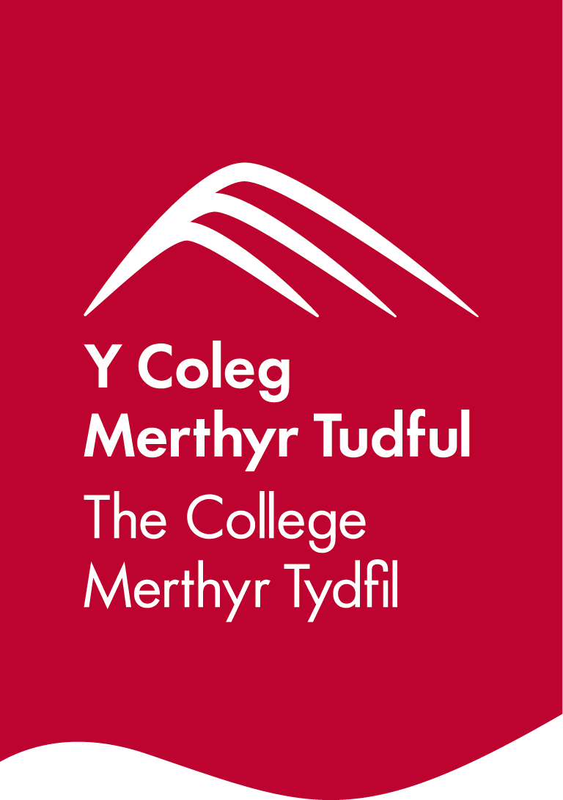

**Briff y Gystadleuaeth**

**Enw’r Gystadleuaeth**

Gosod Systemau Trydanol

**Trosolwg o’r Gystadleuaeth**

Mae Trydanwr yn gosod, trwsio a chynnal a chadw systemau ac offer trydanol modern; ac yn sicrhau eu bod yn gweithio’n effeithiol ac effeithlon. Gellir dod o hyd i’r systemau hyn ym mhob amgylchedd; mewn cartrefi, yn fasnachol neu’n ddiwydiannol.

Yn y gystadleuaeth hon, bydd rhaid i gystadleuwyr gyflawni tasg gosod systemau trydanol a fydd yn herio eu gallu i ddilyn lluniau, gweithio’n gywir a gweithio’n ddiogel bob amser, o fewn amserlen benodedig.

Cynhelir rowndiau rhagbrofol byw mewn sawl lleoliad ledled Cymru.

**Meini Prawf**

Mae'r gystadleuaeth ar gyfer y rhai sy'n astudio tuag at ond heb gyrraedd Lefel 3 ar gyfer gyrfa yn y diwydiant adeiladu ac yn astudio tuag at gymhwyster Gosod Trydanol neu brentisiaeth.

Gwnewch yn siŵr bod eich ymgeiswyr wedi rhoi tro ar y gystadleuaeth ac fod ganddyn nhw’r sgiliau a'r cymwyseddau angenrheidiol i gwblhau'r dasg.

**Cyfyngiadau ymgeisio gan sefydliad**

Gall pob sefydliad gofrestru **uchafswm o 4 cystadleuydd ym mhob lleoliad** ar gyfer y gystadleuaeth hon. Gellir cofrestru **cronfeydd wrth gefn** hefyd i gyfrifon absenoldeb neu dynnu'n ôl os bydd angen.

Dyma’r uchafswm o gystadleuwyr a ganiateir gan sefydliad ar gyfer y gystadleuaeth hon.

Caiff hyn ei benderfynu ar sail ‘lleoliad’ a ‘sefydliad’. Mae ‘sefydliad’ yn cyfeirio at ddarparwr hyfforddiant/cyflogwr y cystadleuwyr. Mae ‘lleoliad’ yn cyfeirio at y safle lle mae’r cystadleuydd yn astudio/cael ei gyflogi.

Gall y gystadleuaeth hon fod yn destun proses ddethol os yw'r niferoedd cofrestru cystadleuwyr yn fwy na chapasiti'r lleoliad cynnal. Lle nodir bod capasiti ar gyfer y gystadleuaeth, gellir gwahodd cystadleuwyr wrth gefn i gystadlu.

Bydd y penderfyniad yn cael ei wneud yn dilyn ymgynghoriad rhwng Cystadleuaeth Sgiliau Cymru ac arweinydd y gystadleuaeth ar ôl i'r cofrestru gau. Bydd pob parti yn cael gwybod am unrhyw newidiadau.

Am ragor o arweiniad ar y canllawiau hyn, [cliciwch yma](https://inspiringskills.gov.wales/competitions/competition-registration-guide).

**Hyd y Dasg**

5 Awr

**Briff**

Caiff y cystadleuwyr luniad (*drawing*) a manyleb yn gofyn iddyn nhw gyflawni tasg gosod system drydanol a chynnal prawf ar y gwaith sydd wedi ei gwblhau.

Caiff y cystadleuwyr eu hasesu yn ôl y meini prawf canlynol:

* Gweithio’n ddiogel
* Lleoli’r offer
* Weirio a therfyniad
* Ansawdd y Gosod
* Archwilio a phrofi
* Gweithredu (*function*) (prawf cloch)
* Nodwch: Ni fydd unrhyw ofyniad i bweru'r gwaith sydd wedi’i gwblhau

Mae briffiau cystadleuaeth flaenorol ar gael i'w gweld a'u llwytho o’r wefan Cystadleuaeth Sgiliau Cymru, [cliciwch yma](https://inspiringskills.gov.wales/competitions/electrical-installation/archives) i gael mynediad iddynt.

**Rhestr Seilwaith**

Rhaid i gystadleuwyr ddod â'r cyfan o’r offer sydd eu hangen ar gyfer y dasg gyda nhw. Sylwer: os oes angen cyllell, dim ond cyllyll trydan a ganiateir—ni chaniateir defnyddio unrhyw fathau eraill o gyllell. Bydd meinciau gwaith yn cael eu darparu yn y lleoliad.

**Rheolau’r Gystadleuaeth**

I weld y telerau ac amodau cystadlu a rheolau’r gystadleuaeth [ewch i](https://inspiringskills.gov.wales/terms/registrations-terms-and-conditions?lang=cy).

**Rheolau cyffredinol**

* Rhaid diffodd ffonau symudol yn ystod y gystadleuaeth ei hun.
* Ni chaniateir gwrando ar gerddoriaeth drwy glustffonau yn ystod y gystadleuaeth ei hun.
* Dylid cyfeirio unrhyw gwestiynau yn ystod gweithgaredd y gystadleuaeth i banel beirniadu’r gystadleuaeth.
* Ni ddylai cystadleuwyr gyfathrebu gyda chystadleuwyr eraill yn ystod y gystadleuaeth ei hun.
* Cyfrifoldeb pob cystadleuydd yw cyrraedd ar amser ar gyfer pob sesiwn gystadlu. Ni chaniateir rhagor o amser os byddwch yn cyrraedd yn hwyr.
* Dylid adrodd am unrhyw fethiant technegol yn eich offer ar unwaith i’r panel beirniadu. Caiff y cystadleuydd amser ychwanegol os yw’r nam y tu hwnt i reolaeth.

**Marcio ac Asesu**

Bydd tîm o arbenigwyr yn y byd Diwydiant, Addysg Bellach neu Ddarparwr Hyfforddiant yn marcio a beirniadu’r gystadleuaeth hon a byddant yn defnyddio meini prawf marcio a marciau sydd wedi eu pennu er mwyn sicrhau cysondeb.

Mae pob marc yn wrthrychol a byddant yn cael eu dyfarnu gan y beirniaid fel a ganlyn:

| **Meini prawf** | **Marciau** |
| --- | --- |
| Iechyd a Diogelwch | 5% |
| Ansawdd y Gosod | 15% |
| Lleoli’r Offer | 24% |
| Weirio a Therfynu | 28% |
| Archwilio a Phrofi | 15% |
| Gweithredu | 13% |
| **Cyfanswm** | **100%** |

**Adborth a Chydnabyddiaeth**

Bydd adborth ar lafar yn cael ei roi i Unigolion a Grwpiau ar ddiwedd y gystadleuaeth. Ni chaiff unrhyw ganlyniadau na dyfarniadau eu cyflwyno ar y diwrnod gan y byddwn yn marcio drwy sicrhau ansawdd.

Bydd pob cystadleuydd yn cael Tystysgrif Cyfranogi ar ddiwrnod y gystadleuaeth. Bydd gwobrau cyntaf, ail, trydydd a chanmoliaeth uchel yn cael eu cyhoeddi yn ystod y digwyddiad dathlu. Mae'r wobr canmoliaeth uchel yn cydnabod yr holl gystadleuwyr sydd wedi cyflawni sgôr uwch na'r cyfartaledd. Cynhelir y digwyddiad dathlu ar Dydd Mercher 18 Mawrth 2026 , bydd manylion pellach yn cael eu rhoi i gystadleuwyr a'u pwyntiau cyswllt trwy e-bost.

Bydd taflenni marciau ar gael ar gais drwy info@skillscompetitionwales.ac.uk i gystadleuwyr ar ôl y digwyddiad dathlu.

**Arweinydd y Gystadleuaeth**

Lead contact - Lewis Jones

Email address -[L.Jones1@merthyr.ac.uk](mailto:L.Jones1@merthyr.ac.uk)

**Ein partneriaid**

Mae'r gystadleuaeth hon yn cael ei chyflwyno mewn partneriaeth â

