**Competition Brief**

**Competition Title**

Digital Media Production

**Competition Overview**

Digital Video Production staff are involved in every stage of a project, be it programme, film or video. They manage the project from start to finish, both in the studio and on location; working with the director, camera, sound, set design and also in post-production to ensure the project is completed successfully, on time and within budget.

In this competition, competitors will have the opportunity to develop and demonstrate a variety of creative, technical and vocational skills that are essential within the contemporary creative media industries.

**Entry Criteria**

The competition is for those training for a career in the Media/ Film Industry and studying towards a Level 2 or 3 qualification.

Please ensure that your entrants have the skills and competences to complete the task.

**Entry capacity restrictions by organisation**

Maximum of up to 1 team per organisation. Teams can be made up of 1 to 5 participants.

There is no passive heat for this competition and you may need to hold internal competitions to decide on your chosen team to put forward.

This is the maximum number of entries permitted by an organisation for this competition.

This is determined by ‘location’ and ‘organisation’. ‘Organisation’ refers to the competitors training provider/employer. ‘Location’ refers to a site where the competitor studies / is employed. For further guidance on these capacities, click [here](https://www.skillscompetitionwales.ac.uk/terms/entry-capacity-restrictions-by-organisation)

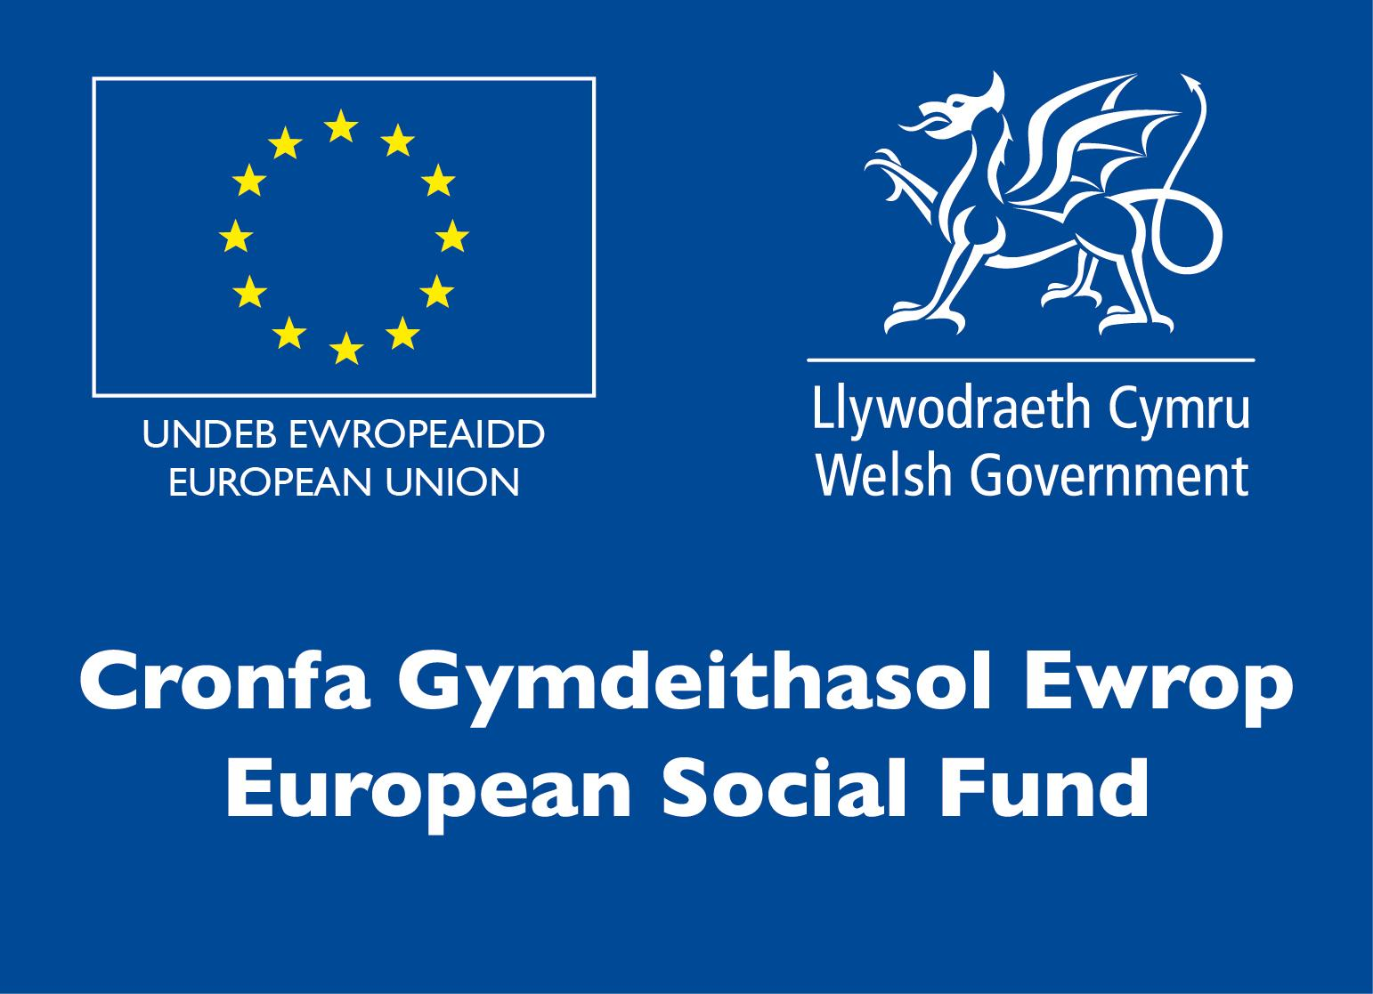

**Brief**

The competition has an open brief - teams may enter moving image work such as:

● Short Fiction

● Short Factual

● Animation

● Motion Graphics

● Music Video

● Promotional Video

You will need to screen your project to a panel of industry judges remotely alongside an audience of fellow competitors. Following your screening, you should make a presentation of five minutes (maximum) duration outlining the following:

* Your project aims and objectives
* How you managed your project
* Your production process in terms of creativity and technique

Finally you will be required to answer questions from the judging panel about your project. You may also submit any supporting production documentation, research and preparatory work to the judges for their consideration at the end of the presentation session. The presentation will form part of the final judging.

We ask that the work be presented **by January 8th** in time forthe competition which will be held on January 13th. This will give organisers time to prepare before the day itself. Copyrighted material must be cleared prior to submission. Please contact [paul.edwards@gllm.ac.uk](mailto:paul.edwards@gllm.ac.uk) for file transfer details.

The work will be shown on the competition Facebook page where work will be released to coincide with competition times): [www.facebook.com/SgiliauCyfryngauaChreadigol/](http://www.facebook.com/SgiliauCyfryngauaChreadigol/)

**Infrastructure List**

Technical information regarding submission of the work will be sent out to entrants after registration.

**Competition Rules**

For full terms and conditions of entry and competition rules visit [www.skillscompetitionwales.ac.uk/terms-and-conditions](http://www.skillscompetitionwales.ac.uk/terms-and-conditions)

**Competitors are to:**

* Work independently (without input from outside the group)
* Submit all requirements listed in the brief
* Ensure that all materials are self-generated and original and that the video is no longer than 5 minutes duration
* Ensure that work adheres to BBCF 12A classification. Further information: https://www.bbfc.co.uk/what-classification/12a-and-12
* Ensure no un-cleared copyright material is to be included (including music)
* Ensure that work is submitted prior to competition by **January 8th 2021**.

**General competition rules:**

* Any questions during competition activity should be addressed to the competition judging panel.
* It is the responsibility of each competitor to arrive on time for each competition session. No additional time will be allowed if you arrive late.
* Technical failure of your equipment should be reported immediately to the judging panel. Additional time will be allocated if the fault is beyond the control of the competitor.

**Marking and Assessment**

Marking and judging of this competition will be done by a team of experts from Industry, Further Education or Training Provider, using a marking criteria and allocated marks to ensure consistency.

The following criteria will be used by the judges to decide which project is the winner of the Skills Competition Wales, Digital Video Production category for 2021:

|  |  |  |
| --- | --- | --- |
| **Criterion ID** | **Description** | **Max Marks** |
| **A** | **Concept/Idea** | 20 |
| **B** | **Quality of finished video**  Does the work demonstrate technical competence in its chosen media – the quality of picture, sound, editing? | 40 |
| **C** | **Style & approach to the project** | 15 |
| **D** | **Clarity of message**  Clarity and purpose of its intended aims and objectives | 15 |
| **E** | **Communication and Presentation**  ● Content: Your project aims and objectives, How you managed your project, Your production process in terms of creativity and technique  ● Logical structure  ● Clear and audible  ● All members participate | 10 |
|  | **Total Marks** | 100 |

**Feedback and Recognition**

Individual and Group verbal feedback will be provided at the end of the competition.

No results or awards will be awarded on the day, as marking will be quality assured.

Certificates of Participation will be issued on the day.

Medallists will be invited to a Celebration Event which will be held in March 2021, where the First, Second and Third Awards will be presented.

Marksheets will be made available to unsuccessful competitors after the quality assurance process has been completed. Further details will be provided to all competitors upon notification of outcomes.

**Competition Lead**

For general enquiries and technical advice about the competition please contact

Paul Edwards: paul.edwards@gllm.ac.uk

**Other Enquiries**

Nia Rhys Jones: n.jones@gllm.ac.uk

**Briff y Gystadleuaeth**

**Enw’r Gystadleuaeth**

Cynhyrchu Cyfryngau Digidol

**Trosolwg o’r Gystadleuaeth**

Mae Staff Cynhyrchu Fideos Digidol yn ymwneud â phob cam o brosiect, boed yn rhaglen, ffilm neu fideo. Maen nhw'n rheoli'r prosiect o'r dechrau i'r diwedd, yn y stiwdio ac ar leoliad; maent yn gweithio gyda chyfarwyddwyr, gyda chamerâu, sain, dylunwyr set, ac maent yn rhan o’r broses ôl-gynhyrchu i sicrhau bod y prosiect yn cael ei gwblhau'n llwyddiannus, yn brydlon, ac o fewn y gyllideb.

Yn y gystadleuaeth hon, bydd cystadleuwyr yn cael cyfle i ddatblygu ac arddangos amrywiaeth o sgiliau creadigol, technegol, a galwedigaethol sy'n hanfodol o fewn y diwydiannau cyfryngau creadigol cyfoes.

**Gofynion Mynediad**

Mae'r gystadleuaeth hon ar gyfer y rhai sy'n hyfforddi ar gyfer gyrfa yn Niwydiant y Cyfryngau / Ffilmiau ac sy’n astudio tuag at gymhwyster Lefel 2 neu 3.

Sicrhewch fod gan eich ymgeiswyr y sgiliau a'r gallu angenrheidiol i gwblhau'r dasg.

**Cyfyngiadau capasiti mynediad yn ôl sefydliad**

Uchafswm o 1 tîm o bob sefydliad. Dylai’t tim cynnwys 1 i 5 berson.

Nid oes unrhyw ragbrofion ar gyfer y gystadleuaeth hon ac efallai y bydd angen i chi gynnal cystadlaethau mewnol i benderfynu ar dîm i'w gyflwyno.

Dyma'r nifer mwyaf o gystadleuwyr a ganiateir o bob sefydliad ar gyfer y gystadleuaeth hon.

Penderfynir ar hyn yn ôl 'lleoliad' a 'sefydliad'. Mae 'sefydliad' yn cyfeirio at gyflogwr/darparwr hyfforddiant y cystadleuwyr. Mae 'lleoliad' yn cyfeirio at y safle lle mae'r cystadleuydd yn astudio/cael eu cyflogi. Am ragor o wybodaeth am y cyfyngiadau hyn, cliciwch [yma](https://www.skillscompetitionwales.ac.uk/terms/entry-capacity-restrictions-by-organisation) 

**Brîff**

Mae gan y gystadleuaeth friff agored - gall timau fynd gyflwyno gwaith delweddau symudol megis:

● Ffuglen Fer

● Ffeithiol Byr

● Animeiddio

● Graffeg Symudol

● Fideo Cerddorol

● Fideo Hyrwyddo

Bydd angen i chi sgriniwch eich prosiect i banel o feirniaid diwydiant o bell ynghyd â chynulleidfa o gyd-gystadleuwyr. Yn dilyn arddangosiad eich darn, dylech wneud cyflwyniad pum munud (uchafswm) o hyd sy’n amlinellu'r canlynol:

* Nodau ac amcanion eich prosiect
* Sut y gwnaethoch reoli eich prosiect
* Eich proses gynhyrchu o ran creadigrwydd a thechneg

Yn olaf, bydd gofyn i chi ateb cwestiynau'r panel beirniadu am eich prosiect. Ar ddiwedd y sesiwn gyflwyno gallwch hefyd gyflwyno unrhyw ddogfennaeth gynhyrchu ategol, gwaith ymchwil, a gwaith paratoadol i'r beirniaid eu hystyried. Bydd y cyflwyniad yn ffurfio rhan o'r feirniadaeth derfynol.

Gofynnwn i'r gwaith gael ei gyflwyno **erbyn Ionawr 8fed,** cyn ygystadleuaeth a fydd yn cael ei chynnal ar 13 Ionawr. Bydd hyn yn caniatau amser i’r trefnwyr baratoi cyn y diwrnod ei hun. Rhaid clirio deunydd hawlfraint cyn ei gyflwyno. Cysylltwch â [paul.edwards@gllm.ac.uk](mailto:paul.edwards@gllm.ac.uk) ar gyfer manylion trosglwyddo ffeiliau os gwelwch yn dda.

Bydd y gwaith yn cael ei ddangos ar dudalen Facebook y gystadleuaeth, lle bydd gwaith yn cael ei ryddhau i gyd-fynd ag amserau cystadlu): [www.facebook.com/SgiliauCyfryngauaChreadigol/](http://www.facebook.com/SgiliauCyfryngauaChreadigol/)

**Rhestr Seilwaith**

Bydd gwybodaeth dechnegol o ran cyflwyno'r gwaith yn cael ei hanfon at y cystadleuwyr ar ôl iddynt gofrestru.

**Rheolau’r Gystadleuaeth**

I weld y telerau ac amodau mynediad a’r rheolau cystadlu yn eu cyfanrwydd ewch i [www.skillscompetitionwales.ac.uk/terms-and-conditions](http://www.skillscompetitionwales.ac.uk/terms-and-conditions)

**Dylai’r Cystadleuwyr:**

* Weithio'n annibynnol (heb fewnbwn o du allan i'r grŵp)
* Ateb yr holl ofynion a restrwyd yn y briff
* Sicrhau bod yr holl ddeunyddiau wedi’u cynhyrchu ganddyn nhw eu hunain, eu bod yn wreiddiol, ac nad yw'r fideo yn hirach na 5 munud o hyd
* Sicrhau bod gwaith yn glynu wrth ddosbarthiad BBCF 12A. Gwybodaeth bellach: https://www.bbfc.co.uk/what-classification/12a-and-12
* Sicrhau nad oes unrhyw ddeunydd hawlfraint heb ei glirio yn cael ei gynnwys (gan gynnwys cerddoriaeth)
* Sicrhau bod gwaith yn cael ei gyflwyno cyn y gystadleuaeth, erbyn **Ionawr 8 2021**.

**Rheolau Cystadlu Cyffredinol:**

* Os bydd unrhyw gwestiynau yn ystod y gweithgareddau cystadlu, dylid eu cyfeirio at banel beirniaid y gystadleuaeth.
* Cyfrifoldeb pob cystadleuydd yw cyrraedd yn brydlon ar gyfer pob sesiwn o'r gystadleuaeth. Ni fydd rhagor amser yn cael ei ganiatáu os byddwch yn cyrraedd yn hwyr.
* Os bydd methiant technegol ar eich offer dylech hysbysu’r panel beirniadu ar unwaith. Bydd amser ychwanegol yn cael ei ganiatau os yw'r nam y tu hwnt i reolaeth y cystadleuydd.

**Marcio ac Asesu**

Caiff y gwaith o farcio a beirniadu'r gystadleuaeth ei gynnal gan dîm o arbenigwyr o Ddarparwyr Hyfforddiant, Addysg Bellach, neu Ddiwydiant gan ddefnyddio meini prawf marcio a marciau wedi'u dyrannu i sicrhau cysondeb.

Bydd y beirniaid yn defnyddio'r meini prawf canlynol i benderfynu pa brosiect sy'n ennill categori Cynhyrchu Fideos Digidol, Cystadleuaeth Sgiliau Cymru 2021 :

|  |  |  |
| --- | --- | --- |
| **Cyf. Maen Prawf** | **Disgrifiad** | **Uchafswm Marciau** |
| **A** | **Cysyniad / Syniad** | 20 |
| **B** | **Ansawdd y fideo gorffenedig**  A yw'r gwaith yn dangos cymhwysedd technegol yn y cyfrwng dewisol – ansawdd y llun, sain, golygu? | 40 |
| **C** | **Arddull a dull gweithio’r prosiect** | 15 |
| **D** | **Eglurder y neges**  Eglurder a phwrpas nodau ac amcanion y darn. | 15 |
| **E** | **Cyfathrebu a Chyflwyniad**  ● Cynnwys: Nodau ac amcanion eich prosiect, sut y gwnaethoch reoli eich prosiect, eich proses gynhyrchu o ran creadigrwydd a thechneg  ● Strwythur rhesymegol  ● Eglur a chlywadwy  ● Pob aelod yn cymryd rhan | 10 |
|  | **Cyfanswm Marciau** | 100 |

**Adborth a Chydnabyddiaeth**

Bydd adborth llafar Unigol a Grŵp yn cael ei ddarparu ar ddiwedd y gystadleuaeth.

Ni roddir canlyniadau na gwobrau ar y diwrnod gan y bydd angen sicrhau ansawdd y gwaith marcio.

Bydd Tystysgrifau Cyfranogiad yn cael eu rhoi ar y diwrnod.

Bydd y rhai sy’n ennill medalau yn cael eu gwahodd i Ddigwyddiad Dathlu a fydd yn cael ei gynnal yn mis Mawrth 2021, lle bydd y Gwobrau Cyntaf, Ail a Thrydedd yn cael eu cyflwyno.

Bydd taflenni marcio’r cystadleuwyr aflwyddiannus ar gael ar ôl i'r broses sicrhau ansawdd gael ei chwblhau. Rhoddir manylion pellach i bob cystadleuydd ar ôl iddyn nhw glywed canlyniad y gystadleuaeth.

**Arweinydd Cystadleuaeth**

Am ymholiadau cyffredinol a chyngor technegol am y gystadleuaeth cysylltwch â

Paul Edwards: paul.edwards@gllm.ac.uk

**Ymholiadau eraill**

Nia Rhys Jones: n.jones@gllm.ac.uk