Competition Brief

Competition Title

Cybersecurity

Competition duration: 3 hours

Covid-19
Due to situations relating to Covid-19, our competition briefs have been adapted to take into account remote participation or in-house participation where required. This approach has been adopted in order to ensure the safety of all competitors, judges and also in order to accommodate the different rules and procedures at the different colleges, universities, organisations and venues taking part.

This competition brief has been designed so that it can be used in-house at competitors' own colleges, universities or organisations, or so that it can be used remotely from competitors’ own homes.

Competition Overview
This competition is intended for those competitors who have an interest in Cyber Security. For this competition cycle we are only running the CTF challenge. This will be an individual competition where competitors will be given a series of challenges.

Entry Criteria
This is an individual competition during COVID-19.
Competitors should currently be in education, training or employment.
Competitors should be enrolled in a programme of study or have recently completed (within 12 months) the equivalent to a level 3 qualification or have been in relevant employment for a maximum of three years.

Entry Capacity Restrictions by Organisation
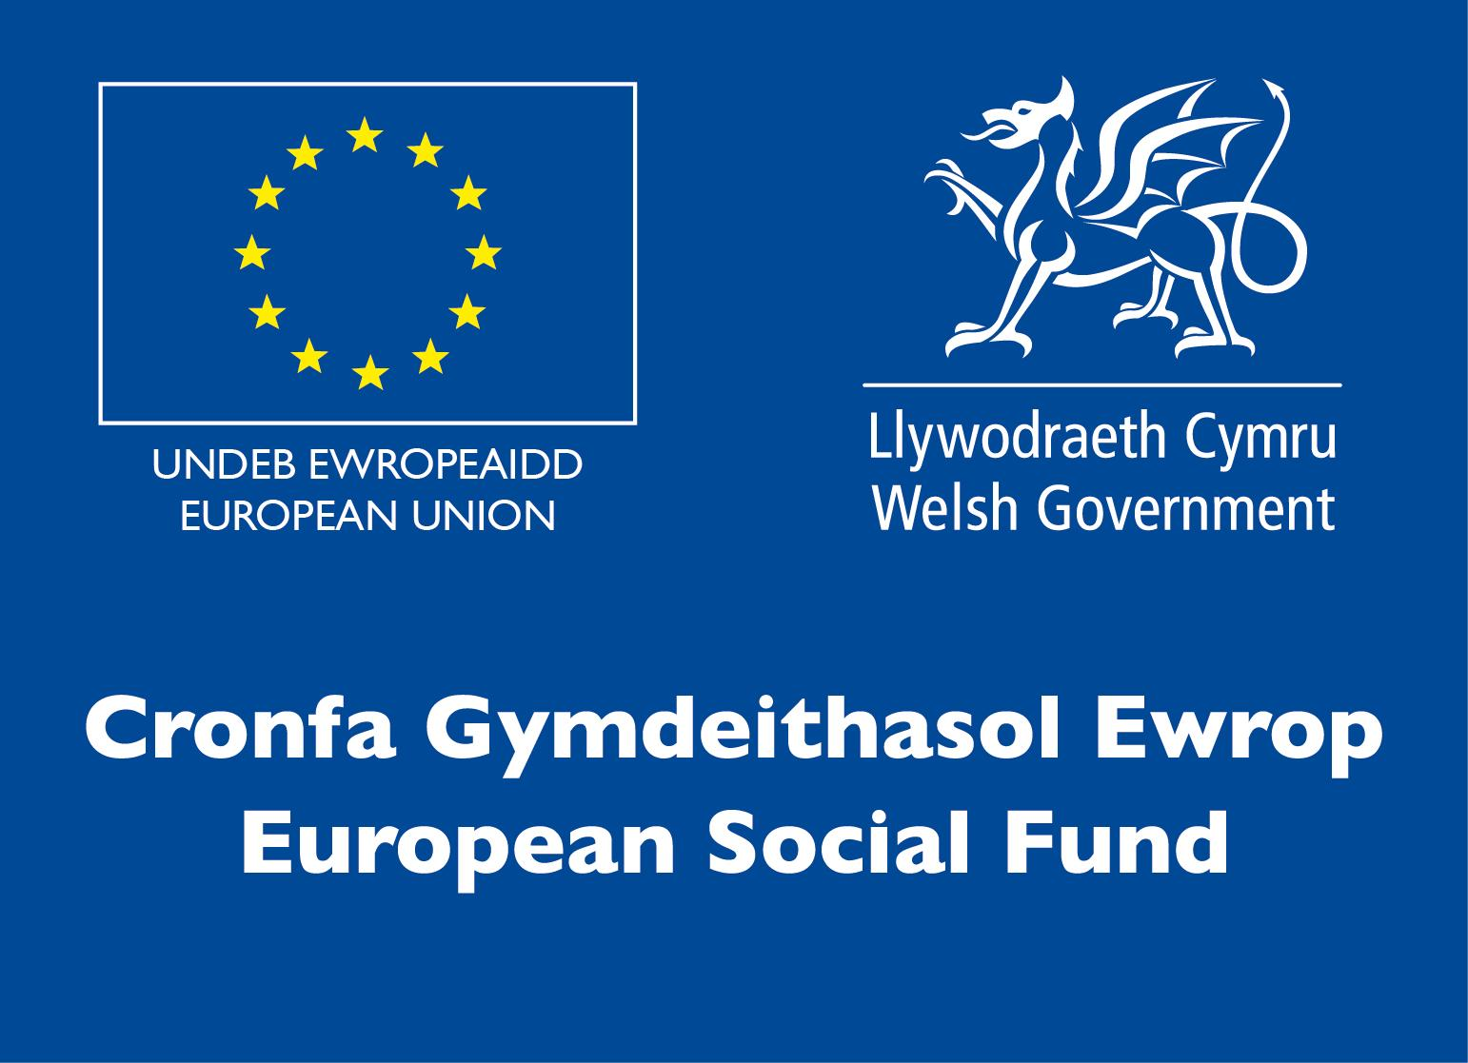
Entries are limited to four entries per organisation. For this year only this is not a team competition.

Brief
Competitors will undertake a series of practical tasks which will demonstrate their abilities and skills in cyber security including identifying security risks and breaches on a network.
The full competition brief will be provided to each competitor on the morning of the competition heat.

The scope of the competition covers the main features of the job role of a Cybersecurity Analyst.

Indicative tasks include:

Cyber Law and Ethics
- GDPR & Computer Misuse Act

Network reconnaissance
- Network Ports & Services
- OSINT

Vulnerability testing
- Vulnerability Scanning and Analysis

Exploitation
- Password Cracking
- Reviewing Vulnerable code
- Gaining Network System Access
- Exploiting Web Applications

Digital Forensics
- Packet Analysis
- Log Analysis

Infrastructure List
Competitors would benefit from being familiar with the following skills and toolsets:
- Kali Linux
- Command Line tools and syntax
- Nmap & Nmap Scripting Engine
- Wireshark
- JavaScript/Python/HTML
- Metasploit
- John the Ripper or similar
- Burp Suite/OWASP ZAP
- Database Commands
- OWASP top 10

A dedicated competition platform will be available to all competitors. They will need a PC/Laptop and internet access.

Competition rules
- Mobile phones are to be switched off during competition activity
- Listening to music via headphones is not permitted during competition activity
- Any questions during competition activity should be addressed to the competition Judge
- Competitors should not communicate with other competitors during competition activity
- It is the responsibility of each competitor to arrive on time for each competition session. No additional time will be allowed if you arrive late
- Technical failure of your equipment should be reported immediately to your judge. Additional time will be allocated if the fault is beyond the control of the competitor

For full terms and conditions of entry and competition rules visit www.skillscompetitionwales.ac.uk/terms-and-conditions

Marking and Assessment
Marking and judging of this competition will be done by a team of experts from Industry, Further Education or Training Provider, using a marking criteria and allocated marks to ensure consistency.

A | Law and Ethics | 10%
B | Network Reconnaissance | 10%
C | Vulnerability Testing | 20%
D | Exploitation | 25%
E | Digital Forensics | 25%
 | Total | 100%

Feedback and Recognition
Only general feedback will be provided at the end of the competition.
No results or awards will be awarded on the day, as marking will be quality assured.
Medallists will be invited to a Celebration Event (dates TBC), where the First, Second and Third Awards will be presented.
Marksheets will be made available to unsuccessful competitors after the quality assurance process has been completed. Further details will be provided to all competitors upon notification of outcomes.

Competition Lead
Lead Contact
Rona Griffiths - rona.griffiths@cambria.ac.uk

Expert Contacts
Leanne Davies - leanned@cyberwales.net
Elaine Haigh - elaine.haigh@southwales.ac.uk

Briff y Gystadleuaeth

Teitl y Gystadleuaeth

Seiberddiogelwch

Hyd y gystadleuaeth: 3 awr

COVID-19
Oherwydd sefyllfaoedd yn ymwneud â Covid-19, mae ein briffiau cystadlu wedi'u haddasu i ystyried cyfranogiad o bell neu gyfranogiad mewnol lle bo angen. Mabwysiadwyd y dull hwn er mwyn ystyried diogelwch yr holl gystadleuwyr, beirniaid a hefyd er mwyn darparu ar gyfer y gwahanol reolau a gweithdrefnau yn y gwahanol golegau, prifysgolion, sefydliadau a lleoliadau sy'n cymryd rhan.

Dyluniwyd y brîff cystadlu hwn fel y gellir ei ddefnyddio’n fewnol yng ngholegau, prifysgolion neu sefydliadau’r cystadleuwyr eu hunain, neu fel y gellir ei ddefnyddio o bell o gartrefi’r cystadleuwyr eu hunain.

Trosolwg o’r Gystadleuaeth
Mae'r gystadleuaeth hon wedi'i bwriadu ar gyfer y cystadleuwyr hynny sydd â diddordeb mewn Seiberddiogelwch. Ar gyfer y cylch cystadlu hwn dim ond yr her CTF yr ydym yn ei rhedeg. Cystadleuaeth unigol fydd hon lle rhoddir cyfres o heriau i gystadleuwyr.

Meini Prawf Cystadlu
Mae hon yn gystadleuaeth unigol yn ystod COVID-19.
Dylai cystadleuwyr fod mewn addysg, hyfforddiant neu gyflogaeth ar hyn o bryd.
Dylai cystadleuwyr fod wedi’u cofrestru mewn rhaglen astudio neu fod wedi cwblhau yr hyn sy'n gyfwerth â chymhwyster lefel 3 yn ddiweddar (o fewn 12 mis) neu fod wedi bod mewn cyflogaeth berthnasol am uchafswm o dair blynedd.

Cyfyngiadau Capasiti Mynediad yn ôl Sefydliad
Mae ceisiadau wedi'u cyfyngu i bedwar cais i bob sefydliad. Am eleni yn unig nid yw hon yn gystadleuaeth tîm.

Briff
Bydd cystadleuwyr yn ymgymryd â chyfres o dasgau ymarferol a fydd yn dangos eu galluoedd a'u sgiliau ym maes seiberddiogelwch gan gynnwys nodi risgiau diogelwch a thorri ar rwydwaith. Bydd briff llawn y gystadleuaeth yn cael ei ddarparu i bob cystadleuydd ar fore rownd gyntaf y gystadleuaeth.

Mae’r gystadleuaeth yn cwmpasu prif nodweddion rôl swydd Dadansoddwr Seiberddiogelwch.

Dyma flas o’r tasgau posibl:

Seibergyfraith a Moeseg
- GDPR a’r Ddeddf Camddefnyddio Cyfrifiaduron

Archwilio rhwydweithiau
- Gwasanaethau a Phyrth Rhwydwaith
- Cudd-wybodaeth ffynhonnell agored (OSINT)

Profi gwendid
- Sganio a Dadansoddi Gwendid

Camddefnyddio
- Darganfod Cyfrineiriau
- Adolygu Codau Anniogel
- Cael Mynediad i Systemau Rhwydwaith
- Camddefnyddio Rhaglenni ar y We

Gwaith Fforensig Digidol
- Dadansoddi Pecynnau
- Dadansoddi Logiau

Rhestr Seilwaith
Byddai’n ddefnyddiol pe bai cystadleuwyr yn gyfarwydd â'r sgiliau a'r setiau offer canlynol:
- Kali Linux
- Offer a chystrawen y Llinell Reoli
- Nmap ac Nmap Scripting Engine
- Wireshark
- JavaScript / Python / HTML
- Metasploit
- John the Ripper neu offeryn tebyg
- Burp Suite / OWASP ZAP
- Gorchmynion Cronfeydd Data
- 10 uchaf OWASP
Bydd platfform cystadlu pwrpasol ar gael i'r holl gystadleuwyr. Bydd angen cyfrifiadur personol / gliniadur a mynediad i'r rhyngrwyd arnyn nhw.

Rheolau’r gystadleuaeth
- Rhaid diffodd ffonau symudol yn ystod y gweithgareddau cystadlu
- Ni chaniateir gwrando ar gerddoriaeth drwy glustffonau yn ystod y gweithgareddau cystadlu
- Os bydd unrhyw gwestiynau yn ystod y gweithgareddau cystadlu, dylid eu cyfeirio at Feirniaid y gystadleuaeth.
- Ni ddylai cystadleuwyr gyfathrebu â chystadleuwyr eraill yn ystod gweithgareddau cystadlu
- Cyfrifoldeb pob cystadleuydd yw cyrraedd yn brydlon ar gyfer pob sesiwn o'r gystadleuaeth. Ni chaniateir amser ychwanegol os byddwch yn cyrraedd yn hwyr
- Os bydd methiant technegol gyda’ch offer dylech hysbysu’ch beirniad ar unwaith. Bydd amser ychwanegol yn cael ei ganiatáu os yw'r nam y tu hwnt i reolaeth y cystadleuydd

I weld y telerau ac amodau mynediad llawn a’r rheolau cystadlu ewch i https://www.skillscompetitionwales.ac.uk/terms-and-conditions

Marcio ac Asesu
Caiff y gwaith o farcio a beirniadu'r gystadleuaeth ei gynnal gan dîm o arbenigwyr o blith Darparwyr Hyfforddiant, gweithwyr Addysg Bellach, neu gynrychiolwyr Diwydiant gan ddefnyddio meini prawf marcio a marciau wedi'u dyrannu i sicrhau cysondeb.

A | Y Gyfraith a Moeseg | 10%
B | Rhagchwilio Rhwydwaith | 10%
C | Profi Bregusrwydd | 20%
D | Camfanteisio | 25%
E | Fforensig Ddigidol | 25%
 | Cyfanswm | 100%

Adborth a Chydnabyddiaeth
Bydd adborth llafar Unigol a Grŵp yn cael ei ddarparu ar ddiwedd y gystadleuaeth.

Ni roddir canlyniadau na gwobrau ar y diwrnod gan y bydd angen sicrhau ansawdd y gwaith marcio.

Gwahoddir medalau i Ddigwyddiad Dathlu (dyddiadau i'w gadarnhau), lle bydd y Wobrau Cyntaf, Ail a Thrydedd yn cael eu cyflwyno.

Bydd taflenni marcio ar gael i gystadleuwyr aflwyddiannus ar ôl i’r broses sicrhau ansawdd gael ei chwblhau. Caiff manylion pellach eu darparu i bob cystadleuydd ar ôl iddynt gael gwybod beth yw’r canlyniadau.
Arweinydd y Gystadleuaeth
Cyswllt Arweiniol
Rona Griffiths - rona.griffiths@cambria.ac.uk

Cysylltiadau Arbenigol
Peter Cresswell - peter.cresswell@cambria.ac.uk
Simon Prince - simon.prince@cambria.ac.uk

