**Competition Brief**

**Competition Title**

Brickwork

**Competition Overview**

A bricklayer lays bricks, pre-cut stone and concrete blocks to build internal and external wall structures for buildings. The type of wall can vary from plain walls to more complex work.

In this competition, competitors have to complete a specific project designed to challenge their ability. Competitors are expected to be able to follow drawings, measure accurately, effectively plan their time, demonstrate competence with tools and keep work stations clean and tidy and working safely at all times.

Live competition heats will be held at various venues across Wales.

**Entry Criteria**

The competition is for those training for a career in the construction industry and studying towards but not yet achieved a Level 3 qualification or apprenticeship.

Please ensure that your entrants have attempted the competition drawing and have the required skills and competences to complete the task.

**Entry capacity restrictions by organisation**

Each organisation may register a maximum of **2 competitors per location** for this competition. **Reserves** may also be registered to account for potential absences or withdrawals.

This is the maximum number of entries permitted by an organisation for this competition. This is determined by ‘location’ and ‘organisation’. ‘Organisation’ refers to the competitors’ training provider/employer. ‘Location’ refers to a site where the competitor studies / is employed.

This competition may be subject to a selection process if competitor registration numbers exceed the host venue capacity. Where capacity is identified in a competition the reserve competitors may be invited to compete.

The decision will be made following a consultation between Skills Competition Wales and the competition lead after registration closes. All parties will be notified of any changes.

For further guidance on these capacities, [click here](https://inspiringskills.gov.wales/competitions/competition-registration-guide).

**Task Duration**

5 Hours

**Brief**

Competitors will be given drawings and are required to carry out a brickwork task, which will challenge their ability to follow detailed instructions, produce accurate and neat work outputs, be economical with materials whilst working to strict timescales.

Competitors will be required to demonstrate the following skills, in this competition;

* Lay to straight line
* Plumb level and gauge
* Demonstrate the ability to joint and maintain clean brickwork
* Demonstrate good housekeeping and Health & Safety

For more information please see the drawings on the Skills Competition Wales website. Previous competition briefs are available to view and download via the Skills Competition Wales website, please [click here](https://inspiringskills.gov.wales/competitions/brickwork/archives) to access.

**Infrastructure List**

Competitors are required to bring their own tools. A workshop technician(s) will be available at the venue for mixing and distributing mortar to competitors and cleaning away waste materials throughout the competition.

**Competition Rules**

For full terms and conditions of entry and competition rules [visit](https://inspiringskills.gov.wales/terms/registrations-terms-and-conditions).

**Generic competition rules**

* Mobile phones are to be switched off during competition activity.
* Listening to music via headphones is not permitted during competition activity.
* Any questions during competition activity should be addressed to the competition judging panel.
* Competitors should not communicate with other competitors during competition activity.
* It is the responsibility of each competitor to arrive on time for each competition session. No additional time will be allowed if you arrive late.
* Technical failure of your equipment should be reported immediately to the judging panel. Additional time will be allocated if the fault is beyond the control of the competitor.

**Marking and Assessment**

Marking and judging of this competition will be done by a team of experts from industry, further education or training providers, using marking criteria and allocated marks to ensure consistency.

**Brief breakdown of marking and assessment**

All marks are objective and will be awarded by the judges as follows:

| **Criteria** | **Marks** |
| --- | --- |
| Dimensions | 22.5% |
| Plumb | 20% |
| Square | 2.5% |
| Level | 10% |
| Alignment | 12.5% |
| Details | 12.5% |
| Jointing | 10% |
| Finish and Housekeeping | 5% |
| Health and Safety | 5% |
| **Total** | **100%** |

**Feedback and Recognition**

Individual and Group verbal feedback will be provided at the end of the competition.

No results or awards will be awarded on the day as marking will be quality assured.

All competitors will be issued with a Participation Certificate on the competition day. First, second, third and highly commended awards will be announced during the celebration event. The highly commended award recognises all competitors who have achieved above average. The celebration event will be held on Wednesday 18th March 2026, further details will be communicated to competitors and their points of contact by email.

Marksheets will be available upon request via [info@skillscompetitionwales.ac.uk](mailto:info@skillscompetitionwales.ac.uk) to competitors after the celebration event.

**Competition Lead**

**Lead Contact:** Lewis Jones

Email address - [L.Jones1@merthyr.ac.uk](mailto:L.Jones1@merthyr.ac.uk)

**Our partners**

This competition is delivered in partnership with

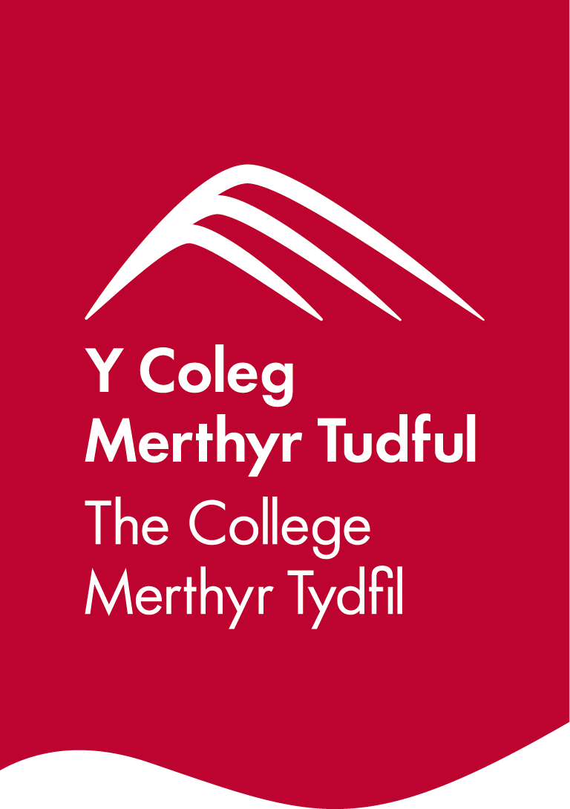

**Briff y Gystadleuaeth**

**Enw’r Gystadleuaeth**

Gosod Brics

**Trosolwg o’r Gystadleuaeth**

Mae gosodwr brics yn gosod brics, cerrig wedi'u torri ymlaen llaw, a blociau concrid i adeiladu waliau mewnol ac allanol ar gyfer adeiladau. Gall y math o wal amrywio o waliau plaen i waith mwy cymhleth.

Yn y gystadleuaeth hon, bydd angen i gystadleuwyr gwblhau prosiect penodol sydd wedi’i gynllunio i herio eu gallu. Disgwylir y bydd yr holl gystadleuwyr yn gallu dilyn darluniau, mesur yn gywir, cynllunio eu hamser yn effeithiol, dangos eu gallu gydag offer, cadw gweithfannau yn lân ac yn daclus, a gweithio’n ddiogel trwy’r adeg.

Cynhelir rowndiau rhagbrofol byw mewn sawl lleoliad ledled Cymru.

**Gofynion Mynediad**

Mae'r gystadleuaeth ar gyfer y rhai sy'n hyfforddi ar gyfer gyrfa yn y Diwydiant Adeiladu ac sy'n astudio tuag at gymhwyster Lefel 3 neu brentisiaeth ond nad ydynt eto wedi'u hennill.

Gwnewch yn siŵr bod eich ymgeiswyr wedi rhoi tro ar y gystadleuaeth ac fod ganddyn nhw’r sgiliau a'r cymwyseddau angenrheidiol i gwblhau'r dasg.

**Capasiti mynediad Cyfyngiadau gan Sefydliad**

Gall pob sefydliad gofrestru **uchafswm o 2 cystadleuydd ym mhob lleoliad** ar gyfer y gystadleuaeth hon. Gellir cofrestru **cronfeydd wrth gefn** hefyd i gyfrifon absenoldeb neu dynnu'n ôl os bydd angen.

Penderfynir ar hyn yn ôl 'lleoliad' a 'sefydliad'. Mae 'sefydliad' yn cyfeirio at gyflogwr/darparwr hyfforddiant y cystadleuwyr. Mae 'lleoliad' yn cyfeirio at y safle lle mae'r cystadleuydd yn astudio/cael eu cyflogi.

Gall y gystadleuaeth hon fod yn destun proses ddethol os yw'r niferoedd cofrestru cystadleuwyr yn fwy na chapasiti'r lleoliad cynnal. Lle nodir bod capasiti ar gyfer y gystadleuaeth, gellir gwahodd cystadleuwyr wrth gefn i gystadlu.

Bydd y penderfyniad yn cael ei wneud yn dilyn ymgynghoriad rhwng Cystadleuaeth Sgiliau Cymru ac arweinydd y gystadleuaeth ar ôl i'r cofrestru gau. Bydd pob parti yn cael gwybod am unrhyw newidiadau.

Am ragor o wybodaeth am y cyfyngiadau hyn, [cliciwch yma](https://inspiringskills.gov.wales/competitions/competition-registration-guide).

**Hyd y Dasg**

5 awr

**Briff**

Bydd cystadleuwyr yn derbyn darluniau a bydd angen iddynt gyflawni tasg osod brics a fydd yn herio eu gallu i ddilyn cyfarwyddiadau manwl, i gynhyrchu gwaith cywir a thaclus, ac i ddefnyddio deunyddiau’n ddiwastraff wrth weithio o fewn cyfyngiadau amser.

Bydd gofyn i gystadleuwyr ddangos y sgiliau canlynol yn y gystadleuaeth hon;

* Gosod mewn llinell syth
* Plymio, lefelu, a mesur
* Dangos y gallu i uniadu a gosod brics yn daclus
* Dangos taclusrwydd wrth weithio ac arferion Iechyd a Diogelwch da

I gael rhagor o wybodaeth, edrychwch ar y darluniau sydd ar wefan Cystadleuaeth Sgiliau Cymru. Mae briffiau cystadleuaeth flaenorol ar gael i'w gweld a'u llwytho o’r wefan Cystadleuaeth Sgiliau Cymru, [cliciwch yma](https://inspiringskills.gov.wales/competitions/brickwork/archives) i gael mynediad iddynt.

**Rhestr Seilwaith**

Bydd angen i gystadleuwyr ddod â'u hoffer eu hunain. Bydd technegydd gweithdai ar gael yn y lleoliad i gymysgu a dosbarthu morter i gystadleuwyr ac i lanhau deunyddiau gwastraff drwy gydol y gystadleuaeth.

**Rheolau’r Gystadleuaeth**

I weld y telerau ac amodau mynediad a’r rheolau cystadlu yn eu cyfanrwydd [ewch i](https://inspiringskills.gov.wales/terms/registrations-terms-and-conditions?lang=cy).

**Rheolau Cystadlu Cyffredinol**

* Rhaid diffodd ffonau symudol yn ystod y gweithgareddau cystadlu.
* Ni chaniateir gwrando ar gerddoriaeth gyda chlustffonau yn ystod y gweithgareddau cystadlu.
* Os bydd unrhyw gwestiynau yn ystod y gweithgareddau cystadlu, dylid eu cyfeirio at banel beirniaid y gystadleuaeth.
* Ni ddylai cystadleuwyr gyfathrebu â chystadleuwyr eraill yn ystod gweithgareddau cystadlu.
* Cyfrifoldeb pob cystadleuydd yw cyrraedd yn brydlon ar gyfer pob sesiwn o'r gystadleuaeth. Ni chaniateir amser ychwanegol os byddwch yn cyrraedd yn hwyr.
* Os bydd methiant technegol ar eich offer dylech hysbysu’r panel beirniadu ar unwaith. Bydd amser ychwanegol yn cael ei ganiatau os yw'r nam y tu hwnt i reolaeth y cystadleuydd.

**Marcio ac Asesu**

Caiff y gwaith o farcio a beirniadu'r gystadleuaeth ei gynnal gan dîm o arbenigwyr o Ddarparwyr Hyfforddiant, Addysg Bellach, neu Ddiwydiant gan ddefnyddio meini prawf marcio a marciau wedi'u dyrannu i sicrhau cysondeb. Bydd o leiaf un beirniad yn mynychu pob un o’r cystadlaethau rhanbarthol.

Mae pob marc yn wrthrychol a byddant yn cael eu dyfarnu gan y beirniaid fel a ganlyn:

| **Meini Prawf** | **Marciau** |
| --- | --- |
| Dimensiynau | 22.5% |
| Plymio | 20% |
| Sgwario | 2.5% |
| Lefelu | 10% |
| Alinio | 12.5% |
| Manylion | 12.5% |
| Uniadu | 10% |
| Gorffeniad a thaclusrwydd wrth weithio | 5% |
| Iechyd a Diogelwch | 5% |
| **Cyfanswm** | **100%** |

**Adborth a Chydnabyddiaeth**

Bydd adborth llafar Unigol a Grŵp yn cael ei ddarparu ar ddiwedd y gystadleuaeth. Ni roddir canlyniadau na gwobrau ar y diwrnod gan y bydd angen sicrhau ansawdd y marcio.

Bydd pob cystadleuydd yn cael Tystysgrif Cyfranogi ar ddiwrnod y gystadleuaeth. Bydd gwobrau cyntaf, ail, trydydd a chanmoliaeth uchel yn cael eu cyhoeddi yn ystod y digwyddiad dathlu. Mae'r wobr canmoliaeth uchel yn cydnabod yr holl gystadleuwyr sydd wedi cyflawni sgôr uwch na'r cyfartaledd. Cynhelir y digwyddiad dathlu ar Dydd Mercher 18 Mawrth 2026, bydd manylion pellach yn cael eu rhoi i gystadleuwyr a'u pwyntiau cyswllt trwy e-bost.

Bydd taflenni marciau ar gael ar gais drwy info@skillscompetitionwales.ac.uk i gystadleuwyr ar ôl y digwyddiad dathlu.

**Arweindd Cystadleuaeth**

**Prif Gyswllt:** Lewis Jones

Cyfeiriad ebost - [L.Jones1@merthyr.ac.uk](mailto:L.Jones1@merthyr.ac.uk)

**Ein partneriaid**

Mae'r gystadleuaeth hon yn cael ei chyflwyno mewn partneriaeth â

