**Competition Brief**

**Competition Title**

Aeronautical Engineering

**Competition Overview**

## An Aeronautical Engineer is responsible for looking after components of aircraft and aircraft systems. They must maintain, repair, service, install and test these vitally important components.

In this competition, competitors will carry out a sheet metal task including wirelocking, remove/replace a main aircraft wheel and aircraft component inspection and wire locking. They will need to demonstrate the specialist knowledge of someone entering the field of Aeronautical Engineering, and the advanced skills expected within the aeronautical industry.

Live competition heats will be held at various venues across Wales.

**Entry Criteria**

The competition is intended for those training for a career in the Aeronautical Engineering industry and studying towards a Level 3 qualification or an apprenticeship.

Please ensure your entrants have the skills and competences to complete the task.

**Entry capacity restrictions by organisation**

Maximum of up to **3 per organisation**. **Reserves** may also be registered to account for potential absences or withdrawals.

This is the maximum number of entries permitted by an organisation for this competition. This is determined by ‘location’ and ‘organisation’. ‘Organisation’ refers to the competitors’ training provider/employer. ‘Location’ refers to a site where the competitor studies / is employed.

This competition may be subject to a selection process if competitor registration numbers exceed the host venue capacity. Where capacity is identified in a competition the reserve competitors may be invited to compete. The decision will be made following a consultation between Skills Competition Wales and the competition lead after registration closes. All parties will be notified of any changes.

For further guidance on these capacities, [click here.](https://inspiringskills.gov.wales/competitions/competition-registration-guide)

**Brief**

This competition involves 2 heats, each taking 6 hours to complete. Both heats will consist of 3 identical tasks. Specific activities and tasks will be handed out on the day.

Task 1: Sheet Metal Task

Task 2: Main Wheel Removal/Replacement

Task 3: Wiring Aircraft Electrical Components

**Core Competencies**

* Perform a simple sheet metal repair scheme
* Interpret Drawings and Wiring Diagrams
* Make the assembly shown in the drawing in accordance with Standard Practices (AC 43 - 13, CAP 562)
* Follow the procedure as per instructions in Aircraft Maintenance Manuals
* Wirelock bolts in accordance with aviation standard practices as found in AC 43 - 13, CAP562 Chapter 51, or an AMM ATA Chapter 20
* Demonstrate knowledge and understanding of reference manuals i.e. AC 43 – 13 Aircraft Standards or CAP562.
* Safely use the following Equipment:
  + Rivet Gun for a range of rivets that include
    - Countersunk SP71
    - Snap Head SP80
    - Mush Head SP85
  + Cherry Max Plier (Squeeze Pliers)
  + Pneumatically operated drills (Pistol and Straight)
  + Wirelocking Pliers
  + Socket sets and Spanners
  + Various basic hand tools to remove material

Previous competition briefs are available to view and download via the Skills Competition Wales website, please [click here](https://inspiringskills.gov.wales/competitions/aeronautical-engineering/archives) to access.

**Infrastructure List**

Resources, equipment available at the venue:

* Sheet metal tool kit
* Rivets
* Pneumatic drill
* Riveting gun
* Riveting squeeze pliers
* Skin pins
* 2 Plates
* Jointing compounds
* Drawing
* Precision marking out instruments
* Locking wire
* Wire locking pliers
* Ratchet and socket
* Wirelocking and Split Pinning Jig
* Wire Crimpers
* Wire Snips
* Daniels Crimping Tool

**Competition Rules**

For full terms and conditions of entry and competition rules [visit](https://inspiringskills.gov.wales/terms/registrations-terms-and-conditions).

**Competition specific rules**

* Only registered competitors may compete, having agreed with T&Cs
* The task will commence immediately after the judges’ Health & Safety brief.
* Plan your time carefully to ensure you are able to complete the task within the allotted time.
* Ensure you have read and fully understood the task objective, the time allocated for the task and all supporting resource material provided within this Competitor Brief.
* If you are unsure about any aspect of the task you may ask the task judge for guidance. It is important to note that depending on the nature of the question asked the judge may decide that guidance is not appropriate in the interest of the competition.
* When you are content with what is required you should commence your work.
* Should you sustain an injury which requires first aid treatment, you are to bring it immediately to the attention of the task judge who will determine the course of action required.

**Health & Safety**

A Health & Safety brief will be conducted immediately prior to the task commencing. It is the individual’s responsibility to take reasonable care of themselves and others whilst at work. This includes the correct wearing of appropriate clothing and footwear for the activity being undertaken.

Any **specialised** Personal Protective Equipment required for an activity will be made available by the competition host. Judges are to provide direction on any actions that are in contravention of the Health & Safety regulations and where appropriate they may deduct marks for such non-compliances. Competitors **WILL** be expected to provide their own Safety Glasses, Safety Boots, and Workwear

Continual disregard for Health & Safety by a competitor during a task may result in the task being terminated prematurely.

**Generic competition rules**

* Mobile phones are to be switched off during competition activity.
* Listening to music via headphones is not permitted during competition activity.
* Any questions during competition activity should be addressed to the competition judging panel.
* Competitors should not communicate with other competitors during competition activity.
* It is the responsibility of each competitor to arrive on time for each competition session. No additional time will be allowed if you arrive late.
* Technical failure of your equipment should be reported immediately to the judging panel. Additional time will be allocated if the fault is beyond the control of the competitor.

**Marking and Assessment**

Marking and judging of this competition will be done by a team of experts from Industry, Further Education or Training Provider, using marking criteria and allocated marks to ensure consistency.

Brief breakdown of marking and assessment:

| Task 1: Sheet Metal Task | 40% |
| --- | --- |
| Task 2: Main Wheel Removal/Replacement | 25% |
| Task 3: Wiring Aircraft Electrical Components | 35% |
| **Total** | **100%** |

**Feedback and Recognition**

Individual and Group verbal feedback will be provided at the end of the competition. No results or awards will be awarded on the day as marking will be quality assured.

All competitors will be issued with a Participation Certificate on the competition day. First, second, third and highly commended awards will be announced during the celebration event. The highly commended award recognises all competitors who have achieved above average. The celebration event will be held on Wednesday 18th March 2026, further details will be communicated to competitors and their points of contact by email.

Marksheets will be available upon request via [info@skillscompetitionwales.ac.uk](mailto:info@skillscompetitionwales.ac.uk) to competitors after the celebration event.

**Competition Lead**

**Lead Contact**

Jamie Mapp-Jones

[jamie.mapp-jones@cambria.ac.uk](mailto:jamie.mapp-jones@cambria.ac.uk)

**Expert Contacts**

Caleb Maxfield

**General Enquiries**

Robert Jones

[robert.jones1@cambria.ac.uk](mailto:robert.jones1@cambria.ac.uk)

**Our partners**

This competition is delivered in partnership with



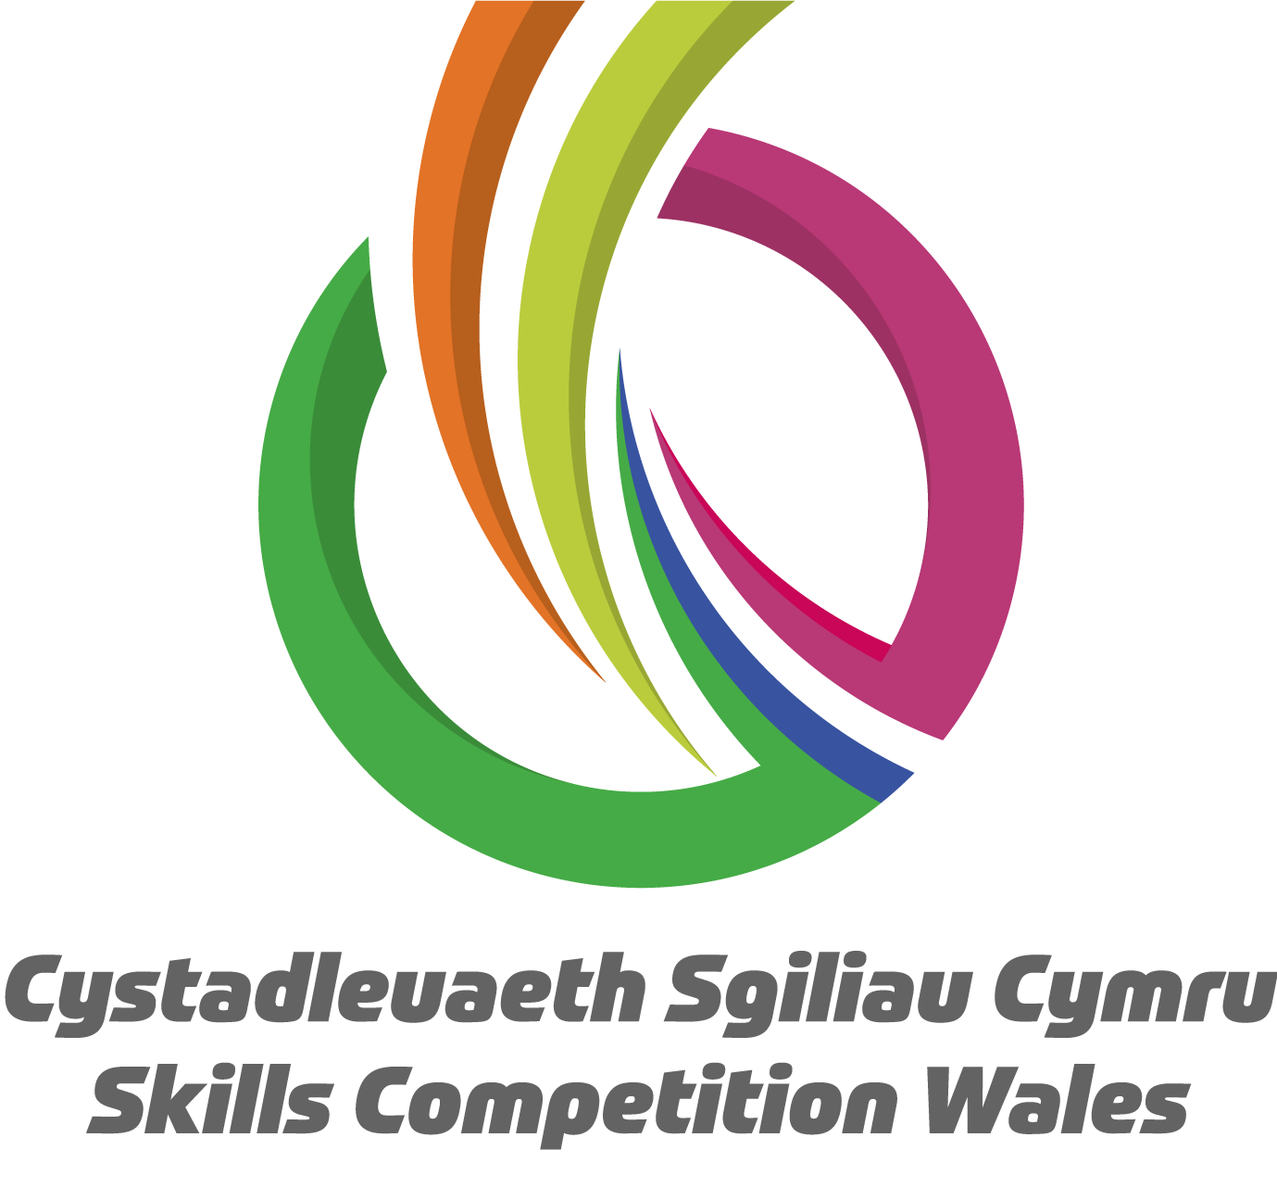

**Briff y Gystadleuaeth**

**Teitl y Gystadleuaeth**

Peirianneg Awyrenegol

**Trosolwg o’r Gystadleuaeth**

Mae Peiriannydd Awyrenegol yn gyfrifol am ofalu am gydrannau awyrennau a systemau awyrennau. Mae’n rhaid iddyn nhw gynnal a chadw, trwsio, gwasanaethu, gosod a phrofi’r cydrannau hanfodol bwysig hyn.

Yn y gystadleuaeth hon, bydd cystadleuwyr yn cyflawni tasg metel dalen gan gynnwys cloi â gwifrau, tynnu/amnewid prif olwyn awyren ac archwilio cydrannau awyren a chloi â gwifrau. Bydd angen iddyn nhw arddangos y wybodaeth arbenigol sydd gan rywun sy’n mynd mewn i faes Peirianneg Awyrenegol, a’r sgiliau uwch sy’n ddisgwyliedig o fewn y diwydiant awyrenegol.

Cynhelir rowndiau rhagbrofol byw mewn sawl lleoliad ledled Cymru.

**Meini Prawf Cystadlu**

Mae’r gystadleuaeth hon ar gyfer y rheini sy’n hyfforddi am yrfa yn y diwydiant Peirianneg Awyrenegol ac sy’n astudio tuag at gymhwyster Lefel 3 neu brentisiaeth.

Sicrhewch fod gan eich ymgeiswyr y sgiliau a’r cymwyseddau i gyflawni’r dasg.

**Cyfyngiadau ar nifer y ceisiadau fesul sefydliad**

Uchafswm o hyd at **3 fesul sefydliad**. Gellir cofrestru **cronfeydd wrth gefn** hefyd i gyfrifon absenoldeb neu dynnu'n ôl os bydd angen.

Dyma’r uchafswm o geisiadau a ganiateir gan unrhyw sefydliad ar gyfer y gystadleuaeth hon.

Mae hyn yn cael ei bennu fesul ‘lleoliad’ a ‘sefydliad’.  Mae ‘sefydliad’ yn cyfeirio at ddarparwr hyfforddiant/cyflogwr y cystadleuydd. Mae ‘lleoliad’ yn cyfeirio at le mae’r cystadleuydd yn astudio / cael ei gyflogi.

Gall y gystadleuaeth hon fod yn destun proses ddethol os yw'r niferoedd cofrestru cystadleuwyr yn fwy na chapasiti'r lleoliad cynnal. Lle nodir bod capasiti ar gyfer y gystadleuaeth, gellir gwahodd cystadleuwyr wrth gefn i gystadlu. Bydd y penderfyniad yn cael ei wneud yn dilyn ymgynghoriad rhwng Cystadleuaeth Sgiliau Cymru ac arweinydd y gystadleuaeth ar ôl i'r cofrestru gau. Bydd pob parti yn cael gwybod am unrhyw newidiadau.

Am fwy o arweiniad ar y niferoedd hyn, [cliciwch yma](https://inspiringskills.gov.wales/competitions/competition-registration-guide).

**Briff**

Mae’r gystadleuaeth hon yn cynnwys 2 gymal, gyda phob un yn cymryd 6 awr i’w gwblhau.Bydd y ddau gymal yn cynnwys 3 tasg union yr un fath. Bydd gweithgareddau a thasgau penodol yn cael eu cyflwyno ar y diwrnod.

Tasg 1: Tasg Llen Fetel

Tasg 2: Tynnu/Amnewid y Brif Olwyn

Tasg 3: Rhwymo Cydrannau Trydanol â Gwifrau

**Cymwyseddau Craidd**

* Cyflawni cynllun trwsio llen fetel syml
* Dehongli Lluniadau a Diagramau Gwifrau
* Cydosod yr hyn a ddangosir yn y lluniad yn unol ag Arferion Safonol (AC 43 – 13, CAP 562)
* Dilyn gweithdrefnau yn ôl cyfarwyddiadau’r Llawlyfrau Cynnal a Chadw Awyrennau
* Cloi bolltau â gwifren yn unol ag arferion safonol awyrennu fel y manylir yn AC 43 - 13, CAP562 Pennod 51, neu yn AMM ATA Pennod 20
* Arddangos gwybodaeth a dealltwriaeth o gyfeirlyfrau h.y. AC 43 – 13 Safonau Awyrennau neu CAP562.
* Defnyddio'r offer canlynol yn ddiogel:
  + Gwn Rhybed ar gyfer amrywiaeth o rybedion sy'n cynnwys
    - Countersunk SP71
    - Snap Head SP80
    - Mush Head SP85
  + Cherry Max Plier (Pleiars Gwasgu)
  + Driliau a weithredir yn niwmatig (Pistol a Syth)
  + Pleiars Cloi Gwifrau
  + Setiau soced a Sbaneri
  + Amryw offer llaw sylfaenol i gael gwared ar ddeunydd

Mae briffiau cystadleuaeth flaenorol ar gael i'w gweld a'u llwytho o’r wefan Cystadleuaeth Sgiliau Cymru, [cliciwch yma](https://inspiringskills.gov.wales/competitions/aeronautical-engineering/archives) i gael mynediad iddynt.

**Rhestr Seilwaith**

Adnoddau, cyfarpar sydd ar gael yn y lleoliad:

* Offer llen fetel
* Rhybedion
* Dril niwmatig
* Gwn rhybedion
* Gefelen gwasgu rhybedion
* Pinnau croen
* 2 Blât
* Cyfansoddion uniadu
* Lluniad
* Offer marcio trachywir
* Gwifren gloi
* Gefelen cloi gwifren
* Clicied a soced
* Cloi â Gwifren a Jig Phinio Hollt

**Rheolau’r Gystadleuaeth**

Am restr gyflawn o delerau ac amodau cystadlu a rheolau’r gystadleuaeth [ewch i](https://inspiringskills.gov.wales/terms/registrations-terms-and-conditions?lang=cy).

**Rheolau penodol y gystadleuaeth**

* Dim ond cystadleuwyr cofrestredig sy’n cael cystadlu, ar ôl cytuno â’r telerau ac amodau
* Bydd amseru’r dasg yn cychwyn yn syth ar ôl sesiwn briffio Iechyd a Diogelwch y beirniaid.
* Cynlluniwch eich amser yn ofalus i sicrhau eich bod yn gallu cwblhau’r dasg yn yr amser dynodedig.
* Gwnewch yn siŵr eich bod chi wedi darllen a deall nod y dasg, amser dynodedig y dasg a’r holl ddeunydd atodol a ddarperir yn y Briff Cystadlu hwn.
* Os ydych chi’n ansicr ynglŷn ag unrhyw agwedd o’r dasg cewch ofyn i feirniad y dasg am arweiniad. Mae’n bwysig nodi y gallai’r beirniad benderfynu nad yw rhoi arweiniad yn briodol er lles y gystadleuaeth, yn ddibynnol ar natur y cwestiwn a ofynnir.
* Unwaith rydych chi’n fodlon â’r hyn sydd ei angen dylech ddechrau ar eich gwaith.
* Os gewch chi anaf sy’n gofyn am driniaeth cymorth cyntaf dylech hysbysu ar unwaith beirniad y dasg a fydd yn penderfynu pa gamau gweithredu y dylid eu cymryd.

**Iechyd a Diogelwch**

Cynhelir sesiwn briffio Iechyd a Diogelwch yn union cyn i’r dasg ddechrau. Cyfrifoldeb yr unigolyn yw gofalu am ei hun ac eraill pan fo’n gweithio. Mae hyn yn cynnwys gwisgo dillad ac esgidiau sy’n briodol i’r gweithgaredd sy’n cael ei gyflawni.

Bydd unrhyw Gyfarpar Diogelu Personol **angenrheidiol** ar gyfer gweithgaredd ar gael gan gynhaliwr y gystadleuaeth. Mae’n rhaid i’r beirniaid roi cyfarwyddyd ynghylch unrhyw weithredoedd sy’n torri rheoliadau Iechyd a Diogelwch ac os yw’n briodol gallan nhw dynnu marciau am beidio â chydymffurfio. **BYDD** disgwyl i gystadleuwyr ddarparu eu Sbectol Diogelwch, Esgidiau Diogelwch a Dillad Gwaith eu hunain.

Gallai diystyru Iechyd a Diogelwch yn barhaus gan gystadleuydd yn ystod tasg arwain at ddod â’r dasg i ben cyn ei hamser.

**Rheolau cyffredinol y gystadleuaeth**

* Dylid diffodd ffonau symudol yn ystod y gystadleuaeth.
* Ni chaniateir gwrando ar gerddoriaeth gyda chlustffonau yn ystod y gystadleuaeth.
* Dylid cyfeirio unrhyw gwestiynau yn ystod y gystadleuaeth at y panel beirniaid.
* Ni ddylai’r cystadleuwyr gyfathrebu gyda chystadleuwyr eraill yn ystod y gystadleuaeth.
* Cyfrifoldeb pob cystadleuydd fydd cyrraedd ar amser ar gyfer pob rhan o’r gystadleuaeth. Pe baech yn cyrraedd yn hwyr, ni roddir amser ychwanegol ichi.
* Pe bai rhyw wall technegol ar eich offer, dylid rhoi gwybod i’r panel beirniaid yn syth. Bydd amser ychwanegol yn cael ei roi os bydd y gwall y tu hwnt i reolaeth y cystadleuydd.

**Marcio ac Asesu**

Bydd tîm o arbenigwyr o Ddiwydiant, Addysg Bellach neu Ddarparwyr Hyfforddiant yn marcio a beirniadu’r gystadleuaeth hon, gan ddefnyddio meini prawf marcio a marciau a dyrennir er mwyn sicrhau cysondeb; bydd o leiaf 1 marciwr yn mynychu pob sesiwn ranbarthol.

Manylion cryno marcio ac asesu:

| Tasg 1: Tasg Llen fetel | 40% |
| --- | --- |
| Tasg 2: Tynnu/Newid Prif Olwyn | 25% |
| Tasg 3: Rhwymo Cydrannau Trydanol â Gwifrau | 35% |
| **Cyfanswm** | **100%** |

**Adborth a Chydnabyddiaeth**

Bydd adborth llafar, yn unigol ac mewn grŵp, yn cael ei roi ar ddiwedd y gystadleuaeth. Ni fydd unrhyw ganlyniadau na gwobrau’n cael eu dyfarnu ar y diwrnod oherwydd bydd angen sicrhau ansawdd y marcio.

Bydd pob cystadleuydd yn cael Tystysgrif Cyfranogi ar ddiwrnod y gystadleuaeth. Bydd gwobrau cyntaf, ail, trydydd a chanmoliaeth uchel yn cael eu cyhoeddi yn ystod y digwyddiad dathlu. Mae'r wobr canmoliaeth uchel yn cydnabod yr holl gystadleuwyr sydd wedi cyflawni sgôr uwch na'r cyfartaledd. Cynhelir y digwyddiad dathlu ar Dydd Mercher 18 Mawrth 2026, bydd manylion pellach yn cael eu rhoi i gystadleuwyr a'u pwyntiau cyswllt trwy e-bost.

Bydd taflenni marciau ar gael ar gais drwy info@skillscompetitionwales.ac.uk i gystadleuwyr ar ôl y digwyddiad dathlu.

**Arweinwyr y Gystadleuaeth**

**Prif Gyswllt :**

Jamie Mapp-Jones

[jamie.mapp-jones@cambria.ac.uk](mailto:jamie.mapp-jones@cambria.ac.uk)

**Cysylltiadau Arbenigol:**

Caleb Maxfield

**Ymholiadau cyffredinol**

Robert Jones

robert.jones1@cambria.ac.uk

**Ein partneriaid**

Mae'r gystadleuaeth hon yn cael ei chyflwyno mewn partneriaeth â

